    Joint Video Experts Team (JVET)  of ITU-T SG 16 WP 3 and ISO/IEC JTC 1/SC 29/WG 11  15th Meeting: Gothenburg, SE, 3–12 July 2019 | Document: JVET-O0550-v3

Title: | CE2-related: Further simplification of chroma residual scaling factors derivation
Status: | Input document to JVET
Purpose: | Proposal
Author(s) or  Contact(s): | Maxim Sychev  Elena Alshina  Building 1/7, Altufievskoe Shosse,  Moscow 127106, Russia | Tel:  Email: | +7-925-008-1124  sychev.maxim@huawei.com  elena.alshina@huawei.com
Source: | Huawei Technologies Co., Ltd.
_____________________________

Abstract
Luma mapping with chroma scaling (LMCS) was adopted into the VVC draft 4. The average value of predicted samples of the luma block is used to derive the scaling factor for chroma. Simplification of this process was encouraged at the 14th JVET meeting. Reference samples proposed to uses instead of predicted samples in JVET-N0477. Modifications proposed in this contribution consist of several aspects for Intra and Inter processing latency reduction jointly with simplification of the process. The first aspect of Intra simplification proposes to use luma DC prediction value instead of using an average value of luma samples for chroma scaling factor derivation. The second aspect about using shifted reference line with offset depended on directional intra prediction angle. Third aspect related to pipeline latency reduction in Inter processing by using reference samples corresponded to displacement with integer motion vector of current block.
Simulation results for Aspect 1, 2 and 3 reportedly show that the average luma BD-rate overhead is negligible in RA and LDB configurations. The influence on encoding/decoding time is insignificant.

Introduction
Reshaping requires chroma scaling factor derivation process based on luma predicted sample values which introduce pipe-line latency in processing unit. Luma prediction process consist of:
- derivation of fractional offsets, depending on: direction for intra prediction modes, or motion vector in inter prediction
- further filtering/interpolation or other processing like averaging reference samples for DC prediction mode or parameters estimations for planar intra prediction mode
- some post processing steps like Position Dependent intra Prediction Sample filtering process (PDPC) or luma reshaping process
Several simplification methods was proposed during JVET activity in contributions JVET-N0220, JVET-N0113, JVET-N0299, JVET-N0417 but all of them requires luma prediction process steps to be done before derivation of chroma scaling factor can be started. Two contributions proposed to use reference samples in chroma scaling factor derivation process: JVET-N0389 and JVET-N0477.
Reduction of pipe-line delay between luma and chroma processing blocks is proposed jointly with simplification of the processing.
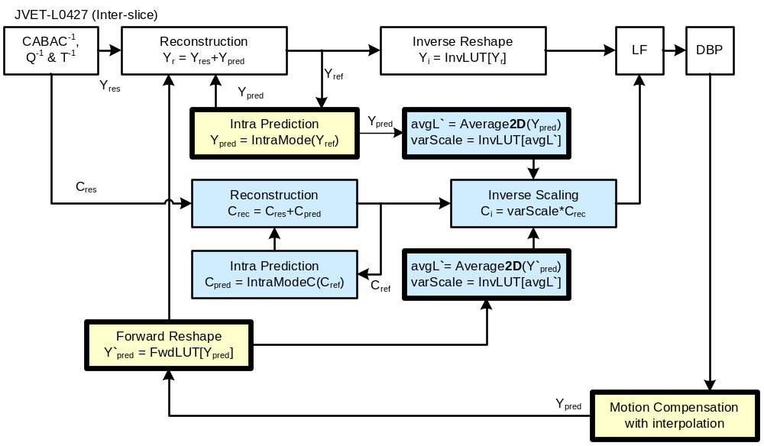Figure 1 Chroma reconstruction process (marked with blue)

Proposal
The proposed approach is depicted on Fig and allows to avoid few intermediate steps used for chroma reconstruction process.
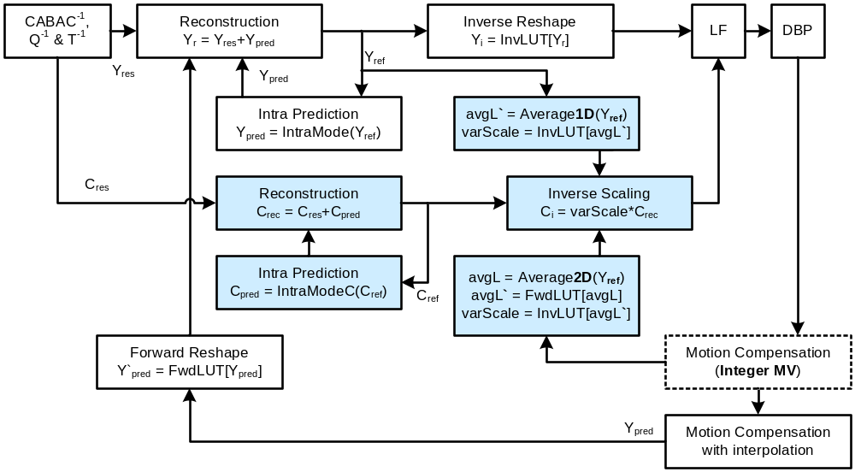
Figure 2 Chroma reconstruction process with proposed optimisation

Aspect 1 (Luma DC)
This method of Intra simplification proposes to use luma DC prediction value instead of using an average value of luma samples for chroma scaling factor derivation.
The influence on BD-rate is provided in Table 2-1:
Table 2-1 – Aspect 1 (Luma DC)
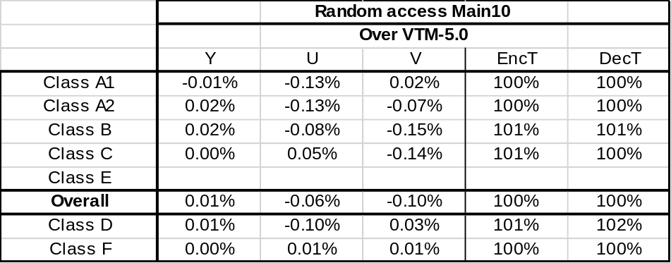

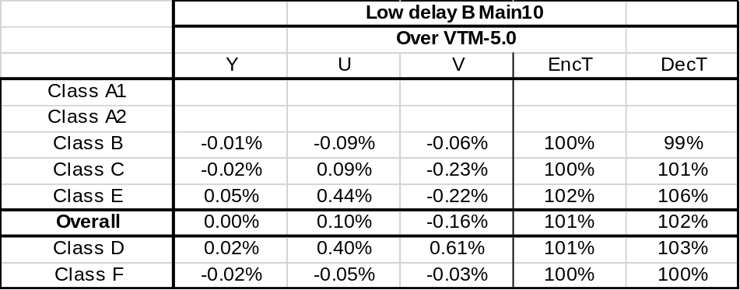

Aspect 2 (offset for Directional Intra modes)
Methods of Intra simplification described in JVET-N0477 based on both top and left reference lines. In this aspect proposed to use shifted reference array for directional Intra modes dependent on prediction angle for more accurate calculation of average value of luma samples for chroma scaling factor derivation. An example of integer offset of reference samples for calculating average luma value used for chroma scaling factor derivation depicted on Figure 3. Offset is equal to L/2 and the length of reference samples array is equal to width of the transform unit nTbW.
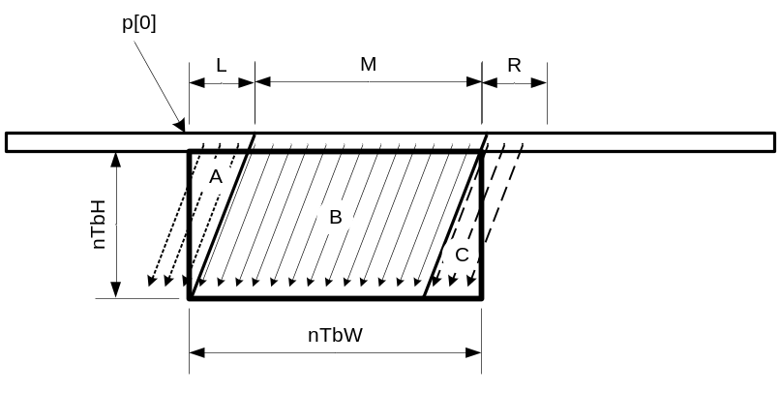
Figure 3 Offset for Directional Intra modes

The influence on BD-rate is provided in Table 2-2:
Table 2-2 –Aspect 2 (offset for Directional Intra modes)
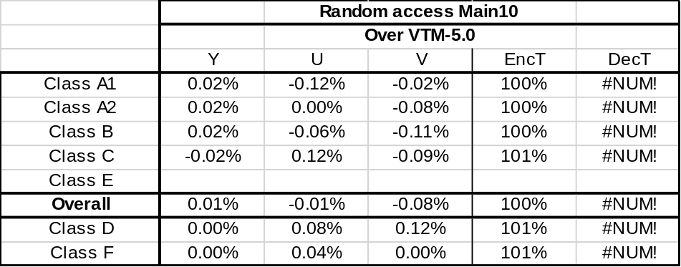
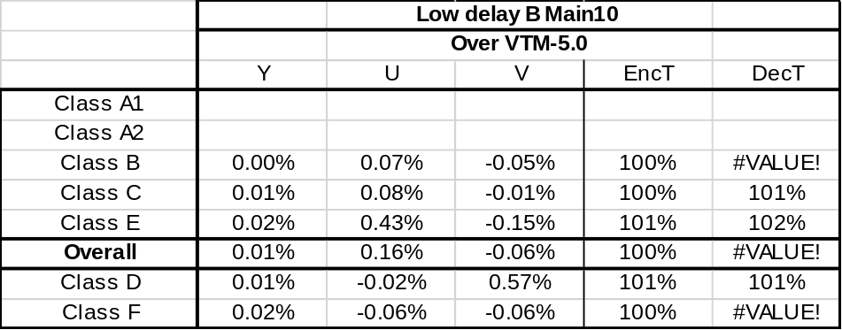

Aspect 3 (reference from Inter modes)
In this aspect for Inter prediction modes proposed to calculate an average value of luma samples directly in reference pictures by using integer MV of current luma block to obtain chroma scaling factor derivation.
The influence on BD-rate is provided in Table 2-3:
Table 2-3 –Aspect 3 (reference from Inter modes)
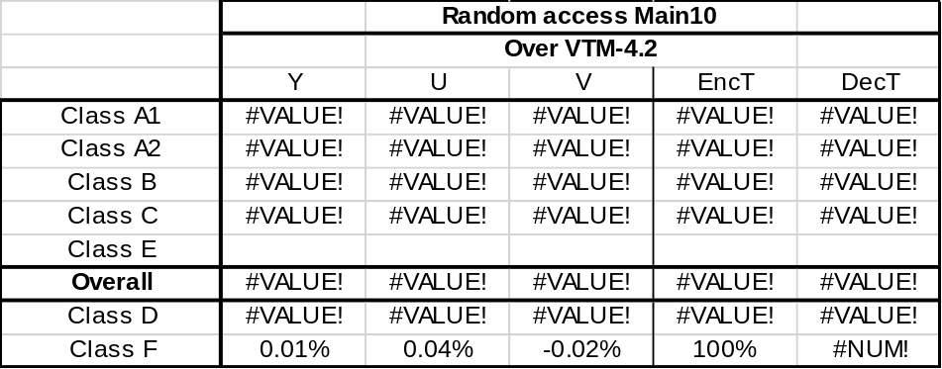
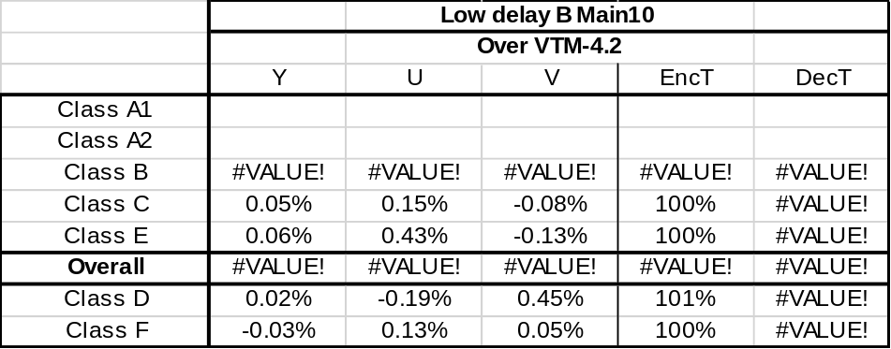

References
- Y. Ye, J. Chen, R. Liao, “On luma mapping with chroma scaling” Document of Joint Video Experts Team, JVET-N0477, March 2019
- B. Bross, J. Chen, S. Liu “Versatile Video Coding (Draft 5)”, Document of Joint Video Experts Team, JVET-N1001-v8, March 2019
- F. Bossen, J. Boyce, X. Li, V. Seregin, and K. Sühring, “JVET common test conditions and software reference configurations for SDR video,” Document of Joint Video Experts Team, JVET-N1010, March 2019

Patent rights declaration(s)
Huawei Technologies Co., Ltd. may have current or pending patent rights relating to the technology described in this contribution and, conditioned on reciprocity, is prepared to grant licenses under reasonable and non-discriminatory terms as necessary for implementation of the resulting ITU-T Recommendation | ISO/IEC International Standard (per box 2 of the ITU-T/ITU-R/ISO/IEC patent statement and licensing declaration form).

