Joint Video Experts Team (JVET)  of ITU-T SG 16 WP 3 and ISO/IEC JTC 1/SC 29/WG 11  15th Meeting: Gothenburg, SE, 3–12 July 2019 | Document: JVET-O0549-v2

Title: | AHG10: Encoder-only GOP-based temporal filter
Status: | Input document to JVET
Purpose: | Proposal
Author(s) or  Contact(s): | P. Wennersten  R. Sjöberg  J. Enhorn | Email: | per.wennersten@ericsson.com  rickard.sjoberg@ericsson.com  jack.enhorn@ericsson.com
Source: | Ericsson
_____________________________

Abstract
This contribution proposes an encoder-only temporal filter. The filtering is done at the encoder side as a pre-processing step. Source pictures before and after the original picture to encode are read and an 8x8 block-based motion compensation method relative to the original picture is applied on those source pictures. Samples in the original picture are temporally filtered using source picture sample values after motion compensation. Only pictures at temporal sub layers 0 and 1 are filtered.
A similar method was proposed as JCTVC-AI0023 and adopted to HM at the previous JCT-VC meeting.
The method was reportedly tested under VTM-5.0 RA, LDB and LDP common test configurations. The average Y/U/V BD-rates for the common test conditions (CTC) are reported to be −3.49%/−6.96%/−6.53% (RA), −1.00%/−1.24%/−2.24% (LDB) and −1.47%/−1.95%/−2.78% (LDP). All BDR numbers were computed using unfiltered source sequences. The method is not proposed for AI encoding.
The version 2 of this document contains updated BDR numbers for RA.
It is proposed to adopt the proposed method into the VTM software but to disable it in the CTC.

Introduction
The VTM[1] encoder minimizes the rate*lambda + distortion metric for each block.
If a current picture is followed by an identical following picture, the coded blocks in the current picture would be skipped. In this case, rate*lambda+2*distortion should be minimized. VTM approximates this for RA by setting different QP values for the temporal layers.
If the following picture is only slightly different, the coded block is still likely to be skipped. In this case, rate*lambda + distortion1 + distortion2 should be minimized. Rather than calculating the two distortions separately, the distortion between the coded block and the average of the original versions of the two pictures can be calculated. This is one motivation for using temporally filtered original pictures. The filter strength should drop off rapidly if the original images are different, as it is no longer likely that the decoded sample values for the first picture will be re-used for the second picture.

Proposal

GOP-based temporal filter
This contribution proposes a temporal filter encoding as follows:
Step 1: A picture is read by the encoder
Step 2: If the picture is low enough in the coding hierarchy, it is filtered before encoding. Otherwise the picture is encoded without filtering. RA pictures with POC % 8 == 0 and LD pictures with POC % 4 == 0 are filtered. AI pictures are never filtered.
The overall filter strength, s_{0,} is set according to the equation below for RA:

if (POC % 16 == 0)
s₀ = 1.5
else if (POC % 8 == 0)
s₀ = 0.95
For the LD case, s₀ = 0.40 is used.
Step 3: For RA, two neighboring pictures before and after the original picture are read. For LD, two neighboring pictures before the original picture are read. In cases where e.g. the original picture is the first picture or close to be the last picture, only the available pictures are read.
Step 4: A motion estimation and motion compensation method is applied on the neighboring pictures. This is done on 8x8 luma blocks.

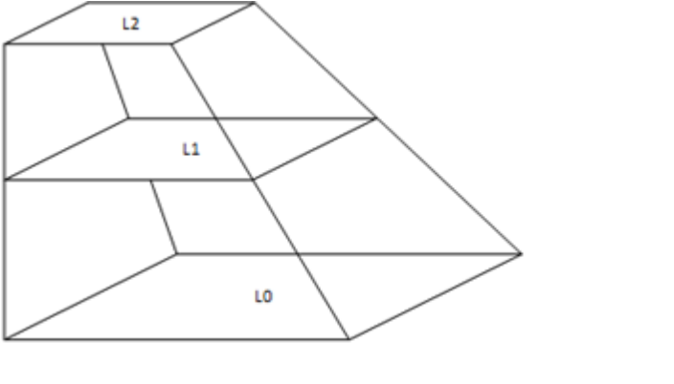
Figure 1 -Layers of the hierarchical motion estimation

A hierarchical motion estimation scheme is used and the subsampling is illustrated in Figure 1 where picture L0 is the current picture. Picture L1 is generated by averaging 2x2 blocks of the sample values in L0. Then picture L2 is generated by averaging 2x2 blocks of sample values in L1. Motion estimation is done by a first L2 full-pel motion vector search. The best motion vector is then scaled and used as a starting point for a full-pel search in L1. The best motion vector found then is again scaled and used as a starting point for a full-pel search in L0 that is followed by a final 16th sub-pel search. Motion compensation is then applied.
Step 5: All sample values of the original picture are replaced by filtered sample values before encoding as follows:
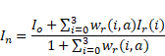
I₀ is the original sample value, I_{r}(i) is the co-located sample value in the neighboring picture i after motion compensation and w_{r}(i,a) is the weight of neighboring picture i when the number of available neighboring pictures is equal to a.
For luma samples, the weight, w_{r}(i,a), is calculated as follows:
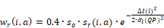
where

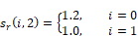
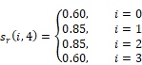
For all other cases of i and a: s_{r}(i,1) = 0.3.

For chroma samples, the weight, w_{r}(i,a), is calculated as follows:
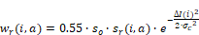
Step 6: The filtered picture is encoded.

Results
The proposal was implemented on top of VTM-5.0. The method is applied for RA and LD coding, but not for AI coding. The BR-rate result relative to VTM-5.0 is reported below.
A small bug was found that affected the RA results. Version 2 of this document contains corrected BDR numbers. The attached excel file was also updated.

 | Random access Main10
 | Over VTM-5.0
 | Y | U | V | EncT | DecT
Class A1 | -1.93% | -6.65% | -4.20% | 93% | 99%
Class A2 | -4.84% | -11.53% | -11.00% | 91% | 94%
Class B | -5.68% | -8.26% | -8.63% | 95% | 100%
Class C | -0.89% | -2.16% | -2.33% | 101% | 98%
Class E
Overall | -3.49% | -6.96% | -6.53% | 95% | 98%
Class D | -0.56% | -2.34% | -2.46% | 100% | 103%
Class F | -0.23% | -1.05% | -0.96% | 106% | 99%

 | Low delay B Main10
 | Over VTM-5.0
 | Y | U | V | EncT | DecT
Class A1
Class A2
Class B | -1.45% | -1.57% | -3.24% | 99% | 96%
Class C | 0.13% | 0.28% | -0.17% | 102% | 101%
Class E | -1.76% | -2.70% | -3.32% | 97% | 100%
Overall | -1.00% | -1.24% | -2.24% | 99% | 99%
Class D | 0.63% | -0.31% | -0.04% | 101% | 101%
Class F | 0.26% | 0.51% | 0.65% | 102% | 98%

 | Low delay P Main10
 | Over VTM-5.0
 | Y | U | V | EncT | DecT
Class A1
Class A2
Class B | -2.10% | -2.29% | -3.84% | 99% | 101%
Class C | -0.04% | -0.09% | 0.01% | 101% | 102%
Class E | -2.34% | -3.85% | -4.73% | 102% | 107%
Overall | -1.47% | -1.95% | -2.78% | 101% | 103%
Class D | 0.59% | -0.53% | -0.66% | 105% | 104%
Class F | 0.26% | 1.97% | 0.84% | 103% | 102%

Conclusion
In this document a temporal filter was introduced providing improved compression efficiency. It is proposed to adopt the proposed method into the VTM software but to disable it in the CTC.

References
[1] VTM-5.0 reference software, https://vcgit.hhi.fraunhofer.de/jvet/VVCSoftware_VTM.git

Patent rights declaration(s)
Ericsson may have current or pending patent rights relating to the technology described in this contribution and, conditioned on reciprocity, is prepared to grant licenses under reasonable and non-discriminatory terms as necessary for implementation of the resulting ITU-T Recommendation | ISO/IEC International Standard (per box 2 of the ITU-T/ITU-R/ISO/IEC patent statement and licensing declaration form).

