    Joint Video Experts Team (JVET)  of ITU-T SG 16 WP 3 and ISO/IEC JTC 1/SC 29/WG 11  15th Meeting: Gothenburg, SE, 3–12 July 2019 | Document: JVET-O0280-v1

Title: | CE4-related: SIMD implementation for weighted sample prediction process of triangle prediction mode
Status: | Input document to JVET
Purpose: | Proposal
Author(s) or  Contact(s): | Yu-Ling Hsiao, Chih-Wei Hsu,  Yu-Wen Huang, Shaw-Min Lei  No. 1, Dusing 1st Rd.,  Hsinchu City 30078, Taiwan | Tel:  Email: | +886-3-5670766  {yuling.hsiao, cw.hsu, yuwen.huang, shawmin.lei} @mediatek.com
Source: | MediaTek Inc.
_____________________________

Abstract
This contribution proposes single instruction multiple data (SIMD) implementation for the weighted sample prediction process of triangle prediction mode. Compared with VTM5.0, the encoding time is reduced by 2% for RA and 3% for LB without BD-rate changes.

Introduction
In Versatile Video Coding Draft 5 [1], the weighted sample prediction process is used to generate combined prediction from two triangle partitions for triangle merge mode. However, in VTM5.0, no SIMD is implemented to speed up the process such that it becomes one of the time-consuming functions as shown in Figure 1 (xWeightedTriangleBlk is the function name for the weighted sample prediction process).

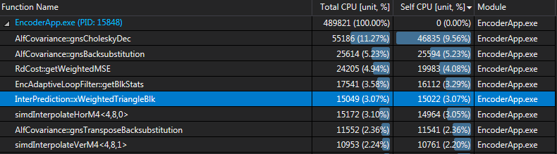
Figure 1. Profiling results of using VTM5.0 to encode BQSquare sequence at QP37 for 1 second

To reduce the encoding time, it is proposed to apply SIMD implementation to the weighted sample prediction process. As shown in Figure 2, the encoding time of the process is reduced after applying SIMD implementation (xWeightedTriangleBlk_SSE is the function name for SIMD implementation of the weighted sample prediction process).

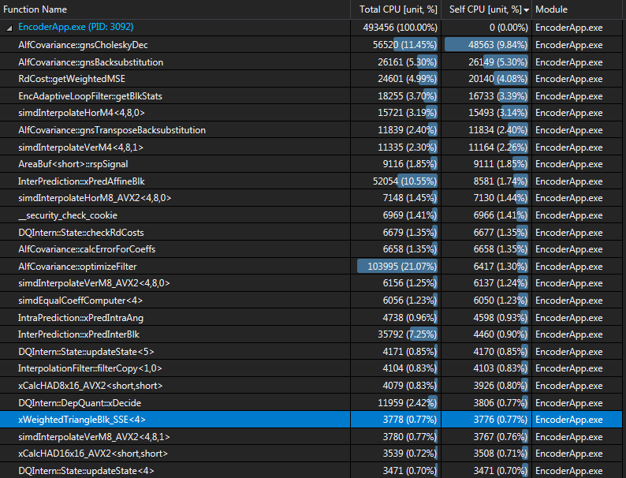
Figure 2. Profiling results of using VTM5.0 with proposed SIMD implementation to encode BQSquare sequence at QP37 for 1 second

Experiment results
The proposed implementation is based on VTM5.0. The common test conditions [2] are used for evaluation. Table 1 summarizes the results of proposed implementation.

Table 1. SIMD implementation for weighted sample prediction process
 | Random access Main10
 | Over VTM-5.0
 | Y | U | V | EncT | DecT
Class A1 | 0.00% | 0.00% | 0.00% | 98% | 98%
Class A2 | 0.00% | 0.00% | 0.00% | 98% | 98%
Class B | 0.00% | 0.00% | 0.00% | 98% | 97%
Class C | 0.00% | 0.00% | 0.00% | 97% | 97%
Class E
Overall | 0.00% | 0.00% | 0.00% | 98% | 98%
Class D | 0.00% | 0.00% | 0.00% | 97% | 100%
Class F | 0.00% | 0.00% | 0.00% | 99% | 97%
 | Low delay B Main10
 | Over VTM-5.0
 | Y | U | V | EncT | DecT
Class A1
Class A2
Class B | 0.00% | 0.00% | 0.00% | 97% | 100%
Class C | 0.00% | 0.00% | 0.00% | 97% | 101%
Class E | 0.00% | 0.00% | 0.00% | 96% | 98%
Overall | 0.00% | 0.00% | 0.00% | 97% | 100%
Class D | 0.00% | 0.00% | 0.00% | 95% | 98%
Class F | 0.00% | 0.00% | 0.00% | 97% | 98%

Conclusion
In this contribution, SIMD implementation for weighted sample prediction process of triangle merge mode is proposed. Compared with VTM5.0, it can reduce 2% - 3% encoding time without BD-rate changes.

References
[1] B. Bross, J. Chen, and S. Liu, “Versatile Video Coding (Draft 5),” Document of Joint Video Experts Team, JVET-N1001.
[2] F. Bossen, J. Boyce, X. Li, V. Seregin, and K. Sühring, “JVET common test conditions and software reference configurations for SDR video,” Document of Joint Video Experts Team, JVET-N1010.

Patent rights declaration(s)
MediaTek Inc. does not have any current or pending patent rights relating to the technology described in this contribution.

