    Joint Video Experts Team (JVET)  of ITU-T SG 16 WP 3 and ISO/IEC JTC 1/SC 29/WG 11  15th Meeting: Gothenburg, SE, 3–12 July 2019 | Document: JVET-O0265

Title: | Non-CE4: Simplified motion field storage for TPM
Status: | Input document to JVET
Purpose: | Proposal
Author(s) or  Contact(s): | Na Zhang, Hongbin Liu, Li Zhang,  Kai Zhang, Yue Wang  Zijinshumayuan 4th building F9, 18 Zhongguancun Nansijie, Haidian District, 100190  Beijing, China | Tel:  Email: | zhangna.cynthia@bytedance.com  lizhang.idm@bytedance.com  liuhongbin.01@bytedance.com
Source: | Bytedance Inc.
_____________________________

Abstract
In this contribution, three simplified motion field storage methods for TPM are proposed. In method #1, the mapping process is removed for the storage of motion information in the weighted area. In method #2, bi-prediction motion is always stored. In method #3, the changes of method #1 and method #2 are combined under the low delay check. Simulation results reportedly show that there is no overall coding performance change for method #3 compared to VTM5.0.

Introduction
The motion vectors of a CU coded in triangle partition mode are stored in 4x4 units. Depending on the position of each 4x4 unit, either uni-prediction or bi-prediction motion are stored. Denote (Mv1, refIdx1) and (Mv2,refIdx2) as uni-prediction motion information for partition 1 and partition 2 as shown in Figure 1, respectively. If a 4x4 unit is located in the non-weighted area shown in the example of Figure 2, either (Mv1,refIdx1) or (Mv2,refIdx2) is stored for that 4x4 unit. Otherwise, if the 4x4 unit is in the weighted area, the motion information to be stored is derived from (Mv1,refIdx1) and (Mv2,refIdx2) according to the following process:
- If Mv1 and Mv2 are from different reference picture lists (one from L0 and the other from L1), then (Mv1,refIdx1) and (Mv2,refIdx2) are simply combined to form the bi-prediction motion.
- Otherwise, if Mv1 and Mv2 are from the same list, and without loss of generality, assume they are both from L0. In this case, a mapping process is conducted as:
  - If the reference picture of either Mv2 (or Mv1) appears in L1, then that Mv2 (or Mv1) is converted to a L1 motion vector using that reference picture in L1. Then the two motion vectors are combined to form the bi-prediction motion;
  - Otherwise, instead of bi-prediction motion, only uni-prediction motion (Mv1,refIdx1) is stored.

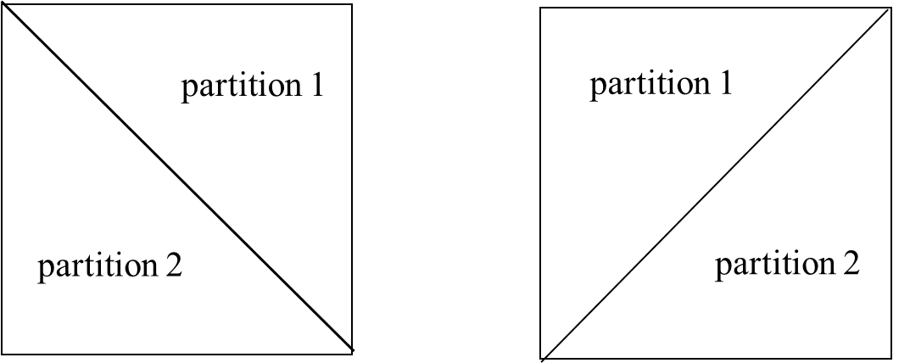
(a) 135 degree partition type (b) 45 degree partition type
Figure 1. Two triangular partition types
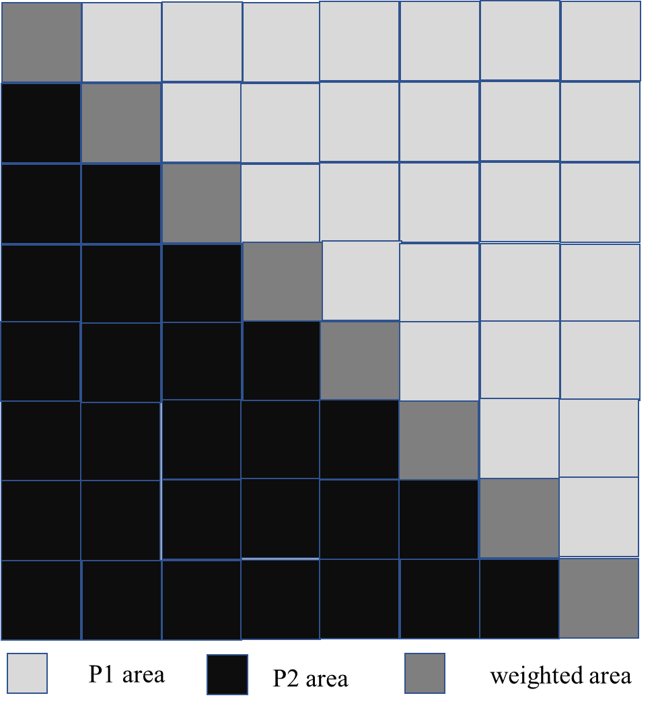
Figure 2. Three motion storage areas of 135 degree partition type for a 32x32 block

Proposed methods
This contribution proposes three simplified motion field storage methods for the weighted area in TPM.

Method #1
In this proposed method, the mapping process is removed for the storage of motion information in the weighted area. The motion information to be stored is derived from (Mv1,refIdx1) and (Mv2,refIdx2) according to the following process:
- If Mv1 and Mv2 are from different reference picture lists, then (Mv1,refIdx1) and (Mv2,refIdx2) are simply combined to form the bi-prediction motion.
- Otherwise, if Mv1 and Mv2 are from the same list, uni-prediction motion (Mv2,refIdx2) is stored.

Method #2
In this proposed method, bi-prediction motion is always stored. The bi-prediction motion is derived from (Mv1,refIdx1) and (Mv2,refIdx2) according to the following process:
- (Mv1,refIdx1) and (Mv2,refIdx2) are combined to form the bi-prediction motion with the reference picture list of partition 2 changed from LX to LY with Y = 1-X, if reference picture list of partition 1 is equal to LX;

Method #3
In this proposed method, the changes of method #1 and method #2 are combined under the low delay check. When the low delay check is false, method #1 is applied, otherwise, method #2 is applied. More specifically, the motion information to be stored is derived from (Mv1,refIdx1) and (Mv2,refIdx2) according to the following process:
- If Mv1 and Mv2 are from different reference picture lists, then (Mv1,refIdx1) and (Mv2,refIdx2) are simply combined to form the bi-prediction motion.
- Otherwise, if Mv1 and Mv2 are from the same list LX,
  - If all reference pictures are with POC values no greater than that of the current picture, Mv2 is converted to a LY (Y is 1-X) motion vector ( the same MV and refence picture index as that in LX). Then (Mv1,refIdx1) and (Mv2,refIdx2) are combined to form the bi-prediction motion;
  - Otherwise, uni-prediction motion (Mv2,refIdx2) is stored.

Experimental Results
The proposed method has been implemented on top of VTM-5.0. Results under RA/LDB configurations are summarized in Table 1 ~ Table 3. The simulations were performed following the the common test conditions [1]. More detailed results can be found in the attached spreadsheets.
Table 1: Coding performance of the proposed method 1.
 | RA |  |  |  |  | LB
 | Y | U | V | EncT | DecT | Y | U | V | EncT | DecT
Class A1 | 0.00% | -0.15% | 0.07% | 100% | 99%
Class A2 | 0.02% | 0.06% | 0.05% | 102% | 102%
Class B | 0.02% | -0.06% | 0.00% | 101% | 102% | 0.08% | 0.39% | 0.06% | 101% | 104%
Class C | -0.03% | -0.02% | -0.16% | 101% | 103% | 0.09% | 0.09% | 0.21% | 101% | 106%
Class E |  |  |  |  |  | 0.03% | 0.28% | -0.19% | 101% | 106%
Overall | 0.00% | -0.05% | -0.02% | 101% | 102% | 0.07% | 0.26% | 0.05% | 101% | 105%
Class D | -0.02% | 0.07% | 0.08% | 100% | 103% | 0.12% | -0.02% | 1.33% | 102% | 104%
Class F | 0.00% | 0.03% | 0.00% | 100% | 101% | 0.09% | 0.02% | -0.38% | 99% | 97%
Class SCC | -0.02% | -0.02% | -0.05% | 98% | 98% | -0.06% | -0.01% | -0.05% | 101% | 101%

Table 2: Coding performance of the proposed method 2.
 | RA |  |  |  |  | LB
 | Y | U | V | EncT | DecT | Y | U | V | EncT | DecT
Class A1 | 0.03% | -0.18% | 0.04% | 100% | 99%
Class A2 | 0.06% | 0.09% | 0.07% | 101% | 101%
Class B | 0.07% | 0.11% | 0.04% | 101% | 102% | 0.00% | 0.00% | 0.00% | 100% | 99%
Class C | 0.07% | 0.12% | 0.00% | 101% | 105% | 0.00% | 0.00% | 0.00% | 101% | 108%
Class E |  |  |  |  |  | 0.00% | 0.00% | 0.00% | 101% | 103%
Overall | 0.06% | 0.05% | 0.03% | 101% | 102% | 0.00% | 0.00% | 0.00% | 101% | 103%
Class D | 0.06% | 0.01% | 0.08% | 101% | 105% | 0.00% | 0.00% | 0.00% | 101% | 105%
Class F | 0.06% | 0.07% | 0.00% | 100% | 102% | 0.00% | 0.00% | 0.00% | 98% | 96%
Class SCC | 0.03% | 0.06% | 0.02% | 99% | 98% | 0.00% | 0.00% | 0.00% | 100% | 97%

Table 3: Coding performance of the proposed method 3.
 | RA |  |  |  |  | LB
 | Y | U | V | EncT | DecT | Y | U | V | EncT | DecT
Class A1 | 0.00% | -0.12% | -0.02% | 98% | 98%
Class A2 | 0.01% | -0.01% | 0.02% | 102% | 102%
Class B | 0.01% | 0.04% | -0.02% | 99% | 99% | 0.00% | 0.00% | 0.00% | 100% | 101%
Class C | -0.01% | -0.01% | -0.04% | 100% | 100% | 0.00% | 0.00% | 0.00% | 101% | 101%
Class E |  |  |  |  |  | 0.00% | 0.00% | 0.00% | 103% | 102%
Overall | 0.00% | -0.02% | -0.02% | 100% | 99% | 0.00% | 0.00% | 0.00% | 101% | 101%
Class D | -0.01% | -0.07% | 0.09% | 99% | 100% | 0.00% | 0.00% | 0.00% | 101% | 99%
Class F | -0.01% | 0.03% | 0.00% | 99% | 98% | 0.00% | 0.00% | 0.00% | 97% | 91%
Class SCC | -0.01% | -0.02% | -0.05% | 98% | 96% | 0.00% | 0.00% | 0.00% | 100% | 99%

- Conclusions
In this contribution, three simplified motion field storage methods for TPM is proposed. There is no overall coding performance change for method #3 compared to VTM5.0 after performing simplification. It is recommended to adopt this simplification method into VVC.

References
[1] F. Bossen, J. Boyce, X. Li, V. Seregin, K. Sühring, “JVET common test conditions and software reference configurations for SDR video,” JVET-N1010, Mar. 2019.

- Patent rights declaration(s)
Bytedance Inc. may have current or pending patent rights relating to the technology described in this contribution and, conditioned on reciprocity, is prepared to grant licenses under reasonable and non-discriminatory terms as necessary for implementation of the resulting ITU-T Recommendation | ISO/IEC International Standard (per box 2 of the ITU-T/ITU-R/ISO/IEC patent statement and licensing declaration form).

