    Joint Video Experts Team (JVET)  of ITU-T SG 16 WP 3 and ISO/IEC JTC 1/SC 29/WG 11  15th Meeting: Gothenburg, SE, 3–12 July 2019 | Document: JVET-O0224

Title: | CE3-related: Further simplifications of the unified MPM list for intra mode coding
Status: | Input document to JVET
Purpose: | Proposal
Author(s) or  Contact(s): | Gagan Rath, Fabien Racapé, Fabrice Urban | Tel:  Email: | +33.2.56.85.62.76  gagan.gath@InterDigital.com  fabien.racape@InterDigital.com  fabrice.urban@InterDigital.com
Source: | InterDigital Inc.
_____________________________

Abstract
This contribution reports the result of using a simplified unified MPM list in the intra mode coding. The list construction follows the same logic as in the unified MPM list adopted in the JVET meeting in Geneva in March 2019, but consists of only 5 MPMs. The complex logic for the adjacency check of the intra modes of the left and top blocks is replaced with a simpler logic. Like the unified list, the simplified list can be used with all coding tools such as the intra prediction with multiple reference lines (MRL), or intra prediction with sub-partitions (ISP), or the regular intra prediction. Compared to the unified list in VTM5.0, 0.01% coding gain in AI, with 98% encoding and 98% decoding time is observed.

Introduction
In the JVET meeting held in Geneva in March 2019, it was agreed to use a unified MPM list [1] which will be used for all coding tools including MRL and ISP. The unified MPM list consists of six MPMs and always includes the planar and DC modes. The current contribution proposes two simplifications of the unified list when the top and left intra modes are angular and different. The number of MPMs is also reduced to five to remove the inconsistency in the last MPM selection, without losing any coding performance.

Problem definition
The unified 6-MPM list [1] is constructed using the intra modes of the left and above neighbor blocks, and some default modes like the Planar mode, the DC mode, the horizontal mode (H) and the vertical mode (V). Let the intra modes of the left and above neighboring blocks be denoted as Left and Above. The MPM list is constructed as follows:
- If both Left and Above are non-angular:
  - MPM list {Planar, DC, V, H, V-4, V+4}. This is the default list.
- If one of Left and Above is angular, and the other is non-angular:
  - MPM list {Planar, Max, DC, Max -1, Max +1, Max -2}, where Max = max(Left, Above)
- If Left and Above are both angular and are different:
  - if the absolute difference between modes Left and Above is in the range of 2 to 62, inclusive
    - MPM list {Planar, Left, Above, DC, Max -1, Max +1}
  - Otherwise
    - MPM list {Planar, Left, Above, DC, Max -2, Max +2}
where Max = max(Left, Above).
- If Left and Above are both angular and equal:
  - MPM list {Planar, Left, Left -1, Left +1, DC, Left -2}
It is to observe that, in the case of (3), the adjacency check to decide between the two sub-cases (a) and (b) is somewhat complex as it is dependent on knowledge of the total number of angular modes.. Secondly, in the sub-case of 3(b), as Left and Above are adjacent, only one of the adjacent modes of the pair (Left, Above) is included in the list.
It is also to observe that, in both sub-cases 3(a) and 3(b), the larger mode between Left and Above is used to derive the last two MPMs in the list. There is no reason why the larger mode should be always more probable than the smaller mode, that is, min(Left, Above). The same argument applies to case 1 (V-4/V+4 over V-1/V+1 or V-2/V+2), case 2 (Max- 2 over Max + 2), case 4 (Left-2 over Left + 2)

Proposed solutions
Considering the above arguments, two simplifications are proposed below:

Simplified List 1
- If both Left and Above are non-angular:
  - MPM list {Planar, DC, V, H, DIAG}
where. DIAG is the diagonal mode (mode 34).
- If one of Left and Above is angular, and the other is non-angular:
  - MPM list {Planar, Max, DC, Max -1, Max +1},
- If Left and Above are both angular and are different:
    - MPM list {Planar, Left, Above, Max -1, Max +1}
if Min = Max – 1, replace Max – 1 by Min – 1.
else if Min = Max + 1, replace Max + 1 by Min + 1
- If Left and Above are both angular and equal:
  - MPM list {Planar, Left, Left -1, Left +1, DC}

Simplified List 2
- If both Left and Above are non-angular modes:
  - MPM list {Planar, DC, V, H, DIAG}
where. DIAG is the diagonal mode (mode 34).
- If one of Left and Above is angular, and the other is non-angular:
  - MPM list {Planar, Max, DC, Max -1, Max +1},
- If Left and Above are both angular and are different:
  - if the absolute difference between modes Left and Above is in the range of 2 to 62, inclusive
    - MPM list {Planar, Left, Above, Mpm -1, Mpm +1}
  - Otherwise
    - MPM list {Planar, Left, Above, Mpm -2, Mpm +2}
where Mpm = Max if Max >= DIAG, Mpm = Min, otherwise.
- If Left and Above are both angular and equal:
  - MPM list {Planar, Left, Left -1, Left +1, DC}
It is to notice that the two proposals differ only in case 3, when the intra modes of left and above blocks are both angular and are different. They produce identical lists in all other cases.
It is also to observe that, in both simplifications, the Planar mode is always the first MPM in the list, and the DC mode does not belong to the list in case 3.
Since the proposed lists contain five MPMs, the existing variable length coding is modified to read/write a maximum of 4 bits for the binarization of an MPM.

Experimental Results
Simulations were performed according to CTC described in [2]. AI and RA results are reported below.
It is to note that the test results with the proposed lists include the encoder code optimization that replaces multiple function calls to generate the MPM list for different cases (MRL, ISP, etc.) inside the RD loop with a single function call. Since the purpose of the unified list is to use the same list in all tools, it is unnecessary to generate the list for each tool separately inside the RD loop.

Test 1 with Simplified List 1
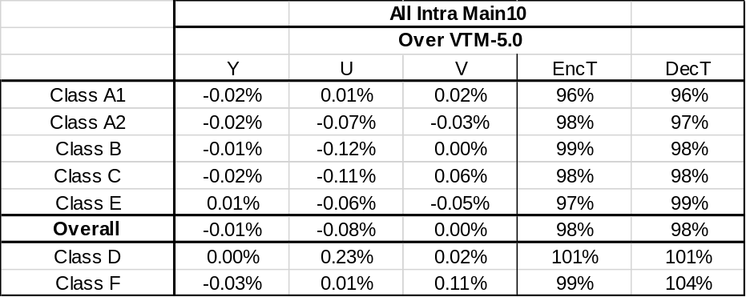

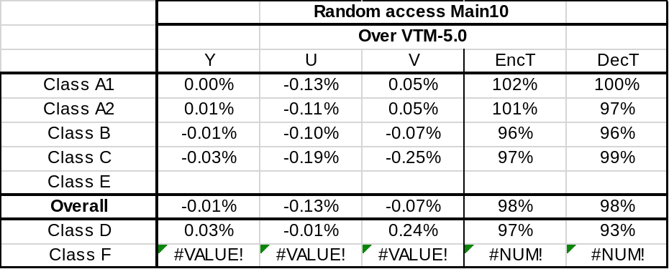

Test 2 with Simplified List 2
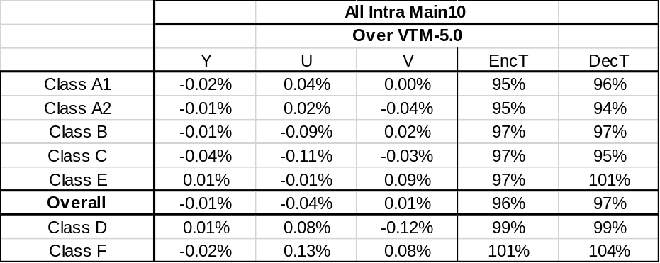

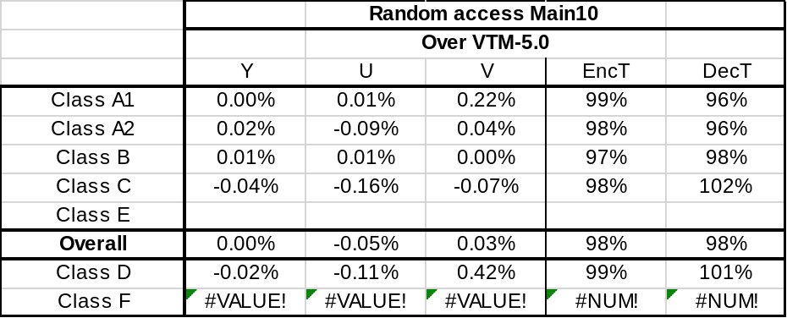

Conclusion
This contribution document reports the results of two simplifications of the unified MPM list used in intra mode coding in VTM 5.0. Like the original unified MPM list, the proposed lists are used for all cases of intra prediction, that is, intra prediction with MRL, ISP and regular intra prediction. Both simplifications yield about the same overall BD-rate gain and complexity reduction. Because of its relatively simpler list construction logic, and slightly better performance over the 2nd simplified list, the Simplified list 1 is proposed to replace the unified MPM list in VTM 5.0.

References
- “CE3-related: A unified MPM list for intra mode coding”, JVET-N0185, B. Wang, A. M. Kotra, S. Esenlik, H. Gao, J. Chen, 14th Meeting, Geneva, CH, March 2019.
- “JVET common test conditions and software reference configurations”, JVET-M1010, F. Bossen, J. Boyce, X. Li, V. Seregin, K. Sühring, 13th Meeting, Marrakech, MA, Jan. 2019.

Patent rights declaration(s)
InterDigital Inc. may have current or pending patent rights relating to the technology described in this contribution and, conditioned on reciprocity, is prepared to grant licenses under reasonable and non-discriminatory terms as necessary for implementation of the resulting ITU-T Recommendation | ISO/IEC International Standard (per box 2 of the ITU-T/ITU-R/ISO/IEC patent statement and licensing declaration form).

