    Joint Video Experts Team (JVET)  of ITU-T SG 16 WP 3 and ISO/IEC JTC 1/SC 29/WG 11  15th Meeting: Gothenburg, SE, 3–12 July 2019 | Document: JVET-O0213

Title: | Non-CE6: Block size restriction of LFNST
Status: | Input document to JVET
Purpose: | Proposal
Author(s) or  Contact(s): | Moonmo Koo  Junghak Nam  Jaehyun Lim  19 Yangjaedaero-11gil  Seocho-gu, Seoul 06772  South Korea  Mehdi Salehifar  Seung Hwan Kim  10225 Willow Creek Rd, San Diego  CA 92131, USA | Tel:  Email: | +1-858-635-5226  moonmo.koo@lge.com  junghak.nam@lge.com  jaehyun.lim@lge.com  mehdi.salehifar@lge.com  seunghwan3.kim@lge.com
Source: | LG Electronics Inc.
_____________________________

Abstract
In the 14th JVET meeting, Low Frequency Non-Separable Transform (LFNST) was adopted, where an LFNST kernel is chosen by LFNST index signaling. Considering that a large CU greater than 64x64 is implicitly split (TU tiling) due to the existing maximum transform size restriction (64x64), an LFNST index search could increase data buffering by four times for a certain number of decode pipeline stages so that it is desirable to disable the LFNST index derivation across 64x64 VPDU boundaries.
Therefore, two suggestions are proposed as follows:
Method 1: the maximum size that LFNST is allowed is restricted to 64x64,
Method 2: the LFNST index signaling is performed in TU-level which guarantees that LFNST index derivation must be performed within maximum size TU.
The experimental results of BD-rate/encoding time/decoding time changes due to explicit size limitation to 64x64 for LFNST are reported to be 0.00%/99%/99% (AI) and 0.00%/100%/100% (RA), and those due to the TU-level signaling of LFNST index 0.00%/100%/100% (AI) and 0.00%/101%/100% (RA).

Spec text changes
The spec text changes of the two approaches are straightforward as presented in 1.1 and 1.2, both of which are based on Working Draft 5 v8.

Explicit size restriction of LFNST to be 64x64
The additional condition check for maximum allowable size is marked with yellow color as follows:

7.3.7.5 Coding unit syntax
coding_unit( x0, y0, cbWidth, cbHeight, treeType ) { | Descriptor
……
numSigCoeff = 0
numZeroOutSigCoeff = 0
transform_tree( x0, y0, cbWidth, cbHeight, treeType )
lfnstWidth = ( treeType == DUAL_TREE_CHROMA ) ?
cbWidth / SubWidthC : cbWidth
lfnstHeight = ( treeType == DUAL_TREE_CHROMA ) ?
cbHeight / SubHeightC : cbHeight
if( Min( lfnstWidth, lfnstHeight ) >= 4 && sps_lfnst_enabled_flag == 1 && CuPredMode[ x0 ][ y0 ] = = MODE_INTRA &&
IntraSubPartitionsSplitType == ISP_NO_SPLIT &&
!intra_mip_flag[ x0 ][ y0 ] && Max( cbWidth, cbHeight ) <= 64 ) {
if( ( numSigCoeff > ( ( treeType == SINGLE_TREE ) ? 2 : 1 ) ) &&
numZeroOutSigCoeff == 0 ) {
lfnst_idx[ x0 ][ y0 ] | ae(v)
}
}
}
}
}

TU-level signaling of LFNST index
The location of lfnst_idx[ x0 ][ y0 ] parsing is moved from Coding unit syntax to Transform unit syntax as the following:

7.3.7.5 Coding unit syntax
coding_unit( x0, y0, cbWidth, cbHeight, treeType ) { | Descriptor
……
transform_tree( x0, y0, cbWidth, cbHeight, treeType )
}
}
}

7.3.7.10 Transform unit syntax
transform_unit( x0, y0, tbWidth, tbHeight, treeType, subTuIndex ) { | Descriptor
……
numSigCoeff = 0
numZeroOutSigCoeff = 0
if( tu_cbf_luma[ x0 ][ y0 ] ) {
if( !transform_skip_flag[ x0 ][ y0 ] )
residual_coding( x0, y0, Log2( tbWidth ), Log2( tbHeight ), 0 )
else
residual_ts_coding( x0, y0, Log2( tbWidth ), Log2( tbHeight ), 0 )
}
if( tu_cbf_cb[ x0 ][ y0 ] )
residual_coding( xC, yC, Log2( wC ), Log2( hC ), 1 )
if( tu_cbf_cr[ x0 ][ y0 ] ) {
if( tu_cbf_cb[ x0 ][ y0 ] )
tu_joint_cbcr_residual[ x0 ][ y0 ] | ae(v)
if( !tu_joint_cbcr_residual[ x0 ][ y0 ] )
residual_coding( xC, yC, Log2( wC ), Log2( hC ), 2 )
}
lfnstWidth = ( treeType == DUAL_TREE_CHROMA ) ? wC : tbWidth
lfnstHeight = ( treeType == DUAL_TREE_CHROMA ) ? hC : tbHeight
if( Min( lfnstWidth, lfnstHeight ) >= 4 && sps_lfnst_enabled_flag == 1 &&
CuPredMode[ x0 ][ y0 ] = = MODE_INTRA &&
IntraSubPartitionsSplitType == ISP_NO_SPLIT &&
!intra_mip_flag[ x0 ][ y0 ] ) {
if( ( numSigCoeff > ( ( treeType == SINGLE_TREE ) ? 2 : 1 ) ) &&
numZeroOutSigCoeff == 0 ) {
lfnst_idx[ x0 ][ y0 ] | ae(v)
}
}
}

Experimental results
The proposed method has been implemented based on VTM 5.0 reference software according to common test conditions defined in JVET-N1010 [2] and Core Experiment description in JVET-N1026 [3].

Explicit size restriction of LFNST to be 64x64

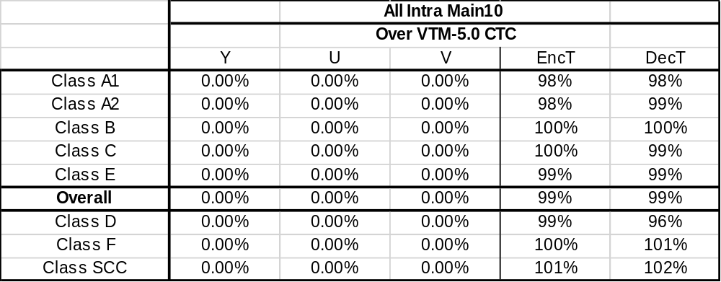

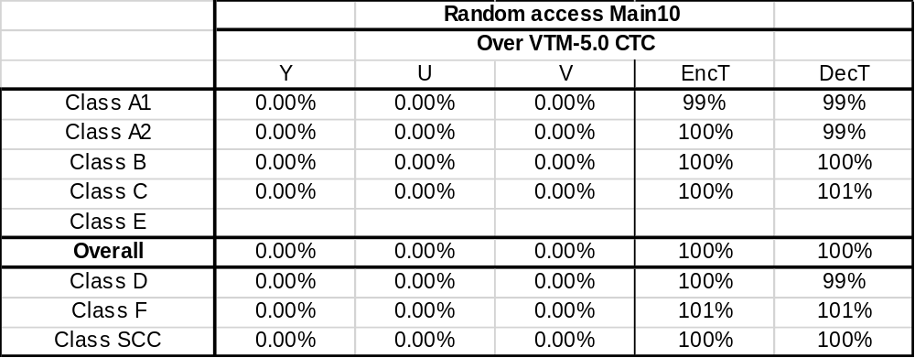

TU-level signaling of LFNST index

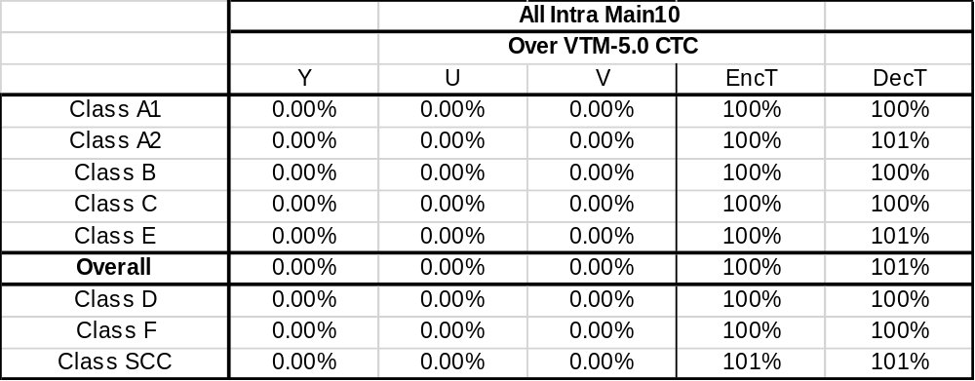

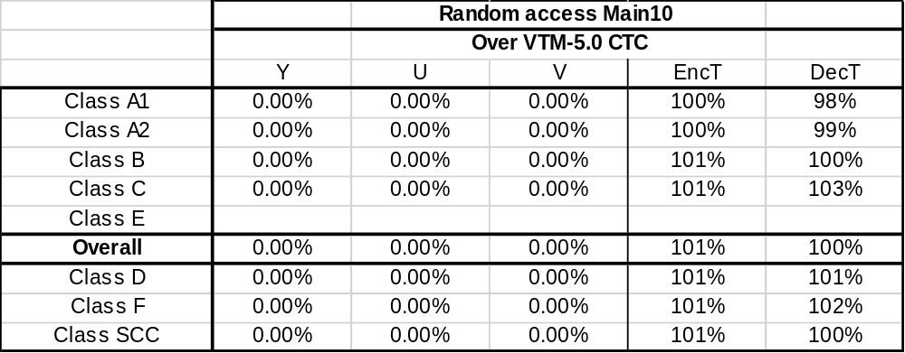

Conclusion
In summary, no effective changes of coding performance and complexity were observed under CTC with the two proposed solutions in order to prohibit the split TUs sharing one LFNST index from occurring. It is strongly recommended that one of the proposed approaches should be adopted in the next VTM.

Reference
- M. Koo et al., “CE6: Reduced Secondary Transform (RST) (CE6-3.1)”, Joint Video Exploration Team (JVET) of ITU-T SG 16 WP 3 and ISO/IEC JTC1/SC 29/WG 11 JVET-N0193, 14th meeting, Geneva, CH, 19–27 March 2019.
- F. Bossen, J. Boyce, K. Suehring, X. Li and V. Seregin, “JVET common test conditions and software reference configurations for SDR video”, JVET-N1010, 14th meeting, Geneva, CH, 19–27 March 2019.
- X. Zhao and H. E. Egilmez, “Description of Core Experiment 6 (CE6): Transforms and transform signalling”, JVET-N1026, 14th meeting, Geneva, CH, 19–27 March 2019.

Patent rights declaration(s)
LG Electronics Inc. may have current or pending patent rights relating to the technology described in this contribution and, conditioned on reciprocity, is prepared to grant licenses under reasonable and non-discriminatory terms as necessary for implementation of the resulting ITU-T Recommendation | ISO/IEC International Standard (per box 2 of the ITU-T/ITU-R/ISO/IEC patent statement and licensing declaration form).

