    Joint Video Experts Team (JVET)  of ITU-T SG 16 WP 3 and ISO/IEC JTC 1/SC 29/WG 11  15th Meeting: Gothenburg, SE, 3–12 July 2019 | Document: JVET-O0116-v3

Title: | CE11-4: Distributed decoding refresh DDR
Status: | Input document to JVET
Purpose: | Proposal
Author(s) or  Contact(s): | Maxim Sychev  Building 1/7, Altufievskoe Shosse,  Moscow 127106, Russia | Tel:  Email: | +7-925-008-1124  sychev.maxim@huawei.com
Source: | Huawei Technologies Co., Ltd.
_____________________________

Abstract
This contribution proposes a method for reducing bit rate fluctuations for achieving low end-to-end delay with random access capabilities. The method is referred to as distributed decoding refresh (DDR) initially proposed in contribution JVET-N0116 [1]. The key idea is to distribute IDR pictures over multiple inter-coded pictures, and such an IDR picture therefore cannot be used by these inter-coded pictures, except for the last one, for inter prediction reference. Such an IDR picture is referred to as a distributed IDR (DIDR) picture. A DIDR picture is not for output. Rather, the inter-codded associated DDR picture, which is a different representation of the same source picture, is for output.
It is asserted that the DDR-based approach can achieve rate smoothness while higher coding efficiency than GDR-based approaches, because no motion restrictions as in GDR are needed. Compared to usual IRAP picture based coding, the DDR-based approach needs to encode one additional inter-coded picture for each random access period, and the last of the multiple inter-coded pictures over which the VCL NAL units of the DIDR picture are distributed is less efficient than usual due to that it cannot use the DIDR picture for reference, while the DIDR would often be a number of pictures away in POC distance.
The proposed detailed spec text changes are provided in an attachment.
Simulation results for CE11-4 was obtained according CE11 specific test conditions [2]. Results reportedly show that the average luma BD-rate overhead is 3.5% in LDB configuration. The influence on encoding/decoding time is insignificant.

Introduction
For VVC, during the 12th JVET meeting in October 2018, it was agreed to have both IDR and CRA pictures as IRAP pictures. AHG14 was established to investigate alternative solutions allowing to reduce end-to-end delay. Several implementations of gradual random access (GRA) techniques have been recommended for further study in CE11.
An IRAP picture provides clean random accessing capabilities, but with very high bit rate fluctuations, which incur relatively high end-to-end delays. In order to reduce this delay the encoder can try to keep all the pictures at similar size in bits, such that the first intra picture is coded at a low quality and then the quality is gradually improved when encoding the following inter-coded pictures. This approach, however, usually has bad temporal perceptual quality, particularly for applications that requires both low end-to-end delay and frequent random access points.
As shown in JVET-N0114, GDR can greatly reduce the end-to-end delay. However, GDR has significant coding efficiency penalties. For example, a coding efficiency loss of about 21% was reported in JVET-M0529 for GDR coding compared to using IRAP pictures for similar random accessing capability.
Aiming at keeping both good quality and random access ability, while at the same time keeping overall coding efficiency high, an approach referred to as distributed decoding refresh (DDR) is proposed.

Proposal
The key idea is to distribute IDR pictures over multiple inter-coded pictures, and such an IDR picture therefore cannot be used by these inter-coded pictures, except for the last one, for inter prediction reference. Such an IDR picture is referred to as a distributed IDR (DIDR) picture. A DIDR picture is not for output. Rather, the inter-codded associated DDR picture, which is a different representation of the same source picture, is for output.
An example of DDR is depicted in Figure 1. The source picture #32 is coded as both a DDR picture and a DIDR picture associated with each other. The DIDR picture #32 intra coded, and uses the IDR_N_LP NAL unit type, has a flag in the tile group header indicating that it is a DIDR picture, and is distributed among the DDR picture #32 and the following pictures till picture #60. Random access is possible starting from AU #32 containing the DDR picture #32 and the first VCL NLA unit of the associated DIDR picture. When random accessing from AU 32, the DDR picture #32 and the following pictures till picture #59 cannot be correctly decoded, the pictures since picture #60 can be correctly decoded.
The DIDR picture #32 is decoded just before decoding of the picture #60, for which the AU contains the last VCL NAL unit of the DIDR picture #32. When a DIDR picture is decoded, all reference pictures in the DPB are marked as "unused for reference".
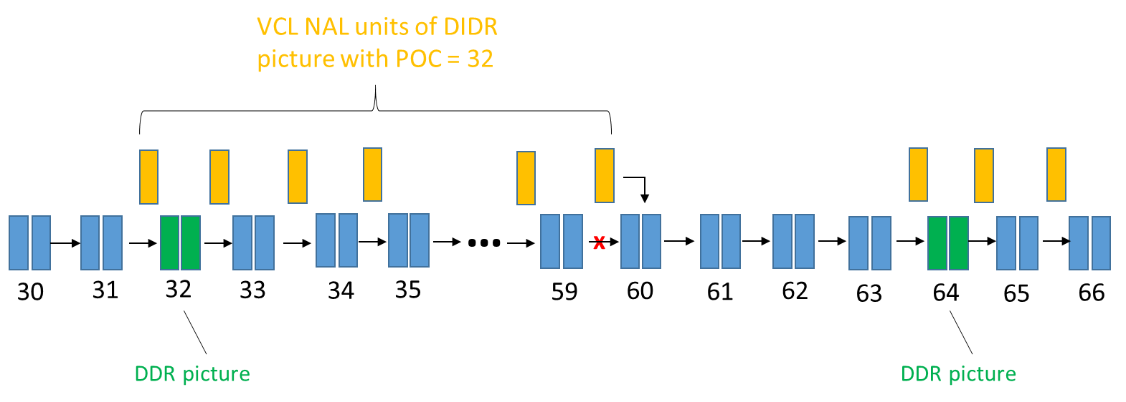
Figure 1 An example of DDR
The proposed design is summarized as follows:
- An access unit contains one coded picture and, optionally, a subset of a DIDR picture.
- A new VCL NAL unit type DDR_NUT is defined for DDR pictures.
  - A DDR picture may be the first picture in the bitstream in decoding order, may be the first picture of a CVS in decoding order, and may appear elsewhere in the bitstream.
  - A DDR picture does not have any associated leading pictures.
  - Each DDR picture is associated with a DIDR picture and vice versa.
  - A DDR picture shall have NuhLayerId equal to 0.
- A DDR AU may start a CVS or a bitstream, or may in the middle of a CVS, similarly as a CRA AU.
- A picture for which each VCL NAL unit has nal_unit_type equal to IDR_NO_LP and didr_pic_flag (in the tile group header) equal to 1 is a DIDR picture. A picture with nal_unit_type equal to IDR_NO_LP and didr_pic_flag equal to 0 is a usual IDR picture.
  - A DIDR picture is associated with a DDR picture and vice versa.
  - An associated pair of DIDR picture and DDR picture are coded presentations of the same picture, and they have the same value of picture order count.
  - A DIDR picture is coded with intra prediction only and coded with at least two VCL NAL units.
  - The VCL NAL units of a DIDR picture are distributed among a set of access units starting from the access unit containing the associated DDR picture, up to but not including any subsequent access unit that is a DDR access unit or an IRAP access unit.
  - A DIDR picture is for inter prediction reference only and not for output.
The proposed detailed spec text changes based on Versatile Video Coding (Draft 5) version 8 [2] are provided in an attachment.

Implementation and configuration settings

Implementation
Proposed DDR technique was implemented based on VTM-5.0 [5]. The proposed functionality is decorated by macro JVET_N0116_DDR. Some supplementary information could be obtained by switching macro JVET_N0116_DDR_LOG on.
Due to specific HLS modification REUSE_CU_RESULTS is not supported in this test for a while. And switched off for both anchor and test.
It is required to skip the first second from BD-rate calculation by the specific test condition of CE11. For simplicity it is implemented in SW and controlled by macro JVET_CE11_SKIP_1SEC.

Test Configuration
To set up the proposed picture type for GRA the DecodingRefreshType equal to 4 is used.
The proposed techniques imposes limits on decoding refresh period, especially under the strict requirements of CE11 test conditions [3][4] to have same QP for all pictures. In order to keep bitrate fluctuation in low level the long term reference distance for the first picture followed by AU contained last DIDR NAL unit is kept as low as possible. The tradeoff between bitrate fluctuation and long term reference distance is defined by 8 pictures for simplicity (DecodingRefreshPeriod : 8).
Occasionally, some coding tools (tools ISP, MMVD, GBi, GBiFast, Triangle was absent in configuration file) was switched off in simulations, but both in anchor and in test, new simulations already ongoing.

Simulations
Simulation results of proposed DDR approach for low delay configuration are provided in Table 4-1:
Table 4-1 – simulation result of DDR approach
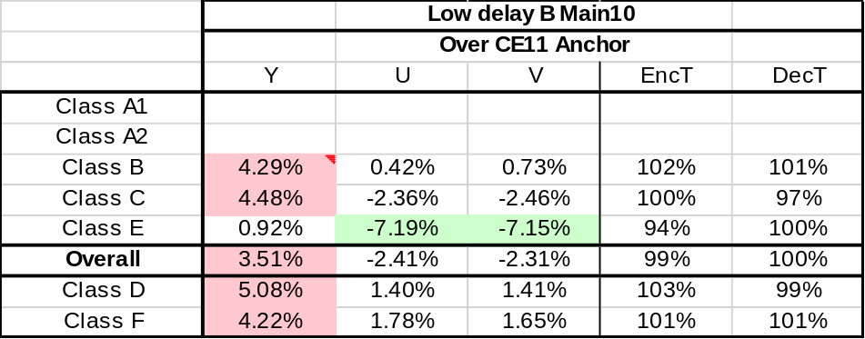
All sequences was checked by decoding at starting shifted RA position. Logs are attached.
Bitrate and PSNR fluctuations are provided with this contribution.

References
- Y-K. Wang, M. Sychev and Hendry, “AHG14/AHG17: DDR – Distributed decoding refresh” Document of Joint Video Experts Team, JVET-N0116, March 2019
- B. Bross, J. Chen, S. Liu “Versatile Video Coding (Draft 5)”, Document of Joint Video Experts Team, JVET-N1001-v8, March 2019
- F. Bossen, J. Boyce, X. Li, V. Seregin, and K. Sühring, “JVET common test conditions and software reference configurations for SDR video,” Document of Joint Video Experts Team, JVET-N1010, March 2019
- K. Kazui, J-M. Thiesse, Hendry, K. Kawamura, “Description of Core Experiment 11 (CE11): Gradual random access”, Document of Joint Video Experts Team, JVET-N1031, March 2019
- Reference software VTM-5.0, https://vcgit.hhi.fraunhofer.de/jvet/VVCSoftware_VTM

Patent rights declaration(s)
Huawei Technologies Co., Ltd. may have current or pending patent rights relating to the technology described in this contribution and, conditioned on reciprocity, is prepared to grant licenses under reasonable and non-discriminatory terms as necessary for implementation of the resulting ITU-T Recommendation | ISO/IEC International Standard (per box 2 of the ITU-T/ITU-R/ISO/IEC patent statement and licensing declaration form).

