    Joint Video Experts Team (JVET)  of ITU-T SG 16 WP 3 and ISO/IEC JTC 1/SC 29/WG 11  15th Meeting: Gothenburg, SE, 3–12 July 2019 | Document: JVET-O0108

Title: | CE9-2.2: Disabled decoder-side motion refinement (DMVR) and bidirectional optical flow (BDOF) for combined inter and intra prediction (CIIP)
Status: | Input document to JVET
Purpose: | Proposal
Author(s) or  Contact(s): | Xiaoyu Xiu, Yi-Wen Chen, Tsung-Chuan Ma, Xianglin Wang | Tel:  Email: | 1-858-209-3851  {xiaoyuxiu, yiwenchen, tsung-chuanma, xianglinwang }@kwai.com
Source: | Kwai Inc.
_____________________________

Abstract
This document reports the results of Core Experiment (CE) 9-2.2 on complexity reduction on combined inter and intra prediction (CIIP). In this CE test, it is proposed to exclude decoder-side motion vector derivation (DMVR) and bi-directional optical flow (BDOF) when generating the inter prediction samples in the CIIP mode. Simulation results show that compared to VTM-5.0 anchors, the average BD-rate impact of the proposed method is {-0.01%, -0.02%, -0.01%} for RA with average encoding and decoding time of 99% and 98%.

Introduction
In the VVC working draft 5 [1], combined inter and intra prediction (CIIP) is applied, which combines the intra prediction and the inter prediction of one inter merge coding unit (CU). Due to the reconstructed neighboring samples used by the intra prediction, the CIIP needs to be carried out in the reconstruction loop where the decoding is done sequentially. Therefore, the computational complexity of the CIIP cannot be too high to ensure enough throughput for real-time decoding.
For the current CIIP design [1], decoder-side motion vector derivation (DMVR) and bidirectional optical flow (BDOF) are always enabled to generate the inter prediction samples when the current CIIP CU is bi-predicted. Given the additional computations resulting from the DMVR and BDOF, in [2], it is proposed to always disable those two tools for the inter prediction of the CIIP mode. The method was included in Core Experiment (CE) 9 as test 2.2 for further evaluation [3]. This document reports the simulation results of the CE test.

Simulation results
The proposed method was implemented based on the VTM-5.0 reference software [4] and tested using the test condition and evaluation criteria that are used in CE9 [3] are applied.
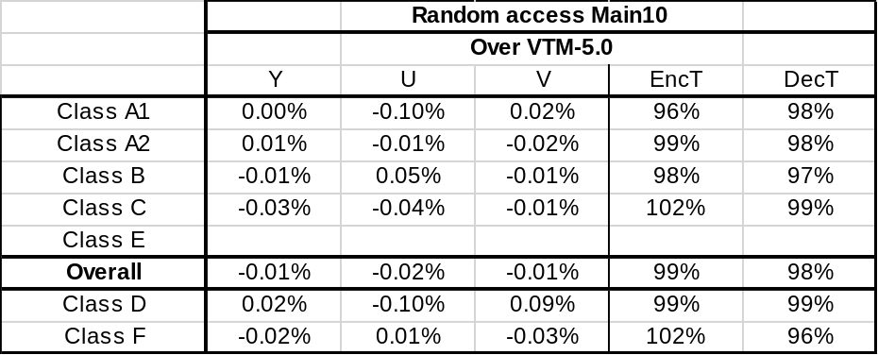

Proposed spec changes

8.5.1 General decoding process for coding units coded in inter prediction mode
- When all of the following conditions are true, dmvrFlag is set equal to 1:
- sps_dmvr_enabled_flag is equal to 1
- general_merge_flag[ xCb ][ yCb ] is equal to 1
- both predFlagL0[ 0 ][ 0 ] and predFlagL1[ 0 ][ 0 ] are equal to 1
- mmvd_flag[ xCb ][ yCb ] is equal to 0
- ciip_flag[ xCb ][ yCb ] is equal to 0
- DiffPicOrderCnt( currPic, RefPicList[ 0 ][ refIdxL0 ]) is equal to DiffPicOrderCnt( RefPicList[ 1 ][ refIdxL1 ], currPic )
- BcwIdx[ xCb ][ yCb ] is equal to 0
- Both luma_weight_l0_flag[ refIdxL0 ] and luma_weight_l1_flag[ refIdxL1 ] are equal to 0
- cbWidth is greater than or equal to 8
- cbHeight is greater than or equal to 8
- cbHeight*cbWidth is greater than or equal to 128

8.5.6.1 General
- If all of the following conditions are true, bdofFlag is set equal to TRUE.
- sps_bdof_enabled_flag is equal to 1.
- predFlagL0[ xSbIdx ][ ySbIdx ] and predFlagL1[ xSbIdx ][ ySbIdx ] are both equal to 1.
- DiffPicOrderCnt( currPic, RefPicList[ 0 ][ refIdxL0 ] ) * DiffPicOrderCnt( currPic, RefPicList[ 1 ][ refIdxL1 ] ) is less than 0.
- MotionModelIdc[ xCb ][ yCb ] is equal to 0.
- merge_subblock_flag[ xCb ][ yCb ] is equal to 0.
- sym_mvd_flag[ xCb ][ yCb ] is equal to 0.
- ciip_flag[ xCb ][ yCb ] is equal to 0
- BcwIdx[ xCb ][ yCb ] is equal to 0.
- luma_weight_l0_flag[ refIdxL0 ] and luma_weight_l1_flag[ refIdxL1 ] are both equal to 0.
- cbHeight is greater than or equal to 8
- cIdx is equal to 0.

References
- B. Bross, J. Chen, S. Liu, “Versatile Video Coding (Draft 5)”, JVET-N1001, March. 2019, Geneva, Switzerland.
- X. Xiu, Y.-W. Chen, T.-C. Ma, X. Wang, “CE10-related: Simplification on combined inter and intra prediction (CIIP)”, JVET-N0327, March. 2019, Geneva, Switzerland.
- S. Esenlik, X. Xiu, “Description of Core Experiment 9 (CE9): Decoder Motion Vector Derivation”, JVET-N1029, March. 2019, Geneva, Switzerland.
- VTM-5.0, https://vcgit.hhi.fraunhofer.de/jvet/VVCSoftware_VTM/tags/VTM-5.0.

Patent rights declaration(s)
Kwai Inc. may have current or pending patent rights relating to the technology described in this contribution and, conditioned on reciprocity, is prepared to grant licenses under reasonable and non-discriminatory terms as necessary for implementation of the resulting ITU-T Recommendation | ISO/IEC International Standard (per box 2 of the ITU-T/ITU-R/ISO/IEC patent statement and licensing declaration form).

