    Joint Video Experts Team (JVET)  of ITU-T SG 16 WP 3 and ISO/IEC JTC 1/SC 29/WG 11  15th Meeting: Gothenburg, SE, 3–12 July 2019 | Document: JVET- O0098-v1

Title: | CE2.1.2: luma-chroma dependency reduction for LMCS
Status: | Input document
Purpose: | Proposal
Author(s) or  Contact(s): | Taoran Lu, Fangjun Pu, Peng Yin, Sean McCarthy, Walt Husak, Tao Chen  432 Lakeside Drive,  Sunnyvale, CA, 94085 US | Tel:  Email: | {pyin, tlu, fpu}@dolby.com
Source: | Dolby Laboratories, Inc.
_____________________________

Abstract
This contribution presents test results of CE2-1.2 for luma-chroma dependency reduction on VTM5.0 for LMCS. CE2-1.2 proposes to use the first co-located luma prediction value to replace the average value of the whole luma block. The worst-case pipeline delay to start chroma residue scaling would thus be only one luma sample. Compared to the VTM5.0 anchor, the BDrate results for PSNR Y/U/V on SDR CTC experiments are:
  - AI { 0.00% 0.00% 0.00%}, Enc: 100%, Dec: 100%
  - RA { 0.00% -0.09% -0.10%}, Enc: 99%, Dec: 99%
  - LDB { 0.02% 0.05% -0.03%}, Enc: 100%, Dec: 98%

Introduction
In current LMCS design, when chroma residue scaling is applied, the chroma residue scale factor for each chroma TU depends on the average value of the corresponding luma prediction block ($avgY'$). The operation to compute $avgY^{'}$ thus requires access of all the samples of the corresponding luma prediction block, which introduces pipeline delay for the reconstruction process of chroma components. For example, for a large TU such as 64x64, decoding pipeline would need to finish the 64x64 luma prediction first and then process chroma residue scaling. Consequently, luma and chroma reconstruction cannot be performed timely in parallel because chroma processing would need to wait for the average of the whole luma block.
N0220 [1] proposed to use the first (upper-left) sample value of the corresponding luma prediction block to replace the average value of the block as in VTM4.0. Hence, the chroma residue scale factor for the chroma TU can be computed immediately after the first corresponding luma prediction sample is available. In CE2-1.2, the same approach is tested on VTM5.0, according to test condition defined in [2].
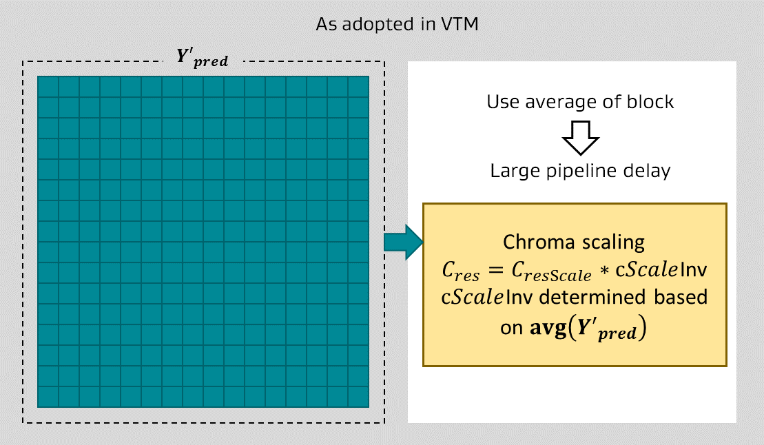

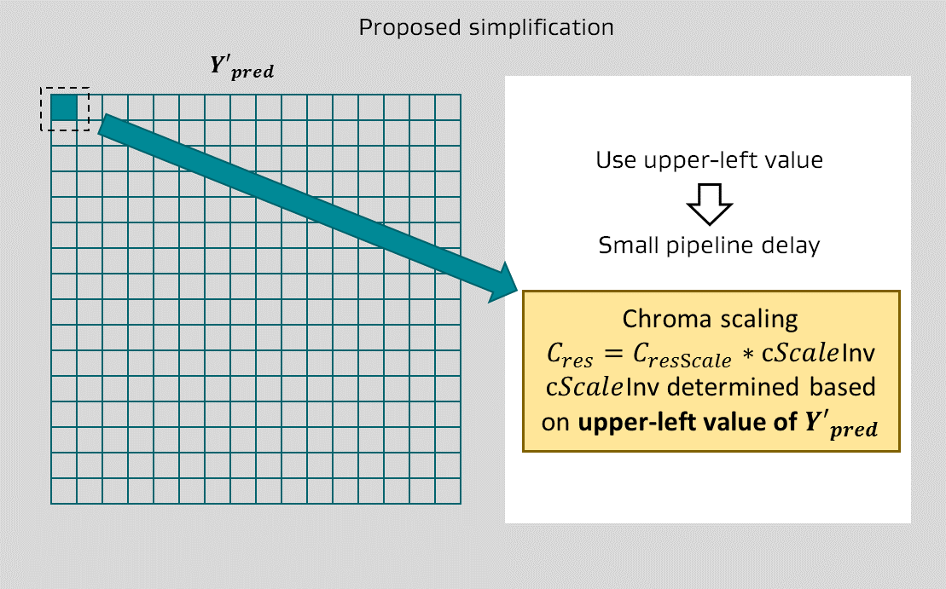

Figure 1. Comparison of derivation of chroma residual scaling factor as currently adopted in VTM5.0 (top) and the current proposal of using only the top-left luma sample (bottom).

Simulation results
Table 1 shows the CE2-1.2 testing results on SDR CTC. Table 2 shows additional CE2-1.2 testing results on HDR PQ clips compared with VTM5.0 settings with LMCS enabled and LumaDQP disabled. For Random Access and Low Delay tests, the results suggested that the proposed solution can significantly reduce the pipeline latency while still preserving the coding efficiency. (Note that results are not shown for All Intra because chroma residue scaling is disabled for dual tree slices. Thus, the CE2-1.2 proposal has no impact on All Intra coding and the AI results are identical to the VTM5.0 anchor.)
Table 1 CE2-1.2 results on SDR CTC
 |  |  | Random access Main10
 |  |  | Over VTM-5.0
 | Y | U | V | EncT | DecT
Class A1 | 0.01% | -0.19% | -0.02% | 101% | 105%
Class A2 | -0.01% | -0.05% | -0.07% | 100% | 97%
Class B | 0.01% | -0.10% | -0.10% | 99% | 96%
Class C | -0.01% | -0.05% | -0.19% | 97% | 101%
Class E
Overall | 0.00% | -0.09% | -0.10% | 99% | 99%
Class D | 0.00% | 0.01% | 0.17% | 99% | 100%
Class F | -0.01% | 0.03% | -0.03% | 99% | 99%
 |  |  | Low delay B Main10
 |  |  | Over VTM-5.0
 | Y | U | V | EncT | DecT
Class A1
Class A2
Class B | 0.02% | 0.06% | -0.20% | 103% | 99%
Class C | 0.01% | 0.00% | 0.21% | 103% | 97%
Class E | 0.04% | 0.12% | -0.08% | 94% | 99%
Overall | 0.02% | 0.05% | -0.03% | 100% | 98%
Class D | 0.01% | -0.33% | 0.99% | 100% | 96%
Class F | 0.05% | 0.20% | 0.08% | 96% | 99%
Table 2 CE2-1.2 results on HDR-PQ vs. HDR-PQ LMCS1 LQP0 (enable LMCS and disable LumaDQP)
 | CE2-1.2 Over vtm5 HDR LMCS1 (LQP0)
 | Random Access: BD-rate
 | DE100 | PSNRL100 | wPsnrY | wPsnrU | wPsnrV
Average HDR-B | 0.08% | 0.00% | -0.01% | 0.05% | 0.27%

Specification changes
CE2-1.2 requires one equation of the current VVC specification [3] to be changed. No other specification changes are required.
In clause 8.7.5.3, replace the following equation:
invAvgLuma = Clip1_{Y}( ( $\sum_{k=0}^{SubWidthC*nCurrSw-1}{\sum_{l=0}^{SubHeightC*nCurrSh-1}{PredMapSamples[ k ][ l ]}}$
+ nCurrSw * nCurrSh * ( ( SubWidthC * SubHeightC ) / 2 ) ) / (8-996)
( nCurrSw * nCurrSh *SubWidthC * SubHeightC ) )
with the following:
invAvgLuma = Clip1_{Y}( predMapSamples[ 0 ][ 0 ]) (8-996)

Conclusion
CE2-1.2 proposal can significantly reduce the pipeline latency and preserve the coding efficiency. The specification change is minimal. It is suggested to adopt the solution into VVC.

Acknowledgements
We would like to thank IDCC(Technicolor) for crosschecking results.

References
- T. Lu, F. Pu, P. Yin, S. McCarthy, W. Husak, T. Chen, “Simplification of Reshaper Implementation”, JVET-N0220, Geneva, CH, 19–27 Mar. 2019.
- J. Chen, E. François, P. Yin, “Description of Core Experiment 2 (CE2): luma-chroma dependency reduction”, JVET-N1022, Geneva, CH, 19–27 Mar. 2019.
- Editors, “Versatile Video Coding (Draft 5)”, JVET-N1001-v8, Geneva, CH, 19–27 Mar. 2019

Patent rights declaration(s)
Dolby Laboratories, Inc. may have current or pending patent rights relating to the technology described in this contribution and, conditioned on reciprocity, is prepared to grant licenses under reasonable and non-discriminatory terms as necessary for implementation of the resulting ITU-T Recommendation | ISO/IEC International Standard (per box 2 of the ITU-T/ITU-R/ISO/IEC patent statement and licensing declaration form).

