    Joint Video Experts Team (JVET)  of ITU-T SG 16 WP 3 and ISO/IEC JTC 1/SC 29/WG 11  14th Meeting: Geneva, CH, 19–27 March 2019 | Document: JVET-N1031-v2

Title: | Description of Core Experiment 11 (CE11): Gradual random access
Status: | Output document approved by JVET
Purpose: | Core experiment description
Author(s) or  Contact(s): | Kimihiko Kazui  Jean-Marc Thiesse  Hendry  Kei Kawamura | Tel:  Email: | kazui.kimihiko@fujitsu.com  jean-marc.thiesse@vitec.com  fnu.hendry@huawei.com  ki-kawamura@kddi.com
Source: | CE11 coordinators

Abstract
This document provides description for core experiment 11 (CE11). The objective of CE11 is to investigate the various methods for supporting gradual random access (GRA) in VVC and implementation of those methods on top of VTM reference software.
The methods to be investigated comprises the following categories:
- Encoder restriction only method
- Virtual boundaries based method
- Coded region based method
- Distributed hidden picture method

Introduction
The tests to be investigated in CE11 are as follow:
Test # | Description | Source | Tester | Crosschecker
CE11-1 | GRA is supported by applying restriction to encoder operation such that there is nothing needs to be changed in the decoder. | JVET-N0080 | Fujitsu | Huawei
CE11-2.1.a | Apply motion vector restriction in encoder and use the following tools in the decoder: virtual boundaries, CIP at picture level. | JVET-N0080/ JVET-N0391 | VITEC | KDDI
CE11-2.1.b | The same as 11-2.1.a with the following change:  - CIP only at the refreshed region. | JVET-N0080, JVET-N0391 | VITEC | Huawei
CE11-2.1.c | The same as 11-2.1.b with the following change:  - treating the virtual boundary of refreshed region as picture boundary. | JVET-N0080, JVET-N0391 | VITEC | Fujitsu
CE11-2.2 | The same as 11-2.1.c with the following change:  - virtual boundaries and CIP activated through a specific intra refresh signalization.  - Parsing of derivable flags are bypassed. | JVET-N0391 | VITEC | Fujitsu
CE11-3.1 | Coded region based method in which refreshed region and un-refreshed region are in different tile groups. | JVET-N0115 | Huawei | VITEC
CE11-3.2 | Coded region based method in which refreshed region and un-refreshed region are in different sub-pictures. | JVET-N0310 | Nokia | Huawei
CE11-4 | GRA is supported as follows:  - GRA picture is coded as a non-IRAP picture.  - IRAP picture is coded in multiple NAL units and distributed across pictures within the GRA period | JVET-N0116 | Huawei | Nokia

CE11 test descriptions

CE11-1 encoder restriction only in JVET-N0080
The functionality of GRA is achieved by encoder-only schemes. That is;
- Vertical intra-coded stripe moving from left to right
- In-loop filter across a tile boundary is allowed.
- Redundant intra-coded stripe at a refresh boundary for avoiding contamination from a dirty region to a clean region.
- Restricted intra prediction mode at a refresh boundary
- Restricted MV for all PU in a clean region
- Disabling TMVP at a recovery point picture
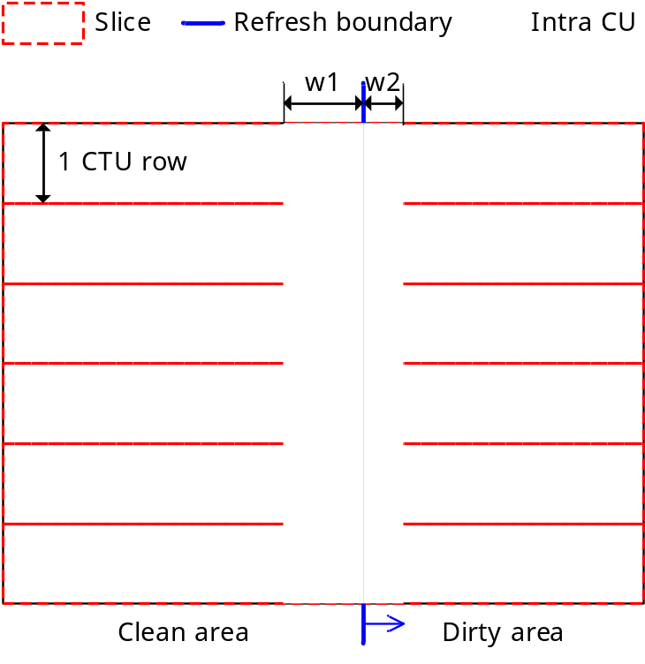
Figure 1: Layout of intra-coded stripe in CE11-1

CE11-2.1.a in JVET-N0080/JVET-N0391
The method to be tested for supporting GRA is achieved by a combination of encoder-only and one normative change.
The encoder-only modification includes:
- Forcing of Intra CU according to a given cycle.
- Virtual boundary between clean and dirty region which are signalized with a new PPS at each picture. The filters are disabled cross these boundaries.
- Motion vectors constraints such that the prediction in clean region didn’t use any dirty pixels.
The additional normative change is enabling of Constrained Intra Prediction (CIP) at picture level.

CE11-2.1.b in JVET-N0080/JVET-N0391
The method to be tested for supporting GRA is achieved with the same as 2.1.a with in addition the Constrained Intra Prediction tool with switching within a picture such that it is enabled only for intra refresh region.

CE11-2.1.c in JVET-N0080/JVET-N0391
The method to be tested for supporting GRA is achieved with the same as 2.1.b with in addition the virtual boundary which are treated as picture boundary.

CE11-2.2 in JVET-N0391
The method to be tested for supporting GRA is achieved with the same as 2.1.c with the CIP and virtual boundary tools which are enabled thanks to the signalization proposed in JVET-N0391:
- SPS level :
  - sps_intra_refresh_enabled_flag
- PPS level :
  - pps_intra_refresh_mode
  - pps_intra_refresh_size
  - pps_intra_refresh_delta_qp
- Tile-group level :
  - tile_group_intra_refresh_direction
  - tile_group_intra_refresh_position
In addition, at least the following flags are not transmitted for CU derived as intra refresh CU : pred_mode_flag and cu_skip_flag

CE11-3.1 in JVET-N0115
The method to be tested for supporting GRA is summarized as follows:
- GRA picture and pictures that follow the associated GRA picture in decoding are coded with at at least two tile groups: one tile group for refresh region and one tile group for un-refreshed region.
- A flag called refreshed_region_flag to specify whether a tile group is part of refreshed region or not is signalled in the tile group header. All tile groups having refreshed_region_flag equal to 1 cover a connected region. A tile group with refreshed_region_flag can be of type I- (i.e., intra tile group) or B- or P- (i.e., inter tile group). Each picture starting from the GRA picture to the last picture in the GRA period contains at least one tile group with refreshed_region_flag equal to 1. A GRA picture contains at least one tile group with refreshed_region_flag equal to 1 that is intra codedProgressive intra refresh for GRA is performed based on intra coding of entire tile groups.
- The boundaries of the refreshed region in a picture are derived based on the values of the refreshed_region_flag in the tile groups of the picture
- When the current block in the current picture is in a tile group with refreshed_region_flag equal to 1 and the reference block is in a reference picture that contains un-refreshed region, a boundary of the refreshed region in a reference picture is treated as if it were a picture boundary in decoding of the current block referring to that reference picture for inter prediction, by applying the modified TMVP derivation and interpolation processes.
- Loop filter between refreshed region and un-refreshed may be disallowed.

CE11-3.2 in JVET-N0310
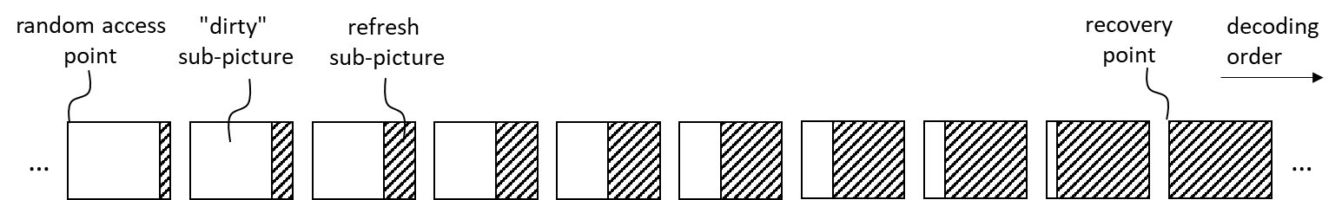
Figure 2. Example of the proposed sub-picture based gradual random access
The proposal is summarized as follows:
- Pictures from the random access point (inclusive) to the recovery point (exclusive) have two sub-pictures, a refresh sub-picture and a “dirty” sub-picture. The size of the refresh sub-picture increases from the random access point towards the recovery point.
- full_pic_ref_flag is included in the PPS. When equal to 0, the sub-picture with the index (in decoding order, within the referenced coded picture) that has the same index as the current sub-picture in the current picture is extracted and used as reference for inter prediction. When equal to 1, the entire reference picture is used as reference for inter prediction of the current sub-picture.
- full_pic_ref_flag is equal to 0 in the active PPS for the refresh sub-picture. Thus, only the previous refresh sub-pictures are used as reference for prediction of the current refresh sub-picture. The boundaries of the refresh sub-pictures are treated like picture boundaries.
- full_pic_ref_flag is equal to 1 in the active PPS for the “dirty” sub-picture. Thus, a “dirty” sub-picture can use samples from both “dirty” sub-picture and refresh sub-pictures for deriving prediction blocks of inter prediction.

CE11-4 in JVET-N0116
The method to be tested for supporting GRA is summarized as follows:
- A new VCL NAL unit type DDR_NUT is defined for DDR pictures.
  - A DDR picture shall have TemporalId equal to 0.
  - DDR picture is coded as B-picture (i.e. trailing picture)
- A picture for which each VCL NAL unit has nal_unit_type equal to IDR_NO_LP and didr_pic_flag (in the tile group header) equal to 1 is a DIDR picture. A picture with nal_unit_type equal to IDR_NO_LP and didr_pic_flag equal to 0 is a usual IDR picture.
  - A DIDR picture is associated with a DDR picture and vice versa.
  - An associated pair of DIDR picture and DDR picture are coded presentations of the same picture, and they have the same value of picture order count.
  - A DIDR picture is coded with intra prediction only and coded with at least two VCL NAL units.
  - The VCL NAL units of a DIDR picture are distributed among a set of access units starting from the access unit containing the associated DDR picture, up to but not including any subsequent access unit that is a DDR access unit or an IRAP access unit.
  - A DIDR picture is for inter prediction reference only and not for output.
- When all NAL units of a DIDR picture is received, decoder decodes the DIDR and marks all reference picture in the DPB as “unused for reference”

Test conditions
Each test shall be conducted with the following conditions:
- Use low-delay B configuration in current common test condition (CTC) (i.e., encoder_lowdelay_vtm.cfg) with the following changes:
  - The first picture is coded as an IDR picture
  - The GOP size is 1. Each picture refers up to 4 immediate preceding pictures in decoding order
  - For test sequences with 60 fps, a GRA picture is inserted every 60 pictures
  - For test sequences with 50 fps, a GRA picture is inserted every 50 pictures
  - For test sequences with 30 fps, a GRA picture is inserted every 30 pictures
  - For test sequences with 20 fps, an GRA picture is inserted every 20 pictures
  - IntraQPOffset and QPoffset are set equal to 0
- Maximum GRA refresh period is 1 second
- SEIDecodedPictureHash is set to 1
Anchor bitstreams shall be encoded with the following conditions:
- Use low-delay B configuration in current common test condition (CTC) (i.e., encoder_lowdelay_vtm.cfg) with the following changes:
  - The first picture is coded as an IDR picture
  - The GOP size is 1. Each picture refers up to 4 immediate preceding pictures in decoding order
  - For test sequences with 60 fps, an IDR picture is inserted every 60 pictures
  - For test sequences with 50 fps, an IDR picture is inserted every 50 pictures
  - For test sequences with 30 fps, an IDR picture is inserted every 30 pictures
  - For test sequences with 20 fps, an IDR picture is inserted every 20 pictures
  - IntraQPOffset and Qpoffset are set equal to 0
- SEIDecodedPictureHash is set to 1

Evaluation criteria
For reporting the performance, the following information shall be provided:
- BD-rate performance excluding the first IDR picture and pictures that follows it until either the second IDR picture (i.e., for anchor) or the first GRA picture (i.e., for test).
- Bit-rate variation of the bitstreams.
- Exact match at a recovery point picture. The source code for testing this functionality is found in JVET-N0080. Crosscheckers are requested to check this at least once per test point and report where the check is performed (i.e., at which POC value) and if the result is exact match or not.

SW integration guideline
All tests are required to be implemented on top of VTM-5.0. The timeline may be adjusted based on the availability of VTM-5.0.

Timeline
T1 | 17 April 2019 | Finalize CE description
T2 | 15 May 2019 | Deliver software packages and begin initial cross-checking
T3 | 05 June 2019 | Software frozen, testers provide full results, and final crosschecking begins
T4 | 19 June 2019 | Submit contribution documents with respective texts and test result
Note: The above timeline is tentative and may be updated based on discussion in the reflector.

Participant list
Company/  Organization | Participant Name | Email Address
Fujitsu | Kimihiko Kazui | kazui.kimihiko@fujitsu.com
Huawei | Hendry  Seungwook Hong  Ye-Kui Wang  Jianle Chen  Maxim Sychev  Sergey Ikonin  Xiang Ma  Sychev Maxim | fnu.hendry@huawei.com  seungwook.hong@huawei.com  yekui.wang@huawei.com  jianle.chen@huawei.com  maxim.sychev@huawei.com  Sergey.Ikonin@huawei.com  maxiang6@huawei.com  Sychev.Maxim@huawei.com
KDDI | Kei Kawamura  Yoshitaka Kidani  Kyohei Unno | ki-kawamura@kddi.com  yo-kinida@kddi.com  ky-unno@kddi-research.jp
Intel | Jill Boyce | jill.boyce@intel.com
Nokia | Kashyap KS  Alireza Aminlou  Limin Wang  Miska Hannuksela | kashyap.kammachi-sreedhar@nokia.com  alireza.aminlou@nokia.com  limin.2.wang@nokia.com  miska.hannuksela@nokia.com
VITEC | Jean-Marc Thiesse  David Gommelet  Didier Nicholson | jean-marc.thiesse@vitec.com  david.gommelet@vitec.com  didier.nicholson@vitec.com
Sharp | Sachin Deshpande  Kiran Misra  Andrew Segall | sdeshpande@sharplabs.com  misrak@sharplabs.com  asegall@sharplabs.com
Qualcomm | Yao-Jen Chang  Yu Han | yjchang@qti.qualcomm.com  yuhan@qti.qualcomm.com
Kwangwoon University | Jongseok Lee | suk2080@kw.ac.kr
Panasonic | Kiyofumi Abe  Tadamasa Toma | abe.kiyo@jp.panasonic.com  toma.tadamasa@jp.panasonic.com
ETRI | Jungwon Kang  Woong Lim | jungwon@etri.re.kr  woong.lim@etri.re.kr
LGE | Hyeongmun Jang  Seethal Paluri  Ling Li  Jaehyun Lim  Seung Hwan Kim | hm.jang@lge.com  seethal.paluri@lge.com  l.li@lge.com  jaehyun.lim@lge.com  seunghwan3.kim@lge.com
MediaTek | Lulin Chen  Chih-Wei Hsu  Ching-Yeh Chen  Tzu-Der (Peter) Chuang  Yu-Wen Huang | lulin.chen@mediatek.com  cw.hsu@mediatek.com  chingyeh.chen@mediatek.com  peter.chuang@mediatek.com  yuwen.huang@mediatek.com
Samsung | Kiho Choi  Woong Il Choi  Min Woo Park  Chirag Pujara | kiho14.choi@samsung.com  woongil.choi@samsung.com  m.w.park@samsung.com  chirag.p@samsung.com
Technicolor | Karam Naser  Fabrice Leleannec  Philippe Bordes  Edouard Francois | Karam.NASER@technicolor.com  fabrice.leleannec@technicolor.com  Philippe.bordes@technicolor.com  Edouard.francois@technicolor.com
Comcast | Dan Grois | grois@ieee.org
SK Telecom | Jaeil Kim | jaeilkim@sk.com
Foxconn | Po-Han Lin  Yu-Ciao Yang | PohanLin@fginnov.com  yuciaoyang@fginnov.com
Sejong university | Dongjae Won | bigdj2002@sju.ac.kr
Kwai | Xiaoyu Xiu  Yi-Wen Chen  Tsung-Chuan Ma  Hong-Jheng Jhu  Xianglin Wang | xiaoyuxiu@kwai.com  yiwenchen@kwai.com  tsung-chuanma@kwai.com  jhuhong-jheng@kwai.com  xianglinwang@kwai.com
Ubilinx | Eric Chai  Weimin Zeng | eric.chai@ublnx.com  weimin.zeng@ublnx.com
Sony | Yoichi Yagasaki  Masa Ikeda | Yoichi.Yagasaki@sony.com  Masaru.Ikeda@sony.com
Ateme | Thomas Guionnet | t.guionnet@ateme.com
Ericsson | Rickard Sjöberg  Martin Pettersson | rickard.sjoberg@ericsson.com  martin.m.pettersson@ericsson.com
Hikvision | Yucheng Sun | sunyucheng@hikvision.com
DJI | Xiaozhen Zheng | xiaozhen.zheng@dji.com

