    Joint Video Experts Team (JVET)  of ITU-T SG 16 WP 3 and ISO/IEC JTC 1/SC 29/WG 11  14th Meeting: Geneva, CH, 19–27 March 2019 | Document: JVET-N0801

Title: | Crosscheck of JVET-N0460 (CE8-related: Default candidates for IBC merge mode)
Status: | Input document
Purpose: | Proposal
Author(s) or  Contact(s): | Yu Han, Wei-Jung Chien  5775 Morehouse Drive,  San Diego, CA, U.S.A. 92121 | Tel:  Email: | +1-858-845-1793  yuhan@qti.qualcomm.com  wchien@qti.qualcomm.com
Source: | Qualcomm Incorporated
_____________________________

Abstract
This contribution is a crosscheck report of JVET-N0460 (CE8-related: Default candidates for IBC merge mode). The simulations were carried out based on the common test condition (CTC) for Class F. Based on the partial results, the test results are matched.

Introduction
In the JVET-N0460, insert default candidates for IBC merge mode is proposed. One fixed position is added as default candidates until merge list is filled iteratively.

Default candidate 1:
A position, (-2*width, 0), is iteratively added as a default candidate. A variable width represents width of current coding block. The default candidate is inserted without any valid checking, which means that whether a candidate is included or not included in the IBC search range.

Default candidate 2:
A position, (-width, 0), is iteratively added as a default candidate. A variable width represents width of current coding block. The default candidates are inserted without any valid checking, which means that whether a candidate is included or not included in the IBC search range.

Simulation results
The simulation is based on VTM4.0 software. The anchor is generated by using VTM4.0 default configurations with IBC mode. Common test conditions for Class F are followed. Results are shown in the following tables:
Default candidate 1:
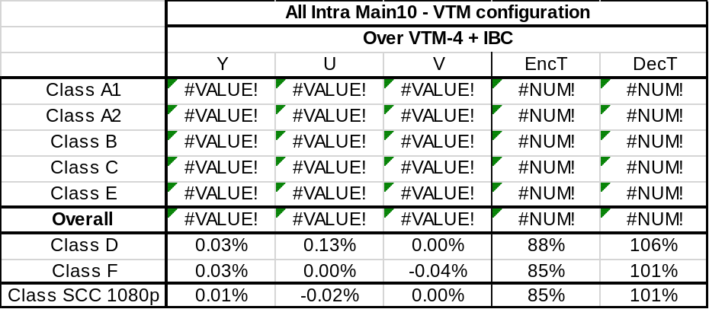
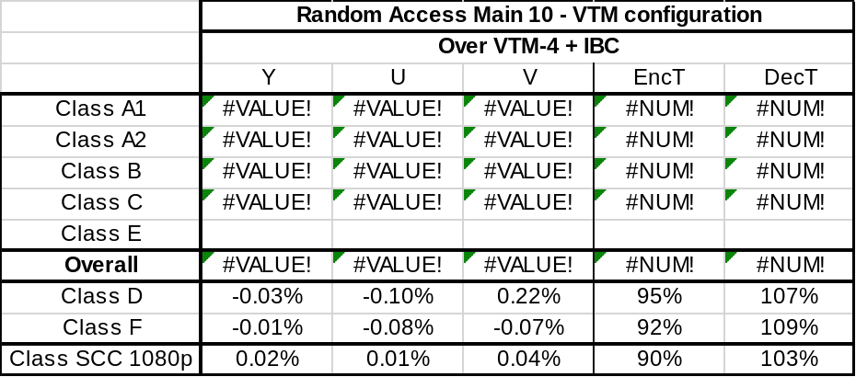
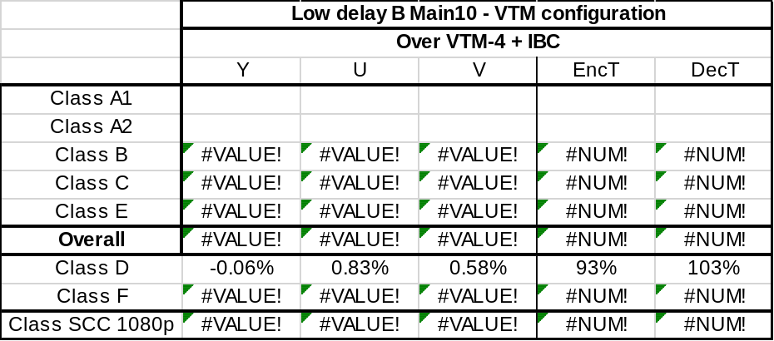
Default candidate 2:
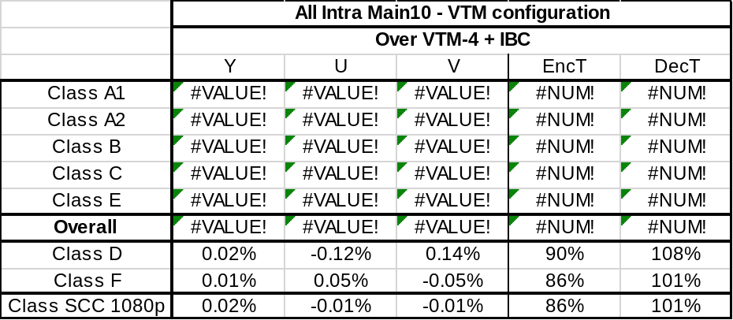
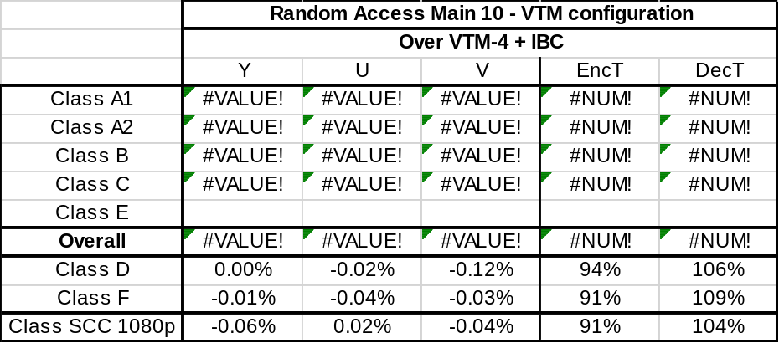
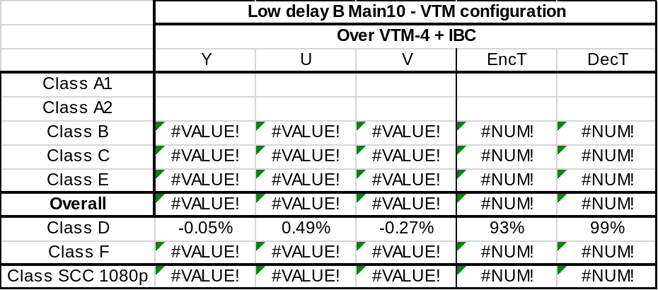

References
- F. Bossen, J. Boyce, X. Li, V. Seregin, K. Sühring, JVET-M1010, “JVET common test conditions and software reference configurations for SDR video”, Marrakech, January 2019.

