    Joint Video Experts Team (JVET)  of ITU-T SG 16 WP 3 and ISO/IEC JTC 1/SC 29/WG 11  14th Meeting: Geneva, CH, 19–27 March 2019 | Document: JVET-N0325

Title: | CE9-related: Improvements on bi-directional optical flow (BDOF)
Status: | Input document to JVET
Purpose: | Proposal
Author(s) or  Contact(s): | Xiaoyu Xiu, Yi-Wen Chen, Tsung-Chuan Ma, Xianglin Wang  8910 University Center Lane  San Diego, CA, U.S.A. 92122 | Tel:  Email: | 1-858-209-3851  {xiaoyuxiu, yiwenchen, tsung-chuanma, xianglinwang} @kwai.com
Source: | Kwai Inc.
_____________________________

Abstract
Bi-directional optical flow (BDOF) is included in the VVC to enhance the granularity and accuracy of the motion vectors (MVs) used for motion compensation. Additionally, in the current BDOF design, the number of bitwise right shifts, which are applied to calculate certain intermediate parameters, is determined based on the internal bit-depth ranging from 8-bit to 12-bit.
In this contribution, two modifications are proposed for improving the BDOF design in the VVC working draft 4. Firstly, the contribution proposes to unify all the bit-shift operations in the BDOF by extending the right shifts that are used for internal 8-bit to be used for internal 10-bit and 12-bit. Secondly, it is reported that the ranges of certain intermediate parameters of the 8-bit BDOF design can potentially exceed 32-bit. To fix such overflow problem, two clipping operations are proposed to guarantee the 32-bit hardware implementation of the BDOF. The performance of the proposed BDOF modifications are summarized as follows:
For 10-bit coding (CTC): {Y, U, V} BD-rate of {-0.02%, -0.02%, -0.01%}, Enc: 101%, Dec: 101%;
For 8-bit: coding: {Y, U, V} BD-rate of { 0.01%, -0.01%, -0.02%}, Enc: 100%, Dec: 100%;
For 12-bit coding: {Y, U, V} BD-rate of {-0.17%, -0.11%, -0.09%}, Enc: 101%, Dec: 100%.

Introduction
In the VVC working draft 4 [1], bi-directional optical flow (BDOF) is applied, which provides the motion refinements based on 4×4 subblocks for bi-predicted coding units (CUs) that has both forward and backward predictions. In addition, at the Marrakech meeting, JVET-M0063 [2] was adopt which applies different numbers of bitwise right shifts to calculate the sample gradients, the difference between L0 and L1 predictions and the sum of the gradients of L0 and L1 predictions. Specifically, the BDOF derivation method in the VVC working draft 4 [1] can be summarized as the following main steps:
- Gradient derivation: the horizonal and vertical gradients are calculated as the difference between two neighboring prediction samples, i.e.,
$$\frac{∂I^{\left(0/1\right)}}{∂x}\left(i, j\right)=\left(I^{\left(0/1\right)}\left(i+1, j\right)-I^{\left(0/1\right)}\left(i-1, j\right)\right)≫shift1$$  $$\frac{∂I^{\left(0/1\right)}}{∂y}\left(i, j\right)=\left(I^{\left(0/1\right)}\left(i, j+1\right)-I^{\left(0/1\right)}\left(i, j-1\right)\right)≫shift1$$ | (1)
- Correlation parameter calculation: the BDOF parameters $ψ_{x}\left(i,j\right)$, $ψ_{y}\left(i,j\right)$ and $θ\left(i,j\right)$ are firstly derived as
$$θ\left(i,j\right)=\left(I^{\left(1\right)}\left(i, j\right)≫shift2\right)-\left(I^{\left(0\right)}\left(i, j\right)≫shift2\right)$$  $$ψ_{x}\left(i,j\right)=\left(\frac{∂I^{\left(1\right)}}{∂x}\left(i, j\right)+\frac{∂I^{\left(0\right)}}{∂x}\left(i, j\right)\right)≫shift3$$  $$ψ_{y}\left(i,j\right)=\left(\frac{∂I^{\left(1\right)}}{∂y}\left(i, j\right)+\frac{∂I^{\left(0\right)}}{∂y}\left(i, j\right)\right)≫shift3$$ | (2)
Then, the following BDOF correlation parameters can be calculated as
$S_{1}=\sum_{(i,j)∈Ω}{ψ_{x}\left(i,j\right)}∙ψ_{x}\left(i,j\right)$, $S_{3}=\sum_{(i,j)∈Ω}{θ\left(i,j\right)}∙ψ_{x}\left(i,j\right)$  $S_{2}=\sum_{(i,j)∈Ω}{ψ_{x}\left(i,j\right)}∙ψ_{y}\left(i,j\right)$  $S_{5}=\sum_{\left(i,j\right)∈Ω}{ψ_{y}\left(i,j\right)}∙ψ_{y}\left(i,j\right)$ $S_{6}=\sum_{(i,j)∈Ω}{θ\left(i,j\right)}∙ψ_{y}\left(i,j\right)$ | (3)
- Motion refinement derivation: the refined MV $\left(v_{x},v_{y} \right)$ is derived as
$$v_{x}=S_{1}>0?clip3\left(-{th}_{BIO}^{'},{th}_{BIO}^{'},-\left(\left(S_{3}∙2^{shift2-shift3}\right)≫\left\lfloor \log_{2}{S_{1}}\right\rfloor \right)\right):0$$  $$v_{y}=S_{5}>0?clip3\left(-{th}_{BIO}^{'},{th}_{BIO}^{'},-\left(\left(S_{6}∙2^{shift2-shift3}-{\left(\left(v_{x}S_{2,m}\right)≪12+v_{x}S_{2,s}\right)}/2\right)≫\left\lfloor \log_{2}{S_{5}}\right\rfloor \right)\right):0$$ | (4)
where $S_{2,m}=S_{2}≫12$ , $S_{2,s}=S_{2}\&\left(2^{12}-1\right)$, and ${th}_{BIO}^{'}=2^{shift6}$.
In equations (1), (2) and (4), the variables $shift1$, $shift2$, $shift3$ and $shift6$ are dependent on the internal bit-depth $BD$, which are set equal to Max(2, 14 - BD), Min(8, BD - 4), Min(5, BD - 7) and Max(1, 13-BD), respectively. Table 1 summarizes the bit-widths of the BDOF intermediate parameters when the internal bit-depth is equal to 8.
Table 1 The bit-width of intermediate parameters of the BDOF derivation in VVC working draft 4, when the internal bit-depth is equal to 8
Operation | Parameter | Bit-width
L0/L1 prediction | $$I^{\left(0\right)}\left(i, j\right), I^{\left(1\right)}\left(i, j\right)$$ | 16
Gradient derivation | $\frac{∂I^{\left(0\right)}}{∂x}\left(i, j\right), \frac{∂I^{\left(0\right)}}{∂y}\left(i, j\right)$ | 11
Gradient derivation | $\frac{∂I^{\left(1\right)}}{∂x}\left(i, j\right), \frac{∂I^{\left(1\right)}}{∂y}\left(i, j\right)$ | 11
Correlation parameter calculation | $θ\left(i,j\right)=\left(I^{\left(1\right)}\left(i, j\right)≫4\right)-\left(I^{\left(0\right)}\left(i, j\right)≫4\right)$ | 13
Correlation parameter calculation | $ψ_{x}\left(i,j\right)=\left(\frac{∂I^{\left(1\right)}}{∂x}\left(i, j\right)+\frac{∂I^{\left(0\right)}}{∂x}\left(i, j\right)\right)≫1$ | 11
Correlation parameter calculation | $ψ_{y}\left(i,j\right)=\left(\frac{∂I^{\left(1\right)}}{∂y}\left(i, j\right)+\frac{∂I^{\left(0\right)}}{∂y}\left(i, j\right)\right)≫1$ | 11
Correlation parameter calculation | $$ψ_{x}\left(i,j\right)∙ψ_{x}\left(i,j\right)$$ | 21
Correlation parameter calculation | $$ψ_{x}\left(i,j\right)∙ψ_{y}\left(i,j\right)$$ | 21
Correlation parameter calculation | $$θ\left(i,j\right)∙ψ_{x}\left(i,j\right)$$ | 23
Correlation parameter calculation | $$ψ_{y}\left(i,j\right)∙ψ_{y}\left(i,j\right)$$ | 21
Correlation parameter calculation | $$θ\left(i,j\right)∙ψ_{y}\left(i,j\right)$$ | 23
Summation | $$S_{1}=\sum_{(i,j)∈Ω}{ψ_{x}\left(i,j\right)}∙ψ_{x}\left(i,j\right)$$ | 27
Summation | $$S_{2}=\sum_{\left(i,j\right)∈Ω}{ψ_{x}\left(i,j\right)}∙ψ_{y}\left(i,j\right)$$ | 27
Summation | $$S_{3}=\sum_{(i,j)∈Ω}{θ\left(i,j\right)}∙ψ_{x}\left(i,j\right)$$ | 29
Summation | $$S_{5}=\sum_{(i,j)∈Ω}{ψ_{y}\left(i,j\right)}∙ψ_{y}\left(i,j\right)$$ | 27
Summation | $$S_{6}=\sum_{(i,j)∈Ω}{θ\left(i,j\right)}∙ψ_{y}\left(i,j\right)$$ | 29
Motion refinement derivation | $$v_{x}=S_{1}>0?clip3\left(-{th}_{BDOF}^{'},{th}_{BDOF}^{'},-\left(\left(S_{3}∙2^{3}\right)≫\left\lfloor \log_{2}{S_{1}}\right\rfloor \right)\right):0$$ | 6
Motion refinement derivation | $$S_{2,m}=S_{2}≫12$$ | 15
Motion refinement derivation | $$S_{2,s}=S_{2}\&\left(2^{12}-1\right)$$ | 12
Motion refinement derivation | $$\left(v_{x}S_{2,m}\right)≪12$$ | 32
Motion refinement derivation | $$\left(v_{x}S_{2,m}\right)≪12+v_{x}S_{2,s}$$ | 33
Motion refinement derivation | $${\left(\left(v_{x}S_{2,m}\right)≪12+v_{x}S_{2,s}\right)}/2$$ | 32
Motion refinement derivation | $$S_{6}∙2^{3}-{\left(\left(v_{x}S_{2,m}\right)≪12+v_{x}S_{2,s}\right)}/2$$ | 33
Motion refinement derivation | $$v_{y}=S_{5}>0?clip3\left(-{th}_{BDOF}^{'},{th}_{BDOF}^{'},-\left(\left(S_{6}∙2^{3}-{\left(\left(v_{x}S_{2,m}\right)≪12+v_{x}S_{2,s}\right)}/2\right)≫\left\lfloor \log_{2}{S_{5}}\right\rfloor \right)\right):0$$ | 6
As can be seen from Table 1, the extreme bit-width in the current BDOF design is 33-bit, which happens at the calculation of $v_{y}$ in (4).

Proposal
To achieve one unified design while ensuring 32-bit implementation, this contribution proposes the following two modifications to the existing BDOF design in the VVC working draft.
- It is proposed to unify all the bitwise shift operations used in the BDOF by extending the right shifts that are used for internal 8-bit to be used for internal 10-bit and 12-bit. Specifically, based on the proposed unification, the variables $shift1$, $shift2$, $shift3$ and $shift6$ in equations (1), (2) and (4) are fixed to be the values when the variable BD is set equal to 8, i.e., they are always set equal to 6, 4, 1and 5, respectively, independent on the internal bit-depth that is used for the coding.
- To ensure 32-bit implementation for the BDOF, two clipping operations are introduced when calculating the values of $S_{2}$ and $S_{6}$ in (3). Specifically, in the proposed method, the values of two parameters are calculated as
$S_{2}=Clip3\left(-2^{25}, 2^{25}-1,\sum_{\left(i,j\right)∈Ω}{ψ_{x}\left(i,j\right)}∙ψ_{y}\left(i,j\right)\right)$  $S_{6}=Clip3\left(-2^{27}, 2^{27}-1,\sum_{(i,j)∈Ω}{θ\left(i,j\right)}∙ψ_{y}\left(i,j\right)\right)$ | (5)
Note that the clipping operations in (5) are only applied once to calculate the motion refinement of each 4×4 subblocks within one BDOF CU. Therefore, the extra complexity due to the clipping operations is very negligible. Table 2 shows the bit-width of the intermediate BDOF parameters after the proposed method is applied. As shown in Table 2, the internal bit-width of the whole BDOF process does not exceed 32-bit.
Table 2 The bit-width of intermediate parameters of the proposed BDOF
Operation | Parameter | Bit-width
L0/L1 prediction | $$I^{\left(0\right)}\left(i, j\right), I^{\left(1\right)}\left(i, j\right)$$ | 16
Gradient derivation | $\frac{∂I^{\left(0\right)}}{∂x}\left(i, j\right), \frac{∂I^{\left(0\right)}}{∂y}\left(i, j\right)$ | 11
Gradient derivation | $\frac{∂I^{\left(1\right)}}{∂x}\left(i, j\right), \frac{∂I^{\left(1\right)}}{∂y}\left(i, j\right)$ | 11
Correlation parameter calculation | $θ\left(i,j\right)=\left(I^{\left(1\right)}\left(i, j\right)≫4\right)-\left(I^{\left(0\right)}\left(i, j\right)≫4\right)$ | 13
Correlation parameter calculation | $ψ_{x}\left(i,j\right)=\left(\frac{∂I^{\left(1\right)}}{∂x}\left(i, j\right)+\frac{∂I^{\left(0\right)}}{∂x}\left(i, j\right)\right)≫1$ | 11
Correlation parameter calculation | $ψ_{y}\left(i,j\right)=\left(\frac{∂I^{\left(1\right)}}{∂y}\left(i, j\right)+\frac{∂I^{\left(0\right)}}{∂y}\left(i, j\right)\right)≫1$ | 11
Correlation parameter calculation | $$ψ_{x}\left(i,j\right)∙ψ_{x}\left(i,j\right)$$ | 21
Correlation parameter calculation | $$ψ_{x}\left(i,j\right)∙ψ_{y}\left(i,j\right)$$ | 21
Correlation parameter calculation | $$θ\left(i,j\right)∙ψ_{x}\left(i,j\right)$$ | 23
Correlation parameter calculation | $$ψ_{y}\left(i,j\right)∙ψ_{y}\left(i,j\right)$$ | 21
Correlation parameter calculation | $$θ\left(i,j\right)∙ψ_{y}\left(i,j\right)$$ | 23
Summation | $$S_{1}=\sum_{(i,j)∈Ω}{ψ_{x}\left(i,j\right)}∙ψ_{x}\left(i,j\right)$$ | 27
Summation | $$S_{2}=Clip3\left(-2^{25}, 2^{25}-1,\sum_{\left(i,j\right)∈Ω}{ψ_{x}\left(i,j\right)}∙ψ_{y}\left(i,j\right)\right)$$ | 26
Summation | $$S_{3}=\sum_{(i,j)∈Ω}{θ\left(i,j\right)}∙ψ_{x}\left(i,j\right)$$ | 29
Summation | $$S_{5}=\sum_{(i,j)∈Ω}{ψ_{y}\left(i,j\right)}∙ψ_{y}\left(i,j\right)$$ | 27
Summation | $$S_{6}=Clip3\left(-2^{27}, 2^{27}-1,\sum_{(i,j)∈Ω}{θ\left(i,j\right)}∙ψ_{y}\left(i,j\right)\right)$$ | 28
Motion refinement derivation | $$v_{x}=S_{1}>0?clip3\left(-{th}_{BDOF}^{'},{th}_{BDOF}^{'},-\left(\left(S_{3}∙2^{3}\right)≫\left\lfloor \log_{2}{S_{1}}\right\rfloor \right)\right):0$$ | 6
Motion refinement derivation | $$S_{2,m}=S_{2}≫12$$ | 14
Motion refinement derivation | $$S_{2,s}=S_{2}\&\left(2^{12}-1\right)$$ | 12
Motion refinement derivation | $$\left(v_{x}S_{2,m}\right)≪12$$ | 31
Motion refinement derivation | $$\left(v_{x}S_{2,m}\right)≪12+v_{x}S_{2,s}$$ | 32
Motion refinement derivation | $${\left(\left(v_{x}S_{2,m}\right)≪12+v_{x}S_{2,s}\right)}/2$$ | 31
Motion refinement derivation | $$S_{6}∙2^{3}-{\left(\left(v_{x}S_{2,m}\right)≪12+v_{x}S_{2,s}\right)}/2$$ | 32
Motion refinement derivation | $$v_{y}=S_{5}>0?clip3\left(-{th}_{BDOF}^{'},{th}_{BDOF}^{'},-\left(\left(S_{6}∙2^{3}-{\left(\left(v_{x}S_{2,m}\right)≪12+v_{x}S_{2,s}\right)}/2\right)≫\left\lfloor \log_{2}{S_{5}}\right\rfloor \right)\right):0$$ | 6

Simulation results
The proposed methods were implemented based on the VTM-4.0 reference software [3]. The following three tests are conducted in the contribution to verify the performance of the proposed methods.
- Test One: both the anchor and the test are generated by following the common test conditions (CTC) as specified in [4].
- Test Two: both the anchor and the test are generated by following the CTC except that the value of InternalBitDepth is set to 8. Additionally, due to the reduced internal bit-depth, only the 8-bit test sequences in Class C, D and F are tested.
- Test Three: both the anchor and the test are generated by following the CTC except that the value of InternalBitDepth is set to 12. Additionally, the bug-fix of the in-loop reshape in merge request #330 [5] is applied in both anchor and the test in order to avoid high bit-depth overflow of reshape look-up table.

BD-rate performance of Test One
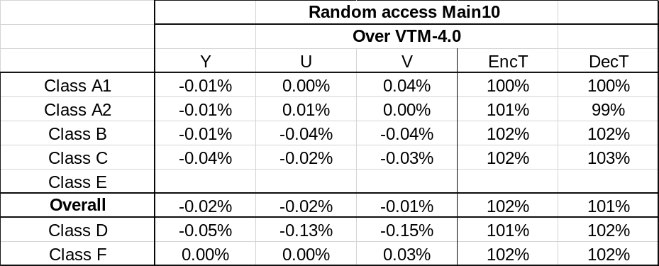

BD-rate performance of Test Two
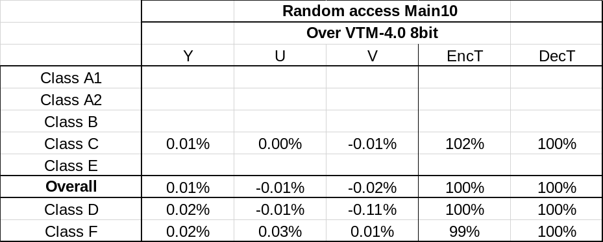

BD-rate performance of Test Three
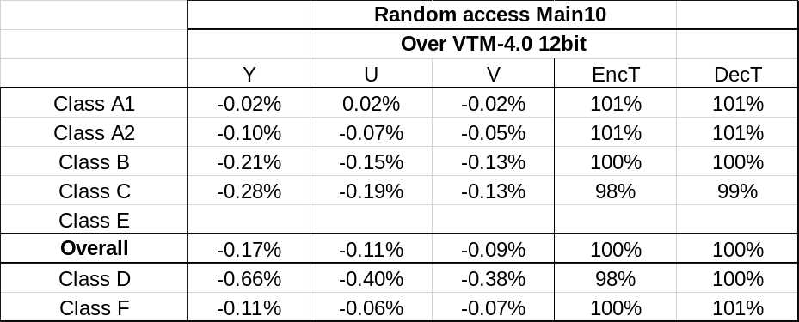

Proposed spec changes

8.5.7.4 Bidirectional optical flow prediction process
……
Output of this process is the (nCbW)x(nCbH) array pbSamples of luma prediction sample values.
Variables bitDepth, shift1, shift2, shift3, shift4, offset4, and mvRefineThres are derived as follows:
- The variable bitDepth is set equal to BitDepth_{Y}.
- The variable shift1 is set to equal to Max( 2, 14 − bitDepth )6.
- The variable shift2 is set to equal to Max( 8, bitDepth − 4 )4.
- The variable shift3 is set to equal to Max( 5, bitDepth − 7 )1.
- The variable shift4 is set equal to Max( 3, 15 − bitDepth ) and the variable offset4 is set equal to 1 << ( shift4 − 1 ).
- The variable mvRefineThres is set equal to Max( 2, 1 << ( 13 − bitDepth ) )5.
……
  - The variables sGx2, sGy2, sGxGy, sGxdI and sGydI are derived as follows:
sGx2 = Σ_{i}Σ_{j} ( tempH[ xSb + i ][ ySb + j ] * tempH[ xSb + i ][ ySb + j ] ) with i, j = −1..4 (8-862)
sGy2 = Σ_{i}Σ_{j}(tempV[ xSb + i ][ ySb + j ] * tempV[ xSb + i ][ ySb + j ] ) with i, j = −1..4 (8-863)
sGxGy = Σ_{i}Σ_{j}(tempH[ xSb + i ][ ySb + j ] * tempV[ xSb + i ][ ySb + j ] ) with i, j −1..4 (8-864)
sGxGy = Clip3(-2¹⁵, -2¹⁵-1, Σ_{i}Σ_{j}(tempH[ xSb + i ][ ySb + j ] * tempV[ xSb + i ][ ySb + j ] )) with i, j −1..4 (8-xxx)
sGxdI = Σ_{i}Σ_{j}( − tempH[ xSb + i ][ ySb + j ] * diff[ xSb + i ][ ySb + j ] ) with i, j = −1..4 (8-865)
sGydI = Σ_{i}Σ_{j}( − tempV[ xSb + i ][ ySb + j ] * diff[ xSb + i ][ ySb + j ] ) with i, j = −1..4 (8-866)
sGydI = Clip3(-217, 217-1, ΣiΣj( − tempV[ xSb + i ][ ySb + j ] * diff[ xSb + i ][ ySb + j ] )) with i, j = −1..4 (8-xxx)

References
- B. Bross, J. Chen, S. Liu, “Versatile Video Coding (Draft 4)”, JVET-M1001, Jan. 2019, Marrakech, Morocco.
- T. Chujoh, T. Ikai, “Non-CE9: An improvement of BDOF”, JVET-M0063, Jan. 2019, Marrakech, Morocco.
- VTM-4.0, https://vcgit.hhi.fraunhofer.de/jvet/VVCSoftware_VTM/tags/VTM-4.0.
- F. Bossen, J. Boyce, X. Li, V. Seregin, K. Sühring, “JVET common test conditions and software reference configurations for SDR video”, JVET-M1010, Jan. 2019, Marrakech, Morocco.
- https://vcgit.hhi.fraunhofer.de/jvet/VVCSoftware_VTM/merge_requests/330.

Patent rights declaration(s)
Kwai Inc. may have current or pending patent rights relating to the technology described in this contribution and, conditioned on reciprocity, is prepared to grant licenses under reasonable and non-discriminatory terms as necessary for implementation of the resulting ITU-T Recommendation | ISO/IEC International Standard (per box 2 of the ITU-T/ITU-R/ISO/IEC patent statement and licensing declaration form).

