    Joint Video Experts Team (JVET)  of ITU-T SG 16 WP 3 and ISO/IEC JTC 1/SC 29/WG 11  14th Meeting: Geneva, CH, 19–27 March 2019 | Document: JVET-N0143

Title: | Non-CE3: Simplification of multi-line intra
Status: | Input document to JVET
Purpose: | Proposal
Author(s) or  Contact(s): | Tomonori Hashimoto  Eiichi Sasaki  Tomohiro Ikai | Email: | +81-43-299-8526  tomonori.hashimoto@sharp.co.jp  eiichi.sasaki@sharp.co.jp  ikai.tomohiro@sharp.co.jp
Source: | Sharp Corporation
_____________________________

Abstract
This contribution proposes a method of MRL simplification which saves on the line buffer for above-left reference samples. MRL intra prediction uses 2 additional reference lines for intra prediction, which results in larger line/columns buffer for reference samples. The proposed method uses one sample instead of eleven samples in above left reference samples. It is reported the proposed method saves 18.6 % line buffer for reference samples with 0.03 % / 0.03 % / 0.00 % coding loss in IO / RA / LDB configuration respectively.

Introduction
The multiple reference line (MRL) intra prediction [1], has been adopted in VVC draft. The MRL intra prediction uses 2 additional reference lines for intra prediction, which results in larger line / columns buffer (just line buffer hereafter) for reference samples. Although the line buffer increase in picture level is avoided by the CTU boundary restriction, the line buffer in CTU needs additional memory. As for above-left reference samples, additional ten samples in 2 additional lines have to be stored for MRL (Figure 1).
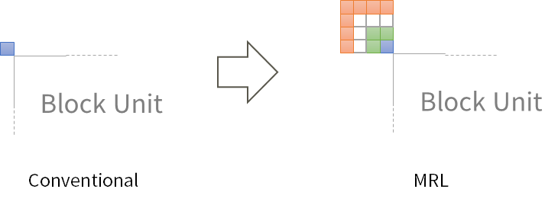
Figure 1: 3 samples in second line (green) and 7 samples in third line (orange) are needed for MRL.
Line buffer for above-left reference samples are small in HEVC and AVC where just one line is used. However in VVC, the number of samples are not small.
The above-left reference samples are stored considering the number of blocks caused by block partitioning. As shown in Figure 2, the maximum number of above-left region (worst case) is derived 2 * depth + 1, where depth is the depth of QT partitioning. For example, when VPDU size (64x64) is divided into the smallest CU (4x4), there are 9 above-left regions. For this case, in MRL, line buffer size for reference samples (left, above and above-left samples) is as followings:
Left: 3 * 64 = 192
Above: 3 * 64 = 192
Above-left: 9 * 11 = 99
Total: 192 + 192 + 99 = 483
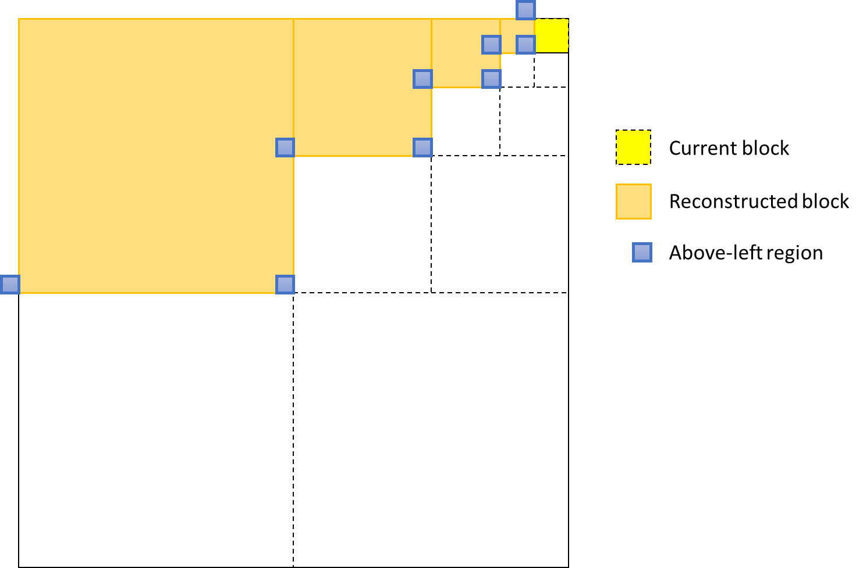
Figure 2: Above-left region
It is noted that the above can be said when following the raster scan. In practice, it may be possible not to follow it considering decoding speed. In that case, more above-left regions can be caused by block partitioning.
This contribution proposes the method of MRL simplification which saves on the line buffer for above-left reference samples.

Proposed Methods
In above-left block, only one conventional above-left sample is stored in line buffer. Additional ten reference samples are generated by a copy of the stored sample (Figure 3).
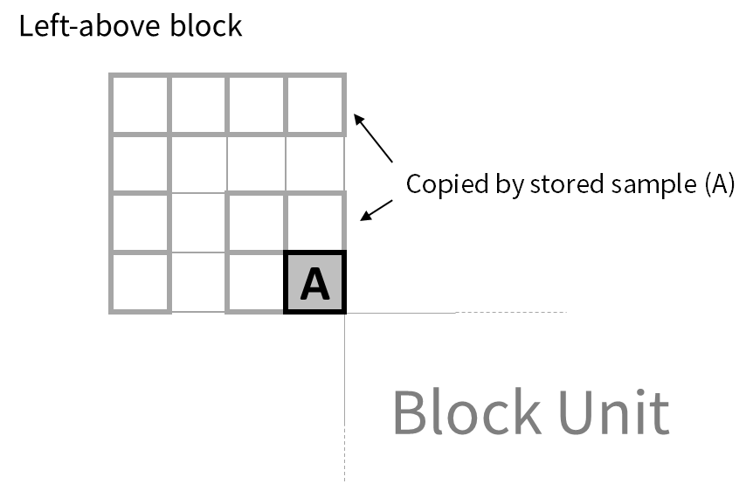
Figure 3: Proposed method for above-left sample
In this proposed method for the above case, line buffer size for reference samples (left, above and above-left samples) is as followings:
Left: 3 * 64 = 192
Above: 3 * 64 = 192
Above-left: 9 * 1 = 9
Total: 192 + 192 + 9 = 393
Save rate: (483-393) / 483 = 0.186
Therefore, the proposed method saves 18.6% line buffer for reference samples.

Experimental Results
The simulations were conducted in the condition of ‘All Intra’, ‘Random Access’ and ‘Low delay’ defined in JVET-M1010 [2]. Table 1 shows the results.

Table 1. Result of proposed MRL simplification
 | All Intra Main10
 | Over VTM-4.0
 | Y | U | V | EncT | DecT
Class A1 | 0.03% | 0.03% | 0.06% | 100% | 100%
Class A2 | 0.03% | 0.11% | 0.01% | 100% | 101%
Class B | 0.04% | 0.11% | 0.11% | 100% | 101%
Class C | -0.01% | 0.06% | 0.06% | 100% | 101%
Class E | 0.09% | 0.08% | 0.01% | 100% | 101%
Overall | 0.03% | 0.08% | 0.06% | 100% | 101%
Class D | 0.00% | 0.02% | -0.14% | 100% | 101%
Class F | -0.03% | 0.09% | -0.04% | 100% | 101%

 | Random Access Main 10
 | Over VTM-4.0
 | Y | U | V | EncT | DecT
Class A1 | 0.02% | 0.05% | -0.09% | 100% | 101%
Class A2 | -0.01% | 0.04% | -0.03% | 101% | 101%
Class B | 0.03% | 0.02% | -0.03% | 101% | 101%
Class C | 0.05% | 0.07% | -0.09% | 100% | 101%
Class E
Overall | 0.03% | 0.04% | -0.06% | 101% | 101%
Class D | 0.03% | -0.19% | -0.11% | 100% | 101%
Class F | 0.01% | -0.05% | 0.01% | 100% | 101%

 | Low delay B Main10
 | Over VTM-4.0
 | Y | U | V | EncT | DecT
Class A1
Class A2
Class B | 0.00% | -0.12% | -0.21% | 101% | 101%
Class C | -0.05% | 0.09% | -0.07% | 101% | 101%
Class E | 0.06% | 0.38% | 0.44% | 100% | 100%
Overall | 0.00% | 0.07% | 0.00% | 101% | 101%
Class D | -0.03% | 0.36% | 0.24% | 101% | 101%
Class F | -0.18% | -0.11% | -0.28% | 101% | 101%

Conclusion
This contribution proposes the method of MRL simplification which saves on the line buffer for above-left reference samples. The proposed method saves 18.6% line buffer for reference samples with 0.03% / 0.03% / 0.00 % coding loss in IO / RA / LDB configuration. It is recommended to adopt this method in the next VVC WD and VTM software.

References
[1] B. Bross, P. Keydel, H. Schwarz, D. Marpe, T. Wiegand, L. Zhao, X. Zhao, X. Li, S. Liu, Y.-J. Chang, H.-Y. Jiang, P.-H. Lin, C.-C. Kuo, C.-C. Lin, C.-L. Lin, “CE3: Multiple reference line intra prediction (Test 1.1.1, 1.1.2, 1.1.3 and 1.1.4),” JVET-L0283, ISO/IEC JTC 1/SC 29/WG 11 Joint Video Exploration Team (JVET) 12th Meeting: Macao, CN, 3–12 Oct. 2018.
[2] F. Bossen, J. Boyce, X. Li, V. Seregin, K. Sühring, “JVET common test conditions and software reference configurations for SDR video,” JVET-M1010, ISO/IEC JTC 1/SC 29/WG 11 Joint Video Exploration Team (JVET) 13th Meeting: Marrakech, MA, 9–18 Jan. 2019.

Patent rights declaration(s)
Sharp Corporation may have current or pending patent rights relating to the technology described in this contribution and, conditioned on reciprocity, is prepared to grant licenses under reasonable and non-discriminatory terms as necessary for implementation of the resulting ITU-T Recommendation | ISO/IEC International Standard (per box 2 of the ITU-T/ITU-R/ISO/IEC patent statement and licensing declaration form).

