    Joint Video Experts Team (JVET)  of ITU-T SG 16 WP 3 and ISO/IEC JTC 1/SC 29/WG 11  13th Meeting: Marrakech, MA, 9–18 Jan. 2019 | Document: JVET-M0906-v4

Title: | Subjective assessment of CE11 proposals
Status: | Input document to JVET
Purpose: | Proposal
Author(s) or  Contact(s): | Vittorio Baroncini,  Andrey Norkin,  Anand Meher Kotra,  Kenneth R. Andersson,  Kiran Misra,  Hyeongmun Jang,  Chia-ming Tsai  Dmytro Rusanovskyy | Tel:  Email: | baroncini@gmx.com  anorkin@netflix.com  anand.meher.kotra@huawei.com  kenneth.r.andersson@ericsson.com  misrak@sharplabs.com  hm.jang@lge.com  chia-ming.tsai@mediatek.com  dmytror@qti.qualcomm.com
Source: | JVET test chair and CE11 coordinators
_____________________________

Abstract
This contribution provides a report of the subjective test for the proposals in Core Experiment 11 on deblocking filtering. Two set of tests were performed during the Marrakesh meeting in accordance with the CE11 description document JVET-L1031[2]. Both tests involved visually evaluating CE proposals versus VTM3 with ALF turned OFF as anchor. ALF was also turned OFF for the CE proposals.
To facilitate further analysis a score representing the number of times the Mean Opinion Score of a CE proposal is better than the anchor, and the anchor lies outside the confidence interval was also computed.

Introduction
Expert viewing was conducted during the Marrakech meeting for both CE 11.1 (Longer tap filter) category and CE 11.2 (4 x 4 luma sample grid filtering). The sequences and the QP points used are as listed in [2]. The invitation for the subjective viewing participation was issued on the JVET reflector. 12 non-proponent viewers were selected as the test participants for subjective testing for both the categories. All the 12 participants were divided into 4 groups containing 3 participants each.
The dates and the actual timings of the viewing sessions are included with the attached spreadsheets along with the contribution. Each coded video was compared with the anchor; the order of presentation of anchor and coded videos was randomly changed. The Anchor used in all the configurations was with ALF (adaptive loop filter) tool turned off. The coded video also had the ALF (adaptive loop filter) tool turned off.
A video (preceded by the latter A) was shown on the screen, followed a second video (preceded by the letter B); once again A video (preceded by the latter A), followed by the second video (preceded by the letter B) is shown on the screen; then the message “Vote N” was presented asking to the viewers to rate if “A was much better than B”, “A was better than B” or “B was better than A” or “B was much better than A”.
The order of presentation of the video clips inside each test session was assigned randomly taking care not to show the same sequence two consecutive times.

Subjective viewing assessment

CE11.1 subjective assessment
For the CE 11.1 category, following test sequences and conditions were used in the subjective tests. The sequence length is 10 seconds.

Num | Name | Resolution | fps | Frames | Mode | QP
01 | FoodMarket | 3840x2160p | 60fps | 600 | RA | 39, 34
02 | Campfire | 3840x2160p | 30fps | 300 | RA | 39, 34
03 | Kimono | 1920x1080p | 24fps | 240 | LDB | 34, 39
04 | KristenAndSara | 1280x720p | 60fps | 600 | LDP | 34, 39
05 | Red Kayak* | 1920x1080p | 30fps | 300 | RA | 34, 39
* First 300 frames of the RedKayak sequence were used.
To facilitate analysis, the scores provided by viewers were translated to a fix scale of 1, 2, 3 or 4, with:
1 representing anchor is much better than a CE proposal,
2 representing anchor is better than a CE proposal,
3 representing a CE proposal is better than the anchor, and
4 representing a CE proposal is much better than the anchor.
The anchor used is VTM3 with ALF OFF. Mean Opinion Score (MOS) and Confidence Intervals (CI) were computed for each data-point. For each QP, these were in turn used to compute:
- Number of times (x) a CE proposal beats the anchor i.e. number of times (MOS – CI) is greater than 2.5; and
- Number of times (y) anchor beats the CE proposal i.e. (MOS + CI) is less than 2.5.
The total score for each CE proposal, for a given QP, is then computed as x – y.

Figure 1: Example illustrating TEST A wins, TEST B tie, TEST C loses for a sequence
Listed below are the total score of the CE proposals in CE11.1. The attached excel contains more detailed results.CE11.1: Long Filters Tests – highest possible total score per QP is +5, lowest possible score per QP is -5:
CE Proposal | Total score for QP34 | Total score for QP39
CE11.1.1 | 2 | 4
CE11.1.2 | 3 | 4
CE11.1.3 | 1 | 2
CE11.1.4 | 2 | 2
CE11.1.5 | 3 | 4
CE11.1.6 | 4 | 5
CE11.1.7 | 2 | 5
CE11.1.8 | 4 | 5

Figure 2: Graphical illustration of the scoring for each test per QP

It is reported that all CE tests in the long filter category were overall better than the anchor. The VTM3 with ALF ON was also evaluated versus VTM3 with ALF OFF and received a total score of 3 for both QP 34 and 39.
The plots below provide visual representation of the results of the ABAB comparison evaluation. Results (grouped by test sequence) show the performances of the CE Proposals. In the plots MOS scores increase from left-to-right. If two or more CE proposals have the same MOS scores then they are ordered with decreasing CI from left-to-right. Plots are shown for QP34 and QP39. The data-point corresponding to comparison of VTM3 with ALF ON versus anchor is also included below.

QP34 results

Campfire
Proponent | MOS | SD | CI
CE11.1.3 | 2.25 | 0.75 | 0.35
CE11.1.5 | 2.75 | 0.75 | 0.35
ALF ON | 2.83 | 0.39 | 0.18
CE11.1.4 | 2.92 | 0.67 | 0.31
CE11.1.8 | 3.08 | 0.79 | 0.37
CE11.1.1 | 3.25 | 0.75 | 0.35
CE11.1.2 | 3.25 | 0.75 | 0.35
CE11.1.7 | 3.25 | 0.75 | 0.35
CE11.1.6 | 3.33 | 0.78 | 0.36

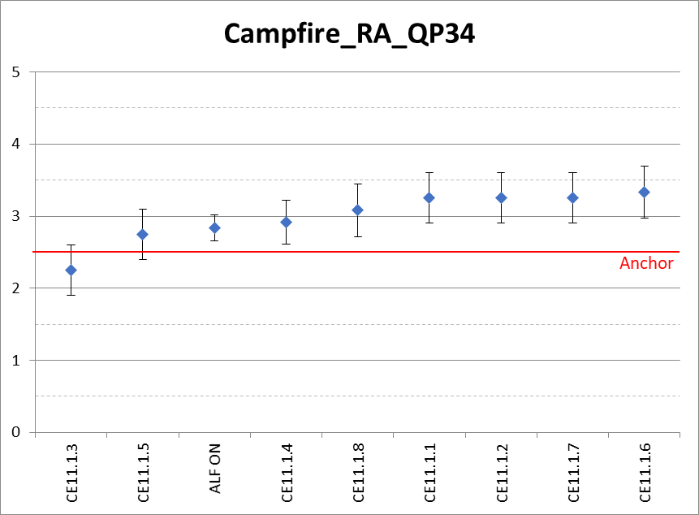

FoodMarket
Proponent | MOS | SD | CI
CE 11.1.6 | 2.42 | 0.51 | 0.24
CE 11.1.7 | 2.42 | 0.51 | 0.24
CE 11.1.1 | 2.67 | 0.49 | 0.23
CE 11.1.2 | 2.67 | 0.49 | 0.23
CE 11.1.4 | 2.67 | 0.49 | 0.23
CE 11.1.5 | 2.67 | 0.49 | 0.23
CE 11.1.3 | 2.75 | 0.45 | 0.21
ALF ON | 2.83 | 0.58 | 0.27
CE 11.1.8 | 2.83 | 0.39 | 0.18

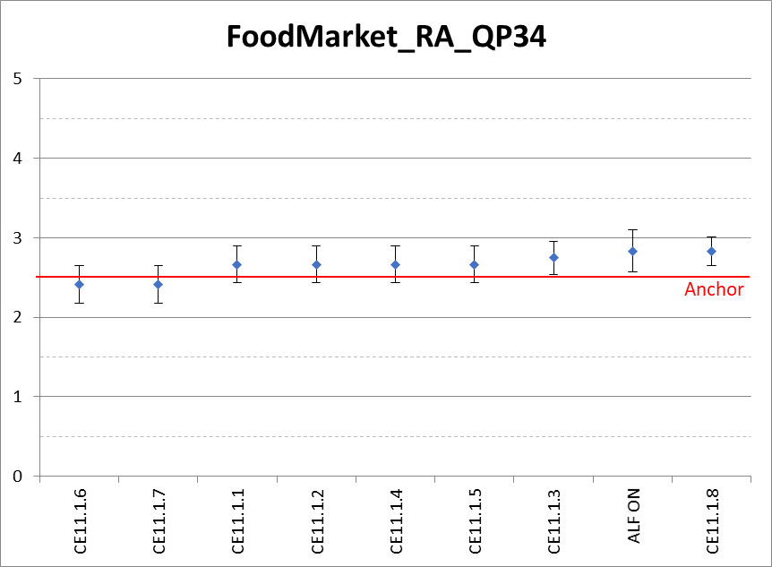

Kimono
Proponent | MOS | SD | CI
CE11.1.8 | 2.25 | 0.75 | 0.35
CE11.1.1 | 2.33 | 0.78 | 0.36
ALF ON | 2.42 | 0.51 | 0.24
CE11.1.3 | 2.42 | 0.51 | 0.24
CE11.1.4 | 2.50 | 0.52 | 0.24
CE11.1.2 | 2.58 | 0.51 | 0.24
CE11.1.7 | 2.58 | 0.51 | 0.24
CE11.1.5 | 2.75 | 0.45 | 0.21
CE11.1.6 | 2.83 | 0.58 | 0.27

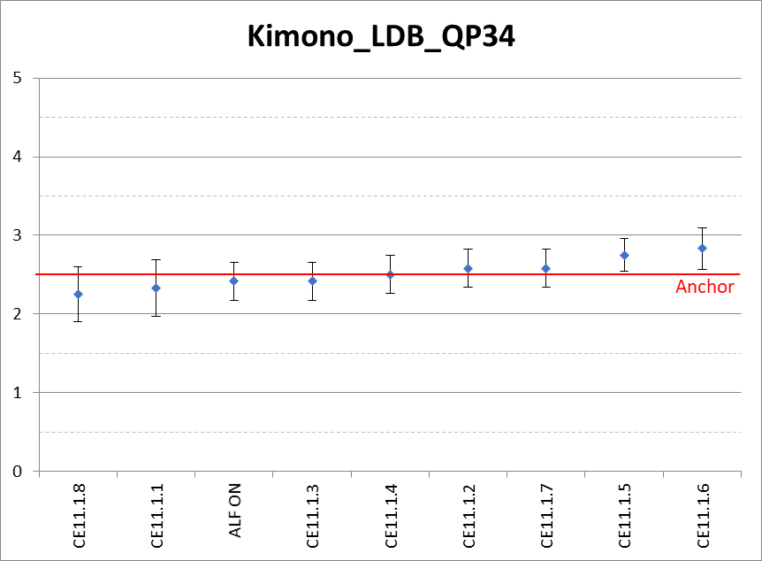

KristenAndSara
proponent | MOS | SD | CI
CE11.1.5 | 2.33 | 0.65 | 0.30
CE11.1.3 | 2.50 | 0.52 | 0.24
CE11.1.1 | 2.67 | 0.49 | 0.23
CE11.1.4 | 2.75 | 0.75 | 0.35
CE11.1.7 | 2.83 | 0.83 | 0.39
CE11.1.8 | 2.83 | 0.58 | 0.27
CE11.1.2 | 2.92 | 0.90 | 0.42
ALF ON | 3.08 | 0.67 | 0.31
CE11.1.6 | 3.17 | 0.58 | 0.27
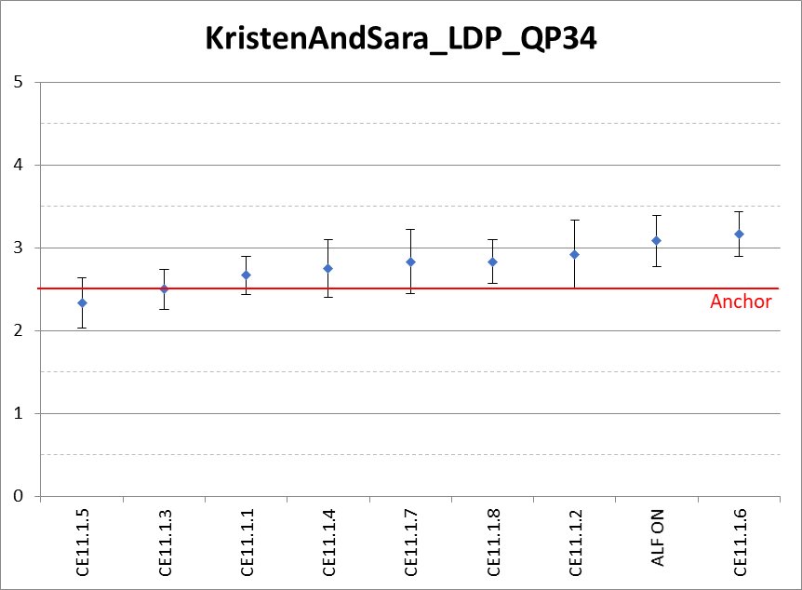

RedKayak
Proponent | MOS | SD | CI
ALF ON | 2.58 | 0.51 | 0.24
CE11.1.3 | 2.58 | 0.51 | 0.24
CE11.1.5 | 3.00 | 0.95 | 0.44
CE11.1.1 | 3.17 | 0.72 | 0.33
CE11.1.4 | 3.25 | 0.87 | 0.40
CE11.1.8 | 3.25 | 0.75 | 0.35
CE11.1.7 | 3.42 | 0.51 | 0.24
CE11.1.2 | 3.50 | 0.67 | 0.31
CE11.1.6 | 3.50 | 0.52 | 0.24

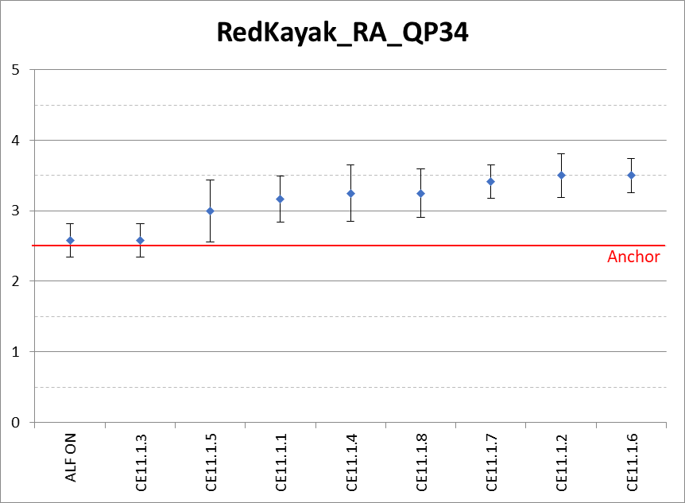

QP39 results

Campfire
Proponent | MOS | SD | CI
ALF ON | 2.58 | 0.51 | 0.24
CE11.1.3 | 2.67 | 0.49 | 0.23
CE11.1.4 | 2.67 | 0.49 | 0.23
CE11.1.1 | 2.75 | 0.45 | 0.21
CE11.1.5 | 3.08 | 0.67 | 0.31
CE11.1.8 | 3.25 | 0.62 | 0.29
CE11.1.7 | 3.25 | 0.62 | 0.29
CE11.1.6 | 3.25 | 0.62 | 0.29
CE11.1.2 | 3.42 | 0.51 | 0.24

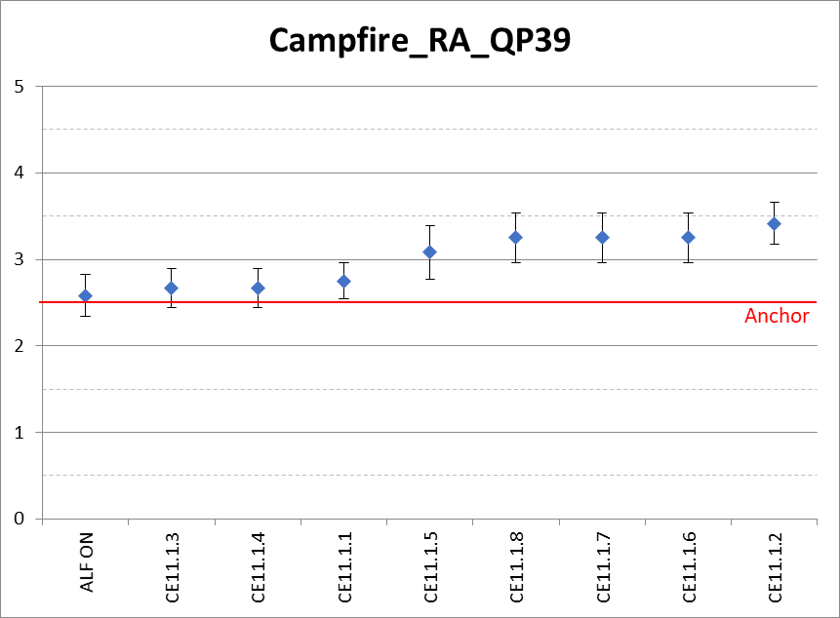

FoodMarket
Proponent | MOS | SD | CI
CE11.1.4 | 2.50 | 0.52 | 0.24
ALF ON | 2.50 | 0.52 | 0.24
CE11.1.3 | 2.92 | 0.51 | 0.24
CE11.1.7 | 3.00 | 0.60 | 0.28
CE11.1.2 | 3.00 | 0.60 | 0.28
CE11.1.5 | 3.08 | 0.67 | 0.31
CE11.1.1 | 3.08 | 0.29 | 0.13
CE11.1.6 | 3.17 | 0.58 | 0.27
CE11.1.8 | 3.42 | 0.51 | 0.24
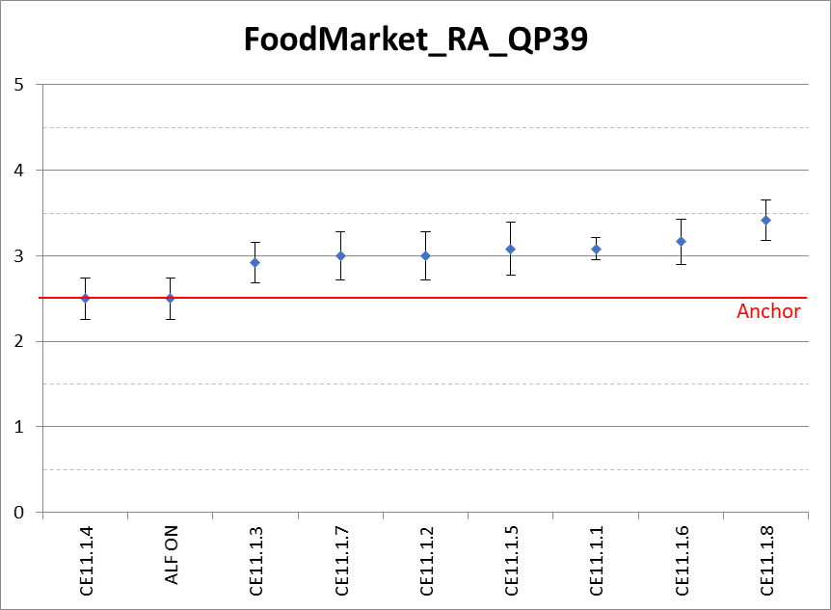

Kimono
Proponent | MOS | SD | CI
CE11.1.3 | 2.58 | 0.51 | 0.24
CE11.1.2 | 2.58 | 0.51 | 0.24
CE11.1.1 | 2.67 | 0.49 | 0.23
CE11.1.7 | 2.83 | 0.72 | 0.33
CE11.1.8 | 2.83 | 0.58 | 0.27
CE11.1.5 | 2.83 | 0.58 | 0.27
CE11.1.6 | 2.92 | 0.67 | 0.31
CE11.1.4 | 2.92 | 0.51 | 0.24
ALF ON | 3.00 | 0.60 | 0.28

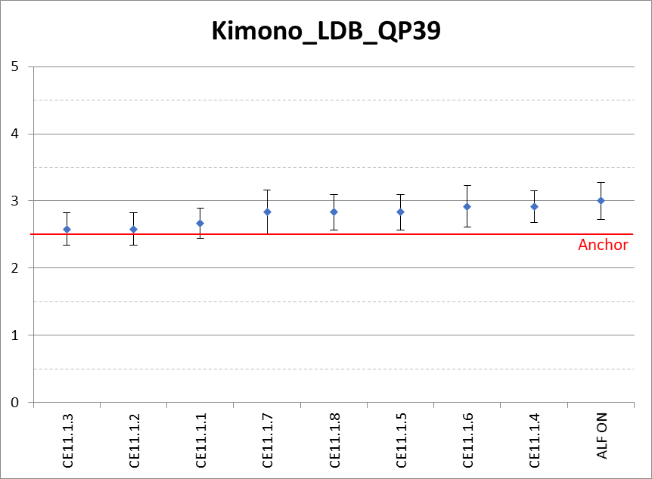

KristenAndSara
Proponent | MOS | SD | CI
CE11.1.4 | 2.58 | 0.51 | 0.24
CE11.1.3 | 2.67 | 0.49 | 0.23
CE11.1.5 | 2.75 | 0.62 | 0.29
CE11.1.1 | 2.83 | 0.39 | 0.18
CE11.1.7 | 2.92 | 0.67 | 0.31
CE11.1.2 | 3.00 | 0.85 | 0.39
CE11.1.6 | 3.00 | 0.60 | 0.28
CE11.1.8 | 3.08 | 0.79 | 0.37
ALF ON | 3.17 | 0.58 | 0.27
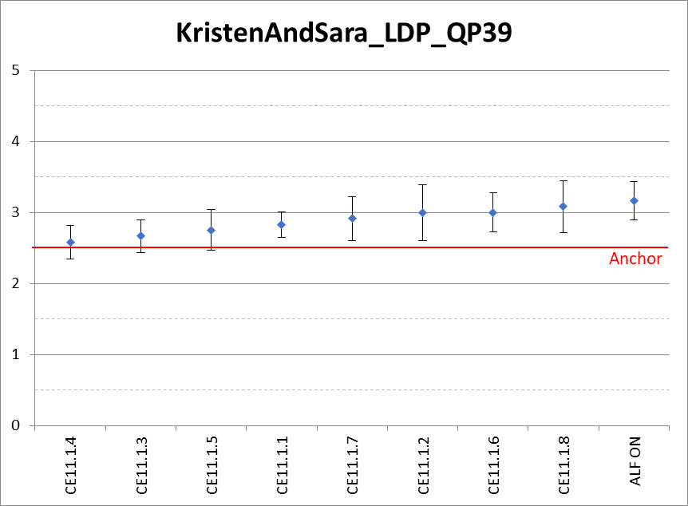

RedKayak
Proponent | MOS | SD | CI
CE11.1.3 | 2.83 | 0.58 | 0.27
ALF ON | 2.92 | 0.51 | 0.24
CE11.1.1 | 3.08 | 0.79 | 0.37
CE11.1.8 | 3.08 | 0.51 | 0.24
CE11.1.6 | 3.25 | 0.87 | 0.40
CE11.1.7 | 3.50 | 0.80 | 0.37
CE11.1.5 | 3.50 | 0.67 | 0.31
CE11.1.2 | 3.58 | 0.67 | 0.31
CE11.1.4 | 3.67 | 0.49 | 0.23
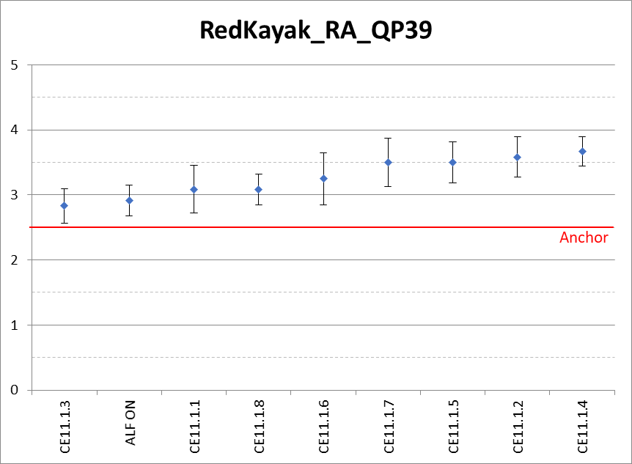

Further verification viewing was conducted on January 17, 2019 starting at 6:45pm. Three viewing sessions were conducted. For the three viewing sessions, there were a total of 20 participants with 12 of them being non-proponents. The purpose of the viewing was to verify if CE11.1.8 provides visual improvement when ALF is turned ON. The Anchor with ALF ON and CE11.1.8 with ALF ON were shown in ABAB configuration. In the ABAB configuration, anchor was always A and CE11.1.8 was always B. The 10 data-points corresponding to the CE11.1 sequence, encoder configuration, QP combination were used in the viewing. After each viewing session the participants were asked to comment, and several participants expressed that they could see clear improvement for CE11.1.8 in Campfire (RA) and RedKayak (RA) sequences. Slight improvement were also reported for FoodMarket (RA) and KristenAndSara (LDP) sequences. For Kimono (LDB) sequence no improvements or deterioration were reported.

CE11.2 subjective assessment
The following sequences and QP were used for subjective evaluation in CE11.2.

Num | Name | Resolution | fps | Frames | Mode | QP
01 | Campfire | 3840x2160p | 30fps | 300 | RA | 30, 34
02 | Johnny | 1280x720p | 60fps | 600 | LDP | 30, 34
03 | Kimono | 1920x1080p | 24fps | 240 | LDB | 30, 34
04 | KristenAndSara | 1280x720p | 60fps | 600 | LDP | 30, 34
Similar to the CE11.1, Mean Opinion Score (MOS) and Confidence Intervals (CI) were computed for each data-point. For each QP, these were in turn used to compute number of times (x) a CE proposal beats the anchor i.e. number of times (MOS – CI) is greater than 2.5; and number of times (y) anchor beats the CE proposal i.e. (MOS + CI) is less than 2.5. The total score for each CE proposal, for a given QP, is then computed as x – y. Listed below are the total score of the CE proposals. The attached excel contains more details of the analysis.
CE11.2: 4x4 Luma Sample Grid Filtering Tests – highest possible total score per QP is +4, lowest possible score per QP is -4:
CE Proposal | Total Score for QP30 | Total Score for QP34
CE11.2.1 | 0 | -1
CE11.2.2 | 0 | 1
It is reported that for QP34, CE11.2.2 was overall better than the anchor. The VTM3 with ALF ON was also evaluated and received a total score of 3 and 2 for QP 30 and QP 34, respectively.
The MOS, CI plots for the tests (including VTM3 with ALF ON) is shown below:

QP 30 results

Campfire
Proponent | MOS | DS | CI
ALF ON | 2.67 | 0.78 | 0.36
CE11_2_1 | 2.58 | 0.67 | 0.31
CE11_2_2 | 2.25 | 0.62 | 0.29

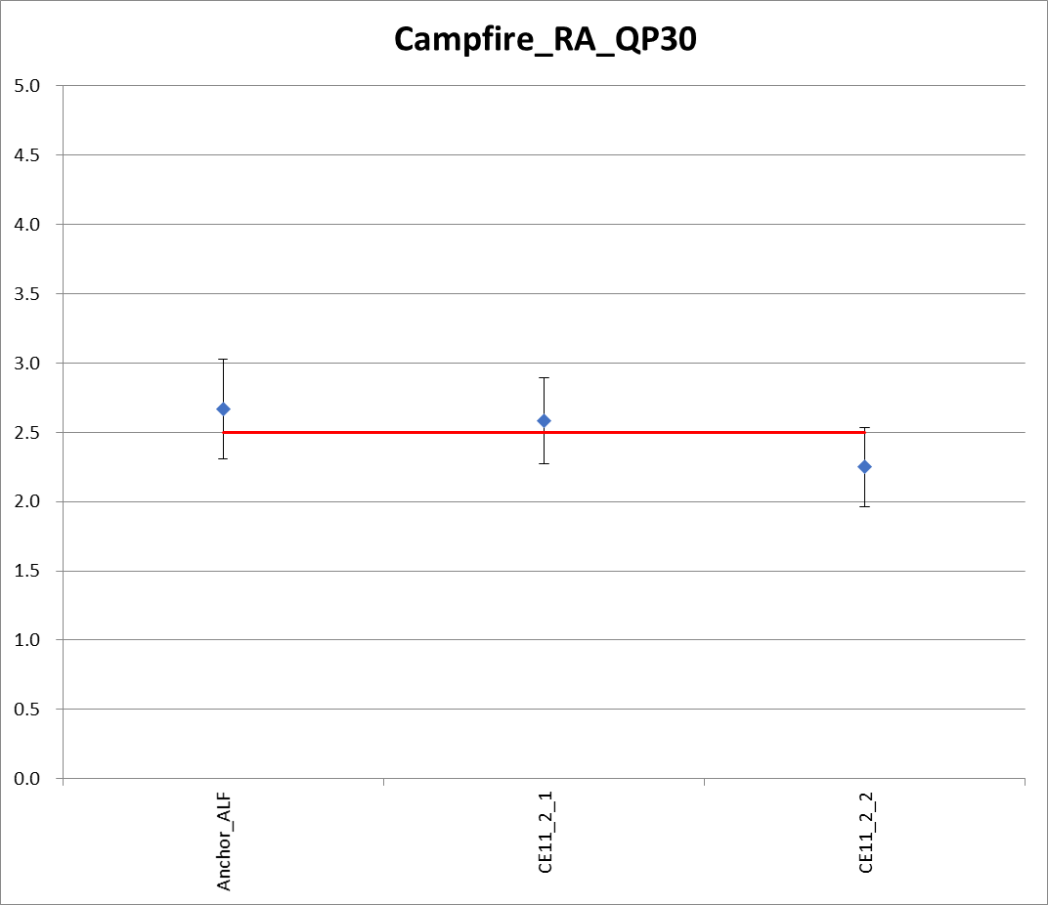

Johnny
Proponent | MOS | DS | CI
ALF ON | 2.83 | 0.72 | 0.33
CE11_2_1 | 2.58 | 0.79 | 0.37
CE11_2_2 | 2.83 | 0.58 | 0.27
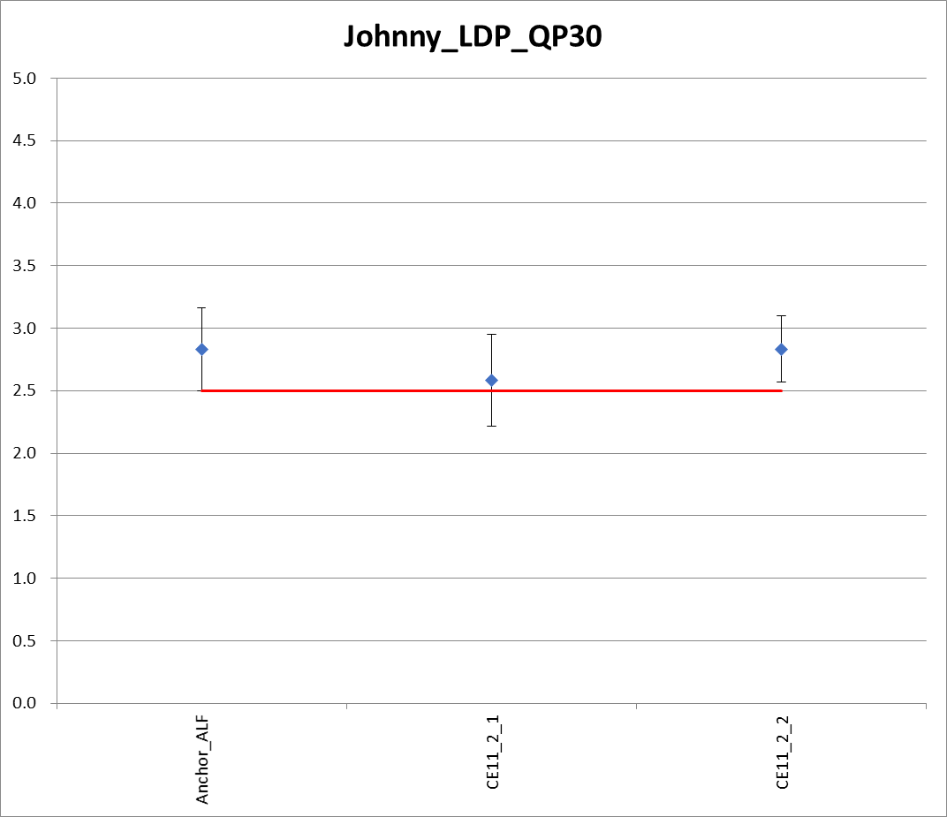

Kimono
Proponent | MOS | DS | CI
ALF ON | 2.50 | 0.67 | 0.31
CE11_2_1 | 2.58 | 0.67 | 0.31
CE11_2_2 | 2.50 | 0.67 | 0.31
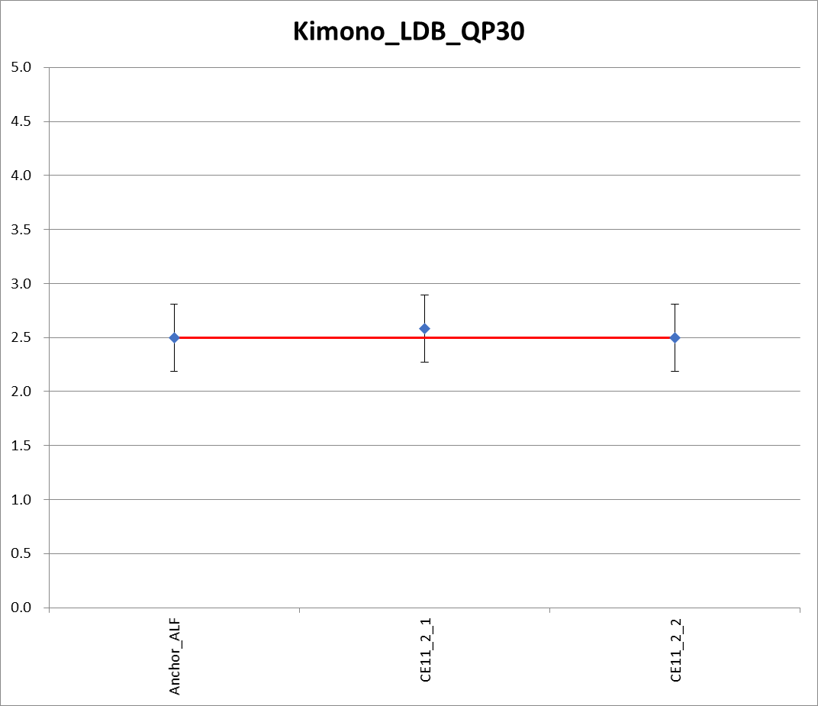

KirstenAndSara
Proponent | MOS | DS | CI
ALF ON | 2.92 | 0.51 | 0.24
CE11_2_1 | 1.92 | 0.79 | 0.37
CE11_2_2 | 2.33 | 0.65 | 0.30
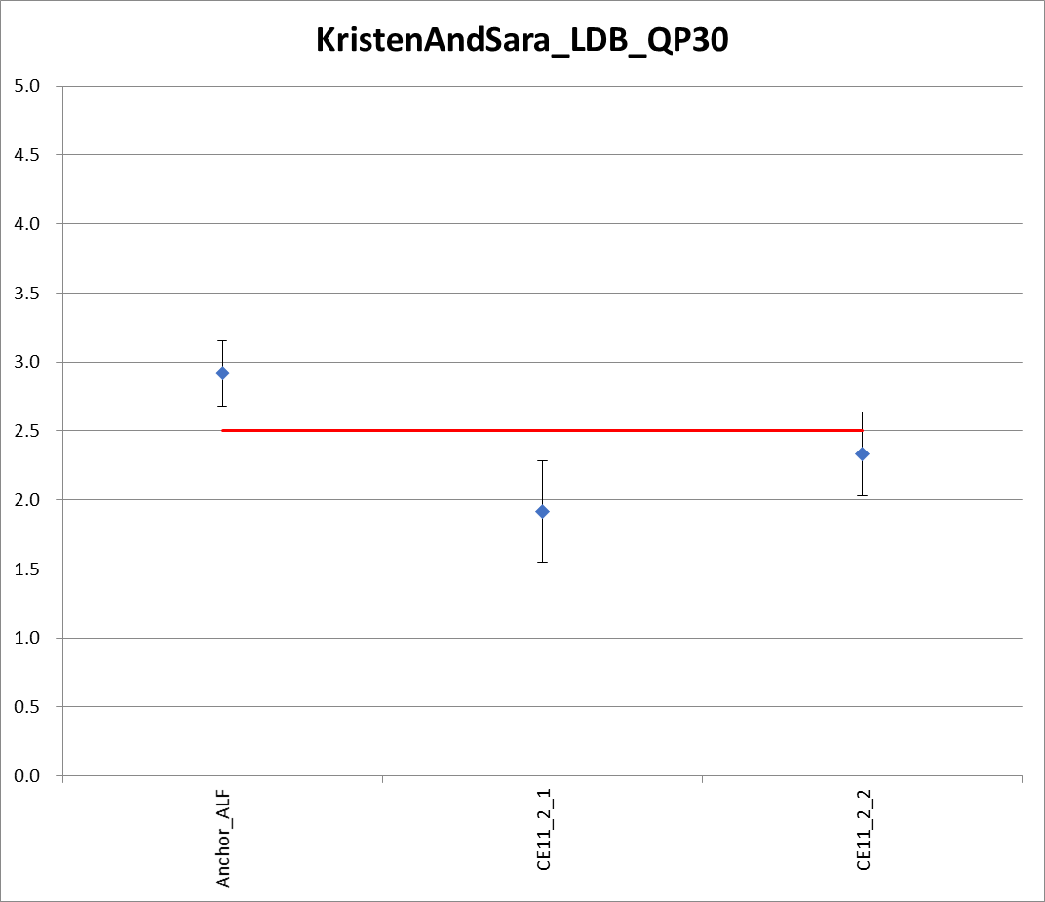

QP 34 results
Campfire
Proponent | MOS | DS | CI
ALF ON | 2.92 | 0.67 | 0.31
CE11_2_1 | 2.67 | 0.78 | 0.36
CE11_2_2 | 2.58 | 0.67 | 0.31
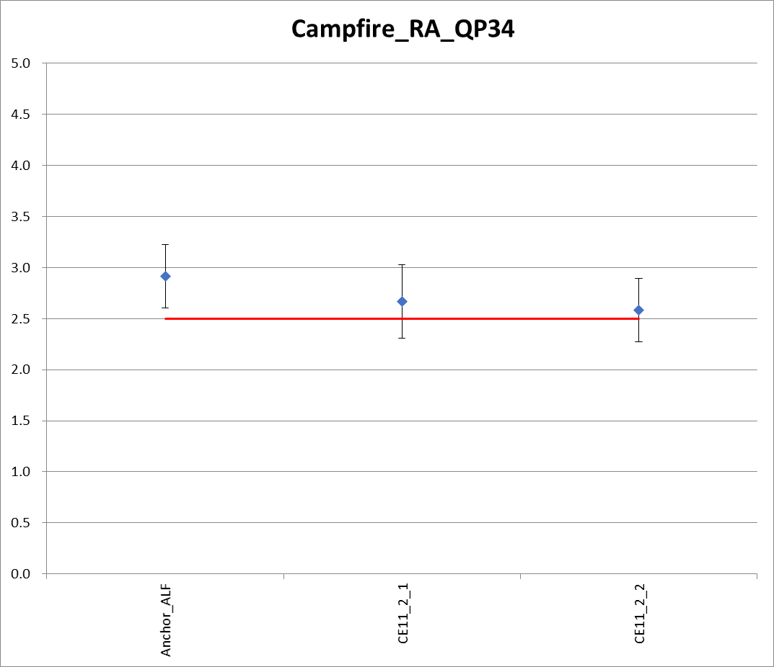

Johnny
Proponent | MOS | DS | CI
ALF ON | 3.08 | 0.79 | 0.37
CE11_2_1 | 2.50 | 0.67 | 0.31
CE11_2_2 | 2.58 | 1.00 | 0.46
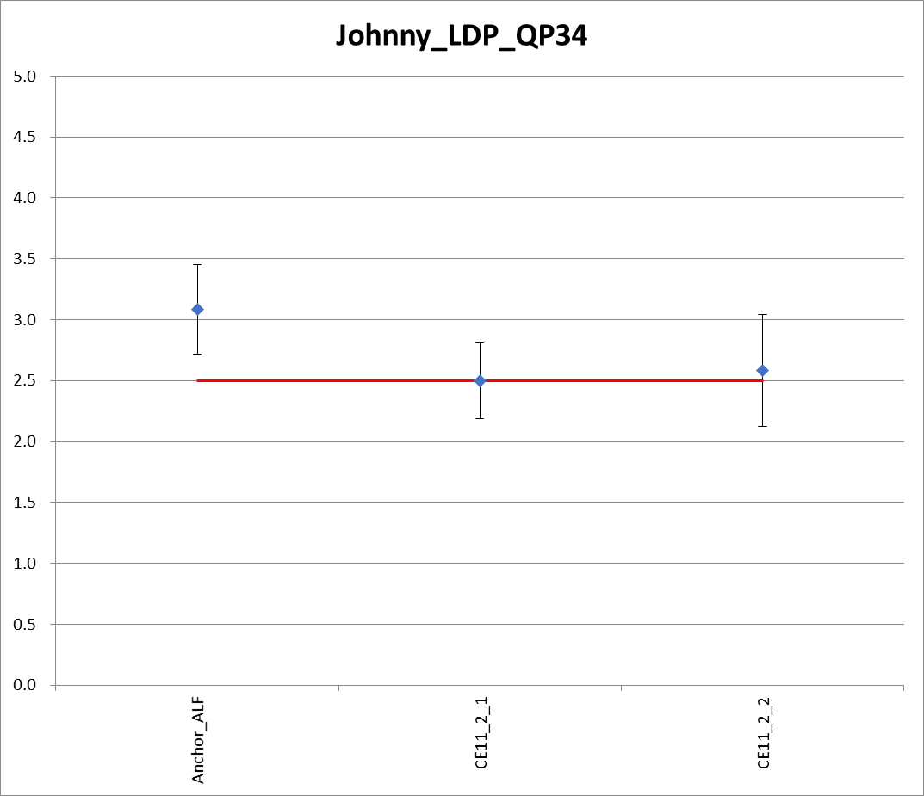

Kimono
Proponent | MOS | DS | CI
ALF ON | 2.67 | 0.49 | 0.23
CE11_2_1 | 2.50 | 0.80 | 0.37
CE11_2_2 | 2.58 | 0.51 | 0.24
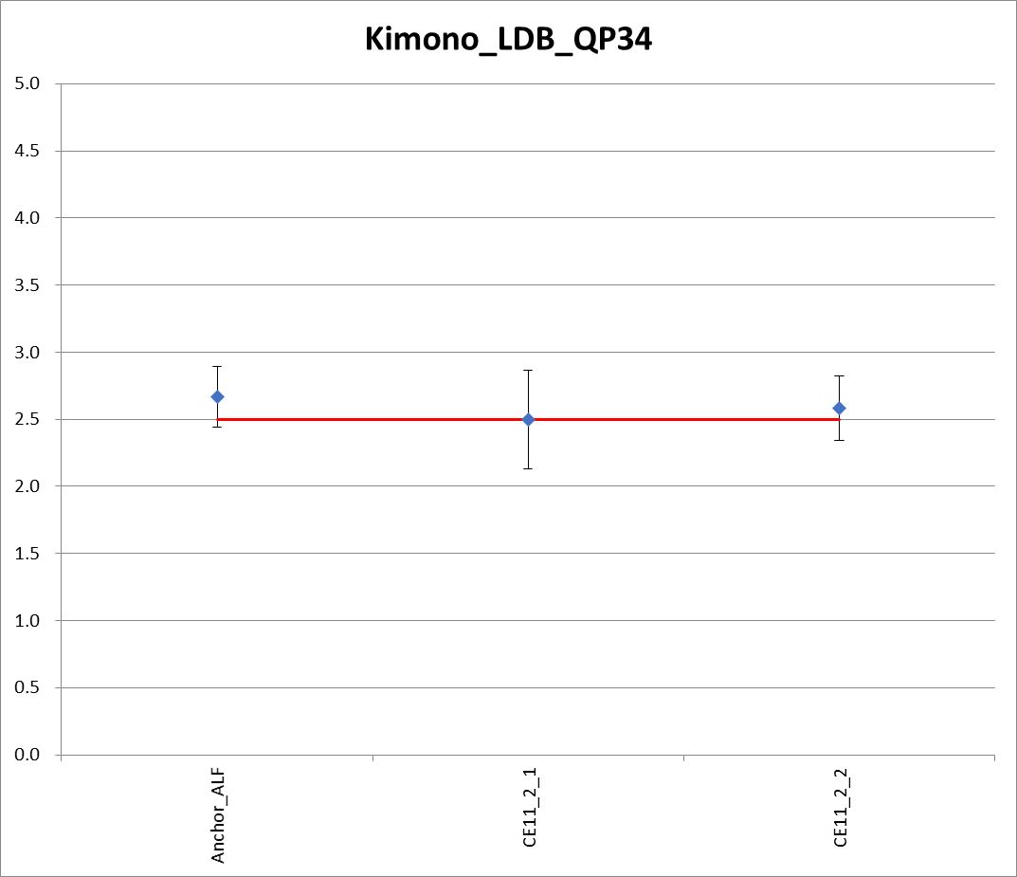

KristenAndSara
Proponent | MOS | DS | CI
ALF ON | 3.33 | 0.65 | 0.30
CE11_2_1 | 2.42 | 0.51 | 0.24
CE11_2_2 | 2.50 | 0.52 | 0.24
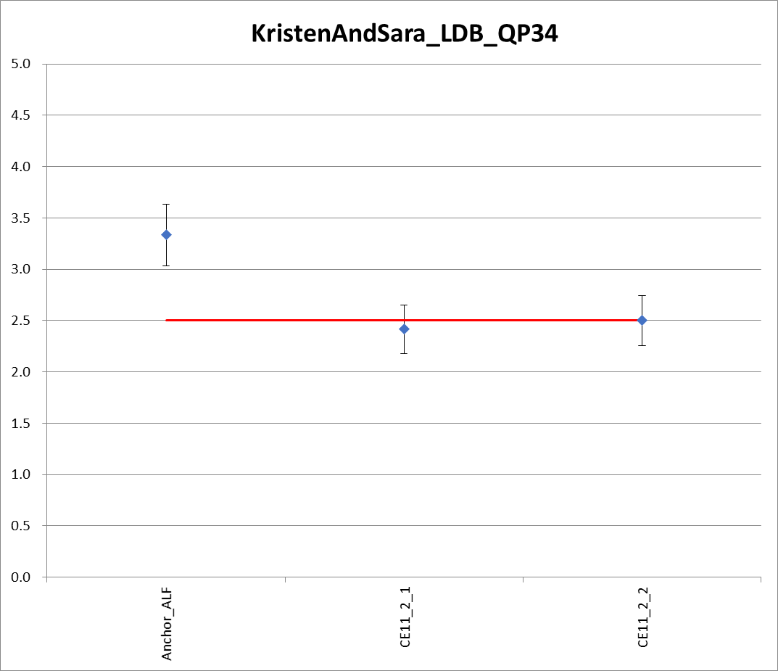

Conclusion
This proposal provides the subjective test results of CE11 proposals. The subjective testing was conducted with Anchor as VTM-3.0 with ALF OFF configuration. The authors would like to especially thank all the participants who spared their valuable time to take part in the subjective viewing session.

References
- “JVET common test conditions and software reference configurations”, JVET-L1010.
- A. Norkin and A. M. Kotra, "Description of Core Experiment 11 (CE11): Deblocking", JVET-L1031.
- A. Norkin and A. M. Kotra, "CE11: Summary report on deblocking", JVET-M0031.

