    Joint Video Experts Team (JVET)  of ITU-T SG 16 WP 3 and ISO/IEC JTC 1/SC 29/WG 11  13th Meeting: Marrakech, MA, 9–18 Jan. 2019 | Document: JVET-M0905-v1

Title: | CE1-related: Picture Boundary Handling regarding to VPDU
Status: | Input document
Purpose: | Proposal
Author(s) or  Contact(s): | Han Gao  Semih Esenlik  Biao Wang  Anand Meher Kotra  Jianle Chen | Tel:  Email: | han.gao@huawei.com  semih.esenlik@huawei.com  jianle.chen@huawei.com
Source: | Huawei Technologies Co.,Ltd.
_____________________________

Abstract
Currently the 64x64 VPDU is considered by the non-boundary located CTU/CU, however the 128x32 and 32x128 CU is allowed for picture boundary, which increased the pipeline payload. In the proposed method, VPDU is considered in the picture boundary handling. Simulation results shows XX% and XX% coding loss for RA and LDB configuration.

Problem Statement
64x64 VPDU [1] is applied in current working draft for non-boundary located CTU/CUs, which means 128x32 or 32x128 CUs are not supported. The current picture boundary handling created 32x128 or 128x32 shapes CUs, These CUs will be tiled into TUs, which both height and width smaller than or equal to 64. However, in some boundary case, these resulting TUs is violating the VPDU rule introduced in [1], which increase the hardware pipeline payload. For example, in Figure1, the red line is picture boundary, the black line is boundary handling implicitly splitting and blue line is TU tiling. In this case, the scan order is crossing the VPDUs as illustrated, which means TUs in one VPDU cannot completely finished.
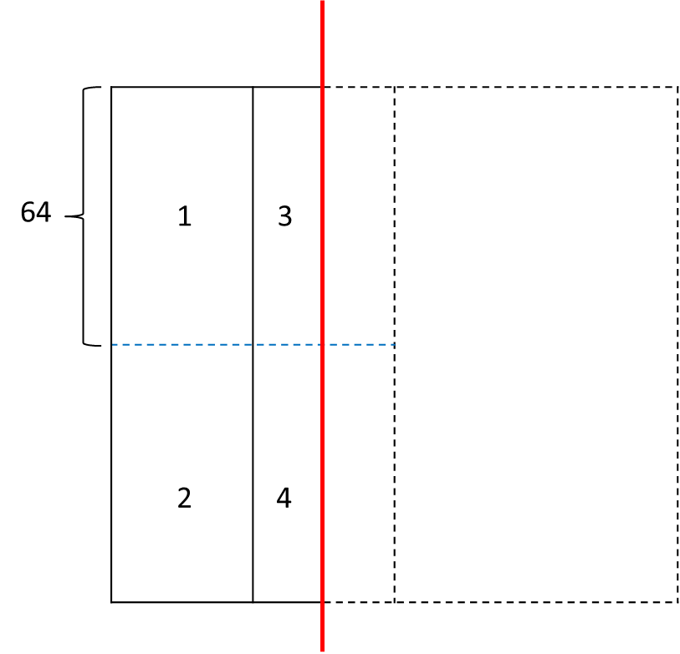
Figure 1, Picture boundary handling regarding less VPDU

Proposed method
In the proposed method, addition to current boundary handling, QT implicitly split is always applied for boundary located CTU/CU, when the height and width is greater than 64. In such a method, all children blocks from the boundary handing is satisfied with the VPDU rules, which ensured the hardware pipeline implementation complexity and memory bandwidth. Figure 2 illustrated the scan order of TUs of the proposed method
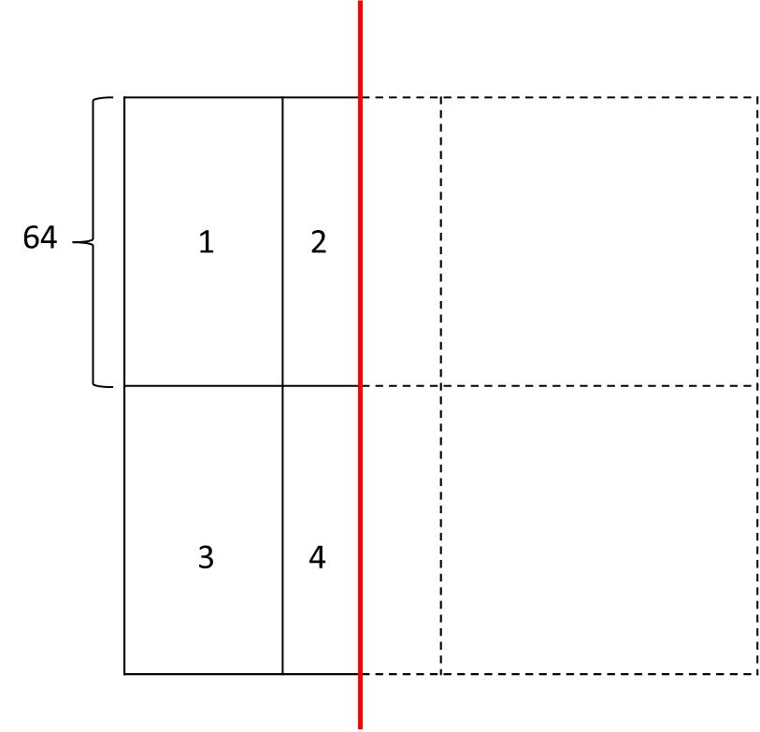
Figure 2, proposed picture boundary handling regarding to VPDU

Simulation results
Table 1 shows the simulation results with proposed method for RA and LDB. The AI will be not effect by the proposed method.
Table 1 Proposed implicit boundary QT split for CTU level.
 | Random Access Main 10
 | Over BMS-1.0 with VTM configuration
 | Y | U | V | EncT | DecT
Class A1 | 0.08% | 0.10% | 0.05% | 100% | 101%
Class A2 | 0.04% | 0.06% | 0.09% | 101% | 102%
Class B | 0.07% | 0.09% | 0.02% | 101% | 100%
Class C | 0.03% | 0.05% | 0.08% | 100% | 101%
Class E
Overall | 0.06% | 0.08% | 0.06% | 101% | 101%
Class D | 0.07% | 0.13% | 0.09% | 99% | 102%
Class F (optional) | 0.04% | 0.05% | 0.06% | 100% | 101%
 | Low delay B Main10
 | Over BMS-1.0 with VTM configuration
 | Y | U | V | EncT | DecT
Class A1
Class A2
Class B | 0.07% | -0.19% | 0.15% | 102% | 103%
Class C | 0.03% | 0.15% | 0.08% | 101% | 101%
Class E | 0.35% | 0.06% | -0.07% | 99% | 102%
Overall | 0.13% | -0.02% | 0.07% | 101% | 102%
Class D | 0.06% | 0.40% | 0.24% | 101% | 101%
Class F (optional) | 0.11% | 0.47% | 0.08% | 100% | 100%

Conclusion
Current boundary handling is regarding less VPDU rule in VVC 3.0 draft, in order to reduce the hardware implementation payload and memory bandwidth, a implicitly QT boundary handling method is proposed on top of the current boundary handling. Simulation results shows 0.XX% and 0.XX coding loss for RA and LDB on average. The contribution is proposed to be included in the VVC

Acknowledgement
We would like to thank Fraunhofer HHI for cross-checking this proposal.

Reference
[1] “ CE1.2.1: Constraint for binary and ternary partitions”, C.-M. Tsai, C.-W. Hsu, T.-D. Chuang, C.-Y. Chen, Y.-W. Huang, S.-M. Lei, doc. JVET-L0081, Oct. 2018
[2] “ Versatile Video Coding (Draft 3)”, B. Bross, J. Chen, S. Liu, doc. JVET-L1001, Oct. 2018

Patent rights declaration(s)
Huawei Technologies Co.,Ltd. may have current or pending patent rights relating to the technology described in this contribution and, conditioned on reciprocity, is prepared to grant licenses under reasonable and non-discriminatory terms as necessary for implementation of the resulting ITU-T Recommendation | ISO/IEC International Standard (per box 2 of the ITU-T/ITU-R/ISO/IEC patent statement and licensing declaration form).

