    Joint Video Experts Team (JVET)  of ITU-T SG 16 WP 3 and ISO/IEC JTC 1/SC 29/WG 11  13th Meeting: Marrakech, MA, 9–18 Jan. 2019 | Document: JVET-M0692

Title: | Crosscheck of JVET-M0329 (CE10-related: Modified enabling condition for triangle prediction unit mode)
Status: | Input document to JVET
Purpose: | Proposal
Author(s) or  Contact(s): | Suhong Wang¹, Xiaozhen Zheng², Shanshe Wang¹, Siwei Ma¹  Peking University¹, DJI² | Email: | suhong.wang@pku.edu.cn  xiaozhen.zheng@dji.com
Source: | SZ DJI Technology Co., Ltd., Peking University
_____________________________

Abstract
This contribution is a crosscheck report for JVET-M0329 (CE10-related: Modified enabling condition for triangle prediction unit mode). The simulations were carried out based on the common test condition (CTC). Based on the partial results, the test results are almost matched except that the encoding time shows some inconsistency due to the instability computing performance.

Introduction
In JVET-M0329[1], the enabling condition for triangle prediction unit mode is modified.

Experimental Results
The experiments were performed under JVET common test conditions.
BD-Rate results of the four tests on top of the VTM-3.0 compared to the anchor with RA, LDB and LDP configurations are shown in following tables. The full results are provided in the attached excel sheets.

Test A
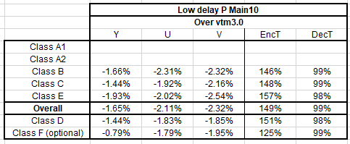

Test B, C
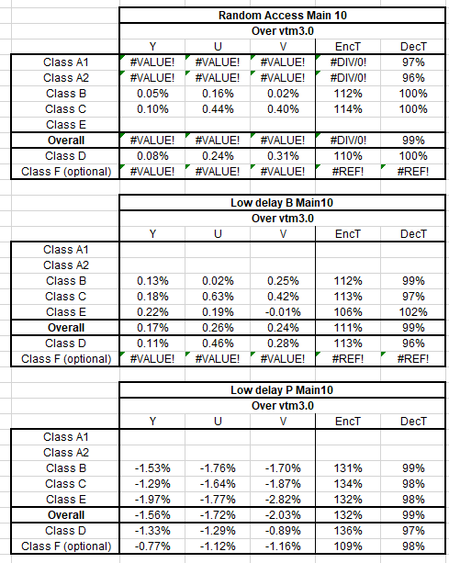

Test D
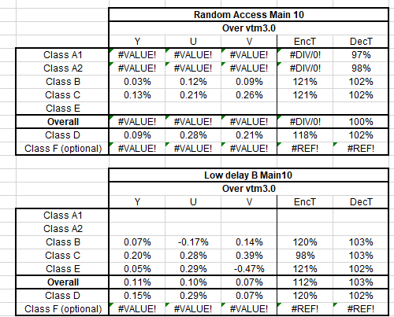

Reference
[1] F. Chen, L. Wang (Hikvision), JVET-M0329, “CE10-related: Modified enabling condition for triangle prediction unit mode”, 13th Meeting: Marrakech, MA, 9–18 Jan. 2019

