    Joint Video Experts Team (JVET)  of ITU-T SG 16 WP 3 and ISO/IEC JTC 1/SC 29/WG 11  13th Meeting: Marrakech, MA, 9–18 Jan. 2019 | Document: JVET-M0539-v2

Title: | CE6-related: Efficient computation of MTS transform combinations
Status: | Input document to JVET
Purpose: | Proposal
Author(s) or  Contact(s): | Amir Said, Hilmi E. Egilmez, Yung-Hsuan Chao, Vadim Seregin, Marta Karczewicz  5775 Morehouse Drive  San Diego, CA, U.S.A. 92121 | Email: | asaid@qti.qualcomm.com
Source: | Qualcomm Incorporated
_____________________________

Abstract
This contribution describes a encoder-only and lossless modification to the computation of MTS transforms using the adjustment method of JVET-M0538, to enable reducing its computational complexity. Instead of computing separately all possible combinations of the DST-7 and DCT-8 along horizontal and vertical directions, it computes the DCT-2 coefficients, and exploits the properties of the DCT-2 and the adjustment matrices to compute all transform combinations simultaneously, and with significant reduction in complexity. Experimental transform throughput measurements show how the proposed methods reduces complexity.

Introduction
In the Multi-Transform Selection (MTS) method of VTM-3, all possible combinations of the DST-7 and DCT-8 transforms, along the horizontal and vertical directions, as shown in Table I, are allowed. It is up to the encoder to decide if MTS is to be used (encoded by the binary MTS flag), and if used, which is the combination used, i.e., the corresponding MTS index is encoded.
The decision of how many of those transform combinations are actually computed and tested is part of an encoder-only design. Nevertheless, it should be clear that having all the transform combination values computed and available for R-D tests should improve the decision on the best combination.

Table I – Selection of horizontal and vertical transforms according to the MTS index.

MTS index | 0 | 1 | 2 | 3
Horizontal transform | DST-7 | DCT-8 | DST-7 | DCT-8
Vertical transform | DST-7 | DST-7 | DCT-8 | DCT-8

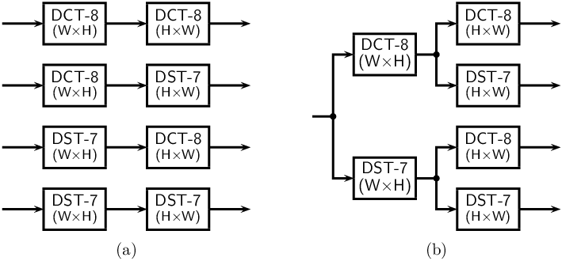
Figure 1 – Schemes for computing all combinations of the MTS transforms.

The current VTM implementation computes all transform combinations independently, as shown in Fig. 1(a). An obvious optimization, at the cost of using more memory, is to save results after the horizontal transformation, and eliminate redundant computations. Unfortunately, the complexity reduction provided by this straightforward approach is not substantial.

Proposed modification
As described in document JVET-M0538, the transform adjustment approach simplifies the computation of the MTS transforms by using only the DCT-2 as main “transform engine,” and only modifies the 8 DCT-2 transforms coefficients corresponding to lowest frequencies.
The simulation results in JVET-M0538 demonstrate that this can result in very small changes in coding gain, while significantly reducing computation complexity.
The fact that the transform adjustment method only changes the first transform coefficients means that, when all transform combinations are computed, some coefficient values are repeated in the four combinations.
Figure 2 shows a diagram indicating which transform coefficients are repeated when the computation of Figure 1(b) is done using transform adjustments, including the case when high-frequency coefficients are “zeroed-out.” We can observe that only a set of 8×8 coefficients corresponding to the lowest frequencies of the horizontal and vertical transforms are unique, and the others are repeated twice or four times.
Thus, the complexity of computing all four two-dimensional transforms can be significantly reduced by avoiding the redundant computation of repeated elements.
Thanks to some unique properties of the DCT-2 and its combination with transform adjustments, the process of eliminating those redundant computations can be greatly simplified, both in terns of implementations, and computations.

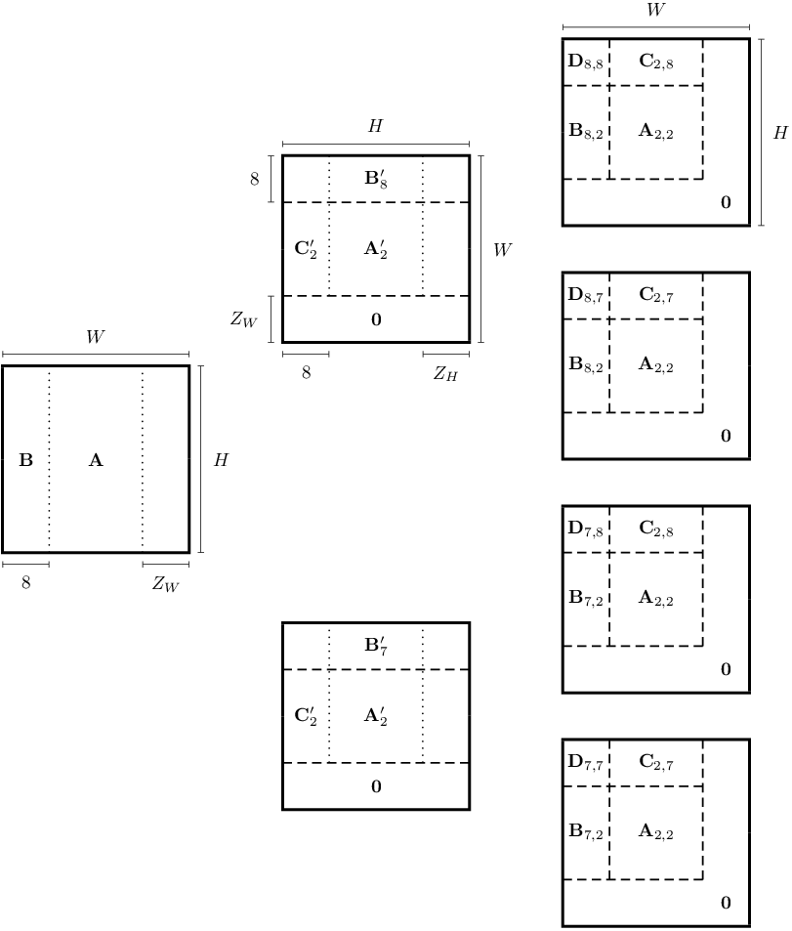
Figure 2 – Diagram of repeated computed transform coefficients (not in scale), when the method of Figure 1(b) is used with the transform adjustment method. Subscripts 2, 7, and 8 identify components obtained after the DCT-2 transform, and after adjustments defined for DST-7 and DCT-8, respectively. Bold zero indicates the optional “zero-out” of high-frequency components.

As presented in JVET-M0538, the 8×8 matrices used for MTS transform adjustments are

const TMatrixCoeff g_TAF_DST7[8][8] =
{
{ 118,-48,-12, -2, -2, -1, -1, 0 },
{ 38,108,-54,-15, -8, -6, -3, -2 },
{ 24, 36,107,-51,-16, -9, -4, -4 },
{ 14, 23, 34,111,-44,-13, -8, -5 },
{ 10, 16, 19, 29,114,-38,-14, -8 },
{ 8, 13, 13, 14, 26,118,-33,-12 },
{ 6, 9, 9, 11, 15, 24,120,-28 },
{ 5, 8, 8, 8, 11, 14, 23,124 }
};

and

const TMatrixCoeff g_TAF_DCT8[8][8] =
{
{ 118, 48,-12, 2, -2, 1, -1, 0 },
{ -38,108, 54,-15, 8, -6, 3, -2 },
{ 24,-36,107, 51,-16, 9, -4, 4 },
{ -14, 23,-34,111, 44,-13, 8, -5 },
{ 10,-16, 19,-29,114, 38,-14, 8 },
{ -8, 13,-13, 14,-26,118, 33,-12 },
{ 6, -9, 9,-11, 15,-24,120, 28 },
{ -5, 8, -8, 8,-11, 14,-23,124 }
};

Representing these matrices as A^{(DST-7)} and A^{(DCT-8)}, we can define the matrices
B = ½ [ A^{(DST-7)} + A^{(DCT-8)} ],
C = ½ [ A^{(DST-7)} – A^{(DCT-8)} ],
and note that due to the unique property of the adjustment matrices (which are defined by symmetries in the DCT-2), half of the elements of matrices B and C are zero, following a fixed chessboard pattern. Thus, the matrix-vector products B x and C x require only 32 multiplications each, and the two matrix-vector products
A^{(DST-7)} x = B x + C x,
A^{(DCT-8)} x = B x – C x,
can be computed using 64 multiplications.
The conclusion is that with practically the same complexity of computing one set of adjusted coefficients for the DST-7 or DCT-8, it is possible to compute the sets of coefficients for both cases.
Figure 3 shows a diagram of the proposed system that exploits those properties to compute the coefficients of all transform combinations without redundancy, and thus greatly reduced computational complexity. In that figure the blocks representing the DCT-2 have two outputs, corresponding to the first 8 coefficients, and the remaining coefficients, and the blocks representing the adjustments output values for both DST-7 and DCT-8 (computing according to the method described above).

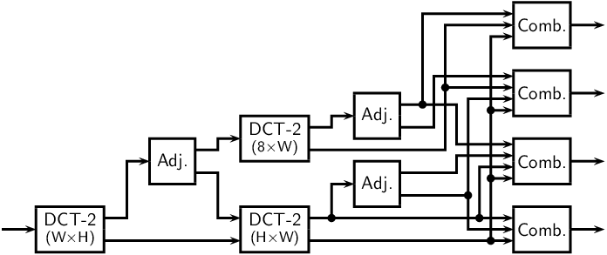

Figure 3 – Diagram representing the efficient computation of all MTS transform combinations by exploiting the properties of the DCT-2 and the transform adjustment matrices.

The final stages correspond to combining the coefficients that have been computed without redundancy. While the diagram looks complicated, it simply means copying the repeated coefficients to their final memory destination, according to the pattern that can be seen in Figure 2.
One important detail is that an additional DCT-2 transformation of 8 lines is computed to replicate the scaling done at the end of the horizontal and vertical transformations at the decoder. This way the change in computation is a completely lossless change, i.e., there is no change in (integer) transform coefficient values if they are computed with the schemes of Figure 1 or Figure 3.

Transform throughput measurements
Using the method of JVET-M0540 to compute and store all MTS transform combinations simultaneously, the throughput of the MTS transforms was measured, using 32 frames of the sequence “Tango2,” AI configuration, and QP = 32. Absolute throughput values are listed in Table II, and relative values in Table III.

Table II – Forward transform computation throughput (10⁶ coefficients per second).

Transform method | Transform dimension
Transform method | 16 | 32 | 64
VTM (matrix) | 169 | 125 | 209
JVET-M0538 | 208 | 172 | 334
JVET-M0538 SIMD | 224 | 197 | 373
JVET-M0539 | 414 | 333 | 1162
JVET-M0539 SIMD | 438 | 380 | 1208

Table III – Throughput ratios, using matrix-based VTM transforms as reference.

Transform method | Transform dimension
Transform method | 16 | 32 | 64
JVET-M0538 | 1.23 | 1.38 | 1.60
JVET-M0538 SIMD | 1.32 | 1.57 | 1.78
JVET-M0539 | 2.44 | 2.67 | 5.56
JVET-M0539 SIMD | 2.59 | 3.04 | 5.78

Simulation results
As explained above, this is an encoder-only and lossless modification, and thus the results are the same as those reported in JVET-M0538, where the MTS transforms are computed independently. Due to the large number of results, they are not repeated here.

Patent rights declaration
Qualcomm Incorporated may have current or pending patent rights relating to the technology described in this contribution and, conditioned on reciprocity, is prepared to grant licenses under reasonable and non-discriminatory terms as necessary for implementation of the resulting ITU-T Recommendation | ISO/IEC International Standard (per box 2 of the ITU-T/ITU-R/ISO/IEC patent statement and licensing declaration form).

