    Joint Video Experts Team (JVET)  of ITU-T SG 16 WP 3 and ISO/IEC JTC 1/SC 29/WG 11  13th Meeting: Marrakech, MA, 9–18 Jan. 2019 | Document: JVET-M0526_v2

Title: | CE2-related: Further simplification of ATMVP collocated block derivation
Status: | Input document to JVET
Purpose: | Proposal
Author(s) or  Contact(s): | Suhong Wang¹, Xiaozhen Zheng² , Shanshe Wang¹, Siwei Ma¹  Peking University¹, DJI² | Email: | suhong.wang@pku.edu.cn  xiaozhen.zheng@dji.com
Source: | SZ DJI Technology Co., Ltd., Peking University
_____________________________

Abstract
At the 11th JVET meeting, alternative temporal motion vector prediction (ATMVP) was adopted to VTM reference software. Aiming at reducing both the average and worst-case complexity, this contribution proposes a simplification of ATMVP co-located block derivation process in the case of bidirectional prediction. Simulation results for the simplification show no performance change compared to VTM-3.0 and observe minor encoding and decoding time decrease.

Introduction
ATMVP derives multiple motion for sub-blocks of one coding unit (CU) based on the motion information of the collocated blocks from temporal reference picture. The main process of ATMVP tool can be described as two parts:
1. Derive the co-located block of current CU in the co-located picture with a temporal motion vector;
2. Derive motion information for each sub-block in the current CU.
In the current design, the first process is complicated in the case of bidirectional prediction which has two reference lists. In the worst case, no valid temporal motion vector is derived even after full looping of the two reference lists.

Proposed Method
In current design, ATMVP predicts the motion vectors of the sub-CUs within a CU in two steps. The first step is to identify the co-located block in the co-located picture. The derivation process of the temporal motion vector to get the co-located block is described as Fig. 1(a). It is obvious that in the case of B slice (bidirectional prediction), a loop for reference lists is needed when the first candidate in the first list is not valid. The worst case is that after a full looping for the two reference lists, no valid temporal motion vector is derived, which is not efficient.
To simplify ATMVP co-located block derivation process, this contribution suggests disable the reference lists loop during the derivation of the co-located block in the case of bidirectional prediction, which is shown in Fig. 1(b).

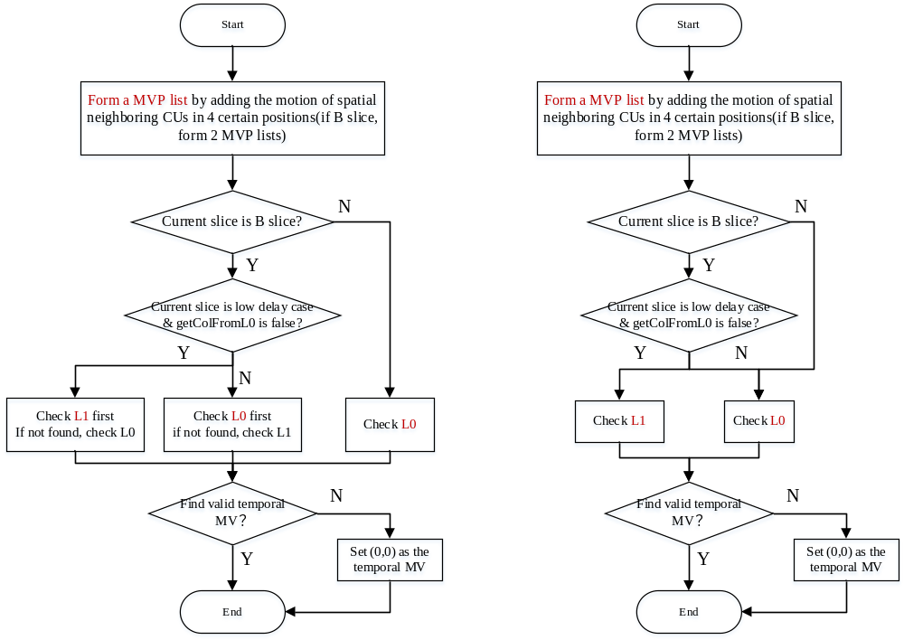Figure. 1 Flowchart of derivation process of temporal MV (a) current design (b) proposed method

Experimental Results
The experiments were performed under JVET common test conditions.
BD-Rate results of the test results on top of the VTM-3.0 compared to the anchor with RA and LDB configurations are shown in following tables. The full results are provided in the attached excel sheets.
Table 1: Test results for ATMVP collocated block derivation simplification
 | Random Access Main 10
Test 1 | Over vtm3.0
 | Y | U | V | EncT | DecT
Class A1 | 0.04% | -0.06% | -0.06% | 100% | 100%
Class A2 | 0.01% | 0.01% | 0.09% | 100% | 99%
Class B | 0.01% | 0.06% | -0.02% | 100% | 100%
Class C | 0.04% | 0.07% | 0.04% | 100% | 100%
Class E
Overall | 0.02% | 0.03% | 0.01% | 100% | 100%
Class D | 0.04% | 0.03% | 0.10% | 100% | 101%
Class F | 0.01% | 0.01% | 0.02% | 100% | 100%
 | Low delay B Main10
 | Over vtm3.0
 | Y | U | V | EncT | DecT
Class A1
Class A2
Class B | #VALUE! | #VALUE! | #VALUE! | #NUM! | #NUM!
Class C | 0.03% | 0.24% | 0.23% | 100% | 99%
Class E | 0.03% | 0.09% | -0.35% | 100% | 102%
Overall | #VALUE! | #VALUE! | #VALUE! | #NUM! | #NUM!
Class D | 0.04% | -0.18% | 0.59% | 100% | 101%
Class F | #VALUE! | #VALUE! | #VALUE! | #NUM! | #NUM!

Conclusion
This contribution proposes a simplification of ATMVP co-located block derivation process in the case of bidirectional prediction, which suggests disable the reference lists loop during the derivation process of the co-located block.
Simulation results for all tests shows no performance change on average compared to VTM 3.0 anchor, while minor encoding and decoding time decrease are observed. Therefore, it is recommended to adopt the proposed simplification method for ATMVP to the next version of VVC working draft.

Patent rights declaration(s)
Peking University may have current or pending patent rights relating to the technology described in this contribution and, conditioned on reciprocity, is prepared to grant licenses under reasonable and non-discriminatory terms as necessary for implementation of the resulting ITU-T Recommendation | ISO/IEC International Standard (per box 2 of the ITU-T/ITU-R/ISO/IEC patent statement and licensing declaration form).

SZ DJI Technology Co., Ltd., may have current or pending patent rights relating to the technology described in this contribution and, conditioned on reciprocity, is prepared to grant licenses under reasonable and non-discriminatory terms as necessary for implementation of the resulting ITU-T Recommendation | ISO/IEC International Standard (per box 2 of the ITU-T/ITU-R/ISO/IEC patent statement and licensing declaration form).

