    Joint Video Experts Team (JVET)  of ITU-T SG 16 WP 3 and ISO/IEC JTC 1/SC 29/WG 11  13th Meeting: Marrakech, MA, 9–18 Jan. 2019 | Document: JVET-M0512_r2

Title: | Non-CE4: On Temporal Motion Buffer Compression
Status: | Input document to JVET
Purpose: | Proposal
Author(s) or  Contact(s): | F. Bossen¹  K. Misra²  A. Segall² | Tel:  Email: | +1-360-817 8451  misrak@sharplabs.com  frank@bossentech.com  asegall@sharplabs.com
Source: | ¹Sharp Electronics of Canada, ²Sharp Laboratories of America
_____________________________

Abstract
This contribution proposes a method to reduce the number of bits stored in the temporal motion buffer. It is reported that the current VVC WD requires 22.5 bits of storage per 4x4 luma sample block, and it is further asserted that the proposed approach reduces the amount requirement to 10.5 bits per 4x4 luma sample block with negligible impact on coding efficiency. The storage reduction is achieved by first scaling the original temporal motion vector to a fixed POC distance, eliminating the need to store delta POC information. The approach then converts the scaled motion vector value to a 6-bit mantissa and 4-exponent representation prior to storage. The selected representation effectively quantizes larger motion vector values more coarsely while retaining higher precision for smaller motion vectors. The proposed method was implemented in VTM-3.0 and its performance evaluated using Random Access (RA) and Low Delay B (LDB) configurations from the Common Test Conditions. It is reported that the proposed method results in an average luma BD Rate of 0.00% (RA), 0.02% (LDB).
Revision 1 of the contribution contains results for disabling the scaling of the original temporal motion vector to a fixed POC distance. It is reported that the proposed method results in an average luma BD Rate of 0.00% (RA), 0.01% (LDB). Also attached is the relevant VVC WD changes.

Introduction
In HEVC, the temporal motion buffer was compressed using a luma subsampling grid of 16x16. This had the benefit of reducing the memory storage requirement to 5.125 bits per 4x4 luma sample block. In VVC WD [1], a luma subsampling approach is still used – and the grid size is set to an 8x8 grid. Moreover, the motion vector range is increased to 18-bits. As a result, the storage requirement for temporal motion buffer in the VVC WD has increased by over 4x to 22.5 bits per 4x4 luma sample block.
To reduce the storage requirement in VVC, this contribution proposes an alternative method for storing the motion vectors. Here, the motion vectors are first scaled to a fixed delta POC distance prior to storage. This eliminates the need to store POC distances associated with temporal motion vectors. Then, the motion vectors are stored using a 6-bit mantissa and a 4-bit exponent to further reduce the storage requirement. The mantissa plus exponent representation effectively quantizes larger motion vector values more coarsely while retaining higher precision for smaller motion vectors, and here the mantissa and exponent are set to -32 and 15 respectively when a temporal motion vector displacement is not available for motion prediction. For example, when intra mode is used, all four motion vector displacement direction values are assigned a mantissa of -32 and exponent of 15. Similarly, when only one of the two motion vectors are valid (e.g. inter_pred_idc[][] is PRED_L0 or PRED_L1), then the motion vector with no valid motion information is assigned a mantissa and exponent of -32 and 15 for both the displacement directions. This approach to indicate availability is applied for temporal motion information that corresponds to current picture referencing as well. Note, this aspect may be achieved non-normatively as well. As a result of these modifications the temporal motion information storage requirement for the proposed approach is 10.5 bits per 4x4 luma sample block.
The stated storage values per 4x4 luma sample blocks are summarized as follows:
 | Bits needed for motion vector storage | Bits needed for delta POC storage | Bits needed for long term flag storage | Motion information cell size (in luma samples) | Number of bits per 4x4 luma block
HEVC | 2 * 2 * 16 = 64 | 2 * 8 = 16 | 2 * 1 = 2 | 16 x 16 | (64+16+2)/16  = 5.125
VVC WD | 2 * 2 * 18 = 72 | 2 * 8 = 16 | 2 * 1 = 2 | 8 x 8 | (72+16+2)/4  = 22.5
Proposed | 2 * 2 * 10 = 40 | 0 | 2 * 1 = 2 | 8 x 8 | (40+2)/4  =10.5
The flowchart below illustrates the steps involved in the storage and retrieval process.
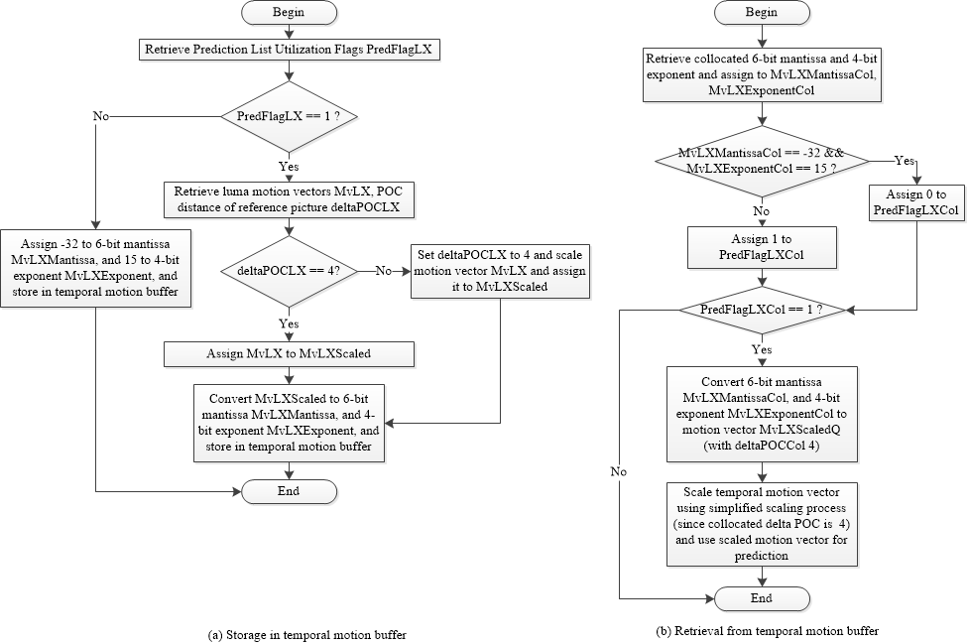
Details of the change to VVC WD for the proposed approach can be found in attached document.

Experimental Results
To determine the efficacy of the approach, the proposed change is implemented in VTM-3.0 [3] and evaluated using Random Access (RA) and Low Delay B (LDB) configurations from the Common Test Conditions [2]. The summary results are listed below, and the detailed results can be found in excel file attached to this contribution. As can be seen from the simulations, the reduction of the memory required to store the temporal motion vectors comes without a significant penalty in coding. Specifically, the overall loss is 0.00% and 0.02%, respectively, in the RA and LDB configurations.

 | Random Access Main 10
 | Over VTM-3
 | Y | U | V | EncT | DecT
Class A1 | 0.03% | 0.04% | 0.02% | 100% | 98%
Class A2 | 0.00% | -0.02% | 0.06% | 97% | 98%
Class B | -0.02% | 0.09% | -0.03% | 100% | 101%
Class C | 0.01% | -0.02% | 0.05% | 100% | 102%
Class E
Overall | 0.00% | 0.03% | 0.02% | 99% | 100%
Class D | 0.00% | -0.09% | -0.06% | 99% | 101%
Class F | -0.02% | -0.01% | -0.01% | 99% | 102%
 | Low delay B Main10
 | Over VTM-3
 | Y | U | V | EncT | DecT
Class A1
Class A2
Class B | 0.01% | -0.30% | -0.11% | 99% | 101%
Class C | -0.03% | 0.18% | 0.13% | 102% | 102%
Class E | 0.09% | 0.15% | -0.26% | 99% | 104%
Overall | 0.02% | -0.02% | -0.07% | 100% | 102%
Class D | 0.03% | 0.00% | 0.17% | 98% | 100%
Class F | 0.07% | 0.02% | -0.25% | 101% | 104%
Results are also presented for disabling the scaling of the original temporal motion vector to a fixed POC distance.
 | Random Access Main 10
 | Over VTM-3
 | Y | U | V | EncT | DecT
Class A1 | 0.01% | -0.12% | -0.01% | 101% | 101%
Class A2 | -0.03% | 0.00% | 0.01% | 97% | 99%
Class B | 0.00% | -0.04% | -0.03% | 98% | 99%
Class C | 0.01% | -0.03% | 0.01% | 99% | 101%
Class E
Overall | 0.00% | -0.04% | -0.01% | 99% | 100%
Class D | 0.00% | -0.06% | -0.02% | 100% | 100%
Class F | -0.02% | 0.03% | 0.04% | 99% | 100%
 | Low delay B Main10
 | Over VTM-3
 | Y | U | V | EncT | DecT
Class A1
Class A2
Class B | 0.02% | -0.18% | -0.16% | 96% | 97%
Class C | 0.01% | 0.16% | 0.25% | 98% | 95%
Class E | -0.01% | 0.02% | -0.18% | 97% | 96%
Overall | 0.01% | -0.02% | -0.03% | 97% | 96%
Class D | 0.01% | -0.14% | 0.22% | 99% | 99%
Class F | 0.06% | 0.32% | 0.43% | 98% | 98%

Recommendation
The current VVC WD has a temporal motion buffer storage requirement of 22.5 bits per 4x4 luma sample block. Here, we propose an approach to reduce this buffer storage requirement to 10.5 bits per 4x4 luma sample block with negligible impact on coding efficiency. We also report results when the POC scaling aspect is disabled. It is recommended that one of these approaches be adopted in the next version of the VVC WD and VTM.

Patent rights declaration(s)
Sharp Laboratories of America may have current or pending patent rights relating to the technology described in this contribution and, conditioned on reciprocity, is prepared to grant licenses under reasonable and non-discriminatory terms as necessary for implementation of the resulting ITU-T Recommendation | ISO/IEC International Standard (per box 2 of the ITU-T/ITU-R/ISO/IEC patent statement and licensing declaration form).

References
[1] B. Bross, J. Chen, S. Liu, “Versatile Video Coding (Draft 3),” JVET-L1001 12th Joint Video Experts Team (JVET) of ITU-T SG 16 WP 3 and ISO/IEC JTC 1/SC 29/WG 11, Macao, CN, 3–12 Oct. 2018
[2] F. Bossen, J. Boyce, X. Li, V. Seregin, K. Sühring, “JVET common test conditions and software reference configurations for SDR video,” JVET-L1010 12th Joint Video Experts Team (JVET) of ITU-T SG 16 WP 3 and ISO/IEC JTC 1/SC 29/WG 11, Macao, CN, 3–12 Oct. 2018
[3] https://vcgit.hhi.fraunhofer.de/jvet/VVCSoftware_VTM/tree/VTM-3.0, VTM-3.0
[4] K. Misra, F. Bossen, “Non-CE4: On clipping of scaled motion vectors,” JVET-M0479,13th Joint Video Experts Team (JVET) of ITU-T SG 16 WP 3 and ISO/IEC JTC 1/SC 29/WG 11, Marrakech, MA, 9–18 Jan. 2019

