    Joint Video Experts Team (JVET)  of ITU-T SG 16 WP 3 and ISO/IEC JTC 1/SC 29/WG 11  13th Meeting: Marrakech, MA, 9–18 Jan. 2019 | Document: JVET-M0507

Title: | CE4-related: Hybrid Merge Estimation Region
Status: | Input document to JVET
Purpose: | Proposal
Author(s) or  Contact(s): | Hongtao Wang,  Vadim Seregin,  Wei-Jung Chien,  Ted Hsieh,  Yu Han,  Marta Karczewicz  5775 Morehouse Dr  San Diego, CA 92121 USA | Tel:  Email: | 1-858-658-4535  hongtaow@qti.qualcomm.com
Source: | Qualcomm Inc.
_____________________________

Abstract
In this contribution, a method of reducing the local inter-dependency as well as the number of merge candidate list generation operations is proposed. The method uses 2 parameters ($N_{1}$ and $N_{2}$) as 2 thresholds of coding splitting node area. ($N_{1}≤N_{2}$). For splitting nodes with the size of $N_{2}$, all merge candidate list generation operations within the area can be performed in parallel. And for all blocks within a splitting area with the size of $N_{1}$, a shared merge candidate list is used. Simulation results for multiple sets of $N_{1}$ and $N_{2}$ are presented.

Introduction
In HEVC, Merge Estimation Region (MER) is defined as a region that no motion information from blocks locates in the same MER as the current block can be used as merge candidate so that all merge candidate list generations within an MER can be performed in parallel. Merge share list is another technique for parallel processing of merge candidate list. Within a share list area, all blocks share one merge candidate list which is generated by assuming the whole area is a CU. These techniques for improving the parallel capability of merge mode have been proposed to VVC and is being studied in CE4.3 [1]. This contribution proposes a method for VVC to have the capability of specifying the region of parallel merge candidate generation (MER) and the allowed number of merge candidate generation operations within an MER.

Proposed techniques

Determination of processing area
In this contribution, 2 types of areas are introduced. MER area is the area in which all merge candidate lists can be generated in parallel and share list area is the area in which all CUs share a same merge candidate list. “Processing area” is used in this contribution as a generic term for these 2 types of area.
The processing area in this contribution is decided by the size of a splitting node. A threshold N is specified as the threshold of area size. If a splitting node larger than N can be split into processing areas of size N naturally (each processing area of size N corresponds to a splitting node), e.g. as shown in Figure 2, N is specified as 4096, the node size of 1 level quad-tree splitting node of a CTU of 128x128 has the size of N ($64×64$). Then such splitting nodes are considered as processing areas.
On the other hand, if no such natural splitting is available ( e.g. at one level the node size is $2N$, but the node is split by QT (at the next level there are 4 child nodes of size $N/2$) or TT ( 2 of the child nodes are of size $N/2$). Multiple splitting nodes may be merged into a processing area. In case of QT, child 0 and child 1 are merged into a processing area and child 2 and 3 are merged into another. Both processing area have the same size N (Figure 1). In case of TT, child 0 and 1 are merged as one processing area and child 2 is treated as another processing area. It is noted that in this case, the TT parent node (Size=$2N$) has 2 processing areas, the first one has the size of $3N/2$ and the second one has the size of $N/2$, the average size of processing areas within the TT parent node is N and no degradation of parallel capability is introduced.

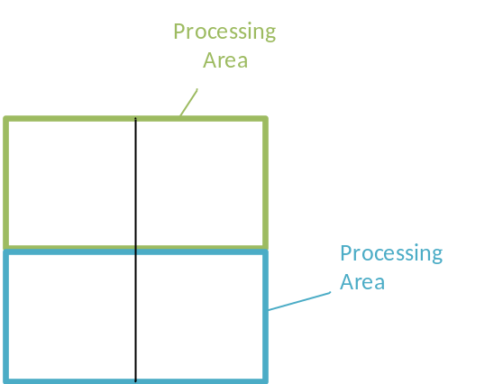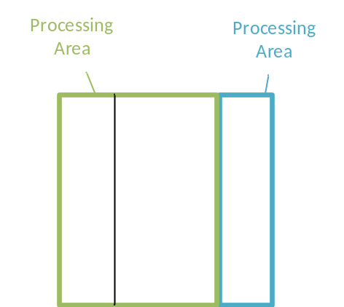
Figure 1.

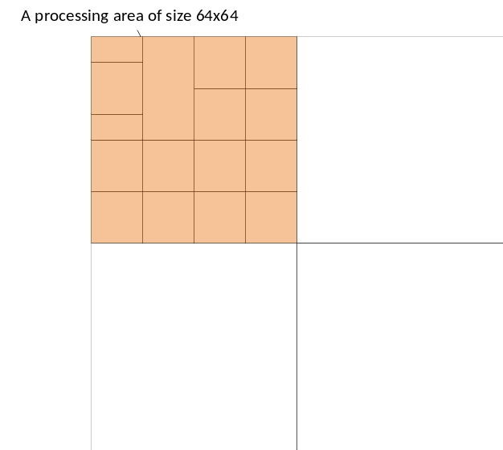
Figure 2.

Hybrid Merge Estimation Region
In this contribution, the threshold for share list area ($N_{1}$) and MER area ($N_{2}$) are supported, an encoder can choose to specify $N_{1}$ or $N_{2}$ only or both $N_{1}$ and $N_{2}$. It is guaranteed that within any MER area, all merge candidate list generation operations can be performed in parallel and within any share list area, all merge candidate lists are exactly same. When $N_{1}$ and $N_{2}$ are both specified, the rules of MER area and share list area are both met. For example, as shown in Figure 3, there’re 4 share list areas within an MER area. For the current CU (represented as an orange square), a shared list generated for the share list area is applied (MV1 – MV7 are considered). At the same time, the spatial MVs 1, 2 and 5 are in same MER area with the current CU, so they are considered unavailable when generating the shared list.
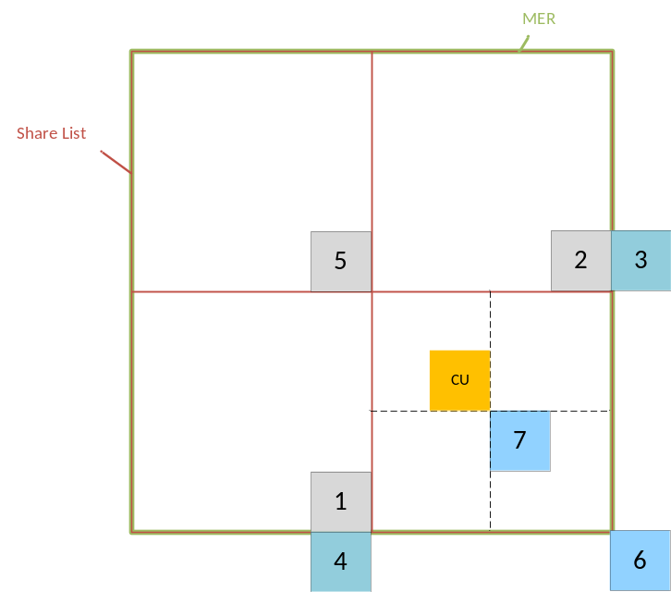
Figure 3

Handling of partial CTUs on picture boundaries
In this contribution, the rule of share list is applied for all CTUs within a picture including the partial ones on picture boundaries. As shown in figure 4, if part of a share list area locates outside the picture, the availability of position 7 for TMVP cannot be guaranteed to be inside the picture, so a check for center location 7 is performed.
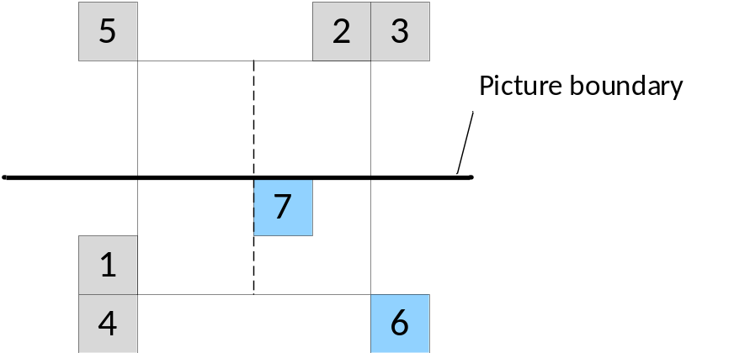
Figure 4.

Simulation results

Performance of the proposed share list
Simulation results as below, the anchor is VTM3.0 with default setting, the proposed share list with size of 32, 64, 128, 256 are tested.
 | Random Access Main 10
 | Over VTM-3.0
 | Y | U | V | EncT | DecT
Class A1 | #VALUE! | #VALUE! | #VALUE! | #NUM! | #NUM!
Class A2 | -0.01% | 0.08% | 0.09% | 93% | 92%
Class B | 0.00% | -0.01% | -0.05% | 97% | 97%
Class C | 0.02% | 0.07% | 0.08% | 100% | 104%
Class E
Overall | #VALUE! | #VALUE! | #VALUE! | #NUM! | #NUM!
Class D | 0.01% | 0.05% | -0.03% | 100% | 101%
Class F (optional) | 0.01% | 0.02% | 0.04% | 99% | 100%
 | Low delay B Main10
 | Over VTM-3.0
 | Y | U | V | EncT | DecT
Class A1
Class A2
Class B | #VALUE! | #VALUE! | #VALUE! | #NUM! | #NUM!
Class C | 0.03% | 0.29% | -0.08% | 97% | 90%
Class E | -0.04% | 0.58% | 0.37% | 96% | 95%
Overall | #VALUE! | #VALUE! | #VALUE! | #NUM! | #NUM!
Class D | 0.04% | 0.34% | -0.02% | 102% | 107%
Class F (optional) | #VALUE! | #VALUE! | #VALUE! | #NUM! | #NUM!

Share list size = 32
 | Random Access Main 10
 | Over VTM-3.0
 | Y | U | V | EncT | DecT
Class A1 | #VALUE! | #VALUE! | #VALUE! | #NUM! | #NUM!
Class A2 | 0.01% | 0.06% | 0.14% | 93% | 93%
Class B | 0.01% | 0.07% | -0.03% | 97% | 97%
Class C | 0.15% | 0.11% | 0.06% | 101% | 104%
Class E
Overall | #VALUE! | #VALUE! | #VALUE! | #NUM! | #NUM!
Class D | 0.22% | 0.05% | 0.17% | 101% | 102%
Class F (optional) | 0.11% | 0.08% | 0.12% | 99% | 100%
 | Low delay B Main10
 | Over VTM-3.0
 | Y | U | V | EncT | DecT
Class A1
Class A2
Class B | #VALUE! | #VALUE! | #VALUE! | #NUM! | #NUM!
Class C | 0.13% | 0.16% | 0.21% | 97% | 91%
Class E | 0.07% | -0.05% | -0.34% | 96% | 95%
Overall | #VALUE! | #VALUE! | #VALUE! | #NUM! | #NUM!
Class D | 0.19% | 0.12% | 0.11% | 103% | 108%
Class F (optional) | #VALUE! | #VALUE! | #VALUE! | #NUM! | #NUM!

Share list size = 64
 | Random Access Main 10
 | Over VTM-3.0
 | Y | U | V | EncT | DecT
Class A1 | #VALUE! | #VALUE! | #VALUE! | #NUM! | #NUM!
Class A2 | 0.07% | 0.20% | 0.26% | 94% | 92%
Class B | 0.10% | 0.23% | 0.16% | 98% | 97%
Class C | 0.44% | 0.52% | 0.56% | 102% | 104%
Class E
Overall | #VALUE! | #VALUE! | #VALUE! | #NUM! | #NUM!
Class D | 0.64% | 0.51% | 0.74% | 102% | 101%
Class F (optional) | 0.23% | 0.29% | 0.31% | 100% | 100%
 | Low delay B Main10
 | Over VTM-3.0
 | Y | U | V | EncT | DecT
Class A1
Class A2
Class B | #VALUE! | #VALUE! | #VALUE! | #NUM! | #NUM!
Class C | 0.51% | 0.57% | 0.69% | 100% | 89%
Class E | 0.08% | 0.10% | 0.31% | 96% | 96%
Overall | #VALUE! | #VALUE! | #VALUE! | #NUM! | #NUM!
Class D | 0.70% | 1.08% | 0.59% | 105% | 109%
Class F (optional) | #VALUE! | #VALUE! | #VALUE! | #NUM! | #NUM!

Share list size = 128
 | Random Access Main 10
 | Over VTM-3.0
 | Y | U | V | EncT | DecT
Class A1 | #VALUE! | #VALUE! | #VALUE! | #NUM! | #NUM!
Class A2 | 0.30% | 0.50% | 0.60% | 95% | 92%
Class B | 0.34% | 0.48% | 0.44% | 98% | 97%
Class C | 1.02% | 1.14% | 1.34% | 103% | 103%
Class E
Overall | #VALUE! | #VALUE! | #VALUE! | #NUM! | #NUM!
Class D | 1.34% | 1.27% | 1.54% | 103% | 100%
Class F (optional) | 0.57% | 0.69% | 0.73% | 100% | 100%
 | Low delay B Main10
 | Over VTM-3.0
 | Y | U | V | EncT | DecT
Class A1
Class A2
Class B | #VALUE! | #VALUE! | #VALUE! | #NUM! | #NUM!
Class C | 1.24% | 1.52% | 1.56% | 100% | 90%
Class E | 0.31% | 0.40% | 0.25% | 97% | 96%
Overall | #VALUE! | #VALUE! | #VALUE! | #NUM! | #NUM!
Class D | 1.65% | 1.64% | 1.54% | 105% | 108%
Class F (optional) | #VALUE! | #VALUE! | #VALUE! | #NUM! | #NUM!

Share list size = 256

Performance of proposed MER
Simulation results as below, the anchor is VTM3.0 with default setting, the proposed MER with size of 32, 64, 128, 256 are tested.
 | Random Access Main 10
 | Over VTM-3.0
 | Y | U | V | EncT | DecT
Class A1 | #VALUE! | #VALUE! | #VALUE! | #NUM! | #NUM!
Class A2 | -0.02% | 0.00% | 0.09% | 94% | 94%
Class B | -0.01% | 0.03% | -0.08% | 97% | 98%
Class C | 0.01% | -0.05% | 0.01% | 100% | 104%
Class E
Overall | #VALUE! | #VALUE! | #VALUE! | #NUM! | #NUM!
Class D | -0.03% | -0.03% | 0.13% | 100% | 103%
Class F (optional) | -0.01% | 0.02% | 0.11% | 99% | 101%
 | Low delay B Main10
 | Over VTM-3.0
 | Y | U | V | EncT | DecT
Class A1
Class A2
Class B | #VALUE! | #VALUE! | #VALUE! | #NUM! | #NUM!
Class C | 0.00% | 0.11% | 0.08% | 97% | 90%
Class E | -0.02% | 0.20% | -0.22% | 95% | 96%
Overall | #VALUE! | #VALUE! | #VALUE! | #NUM! | #NUM!
Class D | 0.01% | 0.10% | 0.05% | 101% | 109%
Class F (optional) | #VALUE! | #VALUE! | #VALUE! | #NUM! | #NUM!

MER size = 32
 | Random Access Main 10
 | Over VTM-3.0
 | Y | U | V | EncT | DecT
Class A1 | #VALUE! | #VALUE! | #VALUE! | #NUM! | #NUM!
Class A2 | 0.01% | 0.02% | 0.09% | 93% | 93%
Class B | 0.00% | 0.10% | -0.01% | 97% | 98%
Class C | 0.07% | 0.06% | 0.15% | 100% | 104%
Class E
Overall | #VALUE! | #VALUE! | #VALUE! | #NUM! | #NUM!
Class D | 0.08% | 0.06% | 0.09% | 100% | 103%
Class F (optional) | 0.02% | 0.03% | 0.04% | 99% | 101%
 | Low delay B Main10
 | Over VTM-3.0
 | Y | U | V | EncT | DecT
Class A1
Class A2
Class B | #VALUE! | #VALUE! | #VALUE! | #NUM! | #NUM!
Class C | 0.04% | 0.22% | 0.36% | 97% | 91%
Class E | -0.04% | 0.42% | -0.16% | 96% | 96%
Overall | #VALUE! | #VALUE! | #VALUE! | #NUM! | #NUM!
Class D | 0.06% | -0.17% | 0.37% | 101% | 109%
Class F (optional) | #VALUE! | #VALUE! | #VALUE! | #NUM! | #NUM!

MER size = 64
 | Random Access Main 10
 | Over VTM-3.0
 | Y | U | V | EncT | DecT
Class A1 | #VALUE! | #VALUE! | #VALUE! | #NUM! | #NUM!
Class A2 | 0.04% | 0.21% | 0.24% | 93% | 93%
Class B | 0.05% | 0.13% | 0.06% | 97% | 98%
Class C | 0.27% | 0.38% | 0.42% | 100% | 104%
Class E
Overall | #VALUE! | #VALUE! | #VALUE! | #NUM! | #NUM!
Class D | 0.27% | 0.25% | 0.26% | 100% | 103%
Class F (optional) | 0.18% | 0.14% | 0.17% | 99% | 101%
 | Low delay B Main10
 | Over VTM-3.0
 | Y | U | V | EncT | DecT
Class A1
Class A2
Class B | #VALUE! | #VALUE! | #VALUE! | #NUM! | #NUM!
Class C | 0.18% | 0.20% | 0.45% | 98% | 90%
Class E | -0.01% | 0.09% | 0.02% | 96% | 96%
Overall | #VALUE! | #VALUE! | #VALUE! | #NUM! | #NUM!
Class D | 0.26% | 0.45% | 0.65% | 102% | 113%
Class F (optional) | #VALUE! | #VALUE! | #VALUE! | #NUM! | #NUM!

MER size = 128
 | Random Access Main 10
 | Over VTM-3.0
 | Y | U | V | EncT | DecT
Class A1 | #VALUE! | #VALUE! | #VALUE! | #NUM! | #NUM!
Class A2 | 0.22% | 0.37% | 0.60% | 95% | 93%
Class B | 0.21% | 0.40% | 0.26% | 98% | 98%
Class C | 0.65% | 0.73% | 0.74% | 102% | 103%
Class E
Overall | #VALUE! | #VALUE! | #VALUE! | #NUM! | #NUM!
Class D | 0.79% | 0.69% | 0.90% | 102% | 103%
Class F (optional) | 0.39% | 0.42% | 0.47% | 100% | 101%
 | Low delay B Main10
 | Over VTM-3.0
 | Y | U | V | EncT | DecT
Class A1
Class A2
Class B | #VALUE! | #VALUE! | #VALUE! | #NUM! | #NUM!
Class C | 0.60% | 0.79% | 0.65% | 99% | 91%
Class E | 0.13% | 0.27% | 0.39% | 96% | 96%
Overall | #VALUE! | #VALUE! | #VALUE! | #NUM! | #NUM!
Class D | 0.79% | 0.52% | 1.57% | 103% | 111%
Class F (optional) | #VALUE! | #VALUE! | #VALUE! | #NUM! | #NUM!

MER size = 256

Performance both share list and MER are enabled
Simulation results as below, the anchor is VTM3.0 with default setting, several combination of MER size and share list size are tested, including (64,32), (128,32), (128,64), (256, 32), (256, 64), (258,128).
 | Random Access Main 10
 | Over VTM-3.0
 | Y | U | V | EncT | DecT
Class A1 | #VALUE! | #VALUE! | #VALUE! | #NUM! | #NUM!
Class A2 | 0.00% | 0.04% | 0.06% | 94% | 94%
Class B | 0.00% | 0.01% | 0.02% | 97% | 98%
Class C | 0.07% | 0.15% | 0.14% | 100% | 104%
Class E
Overall | #VALUE! | #VALUE! | #VALUE! | #NUM! | #NUM!
Class D | 0.06% | 0.03% | 0.11% | 100% | 103%
Class F (optional) | 0.02% | 0.03% | 0.09% | 99% | 101%
 | Low delay B Main10
 | Over VTM-3.0
 | Y | U | V | EncT | DecT
Class A1
Class A2
Class B | #VALUE! | #VALUE! | #VALUE! | #NUM! | #NUM!
Class C | 0.05% | 0.15% | 0.11% | 98% | 92%
Class E | 0.08% | -0.23% | -0.22% | 96% | 96%
Overall | #VALUE! | #VALUE! | #VALUE! | #NUM! | #NUM!
Class D | 0.09% | 0.18% | 0.20% | 102% | 111%
Class F (optional) | #VALUE! | #VALUE! | #VALUE! | #NUM! | #NUM!

MER size = 64, share list size = 32
 | Random Access Main 10
 | Over VTM-3.0
 | Y | U | V | EncT | DecT
Class A1 | #VALUE! | #VALUE! | #VALUE! | #NUM! | #NUM!
Class A2 | 0.05% | 0.13% | 0.26% | 94% | 95%
Class B | 0.05% | 0.14% | 0.05% | 97% | 98%
Class C | 0.25% | 0.32% | 0.31% | 100% | 104%
Class E
Overall | #VALUE! | #VALUE! | #VALUE! | #NUM! | #NUM!
Class D | 0.29% | 0.37% | 0.49% | 101% | 104%
Class F (optional) | 0.17% | 0.16% | 0.22% | 100% | 101%
 | Low delay B Main10
 | Over VTM-3.0
 | Y | U | V | EncT | DecT
Class A1
Class A2
Class B | #VALUE! | #VALUE! | #VALUE! | #NUM! | #NUM!
Class C | 0.20% | 0.47% | 0.46% | 98% | 92%
Class E | -0.15% | 0.10% | -0.12% | 96% | 97%
Overall | #VALUE! | #VALUE! | #VALUE! | #NUM! | #NUM!
Class D | 0.31% | 0.22% | 0.38% | 102% | 111%
Class F (optional) | #VALUE! | #VALUE! | #VALUE! | #NUM! | #NUM!

MER size = 128, share list size = 32
 | Random Access Main 10
 | Over VTM-3.0
 | Y | U | V | EncT | DecT
Class A1 | #VALUE! | #VALUE! | #VALUE! | #NUM! | #NUM!
Class A2 | 0.06% | 0.15% | 0.21% | 94% | 93%
Class B | 0.04% | 0.12% | 0.00% | 97% | 98%
Class C | 0.28% | 0.35% | 0.44% | 101% | 104%
Class E
Overall | #VALUE! | #VALUE! | #VALUE! | #NUM! | #NUM!
Class D | 0.36% | 0.38% | 0.38% | 101% | 103%
Class F (optional) | 0.20% | 0.16% | 0.22% | 100% | 101%
 | Low delay B Main10
 | Over VTM-3.0
 | Y | U | V | EncT | DecT
Class A1
Class A2
Class B | #VALUE! | #VALUE! | #VALUE! | #NUM! | #NUM!
Class C | 0.28% | 0.28% | 0.36% | 99% | 92%
Class E | -0.01% | -0.22% | -0.03% | 96% | 97%
Overall | #VALUE! | #VALUE! | #VALUE! | #NUM! | #NUM!
Class D | 0.44% | 0.01% | 0.53% | 103% | 110%
Class F (optional) | #VALUE! | #VALUE! | #VALUE! | #NUM! | #NUM!

MER size = 128, share list size = 64
 | Random Access Main 10
 | Over VTM-3.0
 | Y | U | V | EncT | DecT
Class A1 | #VALUE! | #VALUE! | #VALUE! | #NUM! | #NUM!
Class A2 | 0.21% | 0.40% | 0.62% | 95% | 94%
Class B | 0.23% | 0.33% | 0.30% | 98% | 98%
Class C | 0.64% | 0.79% | 0.86% | 102% | 104%
Class E
Overall | #VALUE! | #VALUE! | #VALUE! | #NUM! | #NUM!
Class D | 0.75% | 0.77% | 1.06% | 102% | 103%
Class F (optional) | 0.36% | 0.37% | 0.47% | 100% | 101%
 | Low delay B Main10
 | Over VTM-3.0
 | Y | U | V | EncT | DecT
Class A1
Class A2
Class B | #VALUE! | #VALUE! | #VALUE! | #NUM! | #NUM!
Class C | 0.61% | 0.80% | 0.84% | 99% | 92%
Class E | 0.04% | -0.03% | 0.12% | 96% | 97%
Overall | #VALUE! | #VALUE! | #VALUE! | #NUM! | #NUM!
Class D | 0.84% | 0.86% | 0.96% | 104% | 110%
Class F (optional) | #VALUE! | #VALUE! | #VALUE! | #NUM! | #NUM!
MER size = 256, share list size = 32
 | Random Access Main 10
 | Over VTM-3.0
 | Y | U | V | EncT | DecT
Class A1 | #VALUE! | #VALUE! | #VALUE! | #NUM! | #NUM!
Class A2 | 0.20% | 0.45% | 0.50% | 98% | 97%
Class B | 0.21% | 0.31% | 0.30% | 98% | 98%
Class C | 0.66% | 0.75% | 0.95% | 102% | 106%
Class E
Overall | #VALUE! | #VALUE! | #VALUE! | #NUM! | #NUM!
Class D | 0.81% | 0.90% | 0.94% | 103% | 106%
Class F (optional) | 0.39% | 0.43% | 0.47% | 101% | 102%
 | Low delay B Main10
 | Over VTM-3.0
 | Y | U | V | EncT | DecT
Class A1
Class A2
Class B | #VALUE! | #VALUE! | #VALUE! | #NUM! | #NUM!
Class C | 0.65% | 0.81% | 0.81% | 100% | 91%
Class E | 0.13% | 0.26% | 0.03% | 96% | 97%
Overall | #VALUE! | #VALUE! | #VALUE! | #NUM! | #NUM!
Class D | 0.87% | 1.03% | 1.33% | 103% | 105%
Class F (optional) | #VALUE! | #VALUE! | #VALUE! | #NUM! | #NUM!
MER size = 256, share list size = 64
 | Random Access Main 10
 | Over VTM-3.0
 | Y | U | V | EncT | DecT
Class A1 | #VALUE! | #VALUE! | #VALUE! | #NUM! | #NUM!
Class A2 | 0.22% | 0.36% | 0.47% | 95% | 94%
Class B | 0.22% | 0.33% | 0.32% | 98% | 98%
Class C | 0.73% | 0.87% | 1.01% | 102% | 104%
Class E
Overall | #VALUE! | #VALUE! | #VALUE! | #NUM! | #NUM!
Class D | 0.93% | 0.96% | 1.05% | 103% | 104%
Class F (optional) | 0.42% | 0.43% | 0.45% | 101% | 101%
 | Low delay B Main10
 | Over VTM-3.0
 | Y | U | V | EncT | DecT
Class A1
Class A2
Class B | #VALUE! | #VALUE! | #VALUE! | #NUM! | #NUM!
Class C | 0.81% | 1.12% | 1.03% | 97% | 90%
Class E | 0.22% | 0.21% | -0.49% | 96% | 98%
Overall | #VALUE! | #VALUE! | #VALUE! | #NUM! | #NUM!
Class D | 1.09% | 1.31% | 1.19% | 104% | 104%
Class F (optional) | #VALUE! | #VALUE! | #VALUE! | #NUM! | #NUM!
MER size = 256, share list size = 128

Conclusion
In this contribution, a hybrid method for parallel processing of merge candidate list generation is proposed. It is guaranteed that in each MER area, all merge candidate list generation operations can be performed in parallel and in each share list area, all blocks share a same merge candidate list. MER are and share list area can be combined to control both parallel capability and number of list generation operations needed.

Patent rights declaration(s)
Qualcomm Incorporated may have current or pending patent rights relating to the technology described in this contribution and, conditioned on reciprocity, is prepared to grant licenses under reasonable and non-discriminatory terms as necessary for implementation of the resulting ITU-T Recommendation | ISO/IEC International Standard (per box 2 of the ITU-T/ITU-R/ISO/IEC patent statement and licensing declaration form).

References
- H. Yang, S. Liu, K. Zhang, “Description of Core Experiment 4 (CE4): Inter prediction and motion vector coding”, JVET-L1024, Macao, October 2018

