    Joint Video Experts Team (JVET)  of ITU-T SG 16 WP 3 and ISO/IEC JTC 1/SC 29/WG 11  13th Meeting: Marrakech, MA, 9–18 Jan. 2019 | Document: JVET-M0490

Title: | CE2-related: Simplified context model for triangular prediction mode
Status: | Input document to JVET
Purpose: | Proposal
Author(s) or  Contact(s): | Min Gao, Xiang Li, Shan Liu | Tel:  Email: | maxwellgao@tencent.com  xlxiangli@tencent.com  shanl@tencent.com
Source: | Tencent
_____________________________

Abstract
This contribution proposes not using spatial neighbors as the context model for triangular prediction unit mode. It is reported that 0.01% and 0.01% luma BD-rate increase over VTM-3.0 is observed for RA and LD, respectively.

Introduction
The triangular prediction unit mode [1] was adopted in the last meeting to introduce a new triangular partition for motion compensated prediction. This mode is only applied to skip and merge modes. To indicate whether this mode is used or not, one flag namely triangle_flag is signaled. The triangle_flag is CABAC coded with 3 context models and the context model is derived with the sum of the triangle_flag of the 2 neighbouring blocks A2 and B3 as depicted in Figure 1.
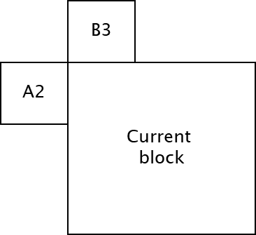
Figure 1. The blocks used in context model derivation for triangle_flag.

Simplified context model for triangle_flag
It is proposed to use only one context model for coding triangle_flag to avoid using the neighbouring blocks. This modification can reduce the line buffer size as well as the parsing complexity, since the triangle_flag of the neighbouring blocks is not used in the context derivation process.

Experimental results
The proposed method is implemented on the top of VTM-3.0. The common test conditions defined in [2] is used in the simulation. Table 1 shows the BD-Rate of the proposed method relative to VTM-3.0. Please note that the timing is not reliable.
Table. 1. The BD-Rate of the proposed method relative to VTM-3.0.
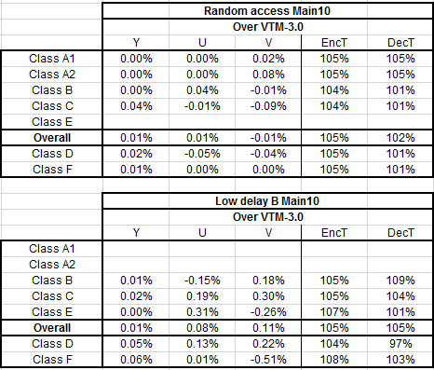

Conclusion
This contribution proposes a simplified context model for triangle_flag, in which there is only one context model and the triangle_flags of the spatial neighboring blocks are not used in the context model derivation. This modification reduces the line buffer size and parsing complexity with minor impact on coding efficiency.

Reference
[1] R. Liao, C. Lim, JVET-L0124, “CE10.3.1.b: Triangular prediction unit mode”, Oct. 2018.
[2] F. Bossen, J. Boyce, X. Li, V. Seregin, K. Suehring, JVET-L1010, “JVET common test conditions and software reference configurations for SDR video”, Oct. 2018.

Patent rights declaration(s)
Tencent does not have any current or pending patent rights relating to the technology described in this contribution.

