    Joint Video Experts Team (JVET)  of ITU-T SG 16 WP 3 and ISO/IEC JTC 1/SC 29/WG 11  13th Meeting: Marrakech, MA, 9–18 Jan. 2019 | Document: JVET-M0481

Title: | CE4: Symmetrical MVD mode (Test 4.4.3)
Status: | Input document to JVET
Purpose: | Proposal
Author(s) or  Contact(s): | Huanbang Chen  Timofey Solovyev  Haitao Yang  Jianle Chen | Tel:  Email: | +79250089652  chenhuanbang@huawei.com  solovyev.timofey@huawei.com  haitao.yang@huawei.com  jianle.chen@huawei.com
Source: | Huawei Technologies. Co., Ltd
_____________________________

Abstract
This contribution presents the simulation results of symmetrical MVD mode for bi-prediction on top of VTM-3.0. The proposed method derives MVD for the list 1 from MVD for the list 0 based on assumption of linear motion. Simulation results reportedly shows on average 0.16% BD-rate saving with encoding and decoding times of 105% and 100% respectively for the RA configuration.

Proposed method
In this contribution, a new mode is proposed for motion information coding in bi-prediction.
Firstly, in slice level, variables BiDirPredFlag, RefIdxSymL0 and RefIdxSymL1 are derived as follows:
- The forward reference picture in reference picture list 0 which is nearest to the current picture is searched. If found, RefIdxSymL0 is set equal to the reference index of the forward picture.
- The backward reference picture in reference picture list 1 which is nearest to the current picture is searched. If found, RefIdxSymL1 is set equal to the reference index of the backward picture.
- If both forward and backward picture are found, BiDirPredFlag is set equal to 1.
- Otherwise, following applies:
- The backward reference picture in reference picture list 0 which is nearest to the current one is searched. If found, RefIdxSymL0 is set equal to the reference index of the backward picture.
- The forward reference picture in reference picture list 1 which is nearest to the current one is searched. If found, RefIdxSymL1 is set equal to the reference index of the forward picture.
- If both backward and forward picture are found, BiDirPredFlag is set equal to 1. Otherwise, BiDirPredFlag is set equal to 0.
Secondly, in CU level, a symmetrical mode flag indicating whether symmetrical mode is used or not is explicitly signaled if the prediction direction for the CU is bi-prediction and BiDirPredFlag is equal to 1.
When the flag is true, only mvp_l0_flag, mvp_l1_flag and MVD0 are explicitly signaled. The reference indices are set equal to RefIdxSymL0, RefIdxSymL1 for list 0 and list 1, respectively. MVD1 is just set equal to –MVD0. The final motion vectors are shown in below formula.
$$\left\{\begin{aligned}{\left({mvx}_{0}, {mvy}_{0}\right)=(mvpx}_{0}+{mvdx}_{0},{mvpy}_{0}+{mvdy}_{0}) \\ {\left({mvx}_{1}, {mvy}_{1}\right)=(mvpx}_{1}-{mvdx}_{0},{mvpy}_{1}-{mvdy}_{0})\end{aligned}\right.$$
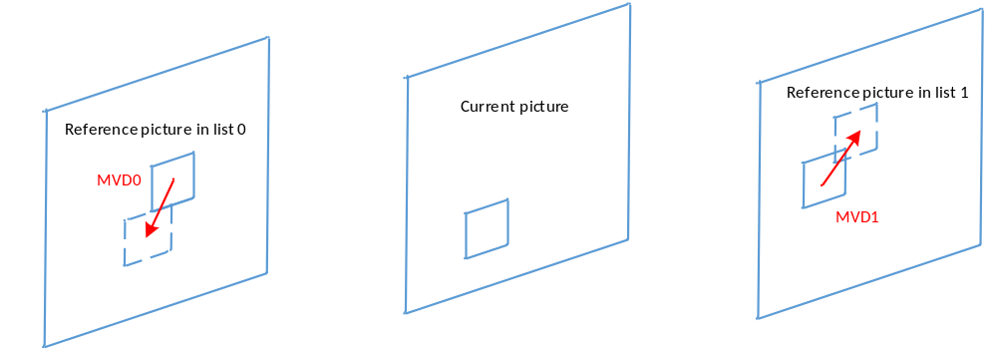
Figure 1 Illustration for symmetrical mode
The modifications in coding unit syntax are shown in Table 1.
Table 1 Modifications in coding unit syntax
coding_unit( x0, y0, cbWidth, cbHeight, treeType ) { | Descriptor
…
if( slice_type = = B )
inter_pred_idc[ x0 ][ y0 ] | ae(v)
if( sps_affine_enabled_flag && cbWidth >= 16 && cbHeight >= 16 ) {
inter_affine_flag[ x0 ][ y0 ] | ae(v)
if( sps_affine_type_flag && inter_affine_flag[ x0 ][ y0 ] )
cu_affine_type_flag[ x0 ][ y0 ] | ae(v)
}
if( inter_pred_idc[ x0 ][ y0 ] == PRED_BI &&
BiDirPredFlag && inter_affine_flag[ x0 ][ y0 ] == 0 )
symmetric_mvd_flag[ x0 ][ y0 ] | ae(v)
if( inter_pred_idc[ x0 ][ y0 ] != PRED_L1 ) {
if( num_ref_idx_l0_active_minus1 > 0 && !symmetric_mvd_flag[ x0 ][ y0 ] )
ref_idx_l0[ x0 ][ y0 ] | ae(v)
mvd_coding( x0, y0, 0, 0 )
if( MotionModelIdc[ x0 ][ y0 ] > 0 )
mvd_coding( x0, y0, 0, 1 )
if(MotionModelIdc[ x0 ][ y0 ] > 1 )
mvd_coding( x0, y0, 0, 2 )
mvp_l0_flag[ x0 ][ y0 ] | ae(v)
} else {
MvdL0[ x0 ][ y0 ][ 0 ] = 0
MvdL0[ x0 ][ y0 ][ 1 ] = 0
}
if( inter_pred_idc[ x0 ][ y0 ] != PRED_L0 ) {
if( num_ref_idx_l1_active_minus1 > 0 && !symmetric_mvd_flag[ x0 ][ y0 ] )
ref_idx_l1[ x0 ][ y0 ] | ae(v)
if( mvd_l1_zero_flag && inter_pred_idc[ x0 ][ y0 ] = = PRED_BI ) {
…
} else {
if( !symmetric_mvd_flag[ x0 ][ y0 ] ) {
mvd_coding( x0, y0, 1, 0 )
if( MotionModelIdc[ x0 ][ y0 ] > 0 )
mvd_coding( x0, y0, 1, 1 )
if(MotionModelIdc[ x0 ][ y0 ] > 1 )
mvd_coding( x0, y0, 1, 2 )
}
mvp_l1_flag[ x0 ][ y0 ] | ae(v)
} else {
MvdL1[ x0 ][ y0 ][ 0 ] = 0
MvdL1[ x0 ][ y0 ][ 1 ] = 0
}
…
}
}
…
}

Simulation results
The proposed method is evaluated for random-access (RA) configuration using VTM-3.0 software according to the common test conditions in JVET-L1010 [1] and the description of Core Experiment 4 [2]. For the test 4.4.3, results reportedly show on average 0.16% BD-rate saving with encoding and decoding times of 105% and 100% respectively for RA configuration. The proposed method does not affect LDB configuration. The detailed experimental results are provided in Table 3.
Table 3. Coding performance of test 4.4.3 over VTM-3.0
 | Random Access Main 10
 | Over VTM-3.0
 | Y | U | V | EncT | DecT
Class A1 | -0.18% | -0.15% | -0.21% | 105% | 100%
Class A2 | -0.20% | -0.15% | -0.15% | 105% | 100%
Class B | -0.15% | -0.09% | -0.17% | 105% | 101%
Class C | -0.13% | -0.11% | -0.11% | 105% | 100%
Class E
Overall | -0.16% | -0.12% | -0.16% | 105% | 100%
Class D | -0.08% | -0.08% | -0.04% | 105% | 101%
Class F (optional) | -0.11% | -0.12% | -0.11% | 105% | 100%

Conclusions
This contribution reports the results of integrating symmetrical MVD mode for bi-prediction on top of VTM-3.0. The proposed method derives MVD for the list 1 from MVD for the list 0 based on assumption of linear motion. Simulation results reportedly show on average 0.16% BD-rate saving with encoding and decoding times of 105% and 100% respectively for the RA configuration.

References
- F. Bossen, J. Boyce, X. Li, V. Seregin, K. Sühring, “JVET common test conditions and software reference configurations for SDR video”, JVET-L1010, ISO/IEC JTC 1/SC 29/WG 11 Joint Video Exploration Team (JVET) 12th Meeting: Macao, CN, 3–12 Oct. 2018.
- Haitao Yang, Shan Liu, Kai Zhang, “Description of Core Experiment 4 (CE4): Inter prediction and motion vector coding,” JVET-L1024, ISO/IEC JTC 1/SC 29/WG 11 Joint Video Exploration Team (JVET) 12th Meeting: Macao, CN, 3–12 Oct. 2018.

Patent rights declaration(s)
Huawei Technologies Co., Ltd may have current or pending patent rights relating to the technology described in this contribution and, conditioned on reciprocity, is prepared to grant licenses under reasonable and non-discriminatory terms as necessary for implementation of the resulting ITU-T Recommendation | ISO/IEC International Standard (per box 2 of the ITU-T/ITU-R/ISO/IEC patent statement and licensing declaration form).

