    Joint Video Experts Team (JVET)  of ITU-T SG 16 WP 3 and ISO/IEC JTC 1/SC 29/WG 11  13th Meeting: Marrakech, MA, 9–18 Jan. 2018 | Document: JVET-M0474-v3

Title: | CE8.1.3: Extended CPR reference with 1 buffer line
Status: | Input document to JVET
Purpose: | Proposal
Author(s) or  Contact(s): | Luong Pham Van  Vadim Seregin  Wei-Jung Chien  Ted Hsieh  Marta Karczewicz  5775 Morehouse Dr  San Diego, CA 92121 | Tel:  Email: | +1-858-658-5664  lphamvan@qti.qualcomm.com
Source: | Qualcomm Inc.
_____________________________

Abstract
This contribution reports the simulation results of the Core Explore test CE8.1.3. In this test, the line buffer (one line above) and one column to left of the current CTU is added to the CPR reference. With the proposed restricted search area, the luma BD-rate changes for [CTC, Class F, class SCC 1080p] are:
CPR on and PLT off:
AI: (-0.29%, -12.21%, -37.14%) and (-0.01%, -0.17%, -0.37%) over VTM3 and VTM3+CPR on, resp.
RA: (0.08%, -9.96%, -22.17%) and (-0.01%, -0.09%, -0.19%) over VTM3 and VTM3+CPR on, resp.
LB: (0.13%, -5.18%, -13.03%) and (-0.01%, -0.05%, 0.07%) over VTM3 and VTM3+CPR on, resp.
CPR on and PLT on:
AI:(-0.19%, -15.57%, -44.89%) and (-0.01%, -0.10%, -0.23%) over VTM3 and VTM3+CPR+PLT on, resp.
RA:(0.21%, -12.00%, -25.74%) and (0.01%, -0.12%, -0.10%) over VTM3 and VTM3+CPR+PLT on, resp.
LB:(0.27%, -6.25%, -14.79%) and (-0.02%, -0.12%, 0.05%) over VTM3 and VTM3+CPR+PLT on, resp.
In addition to the result of CE8.1.3, this document also reports the results of different extended configurations of the CPR reference.

Introduction
The current picture reference (CPR) mode was adopted into BMS software in the last Ljubljana meeting [1]. In the last meeting in Macao, the CPR reference is restricted in the reconstructed area of the current CTU. This limitation significantly reduces the performance of CPR coding compared to full-frame search.

Proposed Method
In order to improve the performance of CPR in restricted CPR reference mode without any additional cost, this CE test (CE8.1.3) utilizes the line buffer to extend the CPR reference. In particularly, one top line above and one column to the left of the current CTU are included into the CPR reference as depicted in Figure 1.

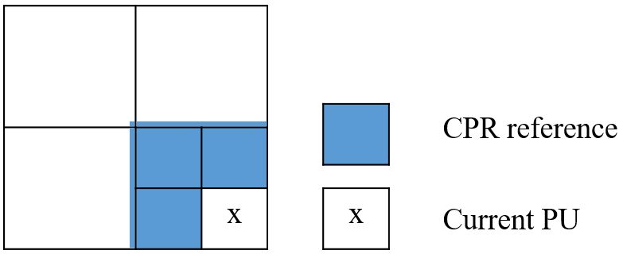
Figure 1 Extended CPR reference of CE8.1.3
In real implementation, 4 lines above the current CTU may be needed for deblocking filter. Utilizing these lines will increase the CPR coding performance without any additional cost. On the other hand, processing of a CTU with the size of 128x128 can be broken into 4 virtual processing data units (VPDUs) of 64x64. Therefore, this document reports the results of CPR using different reference configurations as follow:
Test 1: CPR search area is the current CTU and 4 lines above and 4 left columns of the current VPDU.
Test 2: CPR search area is the current VPDU.
Test 3: CPR search area is the current VPDU and 1 line above and 1 column to the left of current VPDU.
Test 3: CPR search area is the current VPDU and 4 lines above and 4 columns to the left of current VPDU.

Experimental Results
The proposed technique has been implemented on top of VTM3.0. These tests are evaluated with PLT off and PLT off. The gain of CE8.1.3 are summarized in Table 1 while the performance of Test 1, Test 2, Test 3 and Test 4 are presented in Table 2, Table 3, Table 4, and Table 5, respectively.
The performance in terms of the luma BD-rate changes for [CTC, Class F, class SCC 1080p] of CE8.1.3 is reported as:
CPR on and PLT off:
AI: (-0.29%, -12.21%, -37.14%) and (-0.01%, -0.17%, -0.37%) over VTM3 and VTM3+CPR on, resp.
RA: (0.08%, -9.96%, -22.17%) and (-0.01%, -0.09%, -0.19%) over VTM3 and VTM3+CPR on, resp.
LB: (0.13%, -5.18%, -13.03%) and (-0.01%, -0.05%, 0.07%) over VTM3 and VTM3+CPR on, resp.
CPR on and PLT on:
AI:(-0.19%, -15.57%, -44.89%) and (-0.01%, -0.10%, -0.23%) over VTM3 and VTM3+CPR+PLT on, resp.
RA:(0.21%, -12.00%, -25.74%) and (0.01%, -0.12%, -0.10%) over VTM3 and VTM3+CPR+PLT on, resp.
LB:(0.27%, -6.25%, -14.79%) and (-0.02%, -0.12%, 0.05%) over VTM3 and VTM3+CPR+PLT on, resp.

Table 1(a) Test CE8.1.3 with CPR on and PLT off
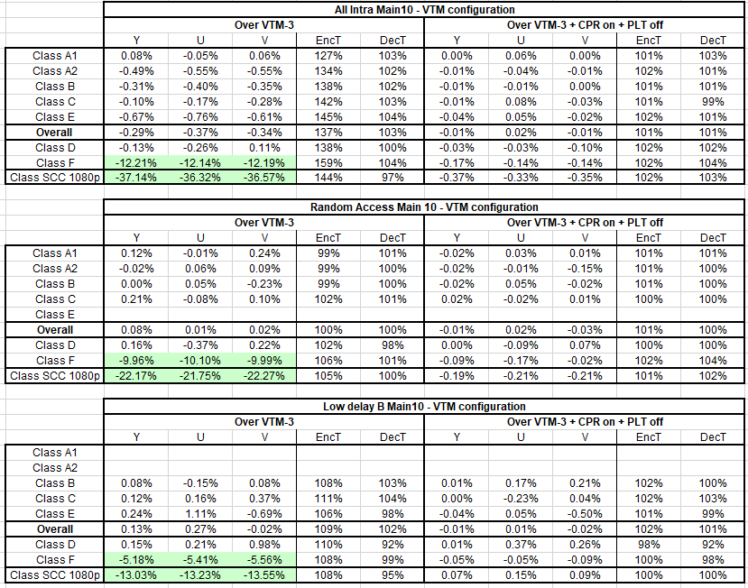

Table 1(b) Test CE8.1.3 with CPR on and PLT on
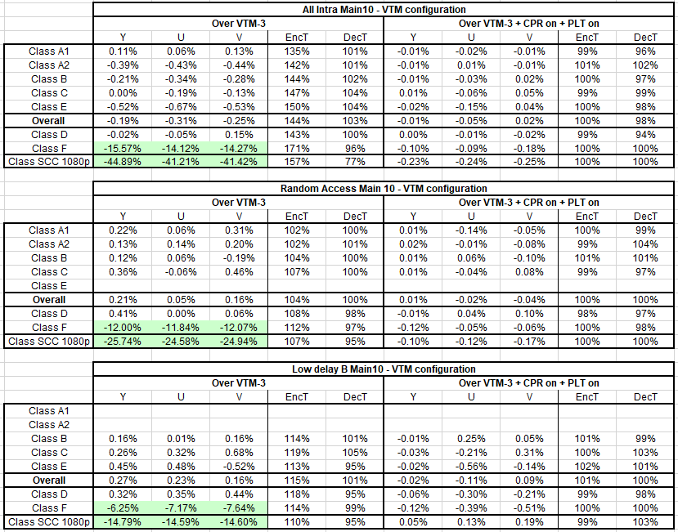
Additional results:
As in Table 2, the luma (CTC, Class F, Class SCC) performance of Test 4 when CPR on and PLT off are:
AI:(-0.30%, -12.69%, -38.56%) and (-0.03%, -0.81%, -2.78%) over VTM and VTM+CPRon+PLToff, resp.
RA:(0.07%, -10.35%, -23.12%), and (-0.01%, -0.62%, -1.51%) over VTM and VTM+CPRon+PLToff, resp.
LDB:(0.12%,-5.39%, -13.71%), and (-0.02%, -0.31%, -0.74%) over VTM and VTM+CPRon+PLToff, resp.

As in Table 5(a), the luma (CTC, Class F, Class SCC) performance of Test 4 when CPR on and PLT off are:
AI:(-0.12%, -9.37%, -29.45%) and (0.16%, 3.65%, 12.44%) over VTM and VTM+CPRon+PLToff, resp.
RA:(0.13%, -7.76%, -16.92%), and (0.05%, 2.87%, 7.01%) over VTM and VTM+CPRon+PLToff, resp.
LDB:(0.14%, -3.80%, -9.17%), and (0.00%, 1.61%, 4.82%) over VTM and VTM+CPRon+PLToff, resp.

As in Table 5(b), the luma (CTC, Class F, Class SCC) performance of Test 4 when CPR on and PLT off are:
AI:(-0.03%, -13.59%, -39.57%) and (0.16%, 2.80%, 9.73%) over VTM and VTM+CPRon+PLToff, resp.
RA:(0.26%, -10.43%, -21.98%), and (0.06%, 2.11%, 5.32%) over VTM and VTM+CPRon+PLToff, resp.
LDB:(0.28%, -5.13%, -11.92%), and (-0.01%, 1.25%, 3.62%) over VTM and VTM+CPRon+PLToff, resp.

Table 2 Test 1: Current CPR and 4 above lines and 4 left columns
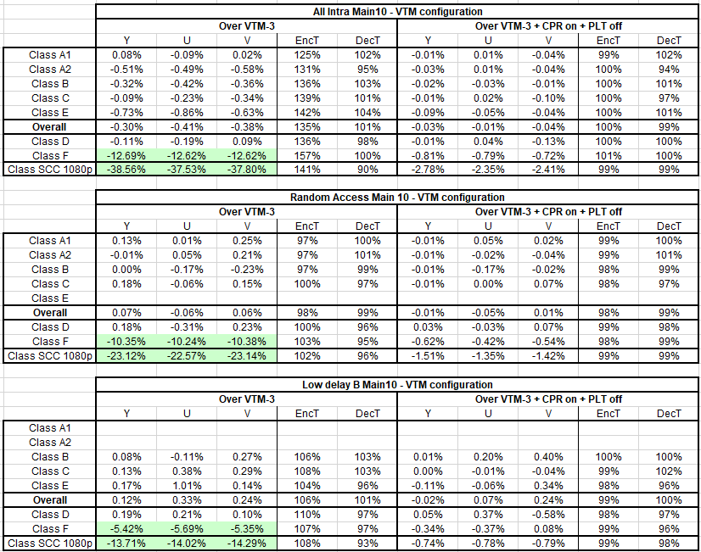

Table 3(a) Test 2 CPR search area is the current VPDU - CPR on + PLT off
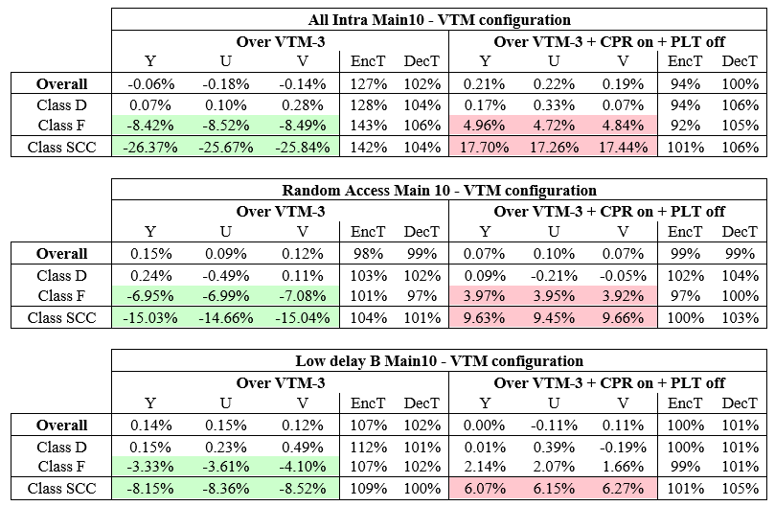
Table 3(b) Test 2 CPR search area is the current VPDU - CPR on + PLT on
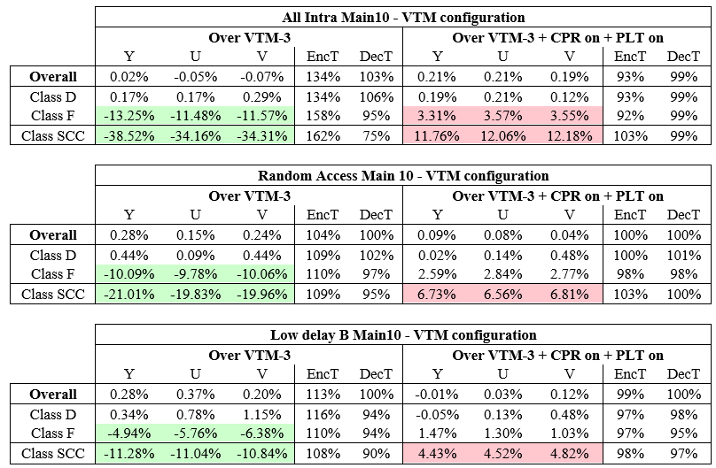

Table 4(a) Test 3 CPR search area is the current VPDU and 1 line above and 1 column to the left of current VPDU - CPR on + PLT off
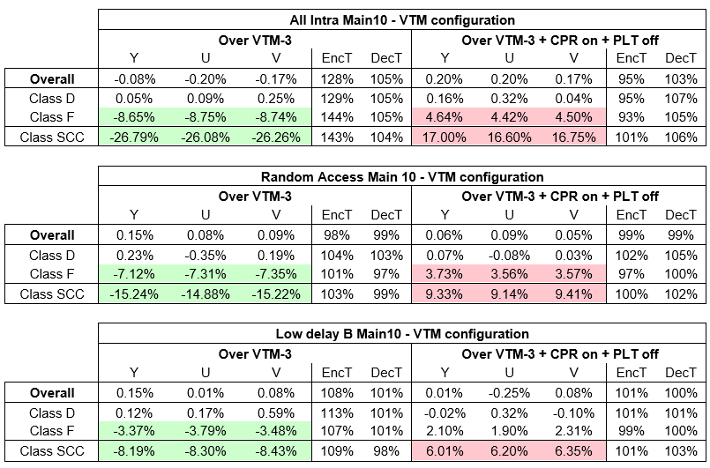
Table 4(b) CPR search area is the current VPDU and 1 line above and 1 column to the left of current VPDU - CPR on + PLT on
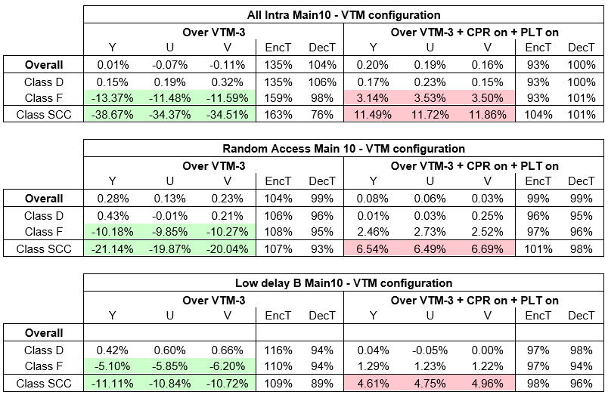

Table 5(a) CPR search area is the current VPDU and 4 lines above and 4 columns to the left of current VPDU - CPR on + PLT off
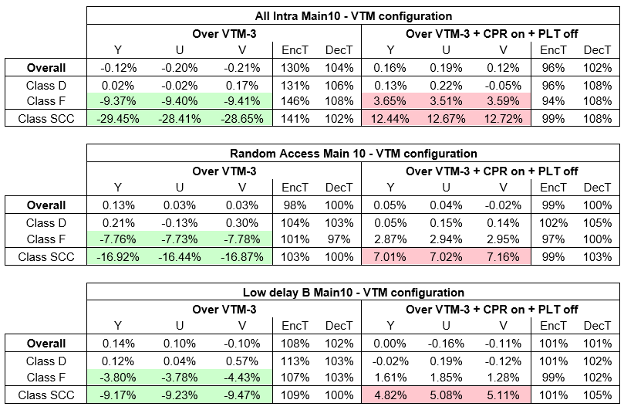
Table 5(b) CPR search area is the current VPDU and 4 lines above and 4 columns to the left of current VPDU - CPR on + PLT on
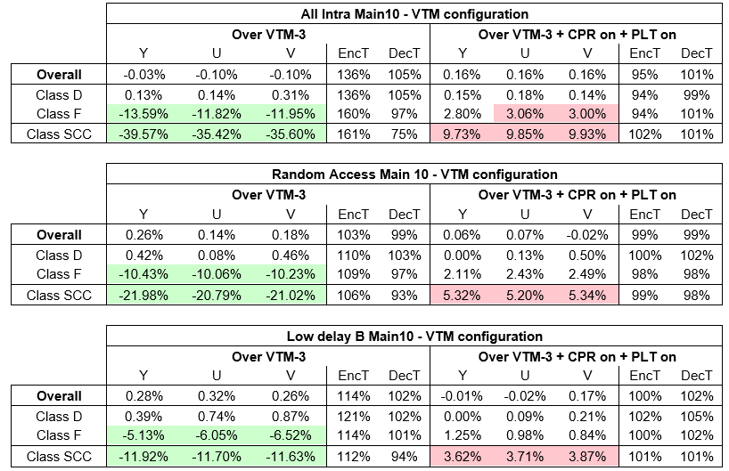

Conclusions
This contribution reports the simulation results of the Core Explore test CE8.1.3. In this test, the line buffer (one line above) and one column to left of the current CTU is added to the CPR reference. In addition to the result of CE8.1.3, this document also reports the results of different extended configurations of the CPR reference.

References
[1] Xiaozhong Xu, Xiang Li and Shan Liu, “CE8-2.2: Current picture referencing using reference index signaling”, JVET-K0076, Ljubljana, SL, July 2018

Patent rights declaration
Qualcomm Inc. may have current or pending patent rights relating to the technology described in this contribution and, conditioned on reciprocity, is prepared to grant licenses under reasonable and non-discriminatory terms as necessary for implementation of the resulting ITU-T Recommendation | ISO/IEC International Standard (per box 2 of the ITU-T/ITU-R/ISO/IEC patent statement and licensing declaration form).

