    Joint Video Experts Team (JVET)  of ITU-T SG 16 WP 3 and ISO/IEC JTC 1/SC 29/WG 11  13th Meeting: Marrakech, MA, 9–18 Jan. 2019 | Document: JVET-M0463

Title: | CE5: Report of throughput analysis of CE5 contributions (CE5.2)
Status: | Input document to JVET
Purpose: | Information
Author(s) or  Contact(s): | Jie Dong, Amir Said, Vadim Seregin, Marta Karczewicz | Tel:  Email: | +1-408-533-9515  jiedong@qti.qualcomm.com
Source: | Qualcomm Inc.
_____________________________

Abstract
This document analyzes the throughput of all the CE5 contributions [1] that are implemented in software [2] in an optimized fashion.

Introduction
All the CABAC engines proposed in CE5 [1] plus AVC/HEVC CABAC engine are implemented in the standalone software [2] outside of VTM3.0. Taking a string of 10 million bins, each CABAC engine executes the arithmetic encoding followed by decoding, and outputs the same string of input bins. The run time required by each engine is measured and the number of bins that each engine can process per second, so called throughput and calculated by dividing 10 million by the run time, is compared.
Two configurations of bin strings are defined in [1], and used in this analysis.
- The bin values and the associated context models are random. The former follows the Bernoulli distribution with parameter p = 0.0, 0.1, 0.2, …, 0.9, 1.0.
- The bin string is obtained by extracting the regular bins and their associated context models from an actual VTM3 bitstream.

Test Setup and Definition

Setup
The software is compiled by Visual Studio 2015 in the release mode, and below is the testing environment.
Processor: Intel® Core™ i5-6300U CPU@2.40GHz
RAM: 20.0GB
OS: Windows10, 64-bit OS, x64-based processor
The bin string representing the natural scenario is obtained by extracting the regular bins and their associated context models from the first segment of BQTerrace (RA, QP=22).
Each test (see the test definition in Section 2.2) were run 10 times, and the maximum throughput value was recorded.

Definition
Fifteen tests are defined, as shown in Table 1.
Table 1 Test definition
Common part of the tests | Tests # | Engines to be tested
 | Test 1 | AVC/HEVC
Use direct multiplication for range update | Test 2 | linear, double window (10b/14b), fixed para., full range-1
Use direct multiplication for range update | Test 3 | linear, double window (10b/14b), fixed para., full range
Use direct multiplication for range update | Test 4 | linear, double window (10b/14b), customized para., full range-1
Use direct multiplication for range update | Test 5 | linear, double window (10b/14b), customized para., full range
Use direct multiplication for range update | Test 6 | linear, single window (14b), customized para., full range-1
Use direct multiplication for range update | Test 7 | linear, single window (14b), customized para., full range
Use direct multiplication for range update | Test 8 | linear, double window (15b/15b), fixed para., counter, full range
Use LUT for range update | Test 9 | log, double window (8b/12b), fixed para.
Use LUT for range update | Test 10 | log, double window (8b/12b), customized para.
Use LUT for range update | Test 11 | log, single window (12b), customized para.
Context probability update uses linear, double window (10b/14b), customized para., full range -1 | Test 12 | direct multi., LUT
 | Test 13 | direct multi., Multi.
 | Test 14 | log multi., LUT
 | Test 15 | log multi., Multi.
For each of the fifteen tests, the macro settings are shown in Table 2.
Table 2 Macro settings for the tests
Tests # | ENGINE | USE_RLPS_TABLE | FULL_RANGE | COUNTER | SINGLE | LOGMULT
Test 1 | 0 | N/A
Test 2 | 4 | 0 | 0 | 0 | 0 | 0
Test 3 | 4 | 0 | 1 | 0 | 0 | 0
Test 4 | 2 | 0 | 0 | 0 | 0 | 0
Test 5 | 2 | 0 | 1 | 0 | 0 | 0
Test 6 | 2 | 0 | 0 | 0 | 1 | 0
Test 7 | 2 | 0 | 1 | 0 | 1 | 0
Test 8 | 4 | 0 | 1 | 1 | 0 | 0
Test 9 | 3 | N/A |  |  | 0 | N/A
Test 10 | 1 |  |  |  | 0 | N/A
Test 11 | 1 |  |  |  | 1 | N/A
Test 12 | 2 | 1 | 0 | 0 | 0 | 0
Test 13 | 2 | 0 | 0 | 0 | 0 | 0
Test 14 | 2 | 1 | 0 | 0 | 0 | 1
Test 15 | 2 | 0 | 0 | 0 | 0 | 1

Throughput Analysis
The full results of the fifteen tests are shown in the enclosed excel spreadsheet. Below are the plots comparing the throughputs in different dimensions.

Linear Model vs. Log Model
Double windows, fixed parameters
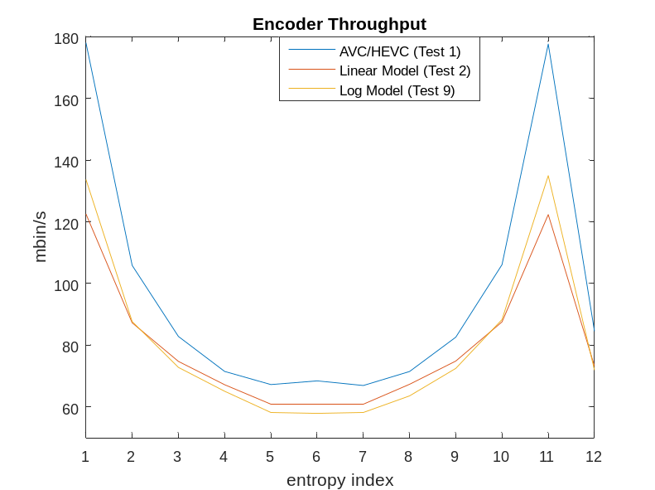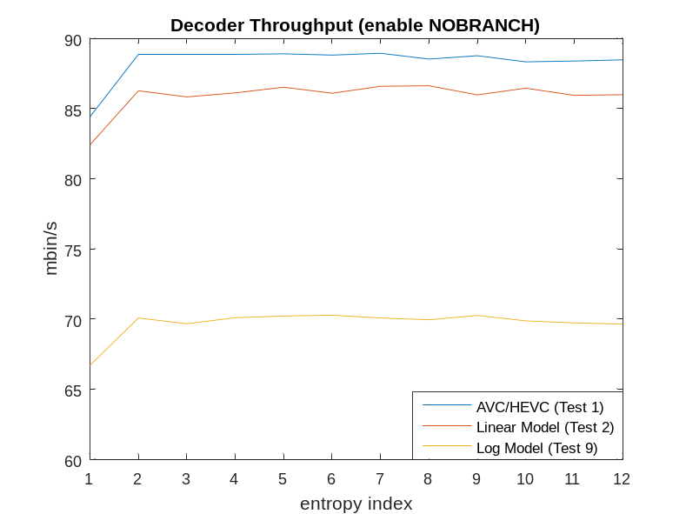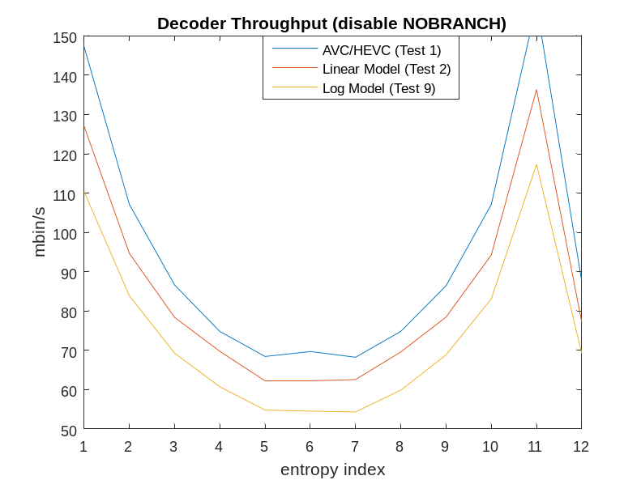
Double window, customized parameters
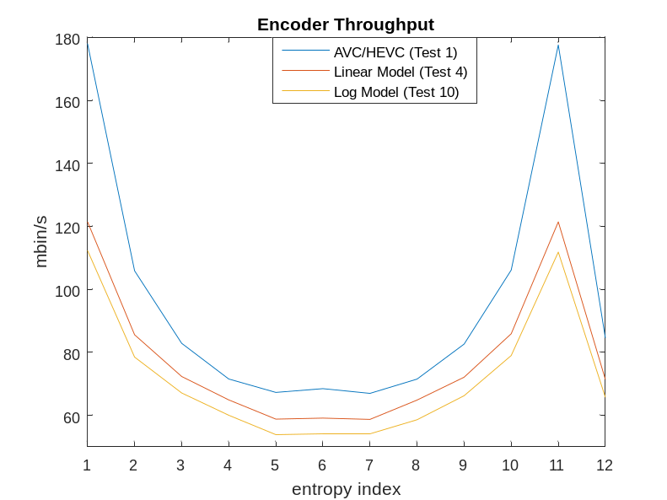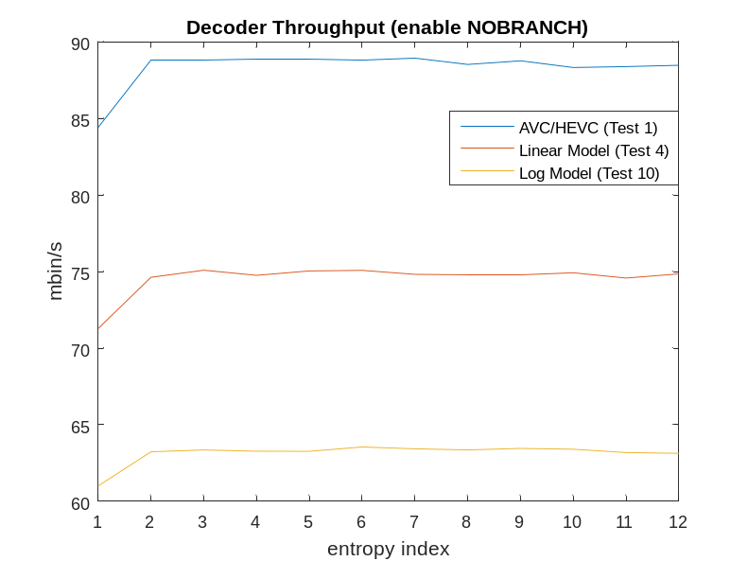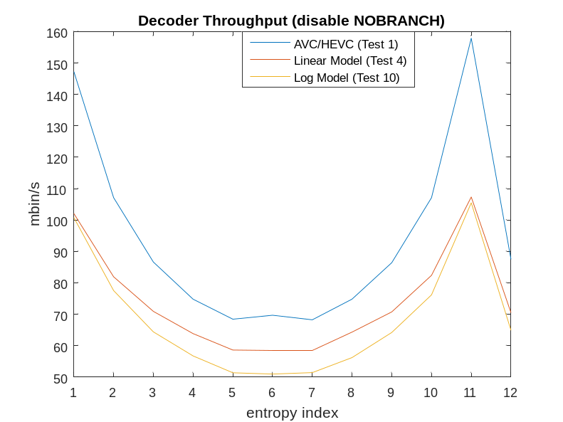

Single window, customized parameters
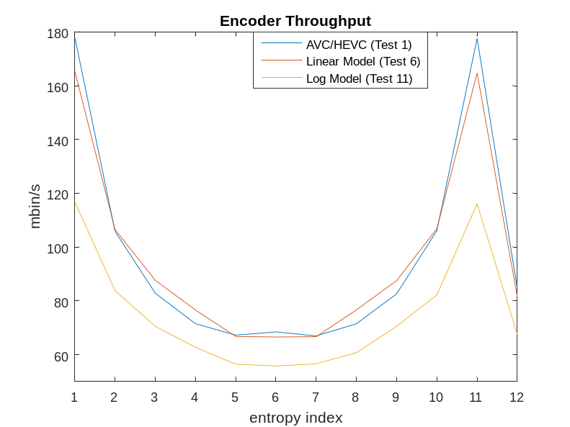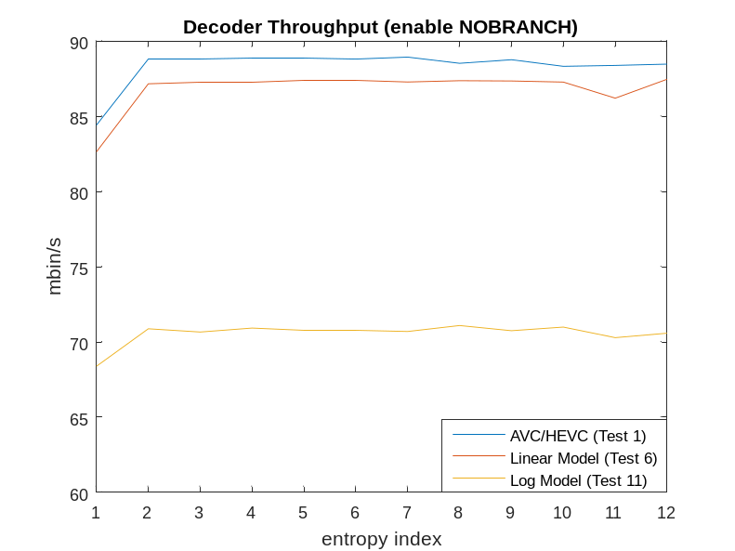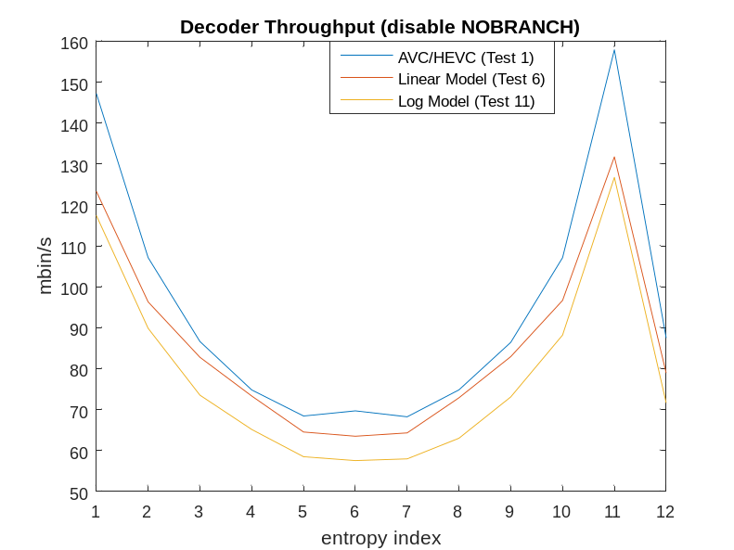

Single/Double Windows and Fixed/Customized Parameters
With Linear Model (enable FULL_RANGE)
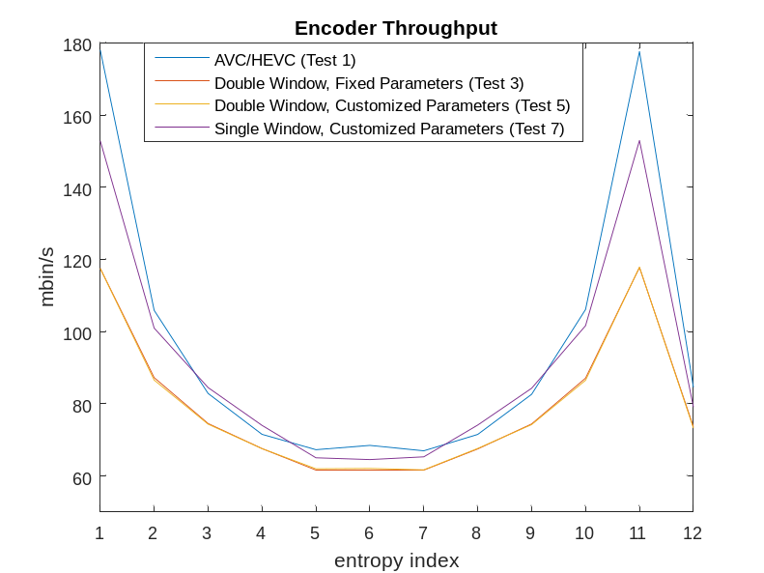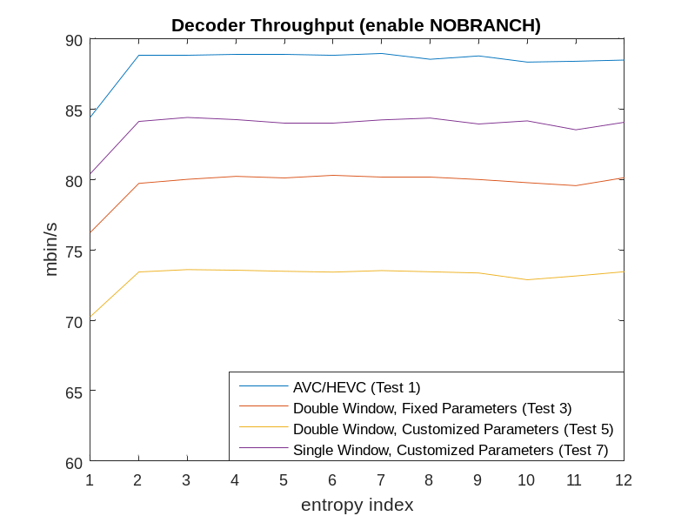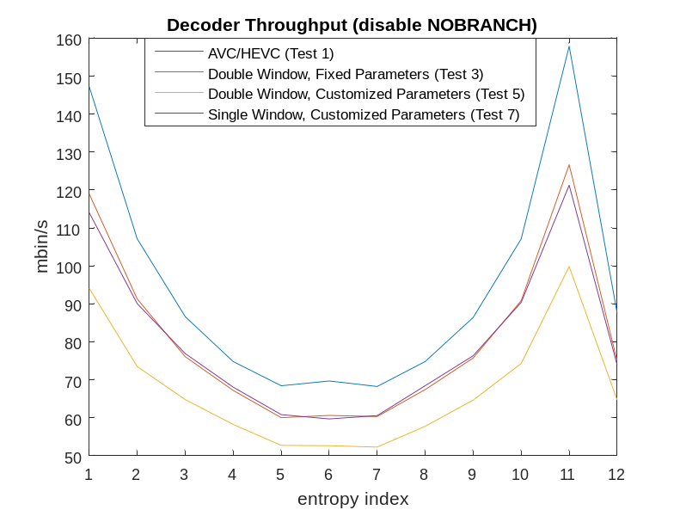
With Linear Model (disable FULL_RANGE)
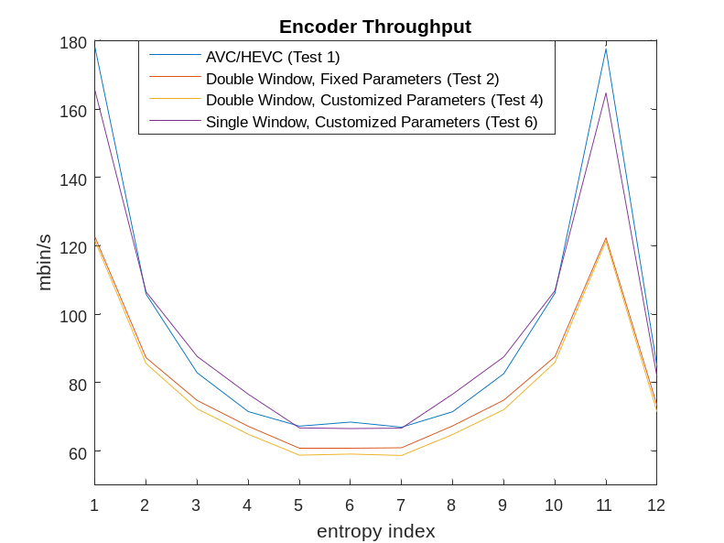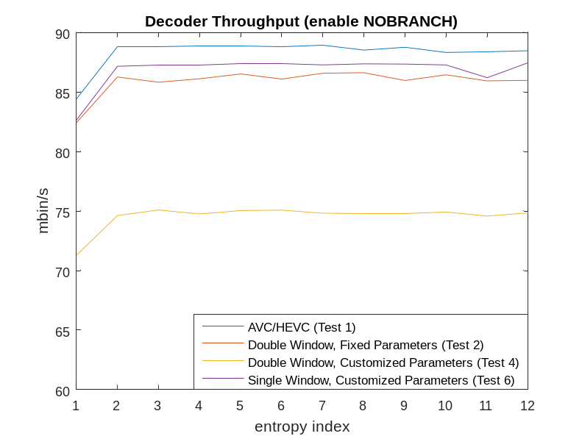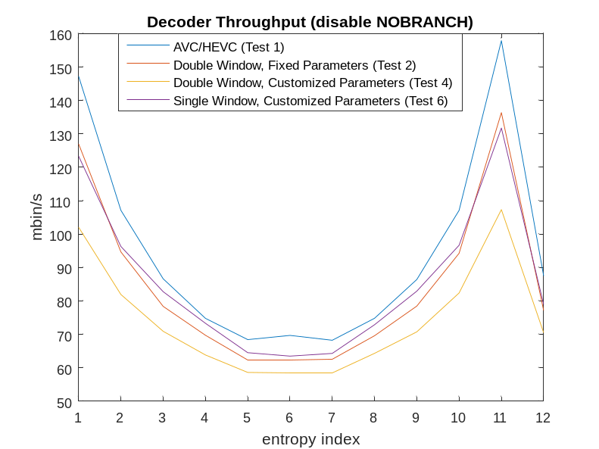
With Log Model
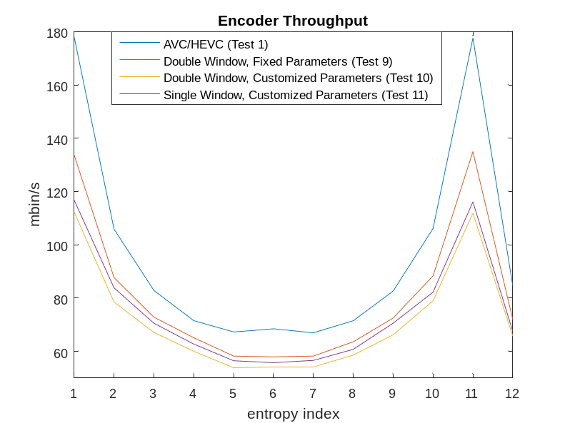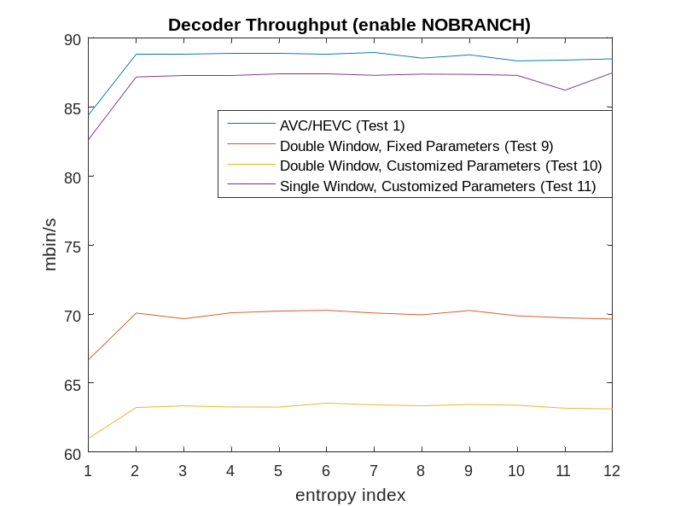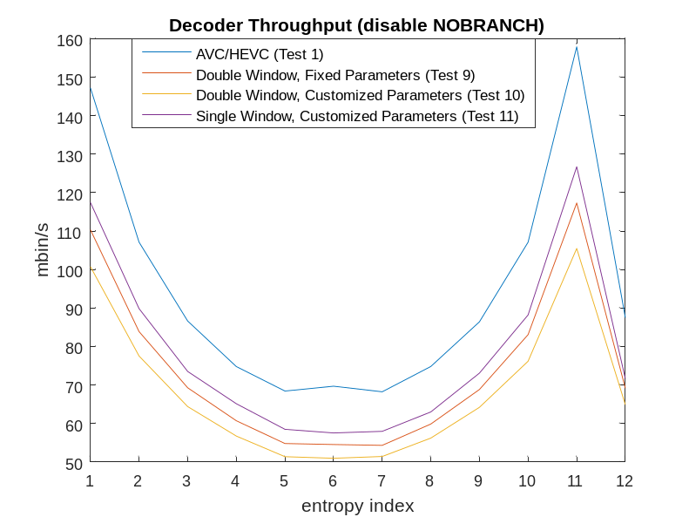

Full Range vs. Full Range minus 1
Linear, Double Window, Fixed Parameters
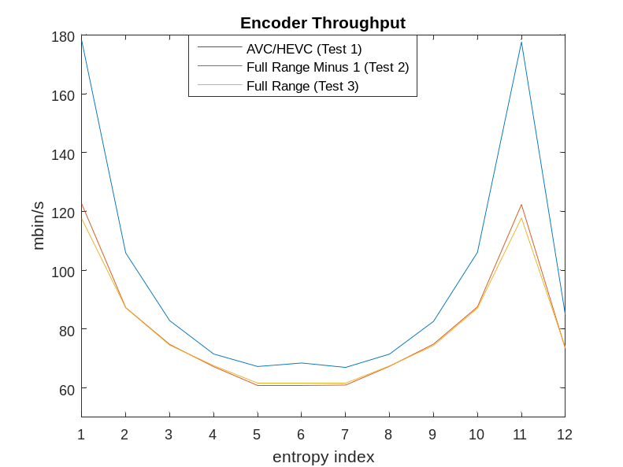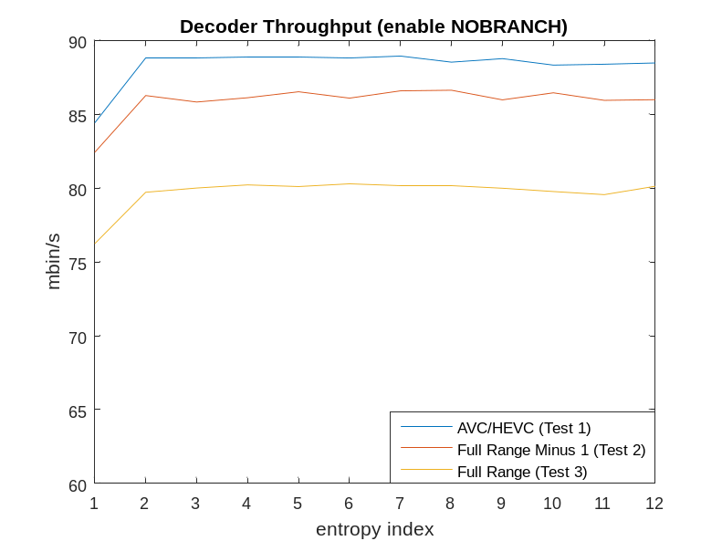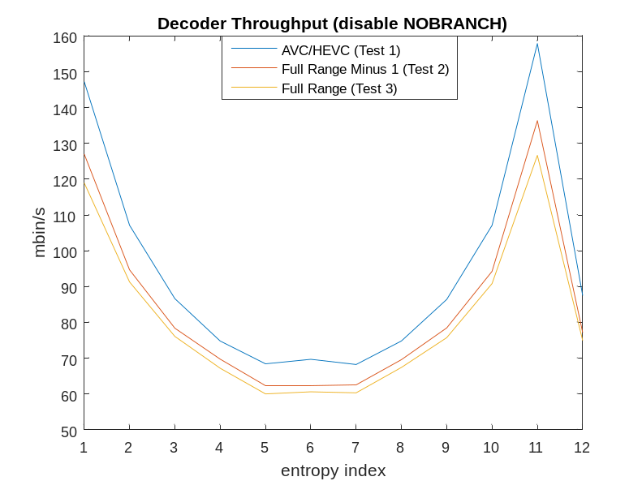
Linear, Double Window, Customized Parameters
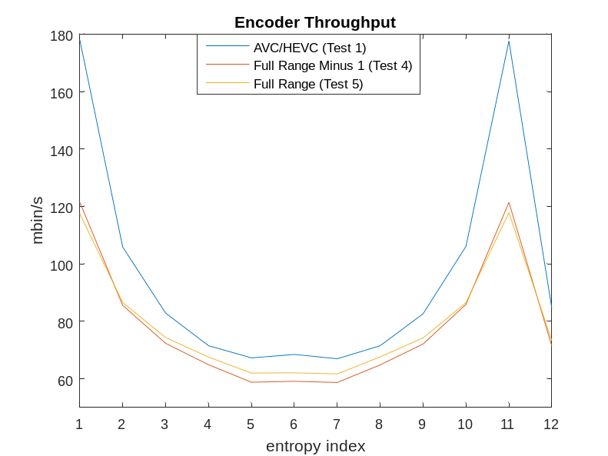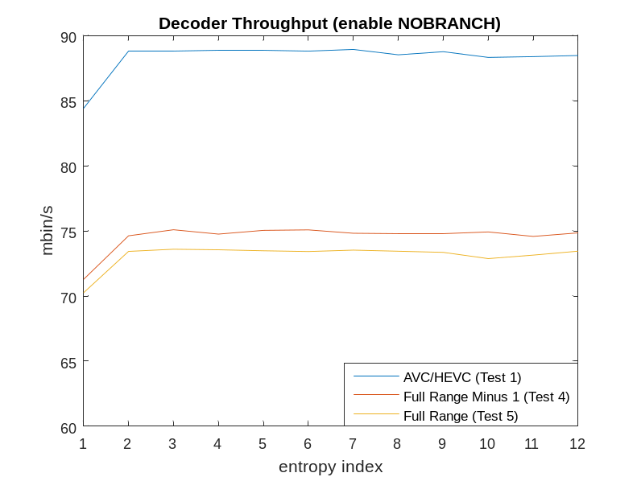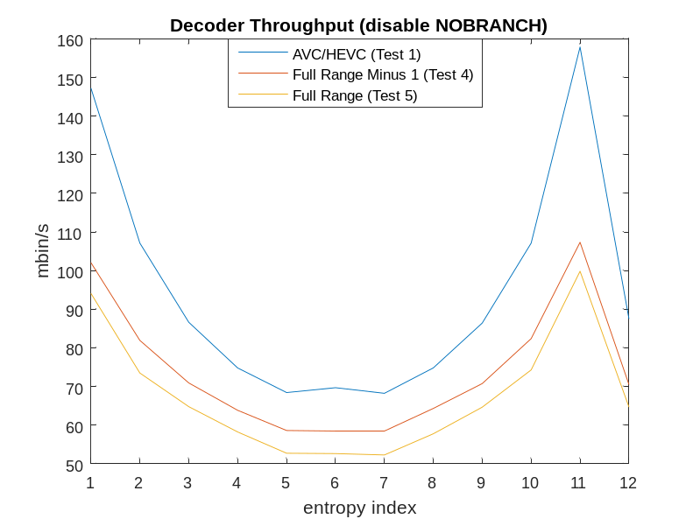
Linear, Single Window, Customized Parameters
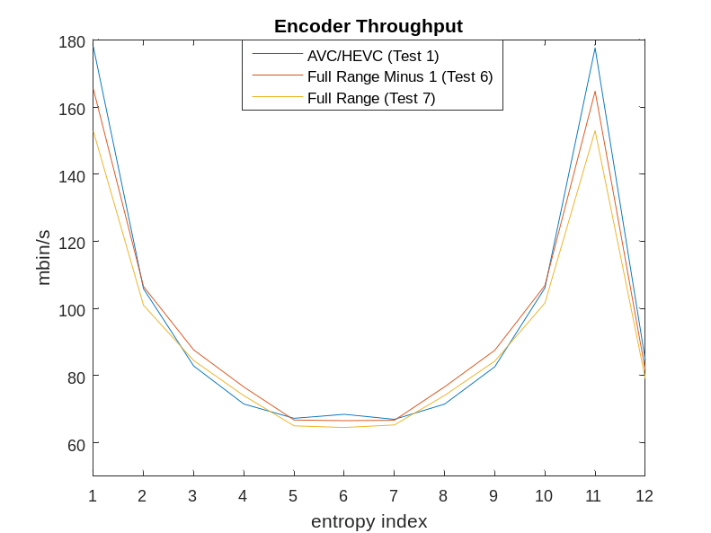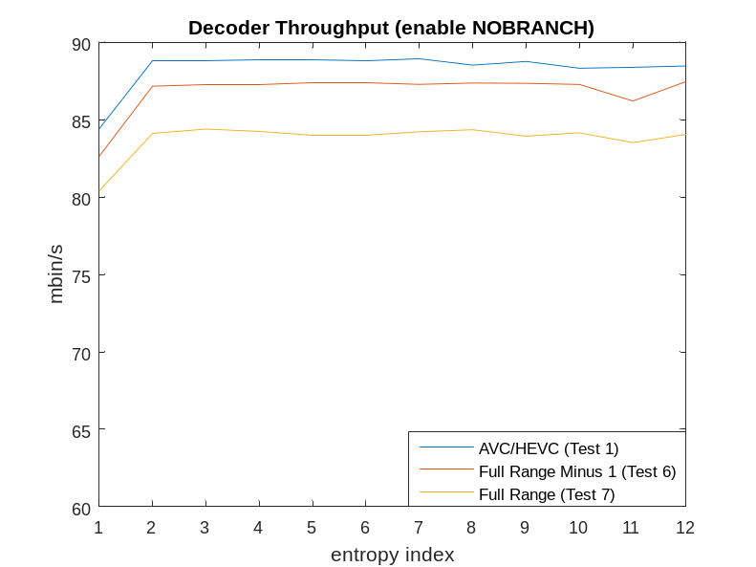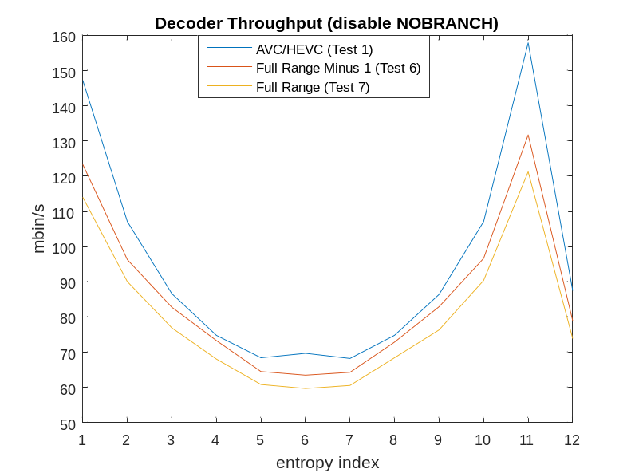

Counter Based Method (with Double Window, Fixed Parameters)
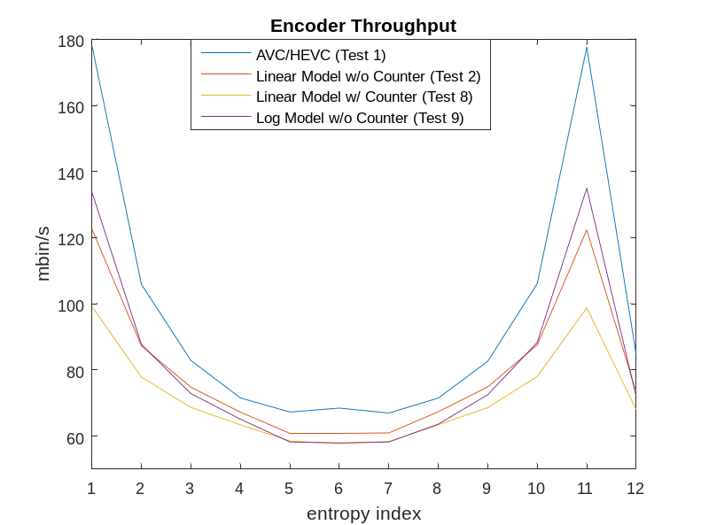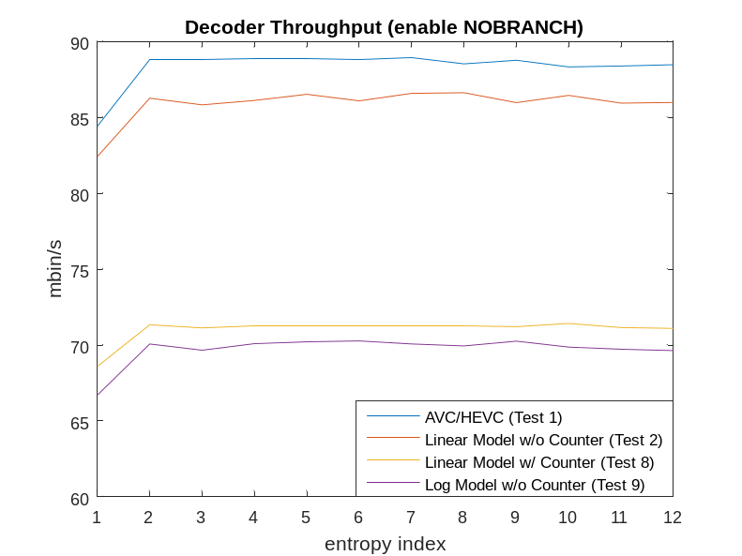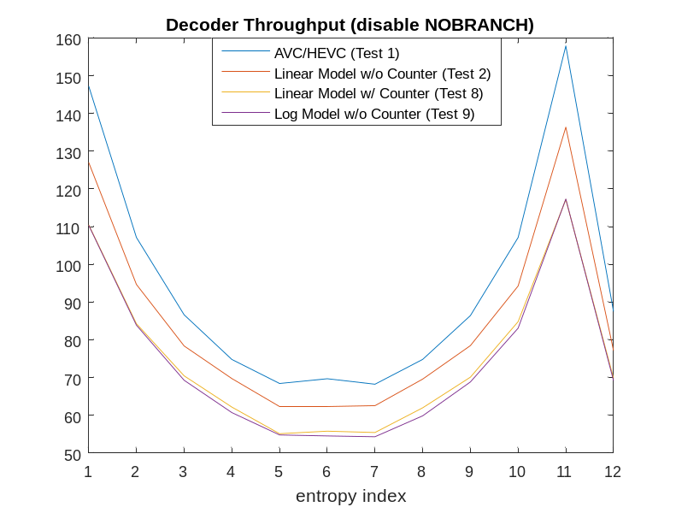

Compare Range Update Methods
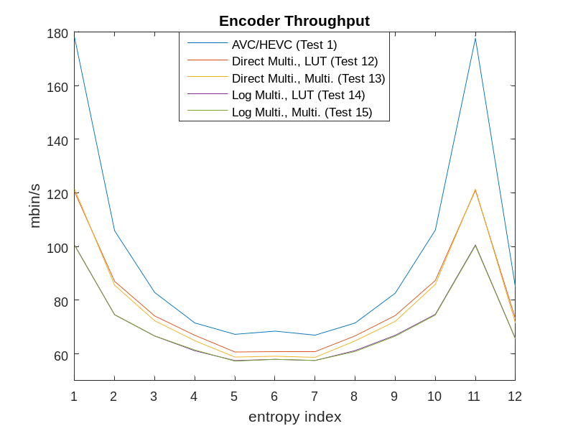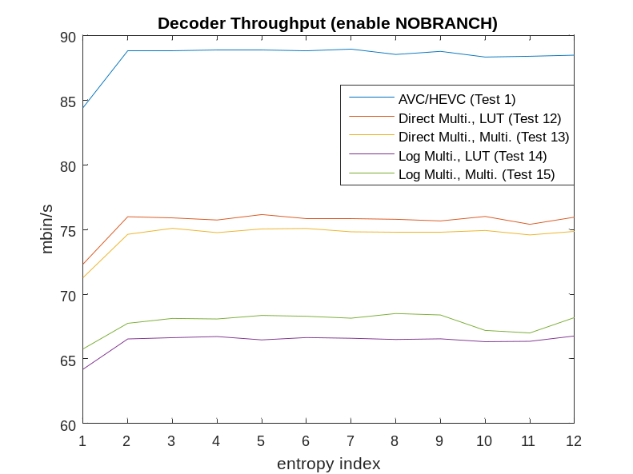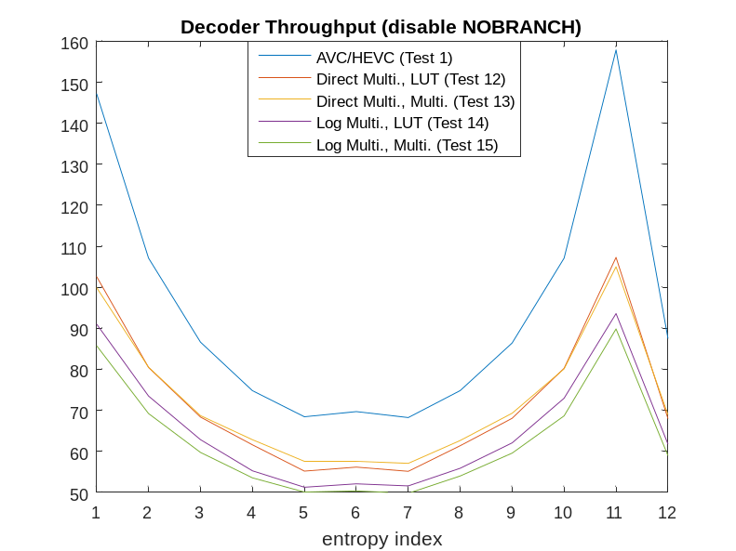

Reference
- H. Kirchhoffer, A. Said, “Description of Core Experiment 5 (CE5): Arithmetic Coding Engine,” JVET-L1025, 12th Meeting, Macao, China, October 2018.
- https://vcgit.hhi.fraunhofer.de/JVET-L-CE5/VVCSoftware_VTM/tree/CE5.2

