    Joint Video Experts Team (JVET)  of ITU-T SG 16 WP 3 and ISO/IEC JTC 1/SC 29/WG 11  13th Meeting: Marrakech, MA, 9–18 Jan. 2019 | Document: JVET-M0447-v1

Title: | CE9: Constrained intra prediction with DMVR (test 9.2.4)
Status: | Input document to JVET
Purpose: | Proposal
Author(s) or  Contact(s): | Meng Xu, Xiang Li, Shan Liu | Tel:  Email: | {mengxxu, xlxiangli, shanl}@tencent.com
Source: | Tencent
_____________________________

Abstract
Decoder side motion vector refinement (DMVR) techniques were proposed to refine the motion vectors at decoder side after parsing stage. As intra prediction may depend on the results of its spatial neighbor’s full reconstruction, it cannot be started until the MV derivation process and the final reconstruction are finished for the neighboring blocks, which leads to serious latency in hardware pipeline. It is reported that the issue can be resolved with the method proposed in this contribution.

Introduction
DMVR is proposed to refine the motion vectors at the decoder side. It shows good coding performance and is studied in CE9.2. However, it leads to high dependency between the intra prediction of the current block and the final reconstruction of the previous block, which leads to pipeline latency issue in hardware design.
In VTM, constrained_intra_prediction_flag is signaled in the PPS, which takes value of 0 or 1. When it is equal to 1, the reconstruction samples of inter blocks are prohibited to be used as the reference in the intra prediction of a neighboring block. When it is equal to 0, such prediction is allowed.
With constrained_intra_prediction_flag equal to 0, a hypothetical decoder implementation for an intra prediction may contain three pipeline stages, as shown in Figure 1.

Figure 1 hypothetical pipeline for intra prediction
When DMVR is turned on, the decoding of an intra block may require an additional pipeline stage for the DMVD, as shown in Figure 2. Since motion search is involved in DMVR and it is quite time-consuming, it would significantly increase the pipeline latency for the intra prediction.

Figure 2 hypothetical pipeline for intra prediction with DMVD
In JVET-L0314, it is proposed that constrained_intra_prediction_flag may be equal to 0, 1, or 2. When it is equal to 0 or 1, the behavior is the same as in VTM. When it is equal to 2, the intra prediction may come from intra or inter coded neighboring blocks where DMVR is not applicable. By allowing constrained intra prediction with DMVR, in addition to removing this pipeline dependency, it also helps to reduce the error propagation when at least one of the DMVR reference blocks is reconstructed in error.

Proposed method
The method proposed in JVET-L0314 is tested in CE9.2.4. Since there is no signaling for DMVR, and it is possible that the final MV of a block is unchanged after MV refinement, unfortunately, it is difficult to distinguish whether the refined MV would be different from unrefined MV without actual MV refinement. Therefore, DMVR for a neighboring block CU_neib is considered applicable if all the following conditions are true in VTM-3.0 DMVR base software.
- CU_neib is in merge mode but not in MMVD
- CU_neib is not affine
- CU_neib has two valid but different reference frames from different directions with equal distance
- CU_neib satisfies certain restrictions (height >= 8, size >= 64, and size <= 1024)

Simulation results
The proposed method is implemented on top of VTM-3.0 DMVR base software. The methods were tested with constrained_intra_prediction_flag equal to 0, 1, and 2.

Test with constrained_intra_prediction_flag=0
Reference: VTM-3.0
Test: VTM-3.0 + DMVR + constrained_intra_prediction_flag=0
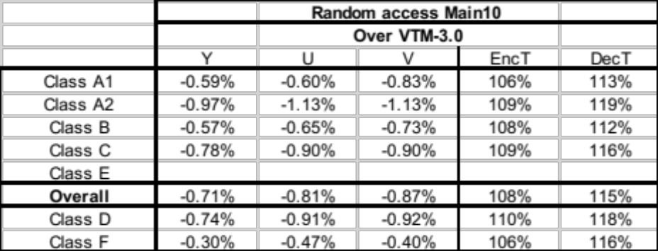
In VTM-3.0 DMVR base software, the default value for constrained_intra_prediction_flag is 0. Thus the result of this test is the same as the VTM-3.0 DMVR base software.

Test with constrained_intra_prediction_flag=1
Reference: VTM-3.0
Test: VTM-3.0 + DMVR + constrained_intra_prediction_flag=1
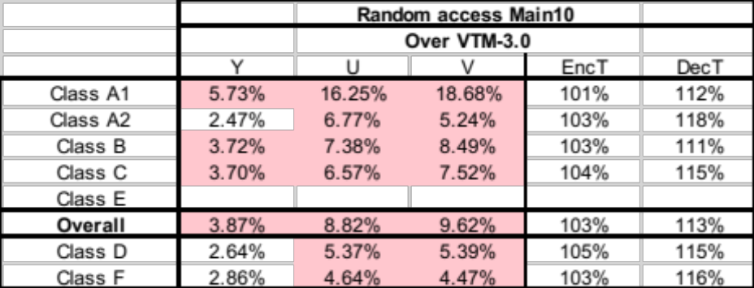
When the intra prediction dependency with inter blocks is completely removed, it shows 3.87% loss on average for luma compared with VTM-3.0.

Test with constrained_intra_prediction_flag=2
Reference: VTM-3.0
Test: VTM-3.0 + DMVR + constrained_intra_prediction_flag=2
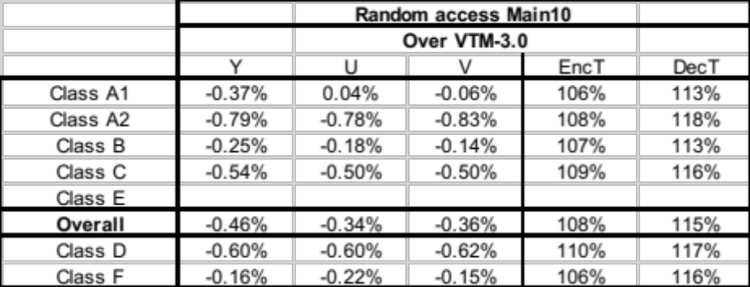
When only the dependency between the intra block and the DMVR coded block is removed, it achieves 0.46% coding gain on average for luma.

Conclusion
An issue in the interaction of intra prediction and decoder side motion vector derivation methods is identified in this contribution, i.e., the MV refinement process imposes dependency between the intra prediction of the current block and the final reconstruction of the neighboring DMVR coded block which leads to serious delay issue in hardware pipeline design. A method to break such dependency is proposed. Simulations shows that the latency issue is solved with around 0.46% BD-rate gain on luma on average for DMVR compared with VTM-3.0.

References
- “JVET common test conditions and software reference configurations for SDR video,” F. Bossen, J. Boyce, X. Li, V. Seregin, K. Sühring, JVET-L1010.
- “Description of Core Experiment 9 (CE9): Decoder-side motion derivation,” X. Xiu, S. Esenlik, JVET-L1029.
- “CE9-related: Constrained intra prediction with decoder side motion vector derivation,” M. Xu, X. Li, S. Liu, JVET-L0314.
- “Versatile Video Coding (Draft 3)”, B. Bross, J. Chen, S. Liu, JVET-L1001.

Patent rights declaration(s)
Tencent may have current or pending patent rights relating to the technology described in this contribution and, conditioned on reciprocity, is prepared to grant licenses under reasonable and non-discriminatory terms as necessary for implementation of the resulting ITU-T Recommendation | ISO/IEC International Standard (per box 2 of the ITU-T/ITU-R/ISO/IEC patent statement and licensing declaration form).

