    Joint Video Experts Team (JVET)  of ITU-T SG 16 WP 3 and ISO/IEC JTC 1/SC 29/WG 11  13th Meeting: Marrakech, MA, 9–18 Jan. 2019 | Document: JVET-M0388

Title: | AHG12/AHG17: On merging of MCTSs for viewport-dependent streaming
Status: | Input document to JVET
Purpose: | Proposal
Author(s) or  Contact(s): | Miska M. Hannuksela  Nokia Technologies, Tampere, Finland | Email: | firstname.lastname@nokia.com
Source: | Nokia
_____________________________

Abstract
Viewing orientation changes in viewport-dependent 360° video streaming are conventionally handled by refreshing the entire 360° coverage with a random-access picture. It is asserted that a viewing orientation change could be handled more efficiently in terms of streaming rate-distortion performance and with less fluctuation in streaming bitrate when only the motion-constrained tile sets (MCTSs) in which the picture quality changes are refreshed with MCTSs from random-access pictures. Thus, the contribution proposes a design goal that the VVC design should enable a way to merge MCTSs originating from a random-access picture and MCTSs originating from a non-random-access picture into the same coded picture without substantial difficulty (e.g., without VLC-level modifications).
Three options are proposed to meet the proposed design goal, for which the nicknames and implications in the VVC design are included below:
- NAL unit header rewriting approach.
The syntax of VCL NAL units is kept independent of the nal_unit_type value. In particular, the VCL NAL unit syntax for all NAL unit types, including IDR, contains syntax elements for reference picture management.
- Picture type indicated in a picture header.
Only one VCL NAL unit type is specified and indicates a tile group VCL NAL unit.
A picture header is present and includes a picture type syntax element differentiating between picture types (e.g. IDR_N_LP, IDR_W_RADL, CRA, STSA, TRAIL, RADL, RASL). The picture type syntax element should be fixed-length-coded and in such a fixed position in the picture header that is not preceded by start code emulation prevention bytes under any circumstances.
- Sub-picture-based partitioning and decoding as proposed in JVET-M0261.
Sub-pictures of the same coded picture are allowed to have different nal_unit_type values.

Introduction

Background: agreed design goal for repositioning and merging MCTSs
The handling of JVET-L0182 in the Macau meeting lead to an agreement to have the following design goal subject to having a solution that does not have a large impact on complexity or coding efficiency:
Extracting VCL NAL units of a subset of MCTSs from one VVC bitstream and reposition them to another VVC bitstream without substantial difficulty (e.g., without VLC-level modifications)

Background: MCTS-based region-wise mixed-quality (RWMQ) viewport-dependent streaming
The example is adapted from clause D.4.2 of OMAF [1] and illustrated in Figure 1. A 4×2 tile grid has been used in forming of the motion-constrained tile sets for equirectangular projected pictures. Two HEVC bitstreams originating from the same source content are encoded at different picture qualities and bitrates. Each motion-constrained tile set sequence is included in one sub-picture track. The OMAF player chooses the quality at which each sub-picture track is received based on the viewing orientation. In this example the OMAF player receives sub-picture tracks 1, 2, 5, and 6 at a particular quality and sub-picture tracks 3, 4, 7, and 8 at another quality. In the Segment decapsulation process, the NAL units are decapsulated from the received Segments and merged to a bitstream to be decoded.
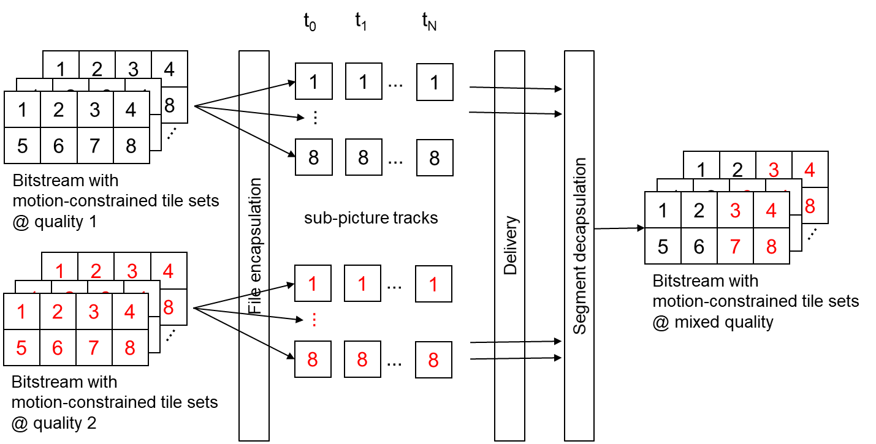
Figure 1. Example of MCTS-based RWMQ viewport-dependent 360° streaming.

Background: representations with different stream access point intervals
Viewport switching in viewport-dependent streaming is enabled at stream access points, which involve intra coding and hence a greater bitrate compared to respective inter coded pictures at the same quality. A compromise between the stream access point interval and the rate-distortion performance is hence chosen in an encoding configuration.
DASH allows creating Representations of a different stream access point interval. The RandomAccess element enables indicating intervals of stream access points for Segments flexibly and the SegmentIndexBox can be used for the same purpose for Subsegments. A content author may provide the same content at several quality and at several stream access point intervals. Segments or Subsegments have the same duration across the different Representations; i.e. they are time aligned.
Figure 2 and the related description below extend the example given in clause D.4.2 of OMAF by including versions at another random-access interval. The figure and the description are simplified versions of those in clause D.10 of OMAF v2 WD (MPEG N17963) [2], excluding discussion of extractor tracks (specific to HEVC file encapsulation) and some details on file format and DASH metadata.
- Encoding: Four versions of the content are generated using either MCTS-based content authoring or sub-picture-based content authoring, as described in clause D.4.2 of OMAF:
  - Bitstream 1 (black): Quality 1, IDR picture interval t_{M}
  - Bitstream 2 (blue): Quality 1, IDR picture interval t_{N} where N is an integer multiple of M
  - Bitstream 3 (green): Quality 2, IDR picture interval t_{M} where M is the same as that in bitstream 1
  - Bitstream 4 (red): Quality 2, IDR picture interval t_{N} where N is the same as that in bitstream 2
The picture output order and the picture decoding order are kept respectively identical in all the four bitstreams.
- Encapsulation of coded data: Each motion-constrained tile set sequence is included in one sub-picture track.
- MPD generation: Each track forms a Representation in the MPD. The random-access interval is indicated in the MPD with RandomAccess@interval.
- Example player behavior: The player first selects sub-picture Representations with the greater random-access interval value (t_{N} in this example), assuming that it would provide a better rate-distortion performance. When a viewing orientation switch causing a new selection of high-quality sub-picture tracks takes place, the player switches to the sub-picture Representations with random-access interval equal to t_{M} for the remaining of the interval of duration t_{N}. For the next interval of duration t_{N}, this process is repeated, i.e. the player first selects the sub-picture Representations with the greater random-access interval value.
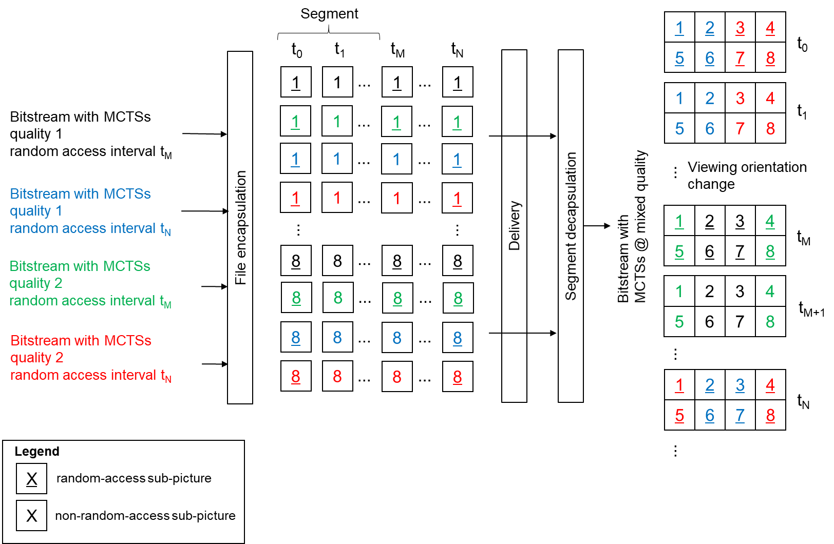
Figure 2. Merging of MCTS-based sub-picture tracks of the same resolution and switching between Representations of a different stream access point interval

Problem statement
The viewing orientation moves gradually in typical viewing situations, the quality changes in only a subset of the sub-picture locations in RWMQ viewport-dependent streaming. For example, in the 4×2 example provided above it is likely that the quality changes in half of the sub-pictures. It is asserted that updating all sub-picture locations with Segments starting with a random-access picture is inefficient in terms of streaming rate-distortion performance and causes a large fluctuation in bitrate, which might cause an interruption in the playback for rebuffering or could be compensated by a sufficiently long initial buffering delay.
It is noted that it has been found that a greater number of MCTSs has been found more advantageous than the 4×2 MCTS grid [3]. The share of MCTSs that need to be updated in quality in response to a viewing orientation change is likely to be lower when the MCTS grid is finer.
Section 2.2 of JVET-M0259 presents a similar analysis as above but for the region-wise mixed-resolution (RWMR) viewport-dependent streaming.

Desired player operation
The desired operation of the player is illustrated in Figure 3 and described as follows: The player first selects sub-picture Representations with the greater random-access interval value (t_{N} in this example), assuming that it would provide a better rate-distortion performance. When a viewing orientation switch causing a new selection of high-quality sub-picture tracks takes place, the player switches to the Representations with random-access interval equal to t_{M} only for those sub-picture Representations where the picture quality changes for the remaining of the interval of duration t_{N}. For the next interval of duration t_{N}, this process is repeated, i.e. the player first selects the sub-picture Representations with the greater random-access interval value.
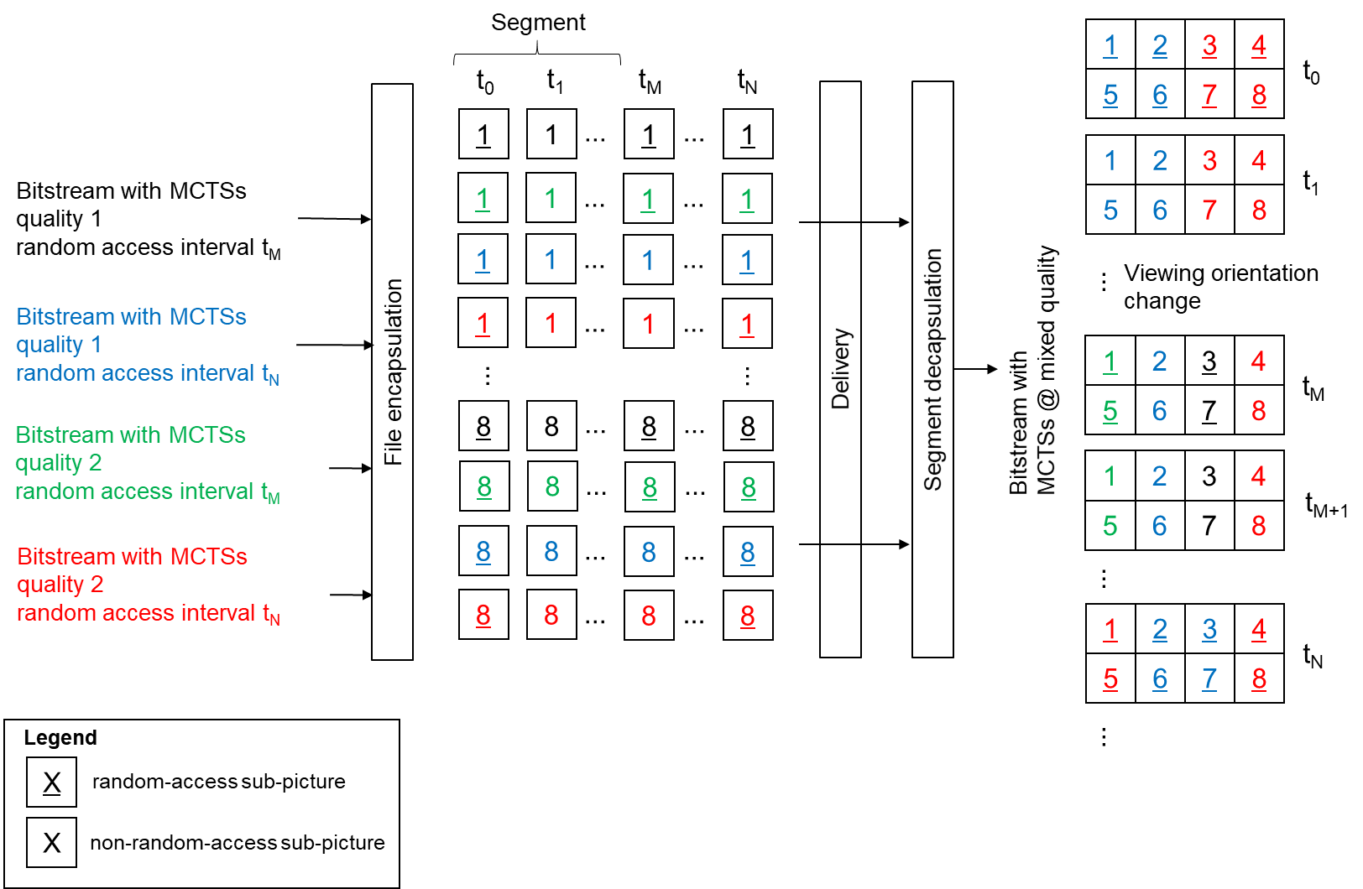
Figure 3. Merging of MCTS-based sub-picture tracks of the same resolution and switching between Representations of a different stream access point interval individually on sub-picture basis

Design goal
The following challenges exist in AVC and HEVC for obtaining a conforming bitstream as a result of the target player behavior.
- As can be observed from the figure the picture at t_{M} contains VCL NAL units from random-access pictures and non-random-access pictures. However, it is required in AVC and HEVC to use the same VCL NAL unit type in all slices of the same coded picture.
- The syntax of NAL units in AVC and HEVC depends on the NAL unit type. Particularly, no_output_of_prior_pics_flag is present only for IRAP pictures and the presence on syntax elements related to reference picture management depends on whether an IDR NAL unit type is indicated. Thus, in AVC and HEVC, rewriting VCL NAL units from one NAL unit type to another NAL unit type may require changes in slice header.
Thus, it is proposed that the VVC design should enable a way to merge MCTSs originating from a random-access picture and MCTSs originating from a non-random-access picture into the same coded picture without substantial difficulty (e.g., without VLC-level modifications).
It is remarked that the systems layer (e.g. OMAF) is expected to provide the signalling whether MCTSs or sub-picture tracks can be merged. For example, two sub-picture tracks can be merged only if they have the same prediction structure and keep the same pictures marked as "used for reference".

Proposal
The following options are proposed in this contribution:
- NAL unit header rewriting approach.
Required changes or design choices in VVC: The syntax of VCL NAL units is kept independent of nal_unit_type value. In particular, the VCL NAL unit syntax for all NAL unit types, including IDR, contains syntax elements for reference picture management.
Player operation: When MCTSs originating from a random-access picture and MCTSs originating from a non-random-access picture are merged into the same coded picture, the player rewrites nal_unit_type in the VCL NAL unit headers to indicate a non-random-access picture.
- Picture type indicated in a picture header.
Required changes or design choices in VVC:
- Only one VCL NAL unit type is specified and indicates a tile group VCL NAL unit.
- A picture header is present and includes a picture type syntax element differentiating between picture types (e.g. IDR_N_LP, IDR_W_RADL, CRA, STSA, TRAIL, RADL, RASL). The picture type syntax element should be fixed-length-coded and in such a fixed position in the picture header that is not preceded by start code emulation prevention bytes under any circumstances.
Player operation: When MCTSs originating from a random-access picture and MCTSs originating from a non-random-access picture are merged into the same coded picture, the player re uses the picture header from the non-random-access picture for the merged coded picture.
- Sub-picture-based partitioning and decoding as proposed in JVET-M0261.
Required changes or design choices in VVC: Sub-pictures of the same coded picture are allowed to have different nal_unit_type values. As discussed in JVET-M0261, sub-pictures are treated like pictures in the decoding process.
Player operation: The player does not modify VCL NAL units originating from different bitstreams when merging them into the same coded picture.
If sub-picture-based partitioning and decoding is chosen for achieving MCTS-like functionality in VVC, the author prefers option 3. Otherwise, the author expresses no preference between options 1 and 2, since they are similar in terms of tile group header syntax and player operation.

References
- MPEG N17563, "Second revised text of ISO/IEC FDIS 23090-2," April 2018.
- MPEG N17963, " WD 3 of ISO/IEC 23090-2 OMAF 2nd edition," October 2018.
- Q. Xie, "OMAF VDC-CE Report," MPEG M40638, April 2017.

Patent rights declaration(s)
Nokia may have current or pending patent rights relating to the technology described in this contribution and, conditioned on reciprocity, is prepared to grant licenses under reasonable and non-discriminatory terms as necessary for implementation of the resulting ITU-T Recommendation | ISO/IEC International Standard (per box 2 of the ITU-T/ITU-R/ISO/IEC patent statement and licensing declaration form).

