    Joint Video Experts Team (JVET)  of ITU-T SG 16 WP 3 and ISO/IEC JTC 1/SC 29/WG 11  13th Meeting: Marrakech, MA, 9–18 Jan. 2019 | Document: JVET-M0381

Title: | CE2: On Subblock Merge index coding (Test CE2.2.2)
Status: | Input document to JVET
Purpose: | Proposal
Author(s) or  Contact(s): | Guillaume Laroche  Christophe Gisquet  Patrice Onno  Jonathan Taquet  Canon Research Centre France  Rue de la Touche Lambert  35510 CESSON-SEVIGNE, FRANCE | Tel:  Email: | +33 299876800  guillaume.laroche@crf.canon.fr
Source: | Canon
_____________________________

Abstract
This contribution reports the results of both tests CE2.2.2.a and CE2.2.2.b related to the reduction of CABAC contexts for Subblock Merge index. In the test CE2.2.2.a only the first bit of the subblock Merge index is CABAC codded compared to the VTM3.0 where each bit of Subblock Merge index is CABAC coded.
In the second test CE2.2.2.b as CE2.2.2.a only the first bit of the Subblock Merge index is CABAC coded. The difference is that its context is shared with the one used to code the regular Merge index.
An average Luma BDR is reported compared to VTM3.0 of 0.00%, 0.03%, -0.04% for respectively RA, LD and LDP configurations for test 2.2.2.a. And an average Luma BDR is reported compared to VTM3.0 of 0.07%, 0.05%, 0.01% for respectively RA, LD and LDP configurations for test 2.2.2.b.

Introduction
The VTM 3.0 contains the Subblock Merge. This mode introduces additional contexts for the coding of its Merge candidate. Indeed the Merge index is coded with a unary max code and each bit has its own CABAC context. By considering that the maximum Merge candidate for the Subblock Merge is limited to 5, this new Merge adds 4 new contexts to encode the subblock Merge index candidate compared to the regular Merge mode which uses only one context. The following table summarizes the difference to encode a regular Merge index and a Subblock Merge index.

Table 1 Number of contexts for Merge index coding and Subblock Merge index coding
 | Number of contexts
Merge index bits position | Merge index | Subblock Merge
0 | 1 | 1
1 | Bypass | 1
2 | Bypass | 1
3 | Bypass | 1
4 | Bypass | n.a.
Total contexts | 1 | 4
Total contexts | 5

Test CE2.2.2.a: One context for Subblock Merge index
In test CE2.2.2.a, only the first bit of the subblock Merge index has a context and the other bits are CABAC bypass as depicted in Table 2. This removed 3 contexts.

Table 2 Number of contexts for Merge index coding and Subblock Merge index coding for CE2.2.2.a
 | Number of contexts
Merge index bits position | Merge index | Subblock Merge
0 | 1 | 1
1 | Bypass | Bypass
2 | Bypass | Bypass
3 | Bypass | Bypass
4 | Bypass | n.a.
Total contexts | 1 | 1
Total contexts | 2

Test CE2.2.2.b: One context for both Subblock Merge index and regular Merge index
Test CE2.2.2.b includes test CE2.2.2.a. In addition, the context of the first bin of the Subblock Merge index is shared with the context of the first bin of the regular Merge index as depicted in Table 3. Consequently, both indexes have the same design except the maximum number of candidates. This experiment removed 4 contexts compared to VTM3.0.

Table 3 Number of contexts for Merge index coding and Subblock Merge index coding for CE2.2.2.a
 | Number of contexts
Merge index bits position | Merge index | Subblock Merge
0 | 1 | 0 (share)
1 | Bypass | Bypass
2 | Bypass | Bypass
3 | Bypass | Bypass
4 | Bypass | n.a.
Total contexts | 1 | 0
Total contexts | 1

Experimental results

Test CE2.2.2.a:
Table 4 gives the results of CE2.2.2.a. The results show no change of coding efficiency for RA configuration. And only 0.03% BDR loss for LD configuration. For LDP configuration a minor BDR gain of -0.04% is obtained.

Table 4 Results of Test CE2.2.2.a 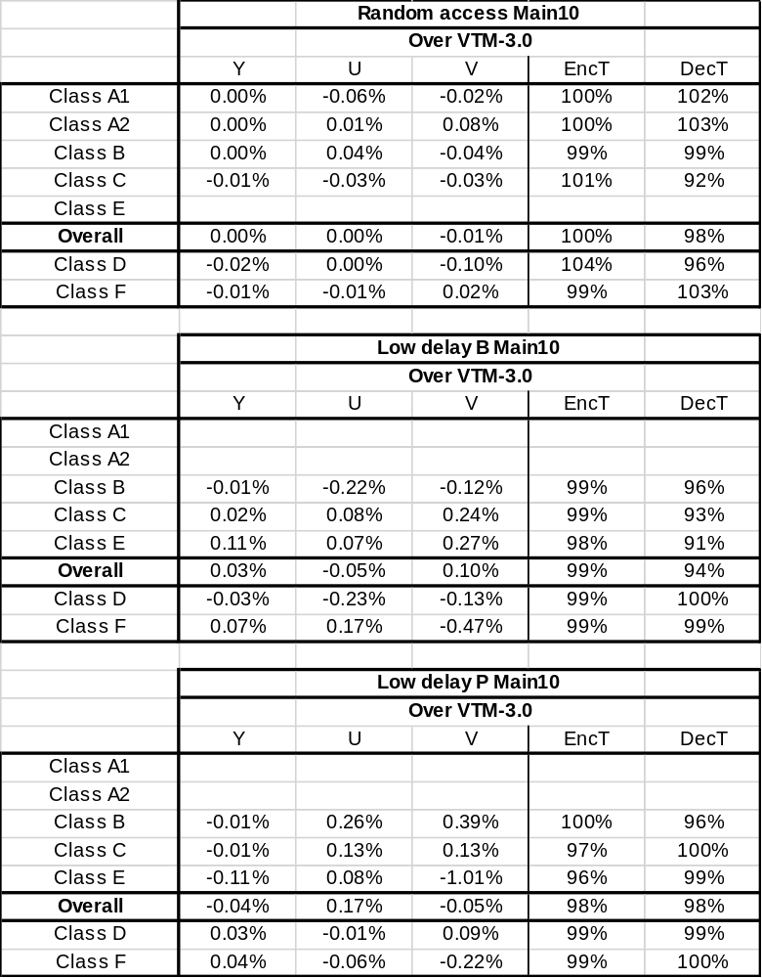

Test CE2.2.2.b:
Table 5 gives the results of CE2.2.2.b where only one context is used for both subblock Merge index and regular Merge index. This test gives losses compared to the previous one but these losses are minor with Luma BDR of 0.05%, 0.10% and 0.08% for RA, LD and LDP configurations.

Table 5 Results of Test CE2.2.2.b 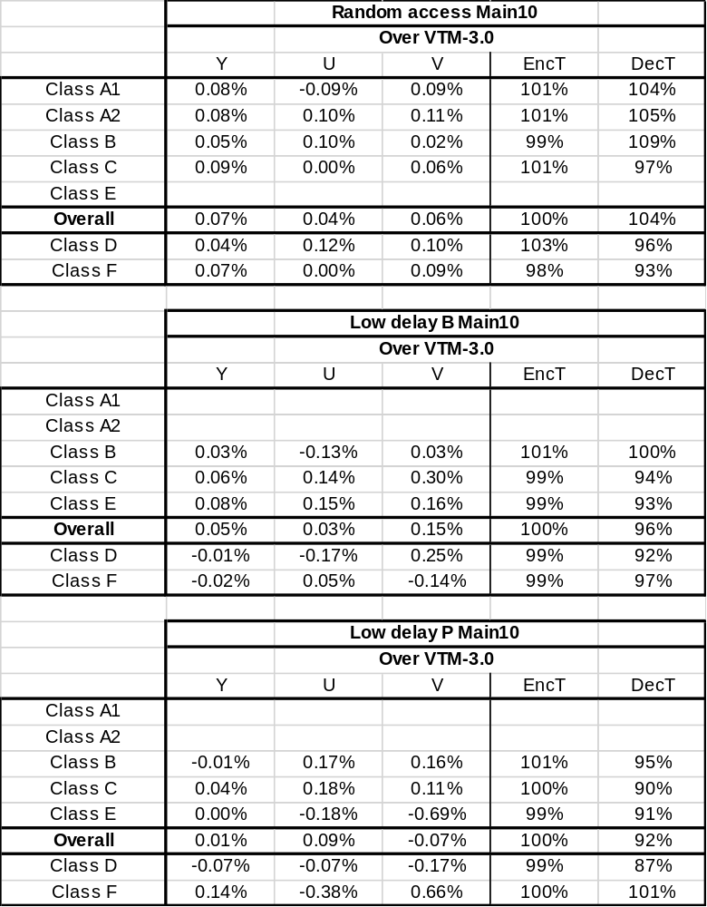

Conclusion
In this contribution, the results of both CE2.2.2.a and CE2.2.2.b are reported. Both tests are related to the reduction of the amount of contexts for subblock Merge index. In CE2.2.2.a the amount of contexts for subblock Merge index is reduced from 4 to 1 context. The impact on coding efficiency is minor.
The second test CE2.2.2.b includes the first test and the amount of contexts dedicated to Subblock Merge index is reduced to 0. Yet the first bin of the subblock Merge index shares its context with the regular Merge index. With this test CE2.2.2.b exactly the same decoding process is applied to both regular and subblock Merge index except the maximum number of candidates which is different (5 for subblock Merge and 6 for Merge). In term of results, this second test gives a little bit more losses than the previous one but reaches in maximum 0.07% BDR losses for RA configuration.
According to the minor impact on coding efficiency, the complexity reduction and the design simplification, we recommend to adopt CE2.2.2.b for the next VTM software.

Patent rights declaration(s)
Canon Research Centre France may have current or pending patent rights relating to the technology described in this contribution and, conditioned on reciprocity, is prepared to grant licenses under reasonable and non-discriminatory terms as necessary for implementation of the resulting ITU-T Recommendation | ISO/IEC International Standard (per box 2 of the ITU-T/ITU-R/ISO/IEC patent statement and licensing declaration form).

