    Joint Video Experts Team (JVET)  of ITU-T SG 16 WP 3 and ISO/IEC JTC 1/SC 29/WG 11  13th Meeting: Marrakech, MA, 9–18 Jan. 2019 | Document: JVET-M0363

Title: | CE13: HEC with in-loop filters using spherical neighbors (Test 1.3)
Status: | Input document to JEVT
Purpose: | Proposal
Author(s) or  Contact(s): | Sheng-Yen Lin, Lin Liu, Jian-Liang Lin, Yung-Chang Chang, Chi-Cheng Ju  No. 1, Dusing Rd. 1, Hsinchu Science Park, Hsinchu, Taiwan 30078 | Tel:  Email: | Jian-Liang Lin  +886-3-5670766 ext. 25250  {Sheng-Yen.Lin, Lin.Liu, jl.lin, yc.zhang,cc.ju}@mediatek.com
Source: | MediaTek Inc.
_____________________________

Abstract
This contribution reports the experiment results of Test 1.3.a, 1.3.b and 1.3.c in CE13: HEC with in-loop filters using spherical neighbors. In terms of end-to-end WS-PSNR-Y/U/V, the experimental results reportedly demonstrate that Test 1.3.a, 1.3.b and 1.3.c achieve an average -0.61%/-0.63%/-0.56%, -0.64%/-0.67%/-0.63% and -0.63%/-0.64%/-0.61% BD-rate saving, respectively, compared to PHEC with in-loop filters disabled across face discontinuities, and achieve an average -0.62%/-0.92%/-0.69%, -0.65%/-0.96%/-0.77% and -0.64%/-0.93%/-0.74% BD-rate saving, respectively, compared to PHEC. In addition, the subjective quality are enhanced by alleviating the seam artifacts across face discontinuities.

Introduction
In the last meeting, Core Experiment 13 (CE13) [1] was established to study removing subjective artifacts at face boundaries for the 360° video category. This contribution reports the results for the in-loop filters, including the de-blocking filter, sample adaptive offset (SAO) filter and the adaptive loop filter (ALF), using spherical neighbors proposed in JEVT-J0019 [2], JVET-K0142 [3] and JVET-L0349 [4]. In CE13.1.3, there are three tests as described in Table I.

Table I. The description of the tests in Test 1.3
Test # | Description
1.3 | HEC with in-loop filters using spherical neighbors  - Deblocking using spherical neighbors, SAO and ALF disabled across face discontinuities  - Deblocking and ALF using spherical neighbors, SAO disabled across face discontinuities  - All in-loop filters using spherical neighbors

Proposed Method

In this contribution, the in-loop filters, including the de-blocking filter, sample adaptive offset (SAO) filter and adaptive loop filter (ALF), are performed necessarily changes to avoid inappropriately filtering at the layout boundary and/or the discontinuous edge. Based on the spherical continuity in 360° video, the in-loop filtering process makes use of the pixel data located at the spherical positions for filtering so that the discontinuous edge, as well as the frame boundary (layout boundary), can be appropriately processed.

De-blocking filter
Based on the concept of spherical continuity, the de-blocking filter fetches the spherical pixels located at another face for filtering when the filtered pixels cross the frame boundary (layout boundary) or the discontinuous edge as illustrated in Fig. 1. The spherical pixels are derived directly from the corresponding face without any interpolation and the boundary strength is set to 2 in the de-blocking filtering process.
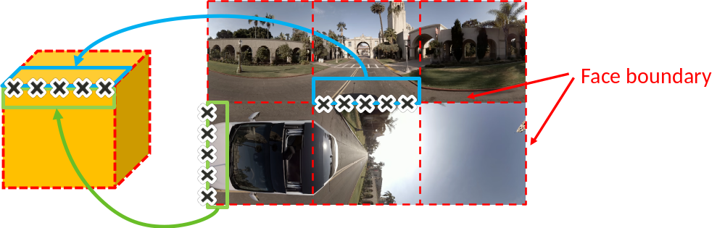
Fig. 1. Spherical pixels from another face for 360°-based de-blocking filter

SAO filter
When the referenced neighboring pixels of the current pixel in SAO filtering process cross the discontinuous edge, the proposed implementation uses the spherical pixels located at another face for SAO filtering as illustrated in Fig. 2. The pixel data in the spherical positions are copied directly from the corresponding face without any interpolation.
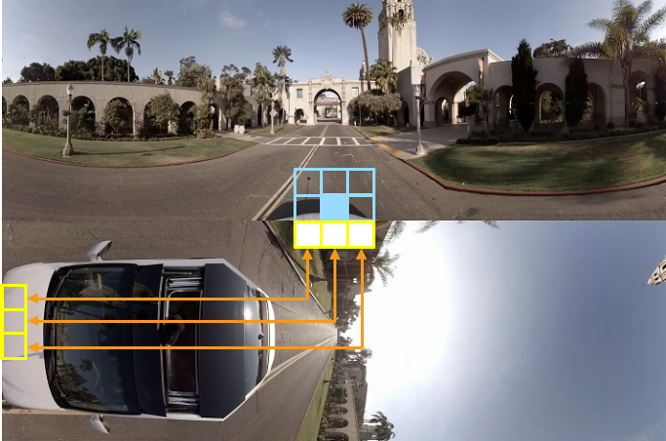
Fig. 2. Spherical pixels from another face for 360°-based SAO filter

Adaptive Loop Filter
In ALF, pixels are multiplied with the filter coefficients which are determined by the pixel classification methods and the Wiener filter approach. During the determination of the filter coefficients or the filtering process, the accessed pixels crossing the frame boundary (layout boundary) or the discontinuous edge are changed to directly copy the pixels data located at the spherical positions without any interpolation as illustrated in Fig. 3.
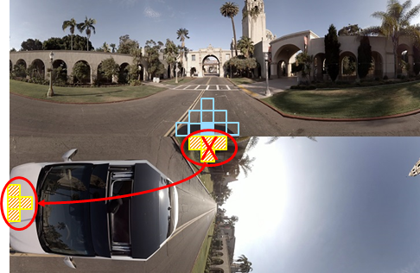
Fig. 3. Spherical pixels from another face for 360°-based ALF filter

Experimental Results
The tests of the proposed in-loop filters using spherical neighbors are conducted on the hybrid equi-angular cubemap (HEC) [5] layout. The software is implemented on 360Lib-8.0 [6] and VTM-3.0 [7] followed by the JVET common test conditions and evaluation procedures for 360° video [8]. The resolution of each face is set to 1280x1280, which yields the frame resolution is 3840x2560. As compared PHEC with in-loop filters disabled across face discontinuities and PHEC, the BD-rate performance in terms of end-to-end WS-PSNR provided by Test 1.3.a, Test 1.3.b, and Test 1.3.c are listed in Table II, Table III, and Table IV, respectively.

Table II. BD-rate performance for Test 1.3.a
 | CE Anchor :  PHEC with in-loop filters disabled across face discontinuities |  |  | CTC Anchor : PHEC
 | Y | U | V | Y | U | V
SkateboardInLot | -0.40% | -0.46% | -0.55% | -0.27% | -0.95% | -0.20%
ChairLift | -0.54% | -0.77% | -0.81% | -0.61% | -0.88% | -0.91%
KiteFlite | -0.61% | -0.45% | -0.32% | -0.64% | -0.43% | -0.44%
Harbor | -0.46% | -0.06% | -0.39% | -0.56% | -0.38% | -0.48%
Trolley | -0.81% | -0.51% | -0.23% | -0.85% | -0.63% | -0.47%
GasLamp | -0.64% | -0.54% | -0.51% | -0.71% | -0.69% | -0.70%
Balboa | -0.51% | -0.71% | -0.22% | -0.47% | -1.12% | -0.16%
Broadway | -0.47% | -1.02% | -0.37% | -0.41% | -1.08% | -0.49%
Landing2 | -0.72% | -0.70% | -0.99% | -0.76% | -2.06% | -1.98%
BranCastle2 | -0.94% | -1.13% | -1.21% | -0.93% | -0.97% | -1.10%
Class S1 | -0.58% | -0.46% | -0.47% | -0.60% | -0.66% | -0.54%
Class S2 | -0.66% | -0.89% | -0.70% | -0.64% | -1.31% | -0.93%
Overall | -0.61% | -0.63% | -0.56% | -0.62% | -0.92% | -0.69%

Table III. BD-rate performance for Test 1.3.b
 | CE Anchor :  PHEC with in-loop filters disabled across face discontinuities |  |  | CTC Anchor : PHEC
 | Y | U | V | Y | U | V
SkateboardInLot | -0.46% | -0.36% | -0.95% | -0.32% | -0.85% | -0.60%
ChairLift | -0.55% | -0.76% | -0.73% | -0.62% | -0.88% | -0.83%
KiteFlite | -0.63% | -0.45% | -0.32% | -0.66% | -0.43% | -0.45%
Harbor | -0.48% | -0.08% | -0.36% | -0.58% | -0.41% | -0.45%
Trolley | -0.82% | -0.51% | -0.21% | -0.85% | -0.63% | -0.46%
GasLamp | -0.68% | -0.56% | -0.54% | -0.74% | -0.71% | -0.73%
Balboa | -0.57% | -1.09% | -0.52% | -0.53% | -1.50% | -0.45%
Broadway | -0.50% | -0.91% | -0.61% | -0.43% | -0.98% | -0.74%
Landing2 | -0.74% | -0.89% | -0.99% | -0.79% | -2.25% | -1.97%
BranCastle2 | -0.95% | -1.09% | -1.11% | -0.94% | -0.93% | -1.00%
Class S1 | -0.60% | -0.46% | -0.52% | -0.63% | -0.65% | -0.59%
Class S2 | -0.69% | -1.00% | -0.81% | -0.67% | -1.41% | -1.04%
Overall | -0.64% | -0.67% | -0.63% | -0.65% | -0.96% | -0.77%

Table IV. BD-rate performance for Test 1.3.c
 | CE Anchor :  PHEC with in-loop filters disabled across face discontinuities |  |  | CTC Anchor : PHEC
 | Y | U | V | Y | U | V
SkateboardInLot | -0.41% | -0.40% | -0.60% | -0.28% | -0.89% | -0.25%
ChairLift | -0.53% | -0.62% | -0.68% | -0.60% | -0.74% | -0.78%
KiteFlite | -0.63% | -0.50% | -0.38% | -0.66% | -0.48% | -0.51%
Harbor | -0.47% | -0.08% | -0.32% | -0.57% | -0.40% | -0.41%
Trolley | -0.82% | -0.50% | -0.22% | -0.86% | -0.62% | -0.46%
GasLamp | -0.68% | -0.54% | -0.56% | -0.75% | -0.69% | -0.74%
Balboa | -0.52% | -0.95% | -0.72% | -0.48% | -1.36% | -0.65%
Broadway | -0.49% | -0.91% | -0.47% | -0.43% | -0.97% | -0.60%
Landing2 | -0.76% | -0.83% | -1.03% | -0.81% | -2.19% | -2.01%
BranCastle2 | -0.95% | -1.10% | -1.11% | -0.94% | -0.94% | -1.00%
Class S1 | -0.59% | -0.44% | -0.46% | -0.62% | -0.64% | -0.53%
Class S2 | -0.68% | -0.95% | -0.83% | -0.66% | -1.36% | -1.07%
Overall | -0.63% | -0.64% | -0.61% | -0.64% | -0.93% | -0.74%

Subjective Quality Testing
In Fig. 4 to Fig. 11, the cropped viewport images of HEC with in-loop filters disabled across face discontinuities, Test 1.3.a, Test 1.3.b and Test 1.3.c are demonstrated (under VTM-3.0 with QP = 37) in order to evaluate the seam artifacts appeared at discontinuous edges.

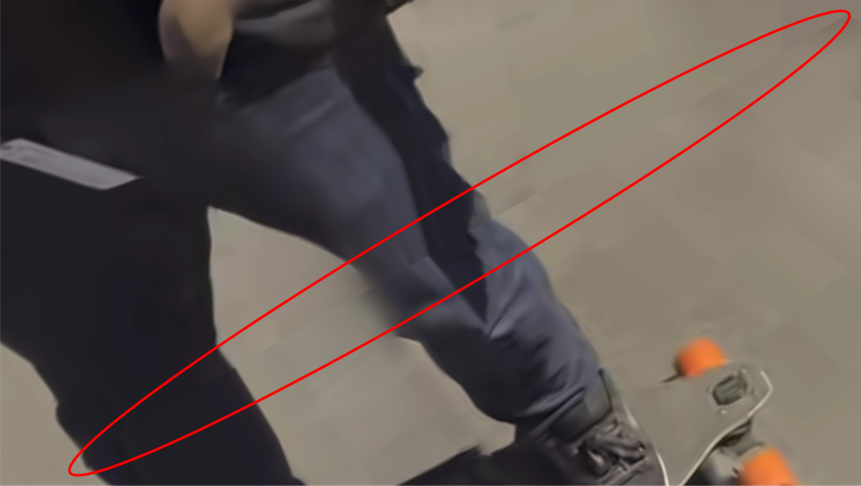
Fig. 4. The subjective quality of SkateboardInLot (frame 66) in HEC with in-loop filters disabled across face discontinuities. The image is cropped from the viewport centered in degree (45, -35).
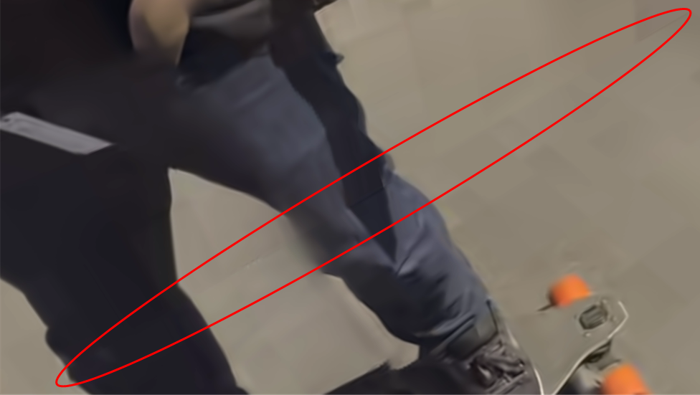
Fig. 5. The subjective quality of SkateboardInLot (frame 66) in Test 1.3.a. The image is cropped from the viewport centered in degree (45, -35).
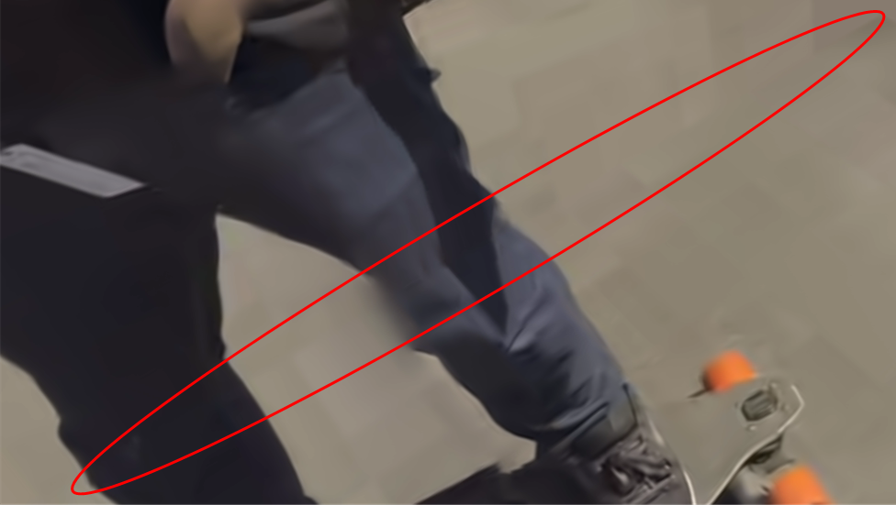
Fig. 6. The subjective quality of SkateboardInLot (frame 66) in Test 1.3.b. The image is cropped from the viewport centered in degree (45, -35).
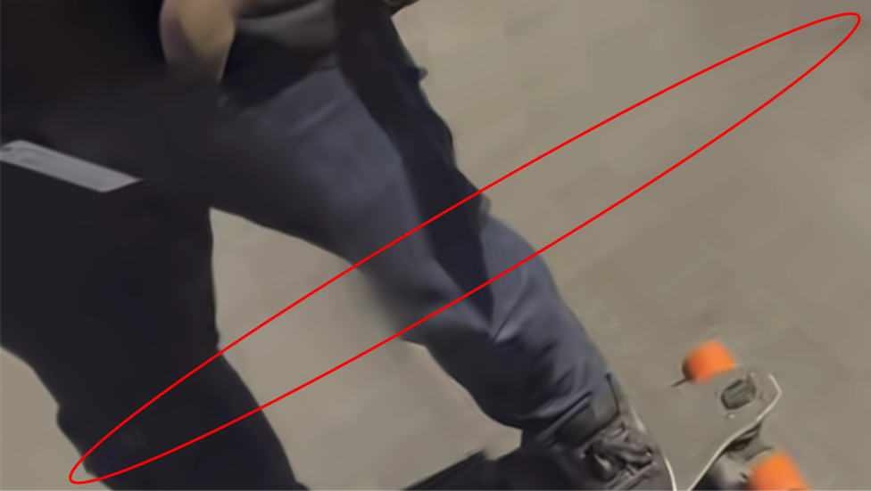
Fig. 7. The subjective quality of SkateboardInLot (frame 66) in Test 1.3.c. The image is cropped from the viewport centered in degree (45, -35).
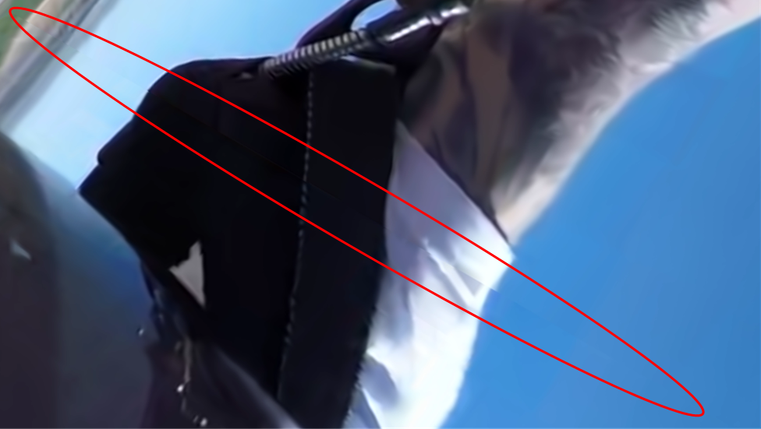
Fig. 8. The subjective quality of Landing2 (frame 5) in HEC with in-loop filters disabled across face discontinuities. The image is cropped from the viewport centered in degree (45, -35).
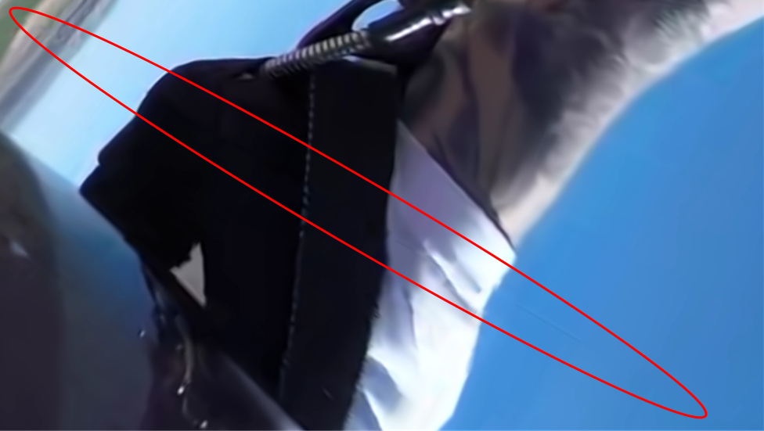
Fig. 9. The subjective quality of Landing2 (frame 5) in Test 1.3.a. The image is cropped from the viewport centered in degree (45, -35).
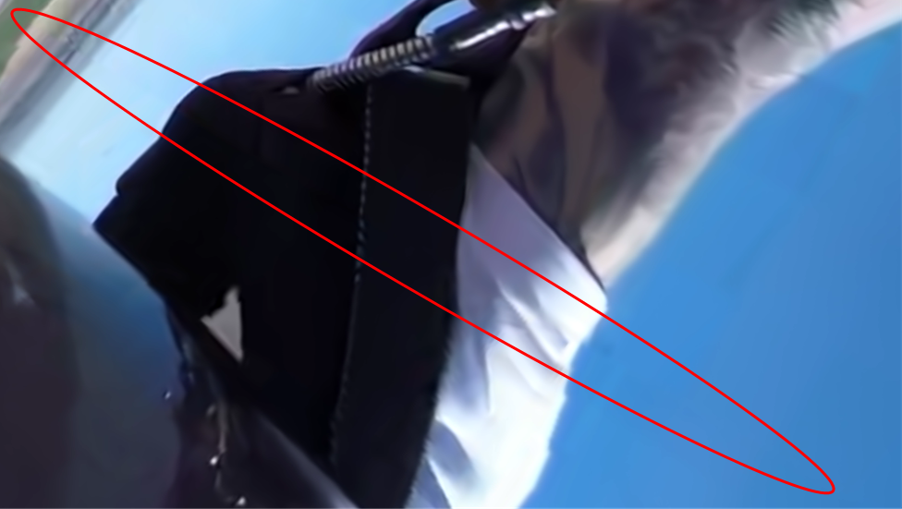
Fig. 10. The subjective quality of Landing2 (frame 5) in Test 1.3.b. The image is cropped from the viewport centered in degree (45, -35).
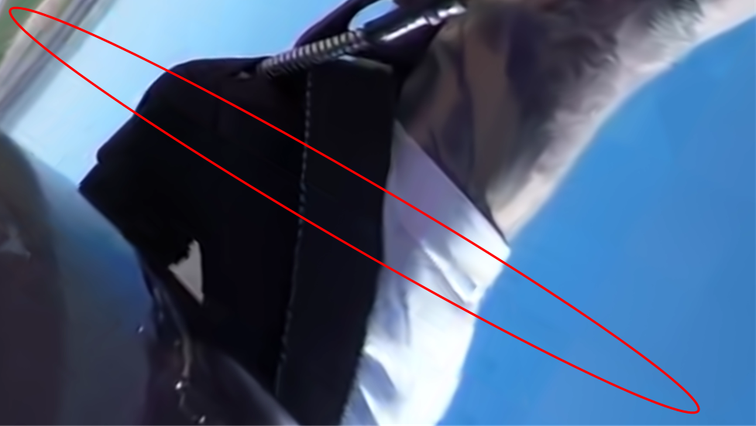
Fig. 11. The subjective quality of Landing2 (frame 5) in Test 1.3.c. The image is cropped from the viewport centered in degree (45, -35).

Conclusion
In this contribution, the performance of Test 1.3.a, 1.3.b and 1.3.c are investigated. The conventional in-loop filters are modified to avoid improper filtering at the discontinuous edge. The experimental results demonstrate that the compression efficiency of the proposed methods are improved. In addition, the proposed methods reduce the visible seam artifacts compared to HEC with in-loop filters disabled across face discontinuities.

References
- P. Hanhart, J.-L. Lin, and C. Pujara, “Description of Core Experiment 13 (CE13): Coding tools for 360° omnidirectional video,” Joint Video Exploration Team of ITU-T SG16 WP3 and ISO/IEC JTC1/SC29/WG11, JVET-L1033, Oct. 2018, Macau, CN.
- J.-L. Lin, Y.-H. Lee, C.-H. Shih, S.-Y. Lin, H.-C. Lin, S.-K. Chang, P. Wang, L. Liu, and C.-C. Ju, “Description of 360° video coding technology proposal by MediaTek,” Joint Video Exploration Team of ITU-T SG16 WP3 and ISO/IEC JTC1/SC29/WG11, JVET-J0019, Apr. 2018, San Diego, USA.
- S.-Y. Lin, L. Liu, C.-H. Shih, J.-L. Lin, H.-C. Lin, S.-K. Chang and C.-C. Ju, “AHG8: 360°-based in-loop filters for cubemap projection,” Joint Video Exploration Team of ITU-T SG16 WP3 and ISO/IEC JTC1/SC29/WG11, JVET-K0142, July 2018, Ljubljana, SI.
- S.-Y. Lin, L. Liu, J.-L. Lin, H.-C. Lin, S.-K. Chang, Y.-C. Chang and C.-C. Ju, “CE13: In-loop filters using spherical neighbors (Test 4.2),” Joint Video Exploration Team of ITU-T SG16 WP3 and ISO/IEC JTC1/SC29/WG11, JVET-L0349, Oct. 2018, Macao, CN.
- Y.-H. Lee, J.-L. Lin, S.-K. Chang and C.-C. Ju,”CE13: Modified Cubemap Projection in JVET-J0019 (Test 5),” Joint Video Exploration Team of ITU-T SG16 WP3 and ISO/IEC JTC1/SC29/WG11, JVET-K0131, July 2018, Ljubljana, SI.
- 360Lib, https://jvet.hhi.fraunhofer.de/svn/svn_360Lib/
- Versatile Video Coding Test Model, https://vcgit.hhi.fraunhofer.de/jvet/VVCSoftware_VTM
- P. Hanhart, J. Boyce, K. Choi and J.-L. Lin, “JVET common test conditions and evaluation procedures for 360° video,” Joint Video Exploration Team of ITU-T SG16 WP3 and ISO/IEC JTC1/SC29/WG11, JVET-L1012, Oct. 2018, Macau, CN.

Patent rights declaration(s)
MediaTek Inc. may have current or pending patent rights relating to the technology described in this contribution and, conditioned on reciprocity, is prepared to grant licenses under reasonable and non-discriminatory terms as necessary for implementation of the resulting ITU-T Recommendation | ISO/IEC International Standard (per box 2 of the ITU-T/ITU-R/ISO/IEC patent statement and licensing declaration form).

