    Joint Video Experts Team (JVET)  of ITU-T SG 16 WP 3 and ISO/IEC JTC 1/SC 29/WG 11  13th Meeting: Marrakech, MA, 9–18 Jan. 2019 | Document: JVET-M0297

Title: | CE6-related: 32 point MTS based on skipping high frequency coefficients
Status: | Input document to JVET
Purpose: | Proposal
Author(s) or  Contact(s): | Moonmo Koo  Mehdi Salehifar  Jaehyun Lim  Seung Hwan Kim  19 Yangjaedaero-11gil  Seocho-gu, Seoul 06772  South Korea | Tel:  Email: | +1-858-635-5226  moonmo.koo@lge.com  mehdi.salehifar@lge.com  jaehyun.lim@lge.com  seunghwan3.kim@lge.com
Source: | LG Electronics Inc.
_____________________________

Abstract
In JVET-L0132, reduced 32-point MTS (RMTS32) based on skipping high frequency coefficients was proposed and tested in the previous CE. Considering that 32-point MTS requires 64 multiplications per pixel and it becomes worst computational complexity, RMTS32 is proposed to reduce computational complexity as well as memory usage with reasonable performance degradation. Specifically two sub-tests are shown as follows;
- Test 1: RMTS32 always produces 16 coefficients for every 32-length row or column
- Test 2: Test 1 + residual coding part is adjusted to accommodate the region of non-zero coefficients
For Test 1, luma BD-rate changes are 0.12% (AI), 0.03% (RA), and 0.02 % (LD). The encoding/decoding time changes are 97%/94% (AI), 99%/99% (RA), and 100%/100% (LD).
For Test 2, luma BD-rate changes are 0.10% (AI), 0.00% (RA), and 0.05 % (LD). The encoding/decoding time changes are 97%/94% (AI), 99%/99% (RA), and 99%/98% (LD).

Proposed Method

  - 32-point MTS based on skipping high frequency coefficients (RMTS32):
RMTS32 was proposed in JVET-L0132 [1]: on top of existing zero-out that up-to top-left 32x32 region is kept, only left (top) half of coefficients are kept if block width (height) is greater than or equal to 32 when MTS flag is 1. Since this zero-out is applied to horizontal and vertical directions independently, RMTS32 is applied to all block shapes. The computational complexity of 32-point MTS in terms of operation count can be reduced by half with RMTS32. From the perspective of memory usage, only half of transform basis vectors in 32-point MTS matrices needs to be stored.
For the region where must be zero, residual coding can be skipped in such a way that the associated subblock flags are implicitly derived to be 0, and truncated unary binarization of last coefficient position can be also adjusted considering maximum feasible position. Therefore, in this contribution, one test (Test 2) with the above residual coding change and the other with residual coding untouched is performed.

  - Memory usage reduction for 32x32 DST-7/DCT-8 due to RMTS32:
The proposed RMTS32 always produces 16 coefficients for every 32-length row or column. Therefore, only first 16 transform basis vectors in 32x32 DST-7/DCT-8 need to be stored, which halves memory usage for storing 32-length DST-7/DCT-8. The memory size is to be reduced from 2KB to 1KB. Also, the amount of text for the associated spec description can be reduced accordingly.

Experimental results
The proposed method has been implemented based on VTM 3.0 reference software according to common test conditions defined in JVET-L1010 [2] and Core Experiment description in JVET-L1026 [3].

  - RMTS32 without residual coding change

2.1.1) Results with inter MTS off (CTC)

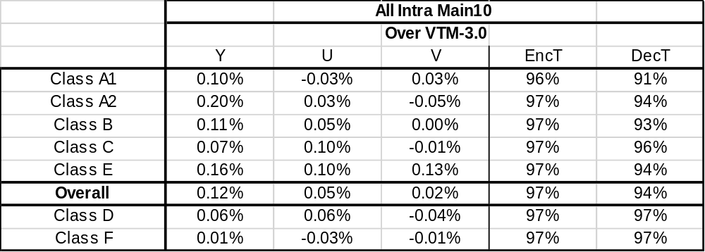

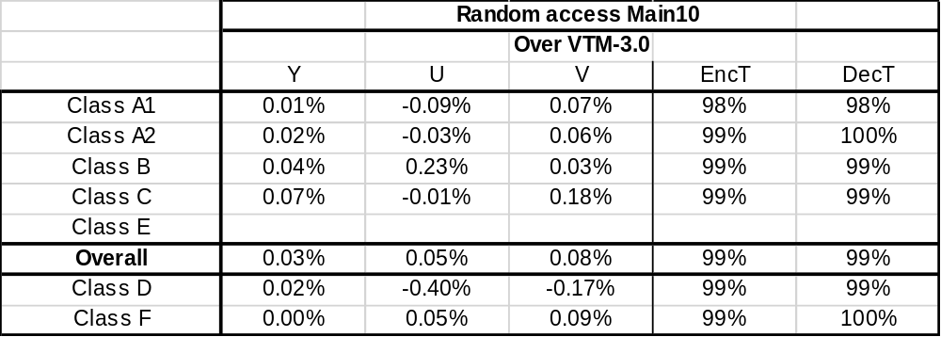

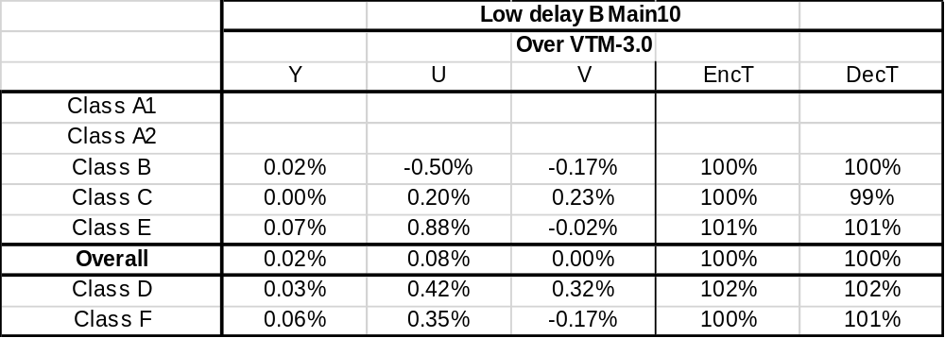

2.1.2) Results with inter MTS on
The same RMTS32 without residual coding change is also applied to inter MTS.

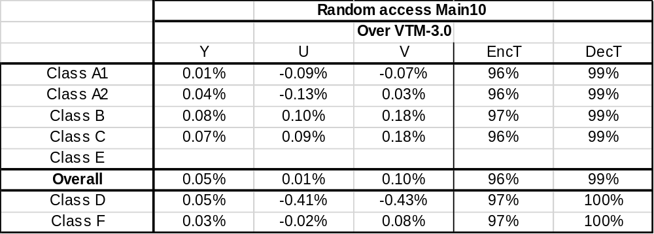

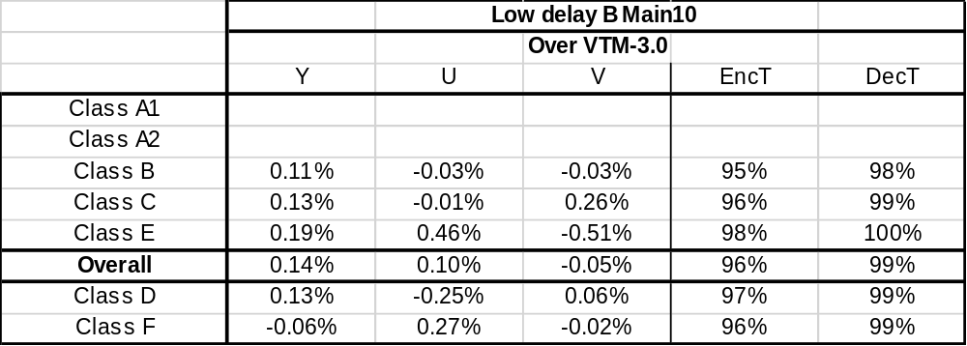

  - RMTS32 with residual coding change

2.2.1) Results with inter MTS off (CTC)

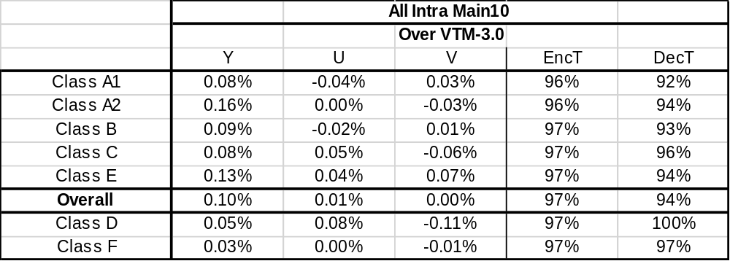

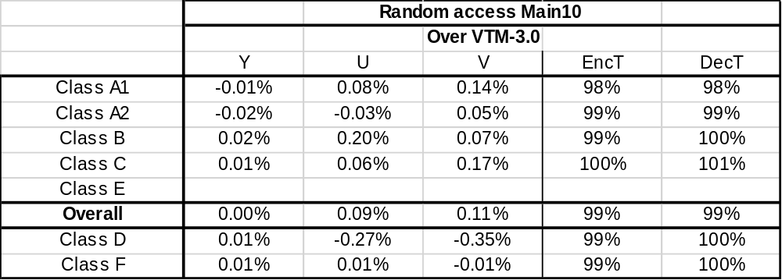

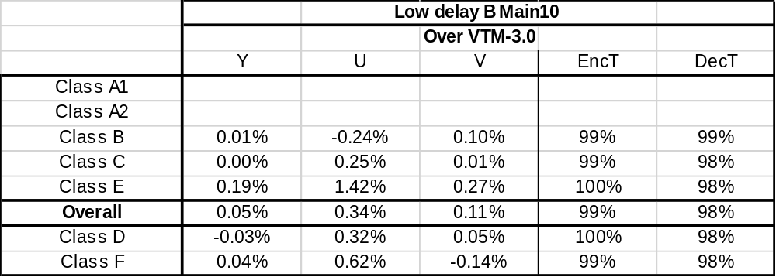

2.2.2) Results with inter MTS on
The same RMTS32 with residual coding change is applied to inter MTS.

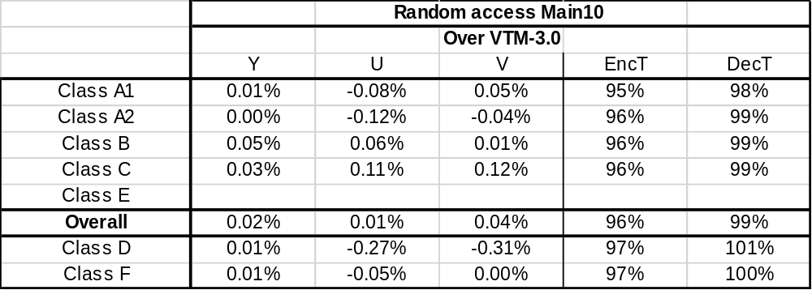

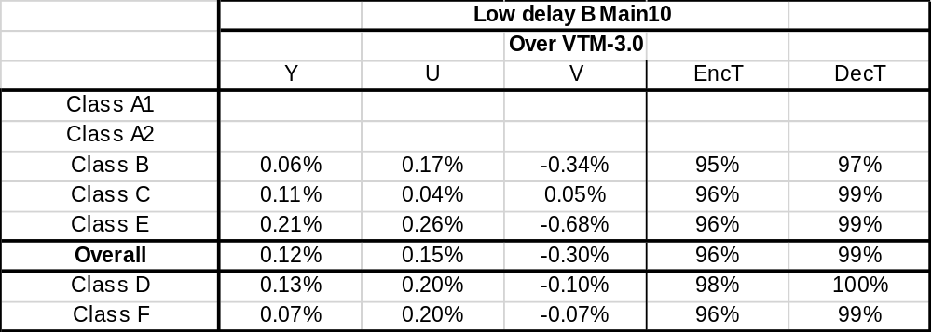

Conclusion
The 32-point MTS based on skipping high frequency coefficients is shown to help reduce complexity additively with reasonable BD-rate loss. It is recommended that RMTS32 with or without residual coding change tested in this contribution should be adopted in the next VTM.

Reference
- M. Koo et al., “CE 6-1.1 (c,d): Fast DST-7/DCT-8 based on DFT and 32 point MTS based on skipping high frequency coefficients”, Joint Video Exploration Team (JVET) of ITU-T SG 16 WP 3 and ISO/IEC JTC1/SC 29/WG 11 JVET-L0132, 12th meeting, Macao, CN, 3-12 Oct. 2018.
- J. Boyce, K. Suehring, X. Li and V. Seregin, “JVET common test conditions and software reference configurations for SDR video”, JVET-L1010, the 12th JVET meeting, Oct. 2018, Macao, CN.
- A. Said and X. Zhao, “Description of Core Experiment 6 (CE6): Transforms and transform signalling”, JVET-L1026, the 12th JVET meeting, Oct. 2018, Macao, CN.

Patent rights declaration(s)
LG Electronics Inc. may have current or pending patent rights relating to the technology described in this contribution and, conditioned on reciprocity, is prepared to grant licenses under reasonable and non-discriminatory terms as necessary for implementation of the resulting ITU-T Recommendation | ISO/IEC International Standard (per box 2 of the ITU-T/ITU-R/ISO/IEC patent statement and licensing declaration form).

Spec Text Changes

For the RMTS32 with residual coding change, all the spec text changes presented in the below are required. For the RMTS32 without residual coding change, only changes in “8.5.4.1 General” and “8.5.4.3 Transformation matrix derivation process” which are presented in the below are needed.

7.3.4.12 Residual coding syntax

residual_coding( x0, y0, log2TbWidth, log2TbHeight, cIdx ) { | Descriptor
if( transform_skip_enabled_flag && ( cIdx ! = 0 | | tu_mts_flag[ x0 ][ y0 ] = = 0 ) &&
( log2TbWidth <= 2 ) && ( log2TbHeight <= 2 ) )
transform_skip_flag[ x0 ][ y0 ][ cIdx ] | ae(v)
last_sig_coeff_x_prefix | ae(v)
last_sig_coeff_y_prefix | ae(v)
if( last_sig_coeff_x_prefix > 3 )
last_sig_coeff_x_suffix | ae(v)
if( last_sig_coeff_y_prefix > 3 )
last_sig_coeff_y_suffix | ae(v)
……
for( i = lastSubBlock; i >= 0; i− − ) {
……
if( ( i < lastSubBlock ) && ( i > 0 ) ) {
if( ( ( tu_mts_flag[ x0 ][ y0 ] == 0 | | cIdx != 0 ) && ( xS << log2SbSize ) < 32 &&
( yS << log2SbSize ) < 32 ) | | ( tu_mts_flag[ x0 ][ y0 ] == 1 &&
( xS << log2SbSize ) < 16 && ( yS << log2SbSize ) < 16 ) )
coded_sub_block_flag[ xS ][ yS ] | ae(v)
inferSbDcSigCoeffFlag = 1
}
……
}
if( tu_mts_flag[ x0 ][ y0 ] && ( cIdx = = 0 ) )
mts_idx[ x0 ][ y0 ][ cIdx ] | ae(v)
}

7.4.5.12 Residual coding semantics
……
last_sig_coeff_x_prefix specifies the prefix of the column position of the last significant coefficient in scanning order within a transform block. The array indices x0, y0 specify the location ( x0, y0 ) of the top-left sample of the considered transform block relative to the top-left sample of the picture. The array index cIdx specifies an indicator for the colour component; it is equal to 0 for luma, equal to 1 for Cb and equal to 2 for Cr. The values of last_sig_coeff_x_prefix shall be in the range of 0 to ( Min( log2TbWidth, ( tu_mts_flag[ x0 ][ y0 ] = = 1 && cIdx == 0 ) ? 4 : 5 ) ) << 1 ) − 1, inclusive.
last_sig_coeff_y_prefix specifies the prefix of the row position of the last significant coefficient in scanning order within a transform block. The array indices x0, y0 specify the location ( x0, y0 ) of the top-left sample of the considered transform block relative to the top-left sample of the picture. The array index cIdx specifies an indicator for the colour component; it is equal to 0 for luma, equal to 1 for Cb and equal to 2 for Cr. The values of last_sig_coeff_y_prefix shall be in the range of 0 to ( Min( log2TbHeight, ( tu_mts_flag[ x0 ][ y0 ] = = 1 && cIdx == 0 ) ? 4 : 5 ) ) << 1 ) − 1, inclusive.
……

8.5.4.1 General
……
The variables nonZeroW and nonZeroH are derived as follows:
nonZeroW = Min( nTbW, trTypeHor == 0 ? 32 : 16 ) (8-810)
nonZeroH = Min( nTbH, trTypeVer == 0 ? 32 : 16 ) (8-811)
……

8.5.4.3 Transformation matrix derivation process
……
- Otherwise, if trType is equal to 1 and nTbs is equal to 32, the following applies:
transMatrix[ m ][ n ] = transMatrixCol0to15[ m ][ n ] with m = 0..15, n = 0..15 (8-824)
transMatrixCol0to15 = (8-825)
{
{ 4 9 13 17 21 26 30 34 38 42 45 50 53 56 60 63 }
{ 13 26 38 50 60 68 77 82 86 89 90 88 85 80 74 66 }
{ 21 42 60 74 84 89 89 84 74 60 42 21 0 −21 −42 −60 }
{ 30 56 77 88 89 80 63 38 9 −21 −50 −72 −85 −90 −84 −68 }
{ 38 68 86 88 74 45 9 −30 −63 −84 −90 −78 −53 −17 21 56 }
{ 45 78 90 77 42 −4 −50 −80 −90 −74 −38 9 53 82 89 72 }
{ 53 85 85 53 0 −53 −85 −85 −53 0 53 85 85 53 0 −53 }
{ 60 89 74 21 −42 −84 −84 −42 21 74 89 60 0 −60 −89 −74 }
{ 66 90 56 −13 −74 −88 −45 26 80 84 34 −38 −85 −78 −21 50 }
{ 72 86 34 −45 −89 −63 13 78 82 21 −56 −90 −53 26 84 77 }
{ 77 80 9 −72 −84 −17 66 86 26 −60 −88 −34 53 90 42 −45 }
{ 80 72 −17 −86 −60 34 90 45 −50 −89 −30 63 85 13 −74 −78 }
{ 84 60 −42 −89 −21 74 74 −21 −89 −42 60 84 0 −84 −60 42 }
{ 86 45 −63 −78 21 90 26 −77 −66 42 88 4 −85 −50 60 80 }
{ 88 30 −78 −56 60 77 −34 −88 4 89 26 −80 −53 63 74 −38 }
{ 90 13 −88 −26 84 38 −78 −50 72 60 −63 −68 53 77 −42 −82 }

{ 90 −4 −90 9 89 −13 −88 17 88 −21 −86 26 85 −30 −84 34 }
{ 89 −21 −84 42 74 −60 −60 74 42 −84 −21 89 0 −89 21 84 }
{ 88 −38 −72 68 42 −86 −4 88 −34 −74 66 45 −85 −9 89 −30 }
{ 85 −53 −53 85 0 −85 53 53 −85 0 85 −53 −53 85 0 −85 }
{ 82 −66 −30 90 −42 −56 86 −13 −77 74 17 −88 53 45 −89 26 }
{ 78 −77 −4 80 −74 −9 82 −72 −13 84 −68 −17 85 −66 −21 86 }
{ 74 −84 21 60 −89 42 42 −89 60 21 −84 74 0 −74 84 −21 }
{ 68 −88 45 30 −84 78 −17 −56 90 −60 −13 77 −85 34 42 −88 }
{ 63 −90 66 −4 −60 90 −68 9 56 −89 72 −13 −53 88 −74 17 }
{ 56 −88 80 −38 −21 72 −90 68 −17 −42 82 −86 53 4 −60 88 }
{ 50 −82 88 −66 21 30 −72 90 −78 42 9 −56 85 −86 60 −13 }
{ 42 −74 89 −84 60 −21 −21 60 −84 89 −74 42 0 −42 74 −89 }
{ 34 −63 82 −90 84 −66 38 −4 −30 60 −80 90 −85 68 −42 9 }
{ 26 −50 68 −82 89 −88 80 −66 45 −21 −4 30 −53 72 −84 90 }
{ 17 −34 50 −63 74 −82 88 −90 88 −84 77 −66 53 −38 21 −4 }
{ 9 −17 26 −34 42 −50 56 −63 68 −74 78 −82 85 −88 89 −90 }
},
transMatrix[ m ][ n ] = transMatrixCol16to31[ m − 16 ][ n ] with m = 16..31, n = 0..15 (8-826)
transMatrixCol16to31 = (8-827)
{
{ 66 68 72 74 77 78 80 82 84 85 86 88 88 89 90 90 }
{ 56 45 34 21 9 −4 −17 −30 −42 −53 −63 −72 −78 −84 −88 −90 }
{ −74 −84 −89 −89 −84 −74 −60 −42 −21 0 21 42 60 74 84 89 }
{ −45 −17 13 42 66 82 90 86 74 53 26 −4 −34 −60 −78 −88 }
{ 80 90 82 60 26 −13 −50 −77 −89 −85 −66 −34 4 42 72 88 }
{ 34 −13 −56 −84 −88 −68 −30 17 60 85 88 66 26 −21 −63 −86 }
{ −85 −85 −53 0 53 85 85 53 0 −53 −85 −85 −53 0 53 85 }
{ −21 42 84 84 42 −21 −74 −89 −60 0 60 89 74 21 −42 −84 }
{ 88 72 9 −60 −90 −63 4 68 89 53 −17 −77 −86 −42 30 82 }
{ 9 −66 −88 −42 38 88 68 −4 −74 −85 −30 50 90 60 −17 −80 }
{ −90 −50 38 89 56 −30 −88 −63 21 85 68 −13 −82 −74 4 78 }
{ 4 82 68 −21 −88 −56 38 90 42 −53 −88 −26 66 84 9 −77 }
{ 89 21 −74 −74 21 89 42 −60 −84 0 84 60 −42 −89 −21 74 }
{ −17 −90 −30 74 68 −38 −88 −9 84 53 −56 −82 13 89 34 −72 }
{ −86 9 90 21 −82 −50 66 72 −42 −85 13 90 17 −84 −45 68 }
{ 30 86 −17 −89 4 90 9 −88 −21 85 34 −80 −45 74 56 −66 }

{ 82 −38 −80 42 78 −45 −77 50 74 −53 −72 56 68 −60 −66 63 }
{ −42 −74 60 60 −74 −42 84 21 −89 0 89 −21 −84 42 74 −60 }
{ −77 63 50 −84 −13 90 −26 −78 60 53 −82 −17 90 −21 −80 56 }
{ 53 53 −85 0 85 −53 −53 85 0 −85 53 53 −85 0 85 −53 }
{ 68 −80 −4 84 −63 −34 90 −38 −60 85 −9 −78 72 21 −88 50 }
{ −63 −26 88 −60 −30 88 −56 −34 89 −53 −38 90 −50 −42 90 −45 }
{ −60 89 −42 −42 89 −60 −21 84 −74 0 74 −84 21 60 −89 42 }
{ 72 −4 −66 89 −50 −26 82 −80 21 53 −90 63 9 −74 86 −38 }
{ 50 −88 77 −21 −45 86 −78 26 42 −85 80 −30 −38 84 −82 34 }
{ −78 34 26 −74 90 −66 13 45 −84 85 −50 −9 63 −89 77 −30 }
{ −38 77 −90 74 −34 −17 63 −88 84 −53 4 45 −80 89 −68 26 }
{ 84 −60 21 21 −60 84 −89 74 −42 0 42 −74 89 −84 60 −21 }
{ 26 −56 78 −89 86 −72 45 −13 −21 53 −77 88 −88 74 −50 17 }
{ −88 78 −63 42 −17 −9 34 −56 74 −85 90 −86 77 −60 38 −13 }
{ −13 30 −45 60 −72 80 −86 90 −89 85 −78 68 −56 42 −26 9 }
{ 90 −88 86 −84 80 −77 72 −66 60 −53 45 −38 30 −21 13 −4 }
},
……
- Otherwise, if trType is equal to 2 and nTbs is equal to 32, the following applies:
transMatrix[ m ][ n ] = transMatrixCol0to15[ m ][ n ] with m = 0..15, n = 0..15 (8-831)
transMatrixCol0to15 = (8-832)
{
{ 90 90 89 88 88 86 85 84 82 80 78 77 74 72 68 66 }
{ 90 88 84 78 72 63 53 42 30 17 4 −9 −21 −34 −45 −56 }
{ 89 84 74 60 42 21 0 −21 −42 −60 −74 −84 −89 −89 −84 −74 }
{ 88 78 60 34 4 −26 −53 −74 −86 −90 −82 −66 −42 −13 17 45 }
{ 88 72 42 4 −34 −66 −85 −89 −77 −50 −13 26 60 82 90 80 }
{ 86 63 21 −26 −66 −88 −85 −60 −17 30 68 88 84 56 13 −34 }
{ 85 53 0 −53 −85 −85 −53 0 53 85 85 53 0 −53 −85 −85 }
{ 84 42 −21 −74 −89 −60 0 60 89 74 21 −42 −84 −84 −42 21 }
{ 82 30 −42 −86 −77 −17 53 89 68 4 −63 −90 −60 9 72 88 }
{ 80 17 −60 −90 −50 30 85 74 4 −68 −88 −38 42 88 66 −9 }
{ 78 4 −74 −82 −13 68 85 21 −63 −88 −30 56 89 38 −50 −90 }
{ 77 −9 −84 −66 26 88 53 −42 −90 −38 56 88 21 −68 −82 −4 }
{ 74 −21 −89 −42 60 84 0 −84 −60 42 89 21 −74 −74 21 89 }
{ 72 −34 −89 −13 82 56 −53 −84 9 88 38 −68 −74 30 90 17 }
{ 68 −45 −84 17 90 13 −85 −42 72 66 −50 −82 21 90 9 −86 }
{ 66 −56 −74 45 80 −34 −85 21 88 −9 −90 −4 89 17 −86 −30 }

{ 63 −66 −60 68 56 −72 −53 74 50 −77 −45 78 42 −80 −38 82 }
{ 60 −74 −42 84 21 −89 0 89 −21 −84 42 74 −60 −60 74 42 }
{ 56 −80 −21 90 −17 −82 53 60 −78 −26 90 −13 −84 50 63 −77 }
{ 53 −85 0 85 −53 −53 85 0 −85 53 53 −85 0 85 −53 −53 }
{ 50 −88 21 72 −78 −9 85 −60 −38 90 −34 −63 84 −4 −80 68 }
{ 45 −90 42 50 −90 38 53 −89 34 56 −88 30 60 −88 26 63 }
{ 42 −89 60 21 −84 74 0 −74 84 −21 −60 89 −42 −42 89 −60 }
{ 38 −86 74 −9 −63 90 −53 −21 80 −82 26 50 −89 66 4 −72 }
{ 34 −82 84 −38 −30 80 −85 42 26 −78 86 −45 −21 77 −88 50 }
{ 30 −77 89 −63 9 50 −85 84 −45 −13 66 −90 74 −26 −34 78 }
{ 26 −68 89 −80 45 4 −53 84 −88 63 −17 −34 74 −90 77 −38 }
{ 21 −60 84 −89 74 −42 0 42 −74 89 −84 60 −21 −21 60 −84 }
{ 17 −50 74 −88 88 −77 53 −21 −13 45 −72 86 −89 78 −56 26 }
{ 13 −38 60 −77 86 −90 85 −74 56 −34 9 17 −42 63 −78 88 }
{ 9 −26 42 −56 68 −78 85 −89 90 −86 80 −72 60 −45 30 −13 }
{ 4 −13 21 −30 38 −45 53 −60 66 −72 77 −80 84 −86 88 −90 }
},
transMatrix[ m ][ n ] = transMatrixCol16to31[ m − 16 ][ n ] with m = 16..31, n = 0..15 (8-833)
transMatrixCol16to31 = (8-834)
{
{ 63 60 56 53 50 45 42 38 34 30 26 21 17 13 9 4 }
{ −66 −74 −80 −85 −88 −90 −89 −86 −82 −77 −68 −60 −50 −38 −26 −13 }
{ −60 −42 −21 0 21 42 60 74 84 89 89 84 74 60 42 21 }
{ 68 84 90 85 72 50 21 −9 −38 −63 −80 −89 −88 −77 −56 −30 }
{ 56 21 −17 −53 −78 −90 −84 −63 −30 9 45 74 88 86 68 38 }
{ −72 −89 −82 −53 −9 38 74 90 80 50 4 −42 −77 −90 −78 −45 }
{ −53 0 53 85 85 53 0 −53 −85 −85 −53 0 53 85 85 53 }
{ 74 89 60 0 −60 −89 −74 −21 42 84 84 42 −21 −74 −89 −60 }
{ 50 −21 −78 −85 −38 34 84 80 26 −45 −88 −74 −13 56 90 66 }
{ −77 −84 −26 53 90 56 −21 −82 −78 −13 63 89 45 −34 −86 −72 }
{ −45 42 90 53 −34 −88 −60 26 86 66 −17 −84 −72 9 80 77 }
{ 78 74 −13 −85 −63 30 89 50 −45 −90 −34 60 86 17 −72 −80 }
{ 42 −60 −84 0 84 60 −42 −89 −21 74 74 −21 −89 −42 60 84 }
{ −80 −60 50 85 −4 −88 −42 66 77 −26 −90 −21 78 63 −45 −86 }
{ −38 74 63 −53 −80 26 89 4 −88 −34 77 60 −56 −78 30 88 }
{ 82 42 −77 −53 68 63 −60 −72 50 78 −38 −84 26 88 −13 −90 }

{ 34 −84 −30 85 26 −86 −21 88 17 −88 −13 89 9 −90 −4 90 }
{ −84 −21 89 0 −89 21 84 −42 −74 60 60 −74 −42 84 21 −89 }
{ −30 89 −9 −85 45 66 −74 −34 88 −4 −86 42 68 −72 −38 88 }
{ 85 0 −85 53 53 −85 0 85 −53 −53 85 0 −85 53 53 −85 }
{ 26 −89 45 53 −88 17 74 −77 −13 86 −56 −42 90 −30 −66 82 }
{ −86 21 66 −85 17 68 −84 13 72 −82 9 74 −80 4 77 −78 }
{ −21 84 −74 0 74 −84 21 60 −89 42 42 −89 60 21 −84 74 }
{ 88 −42 −34 85 −77 13 60 −90 56 17 −78 84 −30 −45 88 −68 }
{ 17 −74 88 −53 −13 72 −89 56 9 −68 90 −60 −4 66 −90 63 }
{ −88 60 −4 −53 86 −82 42 17 −68 90 −72 21 38 −80 88 −56 }
{ −13 60 −86 85 −56 9 42 −78 90 −72 30 21 −66 88 −82 50 }
{ 89 −74 42 0 −42 74 −89 84 −60 21 21 −60 84 −89 74 −42 }
{ 9 −42 68 −85 90 −80 60 −30 −4 38 −66 84 −90 82 −63 34 }
{ −90 84 −72 53 −30 4 21 −45 66 −80 88 −89 82 −68 50 −26 }
{ −4 21 −38 53 −66 77 −84 88 −90 88 −82 74 −63 50 −34 17 }
{ 90 −89 88 −85 82 −78 74 −68 63 −56 50 −42 34 −26 17 −9 }
},
……
9.5.3.1 General
……
Table 9-4 – Syntax elements and associated binarizations
Syntax structure | Syntax element | Binarization
Syntax structure | Syntax element | Process | Input parameters
…… | …… | …… | ……
residual_coding( ) | …… | …… | ……
residual_coding( ) | last_sig_coeff_x_prefix | TR | cMax = ( Min( log2TbWidth, ( tu_mts_flag[ x0 ][ y0 ] == 1 && cIdx == 0 ) ? 4 : 5 ) << 1 ) − 1, cRiceParam = 0
residual_coding( ) | last_sig_coeff_y_prefix | TR | cMax = ( Min( log2TbHeight, ( tu_mts_flag[ x0 ][ y0 ] == 1 && cIdx == 0 ) ? 4 : 5 ) << 1 ) − 1, cRiceParam = 0
residual_coding( ) | …… | …… | ……

