    Joint Video Experts Team (JVET)  of ITU-T SG 16 WP 3 and ISO/IEC JTC 1/SC 29/WG 11  13th Meeting: Marrakech, MA, 9–18 Jan. 2019 | Document: JVET-M0285

Title: | CE1-Related: Prediction Mode Restriction and Implicit Transform Splitting to Enable VPDU
Status: | Input document to JVET
Purpose: | Proposal
Author(s) or  Contact(s): | Yin Zhao,  Semih Esenlik,  Haitao Yang,  Jianle Chen | Tel:  Email: | +49-162-210-6260  semih.esenlik@huawei.com  jianle.chen@huawei.com
Source: | Huawei Technologies. Co., Ltd
_____________________________

Abstract
This contribution presents two alternative methods to enable VPDU based decoding.
Alternative 1:
- Restricting the application of intra prediction if a coding unit or one of its parent blocks has;
  - one dimension smaller than 64 samples and the other dimension greater than 64 samples, or,
  - one dimension greater than 64 samples and is split with TT split.
- Implicit transform tiling if a coding block crosses a 64x64 VPDU grid.
Alternative 2:
- Restricting the signalling of quantized transform coefficients if a coding unit or one of its parent blocks has;
  - one dimension smaller than 64 samples and the other dimension greater than 64 samples, or,
  - one dimension greater than 64 samples and is split with TT split.
In both alternatives, the previously adopted VPDU related split constraints are disabled. Furthermore BIO application region is divided into 2 more 4 regions if the coding block crosses a 64x64 VPDU grid. Compared to VTM3.0 anchor, -0.33% and -0.22% luma BD-rate reduction is achieved for RA and LDB configurations respectively according to the first alternative and -0.24% and -0.XX% luma BD-rate reduction is achieved for the second alternative solution.

Introduction
During the 12th JVET meeting in Macau, the concept of VPDU was introduced into the VVC draft specification. The goal of VPDU is to guarantee completion of the processing of one 64x64 square region before starting the processing of other 64x64 square regions in hardware implementations. This method is intended to reduce the memory footprint of the pipelined hardware implementations. The CU-split restrictions imposed by VPDU are as follows:
- TT splitting is not allowed if the size of the parent block has greater than 64 samples in one direction.
- BT splitting is not allowed if the size of the resulting child CU is smaller than 64 in one direction and greater than 64 in the other direction.
During the same meeting BDOF was included in the VVC draft specification. It is noted that in the current specification the maximum luma CU size that is allowed to apply BDOF is set to be equal to 128x128.

Problem Statement
Two problems exist in the current VVC.
- The application of BDOF on the large coding blocks violate VPDU constraints in the sense that the intended goal of strict sequential processing of 64x64 data units is not possible in the presence of BDOF. The problem is elaborated in contribution document JVET-M0284.
- The restriction on the coding unit splitting causes BD-rate performance degradation, especially for the Class-A sequences where the coding loss reaches 1% in some sequences.

Proposed Solutions
Two alternative solutions are proposed, which are explained in the subsections below:

Alternative 1
According to the proposed solution if one of the following conditions are satisfied, the intra prediction and intra-inter combined prediction are disabled for that CU:
- If the current CU (or a parent block of the current CU) has one dimension that is smaller than 64 samples and the other dimension that is greater than 64 samples.
- If a parent block of the current CU has one dimension greater than 64 samples and is split with TT split.
The restriction is imposed by changing the CU syntax, the pred_mode_flag is not signalled and inferred to be equal to zero if any of the above conditions are satisfied.
Additionally a transform block is split into 2 or 4 transform blocks if the leaf coding unit crosses one or two VPDU boundary.
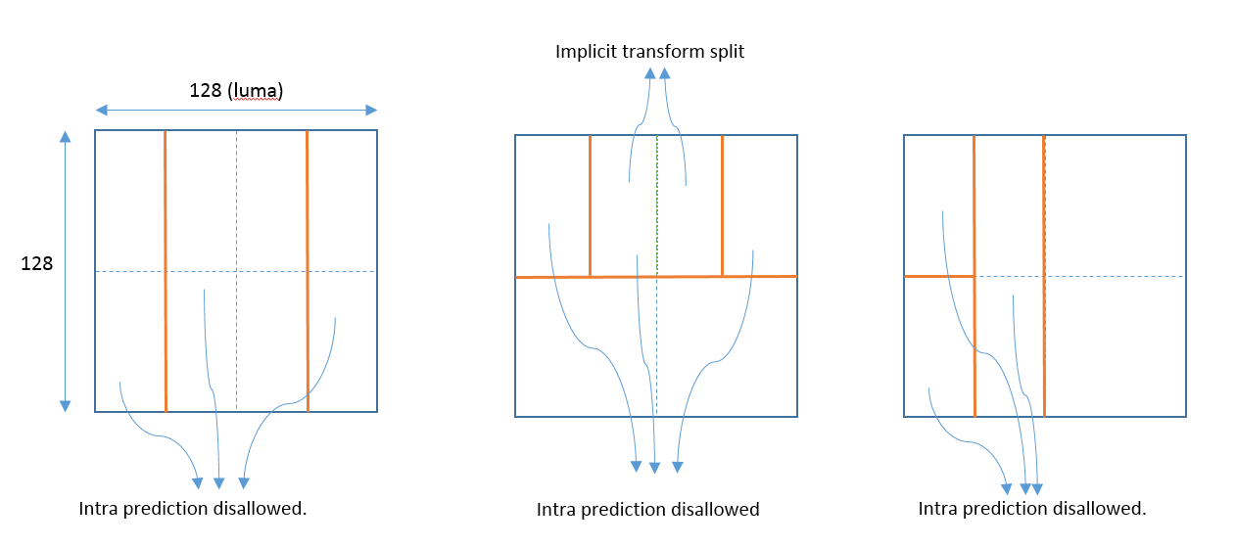
Figure 1: Examples of splits that are possible according to the proposal.
The figure above illustrates 3 example CU split structures that are allowed according to the first alternative solution. On the left figure, the CTU is split into 3 leaf nodes with TT split. In this case the coding units are allowed to use only inter prediction modes and intra prediction modes (including intra-inter combined prediction) are disallowed.
The figure in the middle shows a second example, where vertical TT split is performed after horizontal BT split. In this example intra prediction is disallowed for the top three CUs and additionally the transform unit is split along the VPDU boundary (although the CU size is not greater than the maximum transform size).
In the right figure, intra prediction is disallowed for the 3 CUs on the left, since the following condition is violated:
- If the current CU (or a parent block of the current CU) has one dimension that is smaller than 64 samples and the other dimension that is greater than 64 samples.
In all of the above examples transform unit is implicitly split if the maximum transform size is exceeded, which is unchanged according to the proposal.

Alternative 2
According to the proposed second solution if one of the following conditions are satisfied, signalling of quantized transform coefficients are prohibited for that CU:
- If the current CU (or a parent block of the current CU) has one dimension that is smaller than 64 samples and the other dimension that is greater than 64 samples.
- If a parent block of the current CU has one dimension greater than 64 samples and is split with TT split.
In other words only skip mode and inter prediction mode with cu_cbf flag set equal to zero are permitted to be used.
The restriction is imposed by changing the CU syntax, the pred_mode_flag, merge_flag and cu_cbf flags are not signalled and are all inferred to be equal to zero if any of the above conditions are satisfied.

Disabling CU split constraints for P and B slices
In both alternative solutions the following split constraints are disabled if the current slice (tile) is P slice or B slice:
- TT splitting is not allowed if the size of the parent block has greater than 64 samples in one direction.
- BT splitting is not allowed if the size of the resulting child CU is smaller than 64 in one direction and greater than 64 in the other direction.
Furthermore the maximum default TT split size, which is signalled in the SPS is increased to 128 samples.

Implicit splitting of BDOF application region
In both alternative solutions, if BDOF is applied for a CU which crosses a VPDU boundary, the BDOF is applied on a sub-block basis. This means that the BDOF application region is divided into 2 or 4 sub-blocks, where the regions are by dividing the CU along the VPDU boundaries. Padding is applied during the application of BDOF between the sub-blocks as if they are CU boundaries.
The modification for BDOF is elaborated in the contribution document JVET-M0284.

Experimental Results
The simulation results for the proposed solutions are presented in the table below.

Experimental Results for Alternative 1

 | Random Access Main 10
 | Over VTM-3.0
 | Y | U | V | EncT | DecT
Class A1 | -0.50% | -0.40% | -0.35% | 133% | 102%
Class A2 | -0.64% | -0.52% | -0.41% | 126% | 102%
Class B | -0.27% | -0.28% | -0.26% | 124% | 102%
Class C | -0.05% | -0.04% | 0.02% | 115% | 103%
Class E
Overall | -0.33% | -0.28% | -0.23% | 124% | 102%
Class D | -0.06% | -0.05% | -0.03% | 113% | 103%
Class F (optional) | -0.18% | -0.20% | -0.15% | 119% | 102%
 | Low delay B Main10
 | Over VTM-3.0
 | Y | U | V | EncT | DecT
Class A1
Class A2
Class B | -0.19% | -0.43% | 0.00% | 122% | 103%
Class C | -0.01% | 0.03% | 0.15% | 110% | 103%
Class E | -0.56% | -0.40% | -0.38% | 127% | 101%
Overall | -0.22% | -0.27% | -0.04% | 119% | 102%
Class D | 0.00% | 0.38% | 0.02% | 106% | 103%
Class F (optional) | -0.16% | -0.29% | -0.81% | 113% | 100%

Table 1: Simulation results for first alternative solution

Experimental Results for Alternative 2
 | Random Access Main 10
 | Over VTM-3.0
 | Y | U | V | EncT | DecT
Class A1 | -0.25% | -0.33% | -0.36% | 137% | 102%
Class A2 | -0.48% | -0.49% | -0.44% | 136% | 102%
Class B | -0.22% | -0.20% | -0.28% | 134% | 103%
Class C | -0.06% | 0.01% | 0.05% | 122% | 102%
Class E
Overall | -0.24% | -0.23% | -0.24% | 132% | 102%
Class D | -0.10% | -0.08% | -0.01% | 124% | 103%
Class F (optional) | -0.15% | -0.13% | -0.09% | 132% | 102%

Table 2: Simulation results for second alternative solution

Conclusion
This contribution presents two alternative methods to enable VPDU based decoding. According to the first solution intra prediction is disabled if a coding unit or one of its parent blocks violates VPDU constraints. Additionally the transform unit is implicitly split along VPDU boundaries. According to second alternative solution only skip mode and inter prediction mode with cu_cbf flag set equal to zero is allowed to be used if a CU or one of its parent blocks violates VPDU constraints. In both alternatives, the previously adopted VPDU related split constraints are disabled. Furthermore BIO application region is divided into 2 more 4 regions if the coding block crosses a 64x64 VPDU grid. Compared to VTM3.0 anchor, -0.33% and -0.22% luma BD-rate reduction is achieved for RA and LDB configurations respectively according to the first alternative and -0.24% and -0.XX% luma BD-rate reduction is achieved for the second alternative solution. It is suggested to adopt one of the alternatives in the next version of VVC draft specification.

Patent rights declaration(s)
Huawei Technologies Co., Ltd may have current or pending patent rights relating to the technology described in this contribution and, conditioned on reciprocity, is prepared to grant licenses under reasonable and non-discriminatory terms as necessary for implementation of the resulting ITU-T Recommendation | ISO/IEC International Standard (per box 2 of the ITU-T/ITU-R/ISO/IEC patent statement and licensing declaration form).

