    Joint Video Experts Team (JVET)  of ITU-T SG 16 WP 3 and ISO/IEC JTC 1/SC 29/WG 11  13th Meeting: Marrakech, MA, 9–18 Jan. 2019 | Document: JVET-M0279_v1

Title: | Non-CE7 : Sign coding for transform skip
Status: | Input
Purpose: | Proposal
Author(s) or  Contact(s): | Sunmi Yoo  Jungah Choi  Jin Heo  Jangwon Choi  Ling Li  Jaehyun Lim  19 Yangjaedaero-11gil, Seocho-gu  Seoul 06772, South Korea  Seunghwan Kim  10225 Willow Creek Rd, San Diego  CA 92131, USA | Tel:  Email: | +82-2-6912-6561  sunmi.yoo@lge.com
Source: | LG Electronics Inc.
_____________________________

Abstract
An efficient sign coding for transform skip mode is proposed in this contribution. It is observed that the signs of coefficients in the transform skip block have high correlation each other than those of transformed coefficients. Therefore, it is proposed to have a flag that indicates whether all of the signs in the current block are identical or not, before the signs of each coefficient are coded. The proposed method has BD-bitrate changes, 0.00%, 0.00%, 0.04%, for AI, RA, and LDB, respectively. Especially, it is observed that the proposed scheme has -0.30% and -0.81% of bit savings in Class F and Class SCC in all intra configuration, respectively.

Proposed method
The coefficients (or residuals) of a transform-skipped TU have different characteristics from the one in the transformed block, since they are defined in different domains. One of these properties is that the signs of coefficients in the transform skip block are more likely to be the same from each other than those of transformed coefficients. Thus, a flag which shows whether all of the signs in the current block are identical is sent before the signs of each coefficient are transmitted. If the flag is true, then no more sign information is coded for the block. The proposed flag can be coded when the number of nonzero coefficients are greater than a threshold. In this contribution, the threshold is defined as 4.
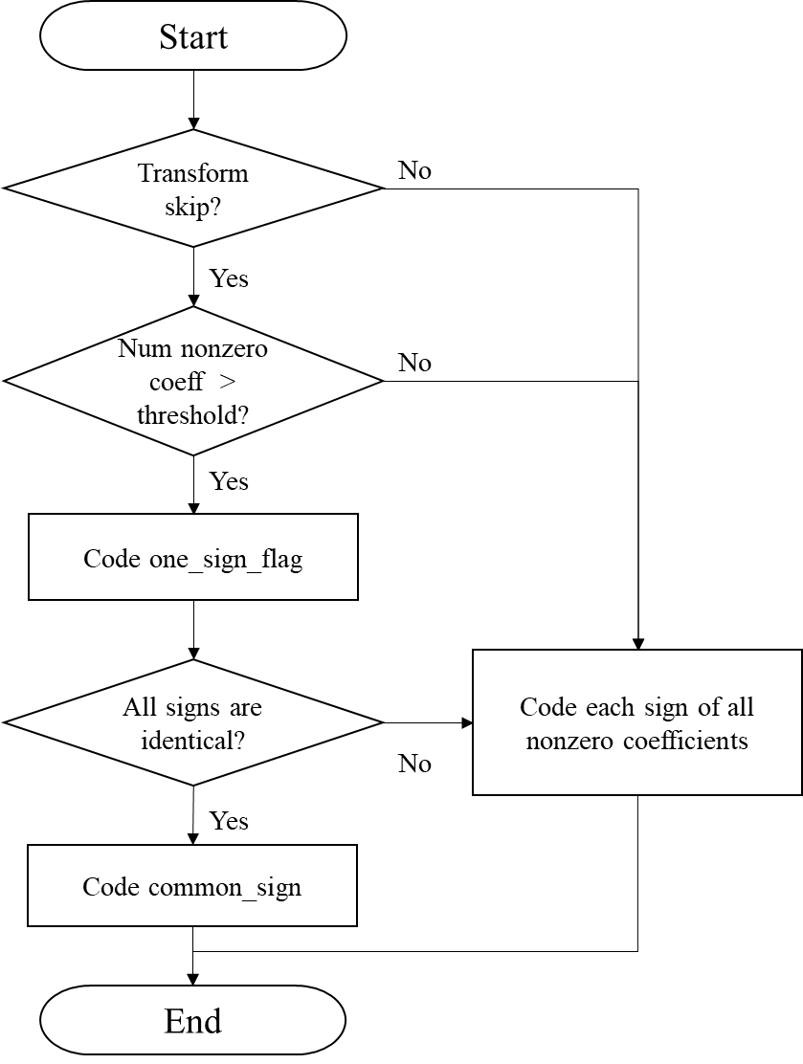
Figure 1 Flow chare of proposed method

Test results
The proposed method has been implemented using VTM-3.0 as software base and experimentally evaluated according to the common test conditions, in addition to SCC sequences used in CE8.
Table 1 Result of proposed method (All intra)
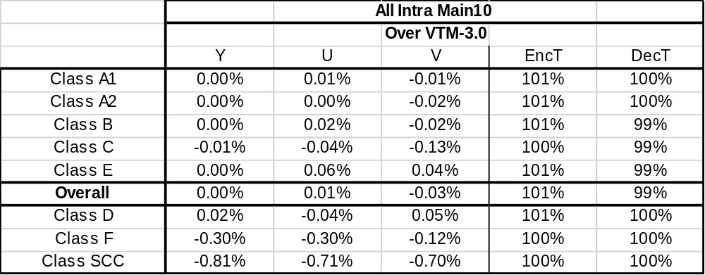
Table 2 Result of proposed method (Random access)
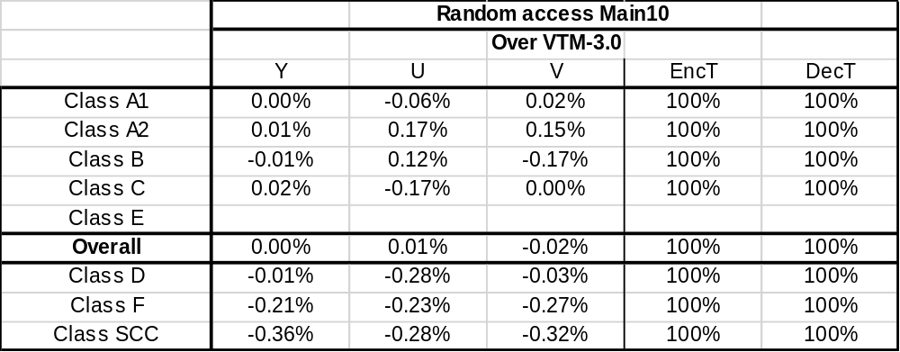
Table 3 Result of proposed method (Low delay B)
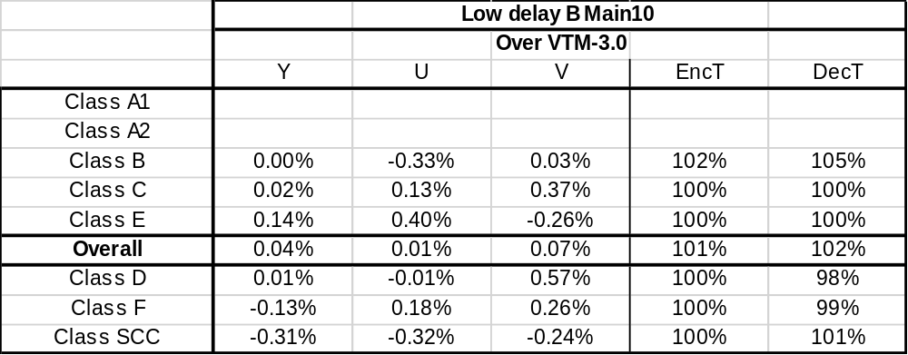

Conclusion
In conclusion, it is proposed to have a flag that indicates whether all of the signs of the current block are identical or not, when the currently coded block is transform-skipped. The experimental results show that the proposed method brings some coding gains, especially in Class F and SCC sequences, which have more transform skip blocks than other sequences. Therefore, it is recommended that this method is studied in CE7 at the next meeting.

Patent rights declaration(s)
LG Electronics Inc. may have current or pending patent rights relating to the technology described in this contribution and, conditioned on reciprocity, is prepared to grant licenses under reasonable and non-discriminatory terms as necessary for implementation of the resulting ITU-T Recommendation | ISO/IEC International Standard (per box 2 of the ITU-T/ITU-R/ISO/IEC patent statement and licensing declaration form).

