    Joint Video Experts Team (JVET)  of ITU-T SG 16 WP 3 and ISO/IEC JTC 1/SC 29/WG 11  13th Meeting: Marrakech, MA, 9–18 Jan. 2019 | Document: JVET-M0241

Title: | CE9-related: A simple gradient calculation at the CU boundaries for BDOF
Status: | Input document to JVET
Purpose: | Proposal
Author(s) or  Contact(s): | Hahyun Lee  Jungwon Kang  Sung-Chang Lim  Jinho Lee  Hui Yong Kim  218 Gajeong-ro, Yuseong-gu, Daejeon, 34129, KOREA | Tel:  Email: | +81-42-860-6138  hanilee@etri.re.kr  jungwon@etri.re.kr  sclim@etri.re.kr  jinosoul@etri.re.kr  hykim5@etri.re.kr
Source: | ETRI (Electronics and Telecommunications Research Institute)
_____________________________

Abstract
In this contribution, an alternative simple gradient calculation is proposed for the samples on CU boundaries without interpolation of the prediction samples in the extended area. After CU boundary samples are directly copied into the extended area, the gradients for the samples on the CU boundaries are calculated with the same gradient filter as that for the samples inside CU. It is reported that the average luma BD-rate is reportedly 0.11% with encoding times of 99% and decoding times of 98% for RA configuration compared to VTM-3.0. Compared to CE9.1.1.c, it is reported that average luma BD-rate is reportedly 0.01% with encoding times of 100% and decoding times of 100% for RA configuration.

Introduction
Bi-directional Optical flow (BDOF) has been adopted in the previous meeting. The current BDOF requires the bi-linear interpolation of the prediction samples in the extended area. In order to avoid the interpolation in the extended area, the different gradient derivation for the samples on CU boundaries and inside CU was proposed in [1] and tested in the CE9.1.1c [2].
$$\frac{∂I^{\left(k\right)}}{∂x}\left(i, j\right)=\left\{\begin{matrix} \left(I^{\left(k\right)}\left(i+1, j\right)-I^{\left(k\right)}\left(i-1, j\right)\right)≫4 & 0<i<W-1 \\ \left(I^{\left(k\right)}\left(i+1, j\right)-I^{\left(k\right)}\left(i, j\right)\right)≫3 & i=0 \\ \left(I^{\left(k\right)}\left(i, j\right)-I^{\left(k\right)}\left(i-1, j\right)\right)≫3 & i=W-1\end{matrix}\right.$$
$$\frac{∂I^{\left(k\right)}}{∂y}\left(i, j\right)=\left\{\begin{matrix} \left(I^{\left(k\right)}\left(i, j+1\right)-I^{\left(k\right)}\left(i, j-1\right)\right)≫4 & 0<j<H-1 \\ \left(I^{\left(k\right)}\left(i, j+1\right)-I^{\left(k\right)}\left(i, j\right)\right)≫3 & j=0 \\ \left(I^{\left(k\right)}\left(i, j\right)-I^{\left(k\right)}\left(i, j-1\right)\right)≫3 & j=H-1\end{matrix}\right.$$

In the CE9.1.1.c, for applying same gradient filter [-1, 0, 1] to the samples on CU boundaries and inside CU, the above different gradient derivations were implemented as follows:
- On the Left/Right CU boundaries, the sample values (P_{ext}) of extended area, which is calculated with CU boundary sample(P_{boundary}) and its nearest neighboring sample (P_{boundary+1}), are used as the left/right neighboring samples for calculating gradients of CU boundary samples
- On the Top/Bottom CU boundaries, the sample values(P_{ext}) of extended area, which is calculated with CU boundary sample(P_{boundary}) and its nearest neighboring sample (P_{boundary+1}), are used as the top/bottom neighboring samples for calculating gradients of CU boundary samples
$P_{ext}=(P_{boundary}≪1)-P_{boundary+1}$
After calculating gradients, the samples of the position on the CU boundaries are padded into the extended area in order to derive the BIO refinement of the current CU as shown in Fig. 1. (a)
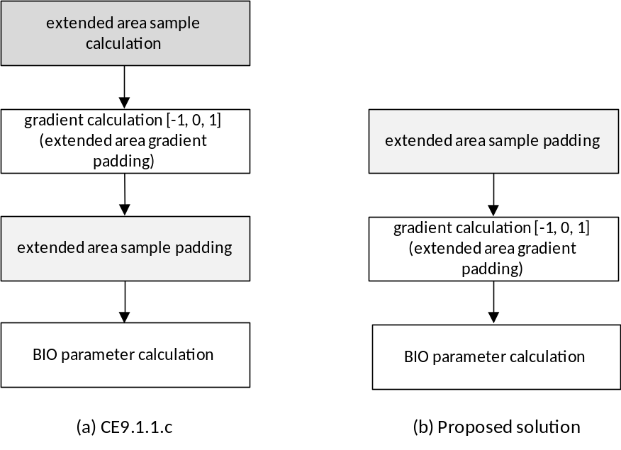
Fig. 1. BDOF refinement process for the current CU
If the extend area’s samples are padded with the samples on CU boundaries before the gradient calculation, it will remove additional operations for calculating extended area samples.

Solution
For applying same gradient filter [-1, 0, 1] to the samples on CU boundaries and inside CU, the extend area’s samples are padded with the samples on CU boundaries before the gradient calculation as shown in Fig.1 (b).
- On the Left/Right CU boundaries, the sample values (P_{ext}) of extended area, which is padded with CU boundary sample(P_{boundary}), are used as the left/right neighboring samples for calculating gradients of CU boundary samples
- On the Top/Bottom CU boundaries, the sample values(P_{ext}) of extended area, which is padded with CU boundary sample(P_{boundary}), are used as the top/bottom neighboring samples for calculating gradients of CU boundary samples
$$P_{ext}=P_{boundary}$$
Specifically, with the proposed solution, the horizontal and vertical gradients derivation can be expressed as follows:
$$\frac{∂I^{\left(k\right)}}{∂x}\left(i, j\right)=\left\{\begin{matrix} \left(I^{\left(k\right)}\left(i+1, j\right)-I^{\left(k\right)}\left(i-1, j\right)\right)≫4 & 0<i<W-1 \\ \left(I^{\left(k\right)}\left(i+1, j\right)-I^{\left(k\right)}\left(i, j\right)\right)≫4 & i=0 \\ \left(I^{\left(k\right)}\left(i, j\right)-I^{\left(k\right)}\left(i-1, j\right)\right)≫4 & i=W-1\end{matrix}\right.$$
$$\frac{∂I^{\left(k\right)}}{∂y}\left(i, j\right)=\left\{\begin{matrix} \left(I^{\left(k\right)}\left(i, j+1\right)-I^{\left(k\right)}\left(i, j-1\right)\right)≫4 & 0<j<H-1 \\ \left(I^{\left(k\right)}\left(i, j+1\right)-I^{\left(k\right)}\left(i, j\right)\right)≫4 & j=0 \\ \left(I^{\left(k\right)}\left(i, j\right)-I^{\left(k\right)}\left(i, j-1\right)\right)≫4 & j=H-1\end{matrix}\right.$$

Where$I^{\left(k\right)}\left(i, j\right)$, $\frac{∂I^{\left(k\right)}}{∂x}\left(i, j\right)$ and $\frac{∂I^{\left(k\right)}}{∂y}\left(i, j\right)$ are the sample values, the horizontal and vertical gradients of the sample at coordinate $\left(i, j\right)$ of the prediction signals.

Experimental Results
The proposed method was integrated on VTM-3.0 and the experiments were performed under JVET common test conditions [3]. The experiments were conducted on the platform of Intel Xeon E5-2690 v2 (3.0GHz) and 64GB RAM with GCC 4.7.2 compiler under CentOS Linux.
Table 1 shows that the average luma BD-rate loss is 0.11% with encoding times of 99% and decoding times of 98% compared to VTM-3.0. Compared to CE9.1.1.c, the average luma BD-rate loss is 0.01% with encoding times of 100% and decoding times of 100% as shown in Table 2.
Table 1. Performance of proposed method compared to VTM-3.0

 |  |  | Random access Main10
 |  |  | Over VTM-3.0
 | Y | U | V | EncT | DecT
Class A1 | 0.06% | -0.04% | -0.03% | 99% | 99%
Class A2 | 0.12% | 0.01% | 0.00% | 99% | 98%
Class B | 0.10% | 0.03% | -0.04% | 99% | 98%
Class C | 0.15% | 0.01% | 0.06% | 99% | 98%
Class E
Overall | 0.11% | 0.01% | -0.01% | 99% | 98%
Class D | 0.26% | -0.02% | 0.12% | 98% | 97%
Class F | 0.03% | 0.00% | -0.02% | 99% | 99%

Table 2. Performance of proposed method compared to CE9.1.1.c

 |  |  | Random access Main10
 |  |  | Over VTM-3.0
 | Y | U | V | EncT | DecT
Class A1 | 0.04% | -0.03% | -0.04% | 100% | 100%
Class A2 | 0.06% | 0.02% | -0.01% | 100% | 100%
Class B | 0.00% | 0.02% | 0.00% | 100% | 100%
Class C | -0.04% | -0.08% | -0.04% | 100% | 100%
Class E
Overall | 0.01% | -0.02% | -0.02% | 100% | 100%
Class D | -0.13% | -0.17% | -0.06% | 100% | 99%
Class F | 0.00% | 0.03% | -0.01% | 100% | 101%

Conclusions
In this contribution, an alternative simple gradient calculation solution is proposed for the samples on CU boundaries without interpolation of the prediction samples in the extended area. After CU boundary samples are directly copied into the extended area, the gradients for the samples on the CU boundaries are calculated with the same gradient calculation method as that for the samples inside CU.

References
[1] X. Xiu, Y. He, Y. Ye, “CE9-related: A simplified design of bi-directional optical flow (BIO),” Joint Video Experts Team (JVET) of ITU-T SG 16 WP 3 and ISO/IEC JTC 1/SC 29/WG 11, JVET-L0591, Oct. 2018.
[2] X. Xiu, S. Esenlik, “Description of Core Experiment 9 (CE9): Decoder Side Motion Vector Derivation”, Joint Video Experts Team (JVET) of ITU-T SG 16 WP 3 and ISO/IEC JTC 1/SC 29/WG 11, JVET-L1029, Oct. 2018.
[3] F. Bossen, J. Boyce, K. Suehring, X. Li, and V. Seregin, “JVET common test conditions and software reference configurations for SDR video,” Joint Video Experts Team (JVET) of ITU-T SG 16 WP 3 and ISO/IEC JTC 1/SC 29/WG 11, JVET-L1010, Oct. 2018

Patent rights declaration(s)
ETRI may have current or pending patent rights relating to the technology described in this contribution and, conditioned on reciprocity, is prepared to grant licenses under reasonable and non-discriminatory terms as necessary for implementation of the resulting ITU-T Recommendation | ISO/IEC International Standard (per box 2 of the ITU-T/ITU-R/ISO/IEC patent statement and licensing declaration form).

