    Joint Video Experts Team (JVET)  of ITU-T SG 16 WP 3 and ISO/IEC JTC 1/SC 29/WG 11  13th Meeting: Marrakech, MA, 9–18 Jan. 2019 | Document: JVET-M0209

Title: | AHG12: On tile group configuration
Status: | Input document to JVET
Purpose: | Proposal
Author(s) or  Contact(s): | Woong Il Choi  Kwang Pyo Choi  Kiho Choi | Email: | woongil.choi@samsung.com  kp5.choi@samsung.com  kiho14.choi@samsung.com
Source: | Samsung
_____________________________

Abstract
The contribution proposes a wrap-around rectangular tile group to support efficient grouping of tiles on 360 video contents and the syntaxes regarding adaptive prediction across tile boundaries based on multiple tile group to support multi-purpose grouping based on both application and parallelization needs.

Introduction
In the last meeting, the tile structure same to HEVC are adopted to support parallel processing and application-driven needs such as region of interest (ROI) or sub-picture based picture access. The slice is replaced to tile group which contains an integer number of complete tiles instead of CTU because it is needed to be able to put multiple tiles in one VCL NAL unit to save overhead data such as ALF coefficients. Based on this motivation of tile and tile group, we can think tiles grouping on rectangular region provides benefit on ROI region access because those regions can be aligned to tile group and it can be easily accessed by NAL unit containing the corresponding tile group.
This contribution proposes two additional features based on rectangular tile group layout; 1) wrap-around tile group and 2) prediction across tile by using multiple tile group layouts. The proposed wrap-around tile group is grouping between the tiles located in left and right (and/or top and bottom) border of image. The motivation comes from the characteristics of 360 video contents which can be connected between both sides of border depending on projection. It is expected to provide more efficient access of ROI region near to image border and improved coding gain by grouping the tiles having the similar image characteristics (e.g. ALF coefficients). The motivation of second feature comes from JVET-L0394 proposal which addresses both the concurrent need for application-driven and parallelization-driven tile layouts. We proposes the multiple tile group layouts to support both needs at the same time and the coding loss minimization scheme by allowing prediction across tile boundaries.

Proposal

Wrap-around tile group
In 360 video, the video contents mostly are connected between left and right side border area or between top and bottom side due to projection. It means the same objects can be located on both sides of image depending on projection format. We propose the wrap-around tile group to support of tile grouping among tiles on both sides of image in order to access those objects and improve coding efficiency by grouping the areas having the similar characteristics of image.
The example of wrap-around tile groups are shown in Figure 1 and the tile order of each corresponding tile group is illustrated in Table 1. The grouping of tiles depends on the relationship between position of the first tile and last tile. The tile order within tile group is started from the first tile to the last tile by raster order within the rectangle area. If the first tile is located in top-left position in rectangle area and the last tile is located in bottom-right position, the normal rectangle tile group is applied. Otherwise, wrap-around tile group is applied.

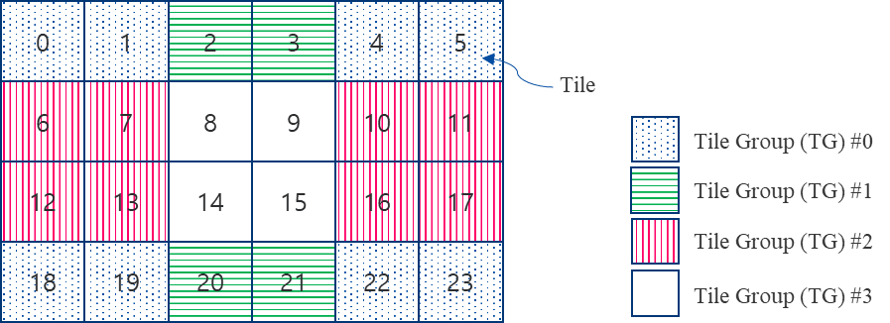
Figure 1 Example of wrap-around tile group

Table 1 Tile order of each tile group
Tile group | First tile | Last tile | Tile order
TG #0 | 22 | 1 | 22,23,18,19,4,5,0,1
TG #1 | 20 | 3 | 20,21,2,3
TG #2 | 10 | 13 | 10,11,6,7,16,17,12,13
TG #3 | 8 | 15 | 8,9,14,15

Prediction across tile boundaries
We propose multiple tile group to support multi-purpose tile layout, such as both parallelization and ROI access without coding loss comes from the increased number of tiles. Figure 2 shows the example of tile layout to support both ROI and parallelization and we can found the number of tiles should be increased due to the different needs of layout. For instance, there is no need to divide tile #0 and tile #1 here. Without changing tile definition, we propose the derivation of prediction across tile boundaries by using additional tile group layout information. Table 2 shows two tile group layouts which comes from each tile design purposes. The tile can be predicted from the previous tiles included in the same tile group of both tile group layouts. Tile #0 can be predicted from Tile #1 because those are in the same tile groups (TG #0 in layout A and TG #0 in layout B).
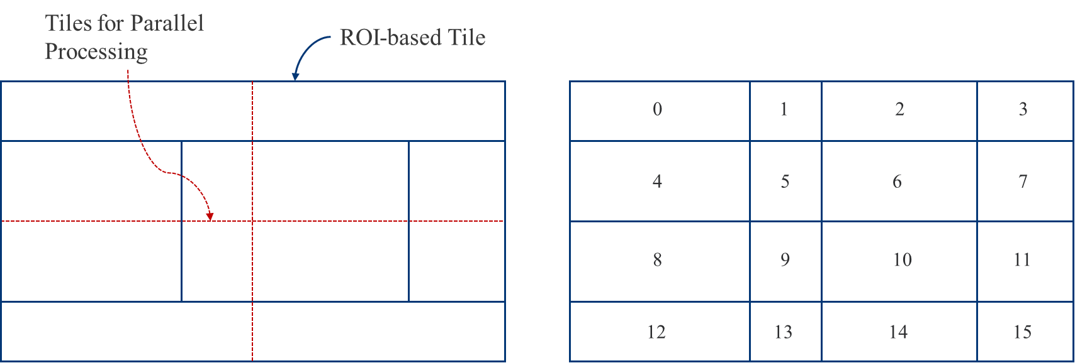
- (b)
Figure 2 (a) Example of tile design based on ROI and parallelization, (b) Tile layout

Table 2 Tile group layout
Tile group layout A  (ROI) | Tile group layout B  (parallelization)
TG #0: 0, 1, 2, 3  TG #1: 4, 8  TG #2: 5, 6, 9, 10  TG #3: 7, 11  TG #4: 12, 13, 14, 15 | TG #0: 0, 1, 4, 5  TG #1: 2, 3, 6, 7  TG #2: 8, 9, 12, 13  TG #3: 10, 11, 14, 15

Proposal summary
The proposed design of tile group for VVC is summarized as follows:
- Tile syntax is not changed.
- Each slice (tile group) contains an integer number of tiles covering a rectangular region of a picture.
  - In slice header, the tile IDs of the first and last tiles are signalled
  - The tile order is derived from the location of first and last tiles
- Additional tile group (prediction_tile_group) is signaled to detect predictable tiles
  - The neighboring tiles corresponding to the same slice and the same prediction tile group are used for prediction
The specification text of the proposal based on JVET-L001-v7 is included in different document.

Patent rights declaration(s)
Samsung Electronics may have current or pending patent rights relating to the technology described in this contribution and, conditioned on reciprocity, is prepared to grant licenses under reasonable and non-discriminatory terms as necessary for implementation of the resulting ITU-T Recommendation | ISO/IEC International Standard (per box 2 of the ITU-T/ITU-R/ISO/IEC patent statement and licensing declaration form).

