    Joint Video Experts Team (JVET)  of ITU-T SG 16 WP 3 and ISO/IEC JTC 1/SC 29/WG 11  13th Meeting: Marrakech, MA, 9–18 Jan. 2019 | Document: JVET-M0197-v2

Title: | AHG14: Software for ultra low-latency encoding
Status: | Input document to JVET
Purpose: | Proposal
Author(s) or  Contact(s): | Kimihiko Kazui | Tel:  Email: | +81 44 754 2049  kazui.kimihiko@fujitsu.com
Source: | FUJITSU LABORATORIES LTD.
_____________________________

Abstract
This contribution proposes software modifications for integrating encoder-only progressive intra refresh in the VTM model, in accordance with the mandates of AHG14 “Progressive intra refresh”. The proposed software modifications are the use of flexible tile partitioning in JVET-M0066 [5] and the methods described in JVET-L0079 “AHG14: Study of methods for progressive intra refresh” [4].
Version 2 contains two additional test results. First one is the comparison with low-delay B. Second one is the comparison with the proposal with normative changes.

Introduction

Ultra low-latency encoding with progressive intra refresh
The progressive intra refresh (a.k.a. gradual intra refresh) scheme, which is commonly used in “very” low-latency coding, refreshes decoded pictures progressively by inserting an intra-coded region in each inter-coded picture (See Figure 1). By dispersing intra-coded CUs in multiple inter-coded pictures, instead of only in an intra-coded picture, the size of each coded picture can be easily averaged. Consequently, the size of the CPB can be reduced to the minimal value (i.e. the bitrate divided by the frame rate), and the encoder-decoder delay time can be reduced to one picture interval.
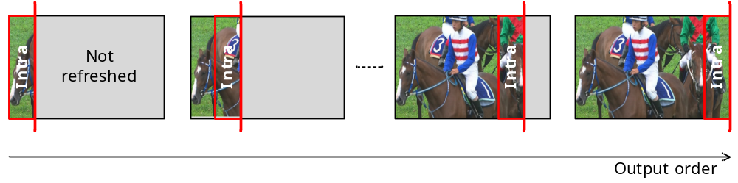
Figure 1: Progressive intra refresh
The HEVC standard further introduces the signalling and HRD operation of a decoding unit (DU) which contains one or more slices so to realize interoperable ultra low-latency coding less than one picture interval. For example, when each DU contains exactly one CTU line and the same number of intra CUs (as illustrated in Figure 1), then the size of the CPB for DU-based HDR operation can be reduced to the averaged size of a DU (i.e. the bitrate divided by the number of DU per second) [1][2].

Correct reconstruction of recovery point picture
Real-time applications generally require a random-access picture in a bitstream. Specifically, correct reconstruction (i.e. exact match) of coded pictures after a recover point picture is required when the decoding process starts from the random-access picture preceding the recover point picture.
Such correct reconstruction is realized by inhibiting any temporal or spatial reference from a CU in the refreshed area to a CU in the not-refreshed area, as discussed in JVET-L0079 [4].

Mandates of AHG14 “Progressive intra refresh”
AHG 14 “Progressive intra refresh” established at the 12th JVET meeting has the following mandates;
- Define relevant test conditions to evaluate low-latency encoding with progressive intra refresh for random access without intra frames.
- Study non-normative ways to produce progressive intra refresh with minimum losses in coding efficiency.
- Propose software modifications for integrating encoder-only intra refresh in the VTM model.
- Characterize progressive intra refresh performance objectively and subjectively.
- Study normative solutions to improve intra refresh performance against encoder-only intra refresh.
This contribution relates to the third mandate, with the consideration of the requirement in the second mandate.

Software design

Direction of refresh and target latency
This contribution proposes to insert intra refresh area vertically and to shift the area from left to right, as illustrated in Figure 1. The CPB size can be reduce to the averaged size of a DU (i.e. the bitrate divided by the number of DU per second).

Use of flexible tile portioning for restricting spatial reference
As discussed in JVET-L0079, one possible way to achieve correct reconstruction with minimal loss in coding efficiency is to set a boundary between the refreshed area and not-refreshed area, at which any spatial reference from one area to another is normatively inhibited. With this boundary control, inter-prediction and in-loop filters can be used without any further restrictions.
Tile partitioning of the VVC draft3.0 specification [3], with loop_filter_across_tiles_enabled_flag set equal to 0, is one of the candidates to define the boundary. However, tile partitioning has a drawback. Specifically, the position of a tile boundary is always on the CTU grid (i.e. 128x128), which is not suitable for many cases. For example, when the picture width is 1,920 and the cycle of random access picture is 60, then the position (in unit of samples) of the boundary in x-axis is shall be set to the multiple of 32 (= 1,920 / 60 ).
JVET-M0066 [5] proposes flexible tile partitioning, in which the position of tile boundary can be set to the multiple of 8. This contribution suggests using flexible tile partitioning for progressive intra refresh.
The proposed software is based on the software contained in JVET-M0066.

Tile boundary setting
A picture is divided into 2xM tiles as illustrated in Figure 2, where M is set to ceil(picture_height / 128).
It is noted no vertical tile boundary is set (i.e. 1xM division) when the boundary locates at the right picture boundary.
It shall be highlighted that horizontal tile boundary is inserted in each CTU line for minimizing CPB size. If no horizontal tile boundary is inserted, then the maximum number of DUs is reduced to two and averaging DU size in bits becomes difficult since the first tile (left side of a picture) contains all intra CU for refresh in a picture while the second tile (left side of a picture) does not.
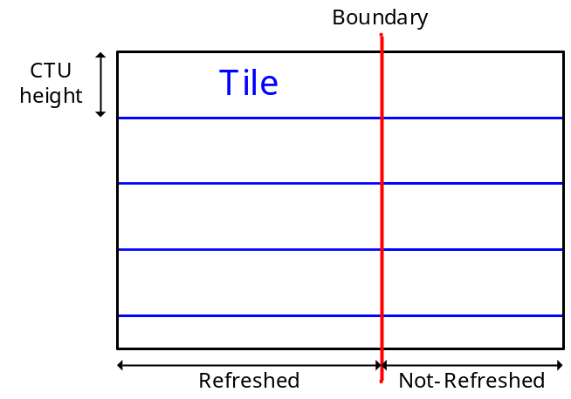
Figure 2: Progressive intra refresh

Temporal reference restriction
Temporal MV prediction is disabled at each random-access picture, as discussed in JVET-L0079. This is achieved by setting slice_temporal_mvp_enabled_flag equal to 0 for all random-access pictures and pictures with the POC value is equal (p0 + 1..(N-1)), where p0 is the POC value of a random-access picture and N is equal to the maximum number of reference pictures.
MV restriction is also applied as discussed in JVET-L0079. When a PU is in the refreshed area of the current picture, then it is controlled so that any reference samples of the PU is also in the refreshed area of the reference picture. This encoder-side control is implemented by setting the cost of inter-prediction of a PU to a very large value if at least one reference sample pointed by the MV is in the not-refreshed area of the reference picture.
A CU in the refreshed area and adjacent to the vertical tile boundary is always intra-coded.

Software

Source code
The source code of the proposed software is attached in this contribution.
The software is based on the software contained in JVET-M0066, which is based on VTM-3.0.
Flexible tile partitioning is enabled by setting the macro JVET_L0359_FLEXIBLE_TILE equal to 1.
When Flexible tile partitioning is enabled, progressive intra refresh is enabled by setting the macro JVET_M0197_PIR equal to 1.

Configuration file
The configuration file for progressive intra refresh is found in encoder_PIR_vtm.cfg, which is compatible with the proposal in JVET-L0160 [6].
Currently, the following restriction exists;
- IntraRefreshType : 1 only (i.e. “classical” refresh mode)
- IntraRefreshDirection : 0 only (i.e. from left to right)
Regarding the tools of VTM-3.0, CPR is not supported yet due to time constraints

Performance

Correct reconstruction
Correct reconstruction at a recovery point picture can be confirmed by enabling the decoded picture hash SEI message.
When the decoder option ‘—RandomAccessPos’ is set with non-zero value, then the decoder resets both reconstructed picture and MV buffer at the specified random-access picture. There should be no mismatch at and after the recovery point picture following the random-access picture.

BD-Rate compared with VTM-3.0 random access
The performance of the proposed software is compared with VTM-3.0 random access anchor with similar refresh cycle. The purpose of this comparison is just for information.
Table 1 Performance of proposed progressive intra refresh compared to random access
Class | Sequence | BD-Rate (Y/U/V) | IRAP interval | Refresh interval
B | MarketPlace | 70.91%/156.09%/194.42% | 64 | 60
 | RitualDance | 52.51%/88.25%/95.15% | 64 | 60
 | Cactus | 79.56%/129.01%/177.57% | 48 | 40
 | BasketballDrive | 40.49%/102.88%/82.52% | 48 | 40
 | BQTerrace | 72.42%/406.41%/525.98% | 64 | 60
C | BasketballDrill | 81.64%/103.62%/90.30% | 48 | 52
 | BQMall | 79.35%/153.63%/151.15% | 64 | 52
 | PartyScene | 102.04%/179.49%/198.70% | 48 | 52
 | RaceHorses | 28.99%/101.21%/97.52% | 32 | 26
D | BasketballPass | 40.94%/97.49%/64.65% | 64 | 52
 | BQSquare | 173.81%/428.96%/466.73% | 48 | 52
 | BlowingBubbles | 106.68%/184.66%/207.78% | 48 | 52
 | RaceHorses | 39.32%/88.03%/89.19% | 32 | 26
F | BasketballDrillText | 86.75%/111.90%/103.63% | 48 | 52
 | ArenaOfValor | 87.38%/126.03%/117.80% | 64 | 60
 | SlideEditing | 80.58%/86.42%/90.69% | 32 | 27
 | SlideShow | 94.81%/120.38%/127.30% | 16 | 15

Table 2 Performance of proposed progressive intra refresh compared to random access
 | Random access Main10
 | Over VTM-3.0
 | Y | U | V | EncT | DecT
Class A1 | #VALUE! | #VALUE! | #VALUE! | #DIV/0! | #DIV/0!
Class A2 | #VALUE! | #VALUE! | #VALUE! | #DIV/0! | #DIV/0!
Class B | 63.18% | 176.53% | 215.13% | #DIV/0! | #DIV/0!
Class C | 73.01% | 134.49% | 134.42% | #DIV/0! | #DIV/0!
Class E
Overall | #VALUE! | #VALUE! | #VALUE! | #DIV/0! | #DIV/0!
Class D | 90.19% | 199.79% | 207.09% | #DIV/0! | #DIV/0!
Class F | 87.38% | 111.18% | 109.86% | #DIV/0! | #DIV/0!
It is noted that the refresh interval is not equal to the IRAP interval of the random-access anchor due to the granularity of the tile boundary position (i.e. 8 samples).

BD-Rate compared with VTM-3.0 low-delay B
The performance of the proposed software is compared with VTM-3.0 low-delay B anchor. Due to time constraints, the number of encoding frames is reduced to 100.
It is noted that the value of IntraPeriod is set equal to 32 for low-delay B. Regarding the proposed progressive intra refresh anchor, actual refresh cycles are 30 and 26 for HD sequences (i.e. class-B sequences and class-F “Arena of Valor”) and other sequences, respectively.
Table 3 Performance of proposed progressive intra refresh compared to low-delay B
 | Low delay B Main10
 | Over VTM-3.0
 | Y | U | V | EncT | DecT
Class A1
Class A2
Class B | 18.17% | 50.67% | 58.42% | #DIV/0! | #DIV/0!
Class C | 27.08% | 46.19% | 40.37% | #DIV/0! | #DIV/0!
Class E | 48.24% | 68.05% | 73.56% | #DIV/0! | #DIV/0!
Overall | 28.66% | 53.52% | 56.19% | #DIV/0! | #DIV/0!
Class D | 29.92% | 59.16% | 59.49% | #DIV/0! | #DIV/0!
Class F | 38.70% | 47.15% | 47.50% | #DIV/0! | #DIV/0!

Possible improvement by normative changes
In this subclause, possible performance improvement by normative changes is demonstrated.
As discussed in JVET-L0079, restrictions by tile boundary is essential only at the refresh boundary for ultra low-latency coding. As illustrated in Figure 2, reference from right tile to left tile is essential while other reference such as tile below to tile above is not needed for progressive intra refresh. The purpose of this test is to show possible performance improvement by normative changes to the current design.

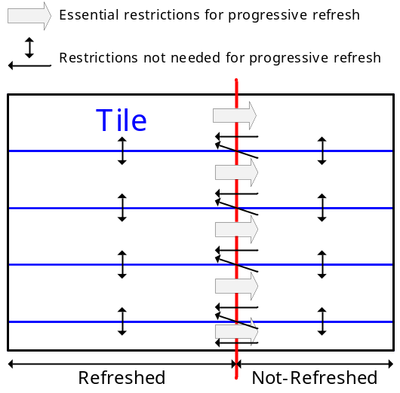
Figure 2: Resitiction at tile boundary for progressive intra refresh
The software of the suggested normative changes is attached to this contribution. This functionality is enabled by setting macro JVET_M0197_RELAXED_RESTRICTION equal to 1. It is noted that ALF is still operated with the restriction of the current design at tile boundary due to time constraints.
Table 4 is the summary of BD-Rate comparison with the proposed progressive intra refresh without normative changes. Due to time constraints, the number of encoding frames is reduced to 100.
On average, 1.9% gain is observed.
Table 4 Performance of normative changes compared to proposal without normative changes
 | Progressive intra refresh Main10
 | Over proposal without normative changes
 | Y | U | V | EncT | DecT
Class A1
Class A2
Class B | -1.89% | -2.35% | -2.88% | #DIV/0! | #DIV/0!
Class C | -1.27% | -1.30% | -1.76% | #DIV/0! | #DIV/0!
Class E | -2.80% | -2.78% | -3.44% | #DIV/0! | #DIV/0!
Overall | -1.91% | -2.11% | -2.65% | #DIV/0! | #DIV/0!
Class D | -0.62% | -1.04% | -0.78% | #DIV/0! | #DIV/0!
Class F | -1.65% | -2.18% | -2.00% | #DIV/0! | #DIV/0!

Conclusion
This contribution proposes software modifications for integrating encoder-only progressive intra refresh in the VTM model, using flexible tile partitioning in JVET-M0066.
It is demonstrated that normative changes increase coding efficient on average 1.9%, up to 2.8%.
It is suggested to further examine, improve and update the proposed software as the formal activity of AHG14 if flexible tile partitioning is adopted at the 13th JVET meeting.

References
[1] J.-M. Thiesse, D.Nicholson, “Improved Cyclic Intra Refresh”, JVET-K0212, July 2018.
[2] K.Kazui, J.Koyama, A.Nakagawa, “Proposal of requirement on very low delay coding”, JCTVC-B031, March 2012.
[3] B.Bross, J.Chen, S.Liu, “Versatile Video Coding (Draft 3)”, JVET-L1001, October 2018.
[4] K.Kazui, “AHG14: Study of methods for progressive intra refresh”, JVET-L0079, October 2018.
[5] Y.Yasugi, T.Ikai, “AHG12: Flexible Tile Partitioning”, JVET-M0066, January 2019.
[6] J.-M. Thiesse, D.Nicholson, D.Gommelet “AHG14: Intra Refresh Test conditions and Anchors generation Proposal”, JVET-L0160, October 2018.

Patent rights declaration(s)
Fujitsu Limited may have current or pending patent rights relating to the technology described in this contribution and, conditioned on reciprocity, is prepared to grant licenses under reasonable and non-discriminatory terms as necessary for implementation of the resulting ITU-T Recommendation | ISO/IEC International Standard (per box 2 of the ITU-T/ITU-R/ISO/IEC patent statement and licensing declaration form).

