    Joint Video Experts Team (JVET)  of ITU-T SG 16 WP 3 and ISO/IEC JTC 1/SC 29/WG 11  13th Meeting: Marrakech, MA, 9–18 Jan. 2019 | Document: JVET-M0144-v1

Title: | CE13: Adaptive frame packing based on test 1.1.a (Test 4.1)
Status: | Input document to JVET
Purpose: | Proposal
Author(s) or  Contact(s): | Philippe Hanhart, Yuwen He  9276 Scranton Rd, #300  San Diego, CA 92121, USA | Tel:  Email: | Philippe.Hanhart@interdigital.com  Yuwen.He@interdigital.com
Source: | InterDigital Communications, Inc.
_____________________________

Abstract
This contribution reports simulation results of CE13 test 4.1. The adaptive frame packing periodically modifies the location of discontinuous face boundaries in the frame packed pictures to improve coding efficiency and reduce the visibility of face seam artifacts. Results based on end-to-end WS-PSNR show that test 4.1 provides {Y, U, V} BD-rate savings of {-0.87%, -0.49%, -0.55%}, {-0.86%, -0.20%, -0.41%}, and {-0.30%, 0.10%, -0.18%} over PHEC, test 1.1.b, and test 1.1.a, respectively.

Introduction
Face discontinuities in the frame packed picture may yield to seam artifacts in reconstructed viewports. One of the goals of CE13 is to study methods to remove subjective artifacts at face boundaries by using normative decoding tools. The tested coding tools include modifications to in-loop filtering and inter prediction, as well as projection format adaptation. This contribution reports the coding performance of adaptive frame packing on top of test 1.1.a (HEC with In-loop filters disabled across face discontinuities), as studied in CE13 test 4.1 [1].

Technical description

Adaptive frame packing
To reduce the visibility of face seam artifacts, adaptive frame packing is proposed to periodically modify the location of discontinuous face boundaries in the frame packed pictures. The advantage of changing frame packing parameters at regular time intervals is that, for a discontinuous face boundary in the current picture, if there is a reference picture which uses a different frame packing where that same face boundary is continuous, then better prediction may be achieved for the areas located near the discontinuous face boundary in the current picture. For example, if the reference and current pictures are packed using different frame packing configurations as depicted in Figure 1(a) and Figure 1(b), respectively, then the face boundary between face #1 and face #4 in 3D geometry, marked by the red dashed lines, can be better predicted from the corresponding areas in the reference picture. This is because the areas near that face boundary in the reference picture, marked by the green line in Figure 1(a), are continuous and therefore generally it is easier to be coded at a higher quality; thus, better prediction may be provided for the current picture around these areas, reducing the visibility of the seam artifact in the current picture. Additionally, by changing frame packing parameters at regular intervals, locations of the discontinuous face boundaries in the frame packed pictures will change periodically. As a result, though face seams may still appear at some point in time, the duration of a face seam at the same location will be reduced. The result is visually more pleasant compared to having a face seam artifact always at the same location, which could catch the viewer’s attention and degrade perceived video quality when watching the viewport video.
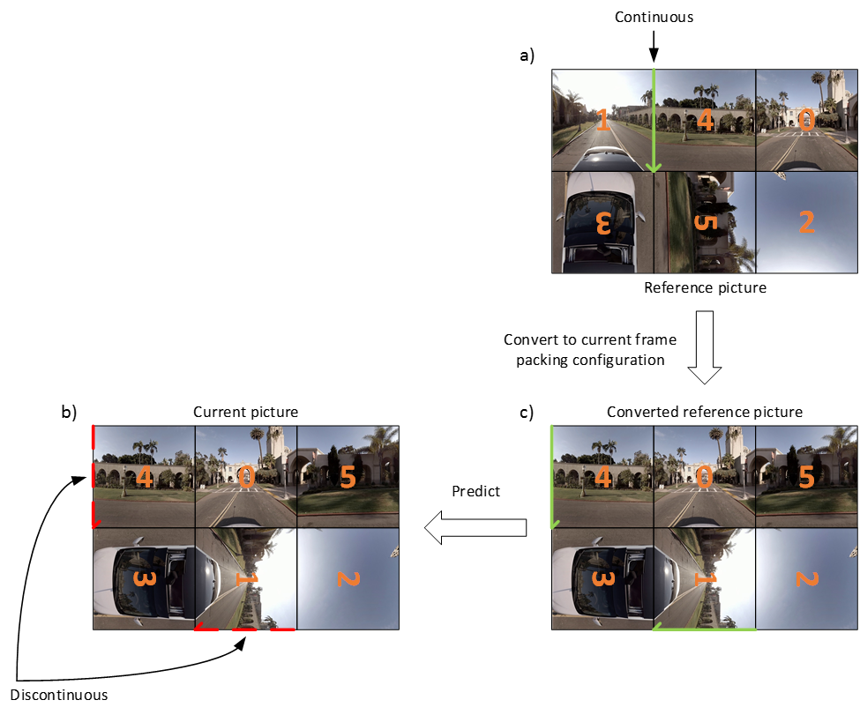
Figure 1. Inter frame prediction in the case of different frame packing configurations between the reference (a) and current (b) pictures. The converted reference picture used to predict the current picture is shown in (c).
As depicted in Figure 1, when the frame packing configuration of the reference picture is different from that of the current picture, the reference picture is first converted into the frame packing configuration of the current picture. This conversion is straightforward and only involves “reshuffling” of the faces within the frame packed pictures. An example of the converted reference picture is shown in Figure 1(c).
To avoid a misalignment of chroma samples after rotation, encoding is performed using chroma sample location type 1. An additional CCLM downsampling filter is implemented to align the location of the downsampled reconstructed luma samples with that of the chroma samples. A simple averaging filter is used
$${rec}_{L}'\left(i,j\right)= \left[{rec}_{L}\left(2i,2j\right)+{rec}_{L}\left(2i+1,2j\right)+{rec}_{L}\left(2i,2j+1\right)+{rec}_{L}\left(2i+1,2j+1\right)+2\right]≫2$$ | (1)
The adaptive frame packing parameters are determined at the encoder side at every IRAP and signaled in the PPS.

Adaptive frame packing determination at the encoder
Considering the HEC 3×2 layout, there are six different combinations to select two face groups of three faces each. Using the face definitions from the 360Lib, these combinations are listed in Table 1. Since the top and bottom parts of the spherical video are typically less interesting and/or easier to encode, only the combinations where three faces along the equators are grouped together. This reduces the problem to four different combinations (combinations 1-4 in Table 1).
Table 1. Combinations to select two face groups of three faces
Combination | Group #1 | Group #2
1 | PX, PZ, NX | PY, NZ, NY
2 | PX, NZ, NX | PY, PZ, NY
3 | PZ, PX, NZ | PY, NX, NY
4 | PZ, NX, NZ | PY, PX, NY
5 | PX, PY, NX | PZ, NY, NZ
6 | PZ, PY, NZ | PX, NY, NX
For any of these four combinations, the three equatorial faces in group #1 are placed horizontally, whereas the remaining three face in group #2 may be rotated in the frame packed picture. However, rotations of ±90° may impact coding efficiency, especially for intra coding. Indeed, a better prediction can be achieved for a pattern composed of diagonal lines, i.e., from upper left to lower right, than for a pattern composed of anti-diagonal lines, i.e., from upper right to lower left, because some intra prediction directions (e.g., those close to the intra mode 2) require reference samples located below left and above right of the current block, respectively, which are more likely to be unavailable.
To determine which rotation is optimal for a face, the horizontal, vertical, diagonal, and anti-diagonal gradients are computed on the luma component using 1-D Laplacian. Then, gradient classification is applied on an 8×8 block basis to determine the dominant gradient in each block. The gradient values are accumulated over all samples within a block. The accumulated horizontal, vertical, diagonal, and anti-diagonal gradient values, denoted g_{h}, g_{v}, g_{d}, and g_{a}, respectively, are compared to each other’s to determine the block’s dominant gradient following the flowchart depicted in Figure 2, where α is a parameter used to classify active from inactive gradients and is set to 2.
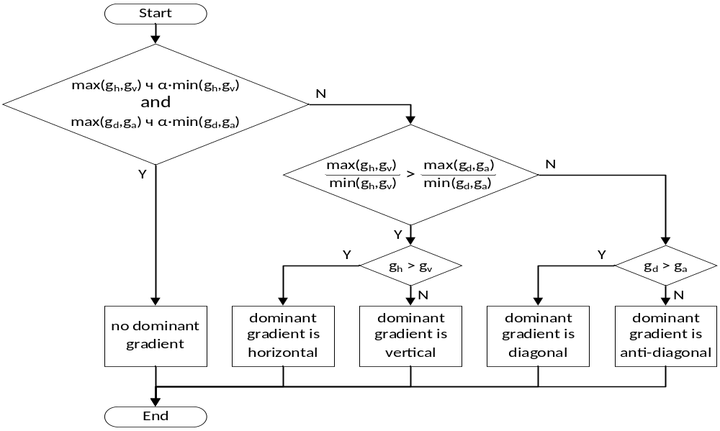
Figure 2. Flowchart for determining the dominant gradient for an 8×8 block.
For each face, a cost function is built as
$$c_{i} = w_{h}∙{\overline{g}}_{h,i}+w_{v}∙{\overline{g}}_{v,i}+w_{d}∙{\overline{g}}_{d,i}+w_{a}∙{\overline{g}}_{a,i}$$ | (2)
Where $i$ is the face index, $w_{h}$, $w_{v}$, $w_{d}$, and $w_{a}$ are the weights assigned to the horizontal, vertical, diagonal, and anti-diagonal dominant gradient counts ${\overline{g}}_{h}$, ${\overline{g}}_{v}$, ${\overline{g}}_{d}$, and ${\overline{g}}_{a}$, respectively. Considering that intra prediction for patterns composed of anti-diagonal lines may be less efficient than for other directions, the following set of weights are used: $w_{h}=w_{v}=w_{d}=-1$, $w_{a}=1$. Then, the overall cost for each combination (see Table 1) is evaluated as the sum of the individual cost of each face, considering the orientation of each face.
A subset of the first four adaptive frame packing combinations shown in Table 1 is used in a rotating manner at the beginning of each IRAP. Among the four combinations, the cost of each combination is calculated using the first picture of the input video sequence. If the cost of any combination is significantly higher than that of the best combination, then that combination is not used in coding the input video sequence to avoid reducing coding efficiency. Since only the first picture in the sequence is used in the determination, this solution can be used together with parallel encoding. Without loss of generality, after analyzing the first picture, assume that all four combinations are determined to be viable, and they are ranked based on their cost as C1, C2, C3, C4. For the first picture, the best combination, i.e., C1, is used. For the subsequent IRAP pictures, two sets of combinations are formed, i.e., {C1,C2} and {C3,C4}, and the optimal combination is selected as
$${\text{C}}_{\text{opt}}=\left\{\begin{matrix}\underset{\{\text{C1,C2}\}}{arg min}{c} & \text{if} t \% 2T=0 \\ \underset{\{\text{C3,C4}\}}{arg min}{c} & \text{otherwise}\end{matrix}\right.$$ | (3)
where $T$ is the IRAP period, % is the modulo operator, and $c$ is the cost function computed for the given IRAP picture. Adaptive frame packing parameters are selected by the encoder using the first picture of each IRAP and signaled once per IRAP.
For sequences with large global camera motion, the content may change drastically within a face during one IRAP and frame packing parameters determined at the beginning of the IRAP may need to be updated more frequently. However, if the training period is less than the IRAP period, additional conversions are needed for the B-pictures. Thus, when the global motion is large, the adaptiveness of adaptive frame packing is disabled, i.e., the default frame packing parameters are used. This detection is performed based on the absolute frame difference computed between the pictures at t=0 and t=0.5s.

Simulation results
The software is implemented on top of test 1.1.a (HEC with in-loop filters disabled across face discontinuities) using the CE13 common codebase, which uses VTM-3.0 and 360Lib-8.0. The encoding was done under 360° video CTC [2]. The following tables only report the end-to-end WS-PSNR results. Results for the other metrics can be found in the accompanying Excel spreadsheet.
Results for test 4.1 over PHEC, test 1.1.b (PHEC with in-loop filters disabled across face discontinuities), and test 1.1.a (HEC with in-loop filters disabled across face discontinuities) are reported in Table 2, Table 3, and Table 4, respectively.
Table 2. BD-rate for test 4.1 over PHEC.
 |  | BD-rate(Y) | BD-rate(U) | BD-rate(V)
Class S1 | SkateboardInLot | -0.63% | -0.04% | 1.19%
Class S1 | ChairLift | -0.76% | 0.45% | -1.20%
Class S1 | KiteFlite | -0.81% | -0.40% | 0.09%
Class S1 | Harbor | -1.09% | -0.81% | -1.01%
Class S1 | Trolley | -1.47% | -1.27% | -1.17%
Class S1 | GasLamp | -1.47% | -1.47% | -1.41%
Class S2 | Balboa | -0.48% | -0.37% | -0.15%
Class S2 | Broadway | -0.26% | 0.74% | 0.20%
Class S2 | Landing2 | -0.73% | -1.54% | -1.48%
Class S2 | BranCastle2 | -1.03% | -0.15% | -0.51%
Class S1 |  | -1.04% | -0.59% | -0.59%
Class S2 |  | -0.62% | -0.33% | -0.49%
Overall |  | -0.87% | -0.49% | -0.55%
Enc Time[%] |  | 100%
Dec Time[%] |  | 106%
Table 3. BD-rate for test 4.1 over test 1.1.b.
 |  | BD-rate(Y) | BD-rate(U) | BD-rate(V)
Class S1 | SkateboardInLot | -0.76% | 0.45% | 0.84%
Class S1 | ChairLift | -0.70% | 0.57% | -1.10%
Class S1 | KiteFlite | -0.77% | -0.42% | 0.21%
Class S1 | Harbor | -0.99% | -0.49% | -0.92%
Class S1 | Trolley | -1.43% | -1.16% | -0.93%
Class S1 | GasLamp | -1.41% | -1.31% | -1.23%
Class S2 | Balboa | -0.52% | 0.04% | -0.22%
Class S2 | Broadway | -0.32% | 0.79% | 0.33%
Class S2 | Landing2 | -0.69% | -0.18% | -0.49%
Class S2 | BranCastle2 | -1.04% | -0.31% | -0.63%
Class S1 |  | -1.01% | -0.39% | -0.52%
Class S2 |  | -0.64% | 0.09% | -0.25%
Overall |  | -0.86% | -0.20% | -0.41%
Enc Time[%] |  | 100%
Dec Time[%] |  | 102%
Table 4. BD-rate for test 4.1 over 1.1.a.
 |  | BD-rate(Y) | BD-rate(U) | BD-rate(V)
Class S1 | SkateboardInLot | -0.41% | 0.29% | 0.65%
Class S1 | ChairLift | -0.29% | 0.82% | -0.82%
Class S1 | KiteFlite | -0.16% | -0.08% | 0.43%
Class S1 | Harbor | -0.52% | -0.65% | -0.72%
Class S1 | Trolley | -0.63% | -0.84% | -0.87%
Class S1 | GasLamp | -0.74% | -0.95% | -0.81%
Class S2 | Balboa | -0.11% | 0.20% | -0.30%
Class S2 | Broadway | 0.06% | 1.31% | 0.41%
Class S2 | Landing2 | -0.03% | 0.44% | 0.18%
Class S2 | BranCastle2 | -0.17% | 0.43% | 0.04%
Class S1 |  | -0.46% | -0.23% | -0.36%
Class S2 |  | -0.06% | 0.59% | 0.08%
Overall |  | -0.30% | 0.10% | -0.18%
Enc Time[%] |  | 100%
Dec Time[%] |  | 102%
BD-rate savings over PHEC, test 1.1.b, and test 1.1.a are around {-0.87%, -0.49%, -0.55%}, {-0.86%, -0.20%, -0.41%}, and {-0.30%, 0.10%, -0.18%}, respectively. The complexity of adaptive frame packing is similar to that of test 1.1.

Conclusion
This contribution reports simulation result of CE13 test 4.1, which evaluates adaptive frame packing on top of test 1.1.a. The results show BD-rate savings of {-0.87%, -0.49%, -0.55%}, {-0.86%, -0.20%, -0.41%}, and {-0.30%, 0.10%, -0.18%} over PHEC, test 1.1.b, and test 1.1.a, respectively.

References
- P. Hanhart, J.-L. Lin, C. Pujara, “Description of Core Experiment 13 (CE13): Coding tools for 360° omnidirectional video”, JVET-L1033, Oct. 2018, Macau, CN.
- P. Hanhart, J. Boyce, K. Choi, J.-L. Lin “JVET common test conditions and evaluation procedures for 360° video”, JVET-L1012, Oct. 2018, Macau, CN.

Patent rights declaration(s)
InterDigital Communications, Inc. may have current or pending patent rights relating to the technology described in this contribution and, conditioned on reciprocity, is prepared to grant licenses under reasonable and non-discriminatory terms as necessary for implementation of the resulting ITU-T Recommendation | ISO/IEC International Standard (per box 2 of the ITU-T/ITU-R/ISO/IEC patent statement and licensing declaration form).

