    Joint Video Experts Team (JVET)  of ITU-T SG 16 WP 3 and ISO/IEC JTC 1/SC 29/WG 11  13th Meeting: Marrakech, MA, 9–18 Jan. 2019 | Document: JVET-M0141-v1

Title: | CE6: RQT-like sub-block transform for inter blocks (Test 6.4.4)
Status: | Input document to JVET
Purpose: | Proposal
Author(s) or  Contact(s): | Yin Zhao,  Han Gao,  Haitao Yang,  Jianle Chen | Email: | yin.zhao@huawei.com  han.gao@huawei.com  haitao.yang@huawei.com  jianle.chen@huawei.com
Source: | Huawei Technologies Co., Ltd
_____________________________

Abstract
This contribution reports the coding performance of a RQT-like sub-block transform for inter blocks. A coding unit can be split into two or three transform units (TU) via a binary split or a ternary split. Each TU is associated with a pre-define transform type. Simulation results reportedly show that -0.59% and -1.01% PSNR-Y BD-rates are achieved for RA and LB configurations, with EncT 120% and 127%, respectively.

Proposed Method
For an inter-predicted CU with cu_root_cbf equal to 1, cu_sbt_flag may be signaled to indicate whether the whole residual block is transformed or the whole residual block is tiled into several TUs. In the former case, inter MTS information is parsed to determine the transform type of the CU. In the latter case, each sub-block TU is coded with inferred adaptive transform type, the same to that in CE6.4.1-a. The sub-block transform is like a depth-1 RQT, except that the split type is binary or ternary split and that the transform type of each TU is adaptive.
The SBT is not applied to the combined inter-intra mode, since almost no coding gain is achieved.
This test is a comparative study of CE6.4.1-a. Compared with CE6.4.1-a, the difference are as follows:

Sub-block TU tiling
In CE6.4.1-a, the TU tiling is binary tree (BT) split or asymmetric binary tree (ABT) split.
In this test, the TU tiling is BT or ternary tree (TT) split. The reason that TT split instead of ABT split is used is to avoid introducing non-power-of-two transform.

Transform type of the sub-block
In CE6.4.1-a, position-dependent transform is applied on luma transform blocks (TB) in SBT-V and SBT-H. More specifically, the horizontal and vertical transforms for each SBT position is specified in Figure 1. For example, the horizontal and vertical transforms for SBT-V position 0 is DCT-8 and DST-7, respectively. When one side of the residual TU is greater than 32, the 3 corresponding transform is set as DCT-2. Chroma TBs always use DCT-2 in CE6.4.1-a and in this test.
In this test, the transform types for BT-split TUs and TT-split side TUs are identical to those in CE6.4.1a, and the TT-split central TU uses DCT-2 for the split side.
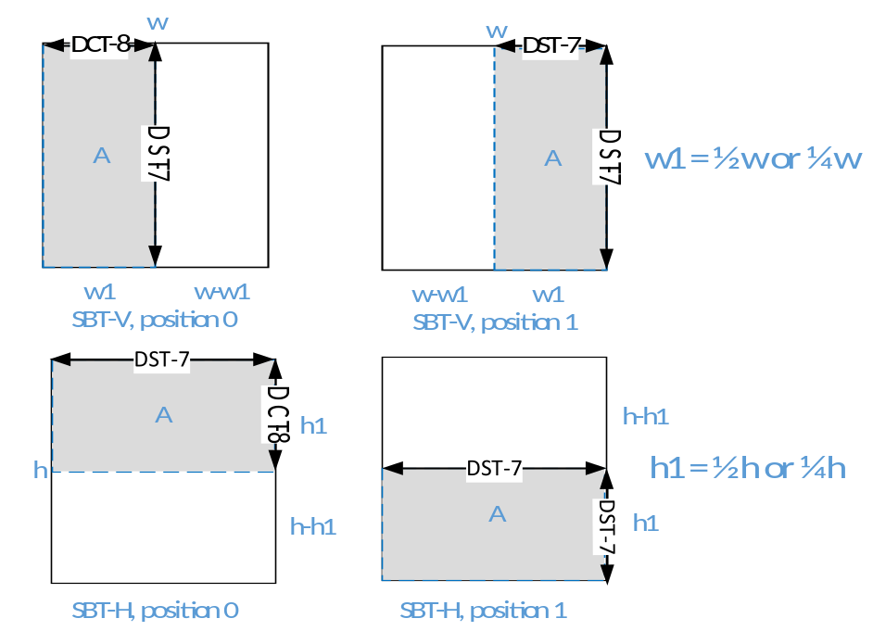
Figure 1 Illustration of sub-block transform modes SBT-V and SBT-H in CE6.4.1-a

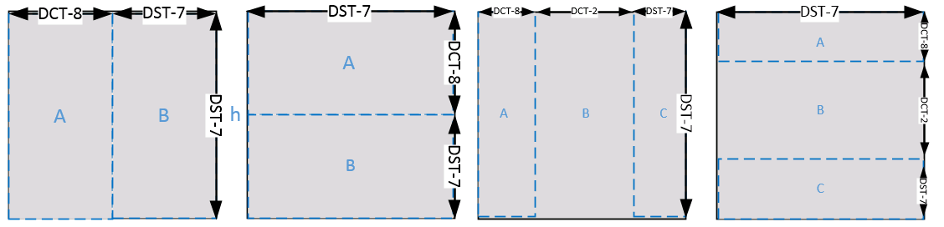
Figure 2 Illustration of sub-block transform modes in this test CE6.4.4-a

Cbf signaling
In CE6.4.1-a, only cbf_y, cbf_u and cbf_v of one TU is signaled, and those of the other TU are inferred to be zero.
In this test, cbf_y, cbf_u and cbf_v are signaled similar to the scheme in HEVC RQT. At transform depth 0, cbf_u and cbf_v are signaled. For the first N-1 TU at transform depth 1 (N =2 for BT tiling and N=3 for TT tiling), if cbf_u and cbf_v at transform depth 0 is one, then cbf_u and cbf_v of the TU are signaled. For the last TU at transform depth 1, if cbf_u of the previous N-1 TUs are zero (and cbf_u at transform depth 0 is also one), the cbf_u of the last TU is inferred to be one. Similar rules are applied to cbf_v.
Cbf_y is signaled for the N-1 TU at transform depth 1, and for the last TU, if cbf_y of the previous N-1 TUs are zero, the cbf_y of the last TU is inferred to be one.

Fast algorithm
To reduce encoder run-time, some fast algorithms have been developed in RDO of SBT.
Algorithm 1: a transform mode save & load is applied (which is improved from that proposed in JVET-K0358). The residual energy (i.e., SSD) and the best transform mode (one among whole block transform with DCT-2, whole block transform with inter MTS, and sub-block transform) of a PU is saved as history information. When the residual energy of a PU matches a previous case, the best transform mode associated with the residual energy is tried while the other transform modes are skipped. This fast algorithm reduces the encoding time of both SBT and inter MTS.
Algorithm 2: if the RD cost of whole residual block being transformed by DCT-2 is much worse than the current best RD cost, the SBT is skipped.
Algorithm 3: if the RD cost of whole residual block being transformed by DCT-2 is small enough, the SBT is skipped.
The fast algorithms are all almost lossless (all together around 0.1% loss in RA).
The major difference between the fast algorithm in CE6.4.1-a and that in this test is that CE6.4.1-a has additional fast algorithm which is based on the SSD of the residual-zeroing-out TU. Since RQT-like SBT allows each TU to have residual, this particular fast algorithm, which is almost lossless for CE6.4.1-a and significantly reducing encoder run-time, does not fit the RQT-like SBT.

Simulation results
The proposed methods were integrated into the VTM 3.0 reference software, and are tested in two configurations: VTM, and VTM plus inter MTS. Table 1 summarizes the simulation results of the tests. Detailed results can be found in the attached excel sheets. The performance of CE6.4.1-a is also provided for comparison.
Table 1 Simulation results of the two tests
 |  | Y | U | V | EncT | DecT
Over VTM 3.0
CE6.4.4-a | RA | -0.59% | -0.35% | 0.10% | 120% | 102%
 | LB | -1.01% | -1.77% | -0.19% | 127% | 103%
CE6.4.1-a | RA | -0.47% | -0.16% | 0.00% | 108% | 101%
 | LB | -0.83% | -0.98% | -0.06% | 113% | 102%
Over VTM 3.0 + Inter MTS
CE6.4.4-a | RA | -0.30% | -0.29% | 0.01% | 107% | 101%
 | LB | -0.52% | -1.32% | -0.54% | 105% | 102%
CE6.4.1-a | RA | -0.28% | -0.21% | -0.06% | 98% | 101%
 | LB | -0.43% | -0.72% | -0.26% | 96% | 100%
Compared to VTM anchor, the RQT-like sub-block transform achieves -0.59% and -1.01% gain in RA and LDB. Compared to VTM anchor plus inter MTS, the RQT like SBT sub-block transform achieves -0.30% and -0.52% gain in RA and LDB, which is similar to the performance of CE6.4.1-a, especially for the RA case. Since RQT-like sub-block transform is less diverse from inter MTS than SBT in CE6.4.1-a, the coding gain overlap between RQT-like SBT and inter MTS is larger.

Combined Test with JVET-M0046
The proposed method is combined sized with JVET-M0046 zero out for 32x32/16x32/32x16 case. The test results with inter MTS on and off is attached.
Table 2 6.4.4.a + JVET-M0046 test 4 (inter MTS off)
 |  |  | Random access Main10
 |  |  | Over VTM 3.0
 | Y | U | V | EncT | DecT
Class A1 | -0.28% | -0.34% | 0.19% | 112% | 100%
Class A2 | -0.62% | -0.69% | -0.14% | 121% | 102%
Class B | -0.66% | -0.23% | 0.31% | 121% | 102%
Class C | -0.56% | -0.41% | 0.21% | 120% | 103%
Class E
Overall | -0.55% | -0.39% | 0.17% | 119% | 102%
Class D | -0.77% | -0.71% | -0.15% | 124% | 103%
Class F | -0.44% | -0.21% | -0.14% | 113% | 102%
 |  |  | Low delay B Main10
 |  |  | Over VTM 3.0
 | Y | U | V | EncT | DecT
Class A1
Class A2
Class B | #VALUE! | #VALUE! | #VALUE! | #VALUE! | #VALUE!
Class C | -1.08% | -1.62% | -0.33% | 131% | 104%
Class E | -0.43% | 0.44% | 0.33% | 113% | 103%
Overall | #VALUE! | #VALUE! | #VALUE! | #VALUE! | #VALUE!
Class D | -1.33% | -2.59% | 0.74% | 138% | 105%
Class F | -1.72% | -1.16% | -1.30% | 120% | 102%

Table 3 6.4.4.a + JVET-M0046 test 5 (inter MTS on)

 |  |  | Random access Main10
 |  |  | Over VTM 3.0 emt3
 | Y | U | V | EncT | DecT
Class A1 | -0.09% | -0.19% | 0.08% | 101% | 99%
Class A2 | -0.26% | -0.62% | -0.27% | 107% | 100%
Class B | -0.30% | -0.17% | 0.28% | 105% | 100%
Class C | -0.32% | -0.26% | 0.11% | 102% | 101%
Class E
Overall | -0.26% | -0.29% | 0.08% | 104% | 100%
Class D | -0.45% | -0.63% | -0.33% | 106% | 103%
Class F | -0.32% | -0.26% | -0.10% | 101% | 101%
 |  |  | Low delay B Main10
 |  |  | Over VTM 3.0 emt3
 | Y | U | V | EncT | DecT
Class A1
Class A2
Class B | #VALUE! | #VALUE! | #VALUE! | #VALUE! | #VALUE!
Class C | -0.52% | -1.65% | -0.31% | 103% | 100%
Class E | 0.12% | -0.17% | -0.31% | 97% | 102%
Overall | #VALUE! | #VALUE! | #VALUE! | #VALUE! | #VALUE!
Class D | -0.76% | -2.68% | -0.56% | 110% | 101%
Class F | -1.47% | -1.53% | -0.97% | 101% | 102%

Conclusions
This contribution reports the performance of a RQT-like sub-block transform method, as a comparative study of the SBT in CE6.4.1-a. The RQT-like SBT is more generic than the partial-residual-zeroing-out SBT in CE6.4.1-a, but does not have significant additional coding gain, especially when inter MTS is turned on.

Acknowledgement
We would like to thank Qualcomm for cross-checking this proposal.

Patent rights declaration(s)
Huawei Technologies Co., Ltd may have current or pending patent rights relating to the technology described in this contribution and, conditioned on reciprocity, is prepared to grant licenses under reasonable and non-discriminatory terms as necessary for implementation of the resulting ITU-T Recommendation | ISO/IEC International Standard (per box 2 of the ITU-T/ITU-R/ISO/IEC patent statement and licensing declaration form).

