    Joint Video Experts Team (JVET)  of ITU-T SG 16 WP 3 and ISO/IEC JTC 1/SC 29/WG 11  13th Meeting: Marrakech, MA, 9–18 Jan. 2019 | Document: JVET-M0137-v1

Title: | AHG12: On tile configuration signalling
Status: | Input document to JVET
Purpose: | Proposal
Author(s) or  Contact(s): | Maxim Sychev  Building 1/7, Altufievskoe Shosse,  Moscow 127106, Russia  Hendry  Ye-Kui Wang  10180 Telesis Court  San Diego, CA, 92121, USA | Tel:  Email: | +7-925-008-1124  sychev.maxim@huawei.com  +1-858-375-8065  fnu.hendry@huawei.com  +1-908-803-3888  yekui.wang@huawei.com
Source: | Huawei Technologies Co., Ltd.
_____________________________

Abstract
This contribution proposes a method for signalling of tile partitioning where tile partitioning can be signalled based on the numbers of rows and columns or based on the width and height of the tiles. It is asserted that such flexibility provides bit saving for signalling of tile partitioning information.

Introduction
The current tile partition is defined by a set of tile columns and a set of tile rows. Tile column runs from the top of a picture to the bottom of the picture. Likewise, tile row runs from the left of the picture to the right of the picture. While such partitioning scheme makes the definition of tile simpler, the signalling of parameters of tile partitions could be more efficient.
When tile partition has uniform spacing, if a picture is partitioned into relatively high number of tile columns and tile rows, tile partition information can be signalled based on tile's width and height. Parallel processing is needed to encode and sometimes also decode large resolution video (such as 4K, 8K or even higher). To cope with the higher resolution, more processing units would need to be used so that more granulated tile partition is required. Examples of such granularity for common high resolution video are shown in Figure 1. The case a) on the figure corresponds to HEVC with minimum tile size equal to 4x4 in term of CTUs with size 64x64 pixels. It is noted that fixed signaling by width and height instead of the numbers of columns and rows is more efficient. Moreover, during MCTS extraction process updating of the number of columns and rows within tile group is required, but if width and height is used for signalling then there is no change in signaling, because the width and height of each tile are the same before and after extraction.
a) 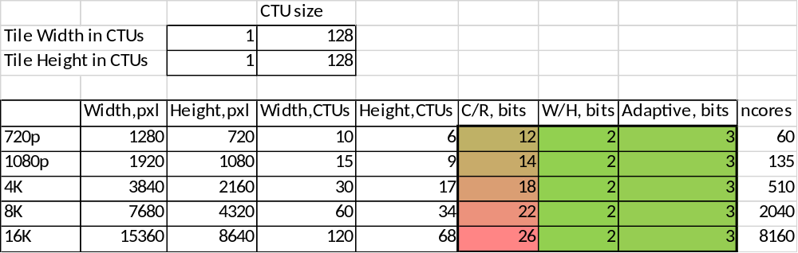
b) 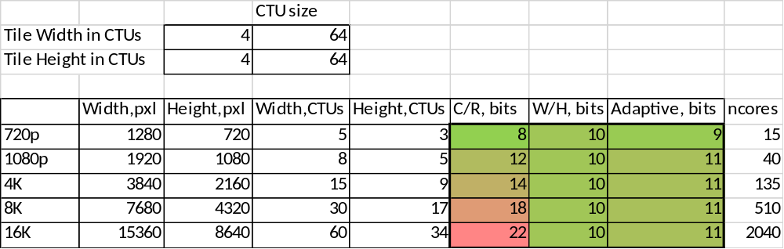
c) 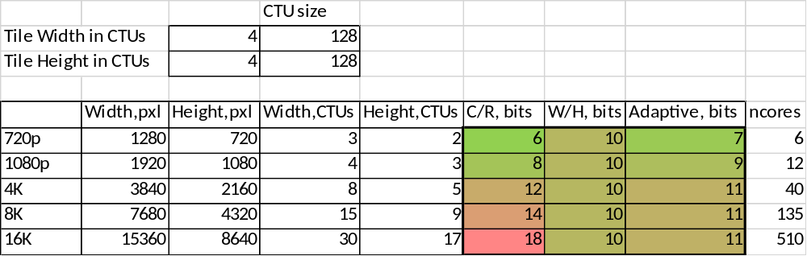
Figure 1 – Example of bit-budget for signaling of tile partitioning for different picture resolutions and different tile unit sizes: a) 1x1 with CTU 128x128 b) 2x2 with CTUs 64x64 c) 4x4 with CTUs 128x128.
In conclusion, depending on the numbers of tile rows and columns for partitioning a picture into tiles, sometimes it is more efficient to signal the partitioning scheme based on the width and height of the partitioning results, and sometimes it is more efficient to signal the partitioning scheme based on the numbers of tile rows and columns. Consequently, the current scheme that always signal the partitioning scheme based on the numbers of rows and columns is not optimal.

Proposed tile configuration signaling
To improve current tile partition signalling, the signalling of tiling partitioning is based on two flags, one specifying whether the signalling of tile rows is based on the numbers of tile rows or based on the tile height, and the other specifying whether the signalling of tile columns is based on the numbers of tile columns or based on the tile width.

The specification text, relative to the basis text in JVET-L0686-v2, is provided below, where the texts in the basis text that are not mentioned below apply as they are, and modified texts relative to the basis text are highlighted in yellow.

CTB raster and tile scanning process
The variable NumTileColumnsMinus1, specifying the number of tile columns within a picture minus 1, and the list ColWidth[ i ] for i ranging from 0 to NumTileColumnsMinus1, inclusive, specifying the width of the i-th tile column in units of CTBs, are derived as follows:
if( uniform_tile_spacing_flag ) {
NumTileColumnsMinus1 = tile_distribution_by_width_flag ?
( PicWidthInCtbsY ) / (tile_hor_split_param_minus1[ i ] + 1) – 1 :
tile_hor_split_param_minus1
for( i = 0; i <= NumTileColumnsMinus1; i++ )
ColWidth[ i ] = ( ( i + 1 ) * PicWidthInCtbsY ) / ( NumTileColumnsMinus1 + 1 ) −
( i * PicWidthInCtbsY ) / ( NumTileColumnsMinus1 + 1 )
} else {
ColWidth[ NumTileColumnsMinus1 ] = PicWidthInCtbsY (6-1)
for( i = 0; i < NumTileColumnsMinus1; i++ ) {
ColWidth[ i ] = tile_column_width_minus1[ i ] + 1
ColWidth[ NumTileColumnsMinus1 ] −= ColWidth[ i ]
}
}
The variable NumTileRowsMinus1 specifying the number of tile rows within a picture minus 1, and the list RowHeight[ j ] for j ranging from 0 to NumTileRowsMinus1, inclusive, specifying the height of the j-th tile row in units of CTBs, are derived as follows:
if( uniform_tile_spacing_flag ) {
NumTileRowsMinus1 = tile_distribution_by_height_flag ?
(PicHeightInCtbsY) / (tile_ver_split_param_minus1[ i ] + 1) – 1 :
tile_ver_split_param_minus1
for( j = 0; j <= NumTileRowsMinus1; j++ )
RowHeight[ j ] = ( ( j + 1 ) * PicHeightInCtbsY ) / ( NumTileRowsMinus1 + 1 ) −
( j * PicHeightInCtbsY ) / ( NumTileRowsMinus1 + 1 )
} else {
RowHeight[ NumTileRowsMinus1 ] = PicHeightInCtbsY (6-2)
for( j = 0; j < NumTileRowsMinus1; j++ ) {
RowHeight[ j ] = tile_row_height_minus1[ j ] + 1
RowHeight[ NumTileRowsMinus1 ] −= RowHeight[ j ]
}
}

Picture parameter set RBSP syntax

pic_parameter_set_rbsp( ) { | Descriptor
pps_pic_parameter_set_id | ue(v)
pps_seq_parameter_set_id | ue(v)
transform_skip_enabled_flag | u(1)
single_tile_in_pic_flag | u(1)
if( !single_tile_in_pic_flag ) {
uniform_tile_spacing_flag | u(1)
if( uniform_tile_spacing_flag ) {
tile_distribution_by_width_flag | u(1)
tile_distribution_by_height_flag | u(1)
}
num_tile_hor_split_param_minus1 | ue(v)
num_tile_ver_split_param_minus1 | ue(v)
if( !uniform_tile_spacing_flag ) {
for( i = 0; i < NumTileColumnsMinus1; i++ )
tile_column_width_minus1[ i ] | ue(v)
for( i = 0; i < NumTileRowsMinus1; i++ )
tile_row_height_minus1[ i ] | ue(v)
}
loop_filter_across_tiles_enabled_flag | u(1)
}
rbsp_trailing_bits( )
}

Picture parameter set RBSP semantics
…
tile_distribution_by_width_flag equal to 1 specifies that num_tile_hor_split_param_minus1 plus 1 specifies the tile column width. tile_distribution_by_width_flag equal to 0 specifies that num_tile_hor_split_param_minus1 plus 1 specifies the number of tile columns. When uniform_tile_spacing_flag is equal to 0, the value of tile_distribution_by_width_flag is inferred to be equal to 0.
tile_distribution_by_height_flag specifies that num_tile_ver_split_param_minus1 plus 1 specifies the tile row height. tile_distribution_by_width_flag equal to 0 specifies that num_tile_ver_split_param_minus1 plus 1 specifies the number of tile rows. When uniform_tile_spacing_flag is equal to 0, the value of tile_distribution_by_height_flag is inferred to be equal to 0.
num_tile_hor_split_param_minus1 plus 1 specifies the number of tile columns or the tile column width depending on the value of tile_distribution_by_width_flag. When not present, the value of num_tile_hor_split_param_minus1 is inferred to be equal to 0.
num_tile_ver_split_param_minus1 plus 1 specifies the number of tile rows or the tile row height depending on the value of tile_distribution_by_height_flag. When not present, the value of num_tile_ver_split_param_minus1 is inferred to be equal to 0.
…

Patent rights declaration(s)
Huawei Technologies Co., Ltd. may have current or pending patent rights relating to the technology described in this contribution and, conditioned on reciprocity, is prepared to grant licenses under reasonable and non-discriminatory terms as necessary for implementation of the resulting ITU-T Recommendation | ISO/IEC International Standard (per box 2 of the ITU-T/ITU-R/ISO/IEC patent statement and licensing declaration form).

