    Joint Video Experts Team (JVET)  of ITU-T SG 16 WP 3 and ISO/IEC JTC 1/SC 29/WG 11  13th Meeting: Marrakech, MA, 9–18 Jan. 2019 | Document: JVET-M0113-v2

Title: | CE7-related: Quantization Group size uniformity
Status: | Input document to JVET
Purpose: | Proposal
Author(s) or  Contact(s): | P. de Lagrange,  E. François,  P. Bordes | Email: | philippe.delagrange@technicolor.com  edouard.francois@technicolor.com  philippe.bordes@technicolor.com
Source: | Technicolor
_____________________________

Abstract
This contribution proposes modifications to the local QP adjustment signalling aiming at adapting the Quantization Groups (QGs) specification to the specificities of VVC compared to HEVC. More specifically, it is proposed to base QGs on block surface instead of split depth, by using a new inferred control parameter, named subdivision level (subdiv parameter). In addition, to avoid inconsistent QGs detection, a new inferred QG control flag is also introduced. The modifications are expected to result in QGs that are more uniform in size. Corresponding draft text modifications are proposed.

Problem statement
In HEVC, Quantization Groups (QG) are based on a split depth limit. Because all CU splits in HEVC are Quad-splits, split depth limit is equivalent to block size limit. All sub-partitions of a CU split are of same size and are aligned on a square grid, which also means that all blocks (or partitions) at a given split depth are of same size and form a regular square grid.
In VVC, new split types are introduced, which breaks this regularity. This is illustrated in Figure 1 and Figure 2. In Figure 1, two different sequences of splits are shown, with in both cases split depth equal to 2, but with final partitions of very different size. In Figure 2, partitions of the same size can be found at different split depths. This potentially results in inconsistent QGs.
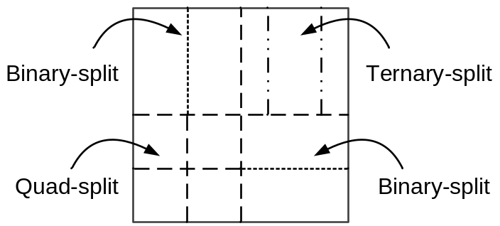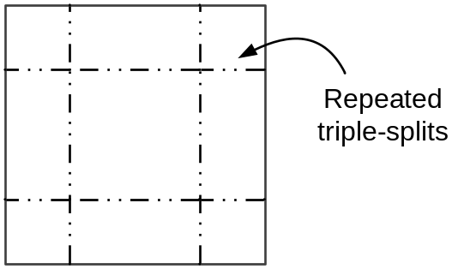
Figure 1. Example of different block sizes at split depth = 2.
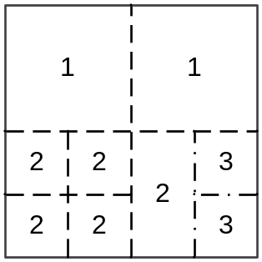
Figure 2. Example of same block sizes at different split depths (numbers indicate split depth).

Subdivision level parameter
To solve this issue, it is proposed to base QGs on a new inferred parameter defined below and named subdivision level (or subdiv), which is closely related to block surface.
While performing block splitting, a subdivision level is attached to each sub-partition, in addition to the split depth. The subdivision level is incremented from parent node’s one, depending on split type and partition number:
- For quad-splits: subdiv is incremented by 2 for all sub-partitions
- For binary-splits: subdiv is incremented by 1 for all sub-partitions
- For ternary-splits: subdiv is incremented by 1 for center partition and by 2 for side partitions
Increments are illustrated in Figure 3. The resulting correlation of subdiv with block size is illustrated in Figure 4 (to be compared with Figure 1 and Figure 2). It can be observed that the parameter subdiv is much more linked to the actual block size than the split depth parameter.
A side effect is that the block surface is very easy to compute as (CTB surface >> subdiv), and readily available at parsing stage, which could be useful for other purposes, like CABAC context selection for split mode.
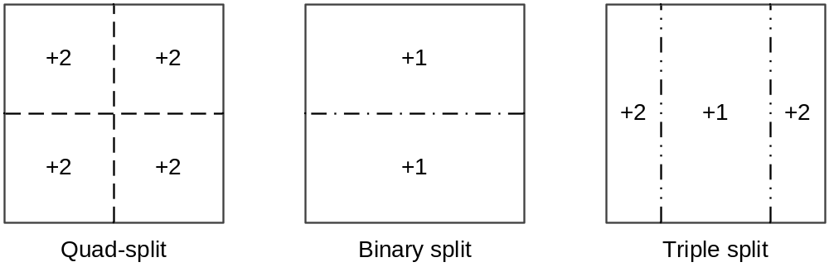
Figure 3. Suggested subdiv increments for different split types
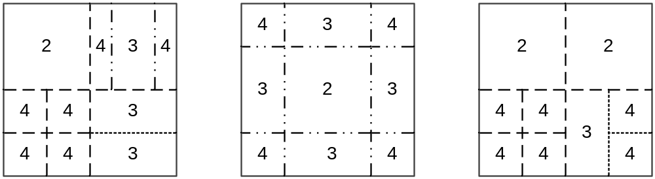
Figure 4. Example of subdiv values for various split trees

Additional QG-enable internal flag
In the current VVC draft, a QG is the smallest tree node with split depth lower than or equal to a given limit (( cqtDepth + mttDepth ) <= diff_cu_qp_delta_depth), see [2] p.32. All blocks resulting from further splits belong to the same QG.
By introducing the concept of subdiv limit for QG definition, a new problem arises because for ternary splits, subdiv value is not the same for all sub-partitions. This may result in configurations where the side partitions can be above the subdiv limit, but not the center partitions. Figure 5 illustrates a conceptual example with a parent’s node subdiv = 0 and a triple split, with a QG subdiv limit equal to 1. The middle partition (subdiv <= 1) does not cross the subdiv limit and is therefore considered as a new QG. But since side partitions cross the subdiv limit (subdiv > 1), their parent node is supposed to be the QG. This would then generate overlapping QGs (or holes), which does not make sense.
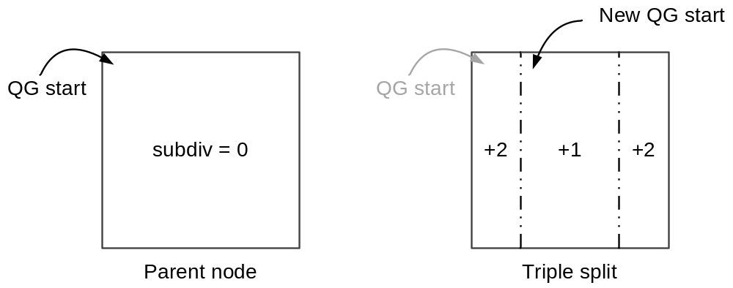
Figure 5. subdiv-based QG ambiguity with ternary-split

What happens without further changes
In the current VVC draft, as long as the condition to start a new QG is true (that is, local QP adjustment is enabled and split depth is not higher than the limit), an internal flag “IsCuQpDeltaCoded” is set to 0 and the current tree node origin is saved as QG origin in CuQgTopLeftX/Y variables. Later, in transform block syntax, if “IsCuQpDeltaCoded” is zero, the QP delta is coded and the flag is set to 1, preventing other QP deltas from being coded until a new QG is found.
Applied to the previous example (ternary-split and QG detection based on subdiv instead of split depth), this would result in the QGs shown in Figure 6 (thick gray dashed line). The first triple-split partition behaves as a QG since the QP-delta coding has been allowed by parent and top-left corner has been saved as QG origin. The middle partition is a new regular QG (since the condition to start a new QG is true), with new origin and new QP-delta. But the last partition, being above subdiv limit, does not trigger a new origin or QP-delta. It keeps the previous one, which means that the last partition is added to the previous QG, which is enlarged to enclose this current partition.
This is a problem, because significantly different-sized QGs are obtained for a same subdiv limit. Additionally, when starting a QG (and saving current node origin as QG origin), its size can not be determined because it could be extended afterwards.
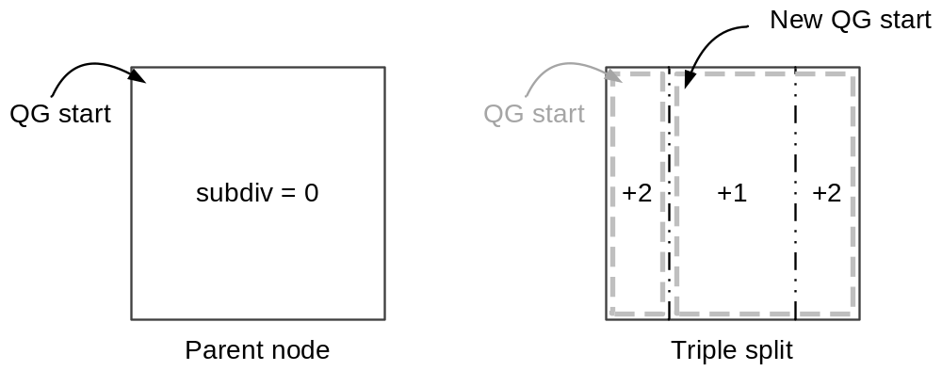
Figure 6. subdiv-based QGs with ternary-split (and no further changes)

QG-enable parameter
The solution proposed is to prevent all sub-partitions of a given node from starting a new QG if any of them has a subdiv value higher than the subdiv limit.
This is performed by defining a new parameter named qgEnable, passed to multi_type_tree( ) syntax function. qgEnable is initially equal to true but it is set equal to false for all children of a ternary-split when side partitions have a subdiv value higher than the subdiv limit. This is illustrated in Figure 7.
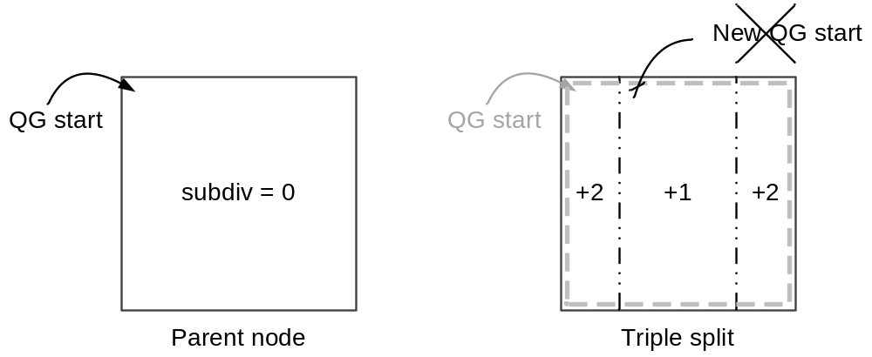
Figure 7. Disable QG start for all children if any is above subdiv limit

qgEnable is then used as an additional condition to start a new QG (and consequently saving the QG origin and allowing the QP delta coding).
We also suggest inverting the logic of IsCuQpDeltaCoded (renamed to CuQpDeltaCoding) to merge conditions and simplify the syntax.

Draft text changes
Coded syntax elements are not changed from the current VVC draft, except for renaming: diff_cu_qp_delta_depth is changed to cu_qp_delta_subdiv, and semantic is adapted accordingly.

pic_parameter_set_rbsp( ) { | Descriptor
[…]
if( cu_qp_delta_enabled_flag )
cu_qp_delta_subdivdiff_cu_qp_delta_depth | ue(v)
[…]
}

cu_qp_delta_enabled_flag equal to 1 specifies that the cu_qp_delta_subdivdiff_cu_qp_delta_depth syntax element is present in the PPS and that cu_qp_delta_abs may be present in the transform unit syntax. cu_qp_delta_enabled_flag equal to 0 specifies that the cu_qp_delta_subdivdiff_cu_qp_delta_depth syntax element is not present in the PPS and that cu_qp_delta_abs is not present in the transform unit syntax.
cu_qp_delta_subdivdiff_cu_qp_delta_depth specifies the maximum cbSubDiv value of coding units coding tree depth difference between the coding units of minimum coding tree depth and coding units of maximum coding tree depth that convey cu_qp_delta_abs and cu_qp_delta_sign_flag. The value range of cu_qp_delta_subdivdiff_cu_qp_delta_depth is specified as follows:
- If slice_type is equal to I, the value of cu_qp_delta_subdivdiff_cu_qp_delta_depth shall be in the range of 0 to 2*(log2_ctu_size_minus2 − log2_min_qt_size_intra_slices_minus2 + MaxMttDepthY), inclusive.
- Otherwise (slice_type is not equal to I), the value of cu_qp_delta_subdivdiff_cu_qp_delta_depth shall be in the range of 0 to 2*(log2_ctu_size_minus2 − log2_min_qt_size_inter_slices_minus2 + MaxMttDepthY), inclusive.
When not present, the value of cu_qp_delta_subdivdiff_cu_qp_delta_depth is inferred to be equal to 0.
Then, cbSubDiv parameter is added to tree syntax, and incremented for each partition as required; IsCuQpDeltaCoding is changed to CuQpDeltaCoding with inverted logic and cp_qp_delta_enabled_flag merged. For multi_type_tree, a qgEnable parameter is added with a specific modification for ternary splits, and qgEnabled is added to QG start condition.

coding_tree_unit( ) { | Descriptor
[…]
if( slice_type = = I && qtbtt_dual_tree_intra_flag )
dual_tree_implicit_qt_split ( xCtb, yCtb, CtbLog2SizeY, 0, 0 )
else
coding_quadtree( xCtb, yCtb, CtbLog2SizeY, 0, 0, SINGLE_TREE )
}

dual_tree_implicit_qt_split( x0, y0, log2CbSize, cqtDepth, cbSubdiv ) { | Descriptor
if( log2CbSize > 6 ) {
if( cbSubdiv <= cu_qp_delta_subdiv ) {
CuQpDeltaCoding = cu_qp_delta_enabled_flag
CuQpDeltaVal = 0
CuQgTopLeftX = x0
CuQgTopLeftY = y0
}
x1 = x0 + ( 1 << ( log2CbSize − 1 ) )
y1 = y0 + ( 1 << ( log2CbSize − 1 ) )
dual_tree_implicit_qt_split( x0, y0, log2CbSize − 1, cqtDepth + 1, cbSubdiv + 2 )
if( x1 < pic_width_in_luma_samples )
dual_tree_implicit_qt_split( x1, y0, log2CbSize − 1, cqtDepth + 1, cbSubdiv + 2 )
if( y1 < pic_height_in_luma_samples )
dual_tree_implicit_qt_split( x0, y1, log2CbSize − 1, cqtDepth + 1, cbSubdiv + 2 )
if( x1 < pic_width_in_luma_samples && y1 < pic_height_in_luma_samples )
dual_tree_implicit_qt_split( x1, y1, log2CbSize − 1, cqtDepth + 1, cbSubdiv + 2 )
} else {
coding_quadtree( x0, y0, log2CbSize, cqtDepth, cbSubdiv, DUAL_TREE_LUMA )
coding_quadtree( x0, y0, log2CbSize, cqtDepth, cbSubdiv, DUAL_TREE_CHROMA )
}
}

coding_quadtree( x0, y0, log2CbSize, cqtDepth, cbSubdiv, treeType ) { | Descriptor
[…]
if( cu_qp_delta_enabled_flag && cqtDepth <= diff_cu_qp_delta_depthcbSubdiv <= cu_qp_delta_subdiv) {
IsCuQpDeltaCoded = 0CuQpDeltaCoding = cu_qp_delta_enabled_flag
CuQpDeltaVal = 0
CuQgTopLeftX = x0
CuQgTopLeftY = y0
}
if( qt_split_cu_flag[ x0 ][ y0 ] ) {
x1 = x0 + ( 1 << ( log2CbSize − 1 ) )
y1 = y0 + ( 1 << ( log2CbSize − 1 ) )
coding_quadtree( x0, y0, log2CbSize − 1, cqtDepth + 1, cbSubdiv + 2, treeType )
if( x1 < pic_width_in_luma_samples )
coding_quadtree( x1, y0, log2CbSize − 1, cqtDepth + 1, cbSubdiv + 2, treeType )
if( y1 < pic_height_in_luma_samples )
coding_quadtree( x0, y1, log2CbSize − 1, cqtDepth + 1, cbSubdiv + 2, treeType )
if( x1 < pic_width_in_luma_samples && y1 < pic_height_in_luma_samples )
coding_quadtree( x1, y1, log2CbSize − 1, cqtDepth + 1, cbSubdiv + 2, treeType )
} else
multi_type_tree( x0, y0, 1 << log2CbSize, 1 << log2CbSize, cqtDepth, 0, cbSubDiv, 1, 0, 0, treeType )
}

multi_type_tree( x0, y0, cbWidth, cbHeight, cqtDepth, mttDepth, cbSubdiv, qgEnable, depthOffset, partIdx, treeType ) { | Descriptor
if( ( allowSplitBtVer | | allowSplitBtHor | | allowSplitTtVer | | allowSplitTtHor ) &&
( x0 + cbWidth <= pic_width_in_luma_samples ) &&
(y0 + cbHeight <= pic_height_in_luma_samples ) )
mtt_split_cu_flag | ae(v)
if( cu_qp_delta_enabled_flag && ( cqtDepth + mttDepth ) <= diff_cu_qp_delta_depth qgEnable && cbSubdiv <= cu_qp_delta_subdiv) {
IsCuQpDeltaCoded = 0CuQpDeltaCoding = cu_qp_delta_enabled_flag
CuQpDeltaVal = 0
CuQgTopLeftX = x0
CuQgTopLeftY = y0
}
if( mtt_split_cu_flag ) {
if( ( allowSplitBtHor | | allowSplitTtHor ) &&
( allowSplitBtVer | | allowSplitTtVer ) )
mtt_split_cu_vertical_flag | ae(v)
if( ( allowSplitBtVer && allowSplitTtVer && mtt_split_cu_vertical_flag ) | |
( allowSplitBtHor && allowSplitTtHor && !mtt_split_cu_vertical_flag ) )
mtt_split_cu_binary_flag | ae(v)
if( MttSplitMode[ x0 ][ y0 ][ mttDepth ] = = SPLIT_BT_VER ) {
depthOffset += ( x0 + cbWidth > pic_width_in_luma_samples ) ? 1 : 0
x1 = x0 + ( cbWidth / 2 )
multi_type_tree( x0, y0, cbWidth / 2, cbHeight,
cqtDepth, mttDepth + 1, cbSubdiv + 1, qgEnable, depthOffset, 0, treeType )
if( x1 < pic_width_in_luma_samples )
multi_type_tree( x1, y0, cbWidth / 2, cbHeightY,
cqtDepth, mttDepth + 1, cbSubdiv + 1, qgEnable, depthOffset, 1, treeType )
} else if( MttSplitMode[ x0 ][ y0 ][ mttDepth ] = = SPLIT_BT_HOR ) {
depthOffset += ( y0 + cbHeight > pic_height_in_luma_samples ) ? 1 : 0
y1 = y0 + ( cbHeight / 2 )
multi_type_tree( x0, y0, cbWidth, cbHeight / 2,
cqtDepth, mttDepth + 1, cbSubdiv + 1, qgEnable, depthOffset, 0, treeType )
if( y1 < pic_height_in_luma_samples )
multi_type_tree( x0, y1, cbWidth, cbHeight / 2,
cqtDepth, mttDepth + 1, cbSubdiv + 1, qgEnable, depthOffset, 1, treeType )
} else if( MttSplitMode[ x0 ][ y0 ][ mttDepth ] = = SPLIT_TT_VER ) {
x1 = x0 + ( cbWidth / 4 )
x2 = x0 + ( 3 * cbWidth / 4 )
qgEnable = qgEnable && (cbSubdiv + 2 <= cu_qp_delta_subdiv)
multi_type_tree( x0, y0, cbWidth / 4, cbHeight,
cqtDepth, mttDepth + 1, cbSubdiv + 2, qgEnable, depthOffset, 0, treeType )
multi_type_tree( x1, y0, cbWidth / 2, cbHeight,
cqtDepth, mttDepth + 1, cbSubdiv + 1, qgEnable, depthOffset, 1, treeType )
multi_type_tree( x2, y0, cbWidth / 4, cbHeight,
cqtDepth, mttDepth + 1, cbSubdiv + 2, qgEnable, depthOffset, 2, treeType )

} else { /* SPLIT_TT_HOR */
y1 = y0 + ( cbHeight / 4 )
y2 = y0 + ( 3 * cbHeight / 4 )
qgEnable = qgEnable && (cbSubdiv + 2 <= cu_qp_delta_subdiv)
multi_type_tree( x0, y0, cbWidth, cbHeight / 4,
cqtDepth, mttDepth + 1, cbSubdiv + 2, qgEnable, depthOffset, 0, treeType )
multi_type_tree( x0, y1, cbWidth, cbHeight / 2,
cqtDepth, mttDepth + 1, cbSubdiv + 1, qgEnable, depthOffset, 1, treeType )
multi_type_tree( x0, y2, cbWidth, cbHeight / 4,
cqtDepth, mttDepth + 1, cbSubdiv + 2, qgEnable, depthOffset, 2 , treeType)
}
} else
coding_unit( x0, y0, cbWidth, cbHeight, treeType )
}

transform_unit( x0, y0, tbWidth, tbHeight, treeType ) { | Descriptor
[…]
if( ( tu_cbf_luma[ x0 ][ y0 ] | | tu_cbf_cb[ x0 ][ y0 ] | | tu_cbf_cr[ x0 ][ y0 ] ) &&
treeType != DUAL_TREE_CHROMA ) {
if( cu_qp_delta_enabled_flag && !IsCuQpDeltaCoded CuQpDeltaCoding ) {
CuQpDeltaCoding = 0
cu_qp_delta_abs | ae(v)
if( cu_qp_delta_abs )
cu_qp_delta_sign_flag | ae(v)
}
}
[…]
Finally, IsCuQpDeltaCoded can be removed from semantics:
When cu_qp_delta_abs is present, the variables IsCuQpDeltaCoded and CuQpDeltaVal are is derived as follows:
IsCuQpDeltaCoded = 1 (7-71)
CuQpDeltaVal = cu_qp_delta_abs * ( 1 − 2 * cu_qp_delta_sign_flag ) (7-72)

Extension to chroma Quantization Groups
The modifications proposed here should be extended to the definition of chroma quantization groups, which control coding of local chroma QP adjustments (not yet in VVC draft): replace diff_cu_chroma_qp_offset_depth with cu_chroma_qp_offset_subdiv, change IsCuChromaQpOffsetCoded to CuChromaQpOffsetCoding with inverted logic, add chroma-specific qgEnable, etc.

References
[1] HEVC standard, ITU-T REC H265. Version 3 (04/2015) available at http://handle.itu.int/11.1002/1000/12455. Pages 37, 39, 51, 57, 79, 82, 104, and 159-162 are relevant here.
[2] B. Bross, J. Chen, S. Liu, "Versatile Video Coding (Draft 3)", JVET-L1001, Macao, CN, October 2018 (version 3 is used here).

Patent rights declaration(s)
Technicolor may have current or pending patent rights relating to the technology described in this contribution and, conditioned on reciprocity, is prepared to grant licenses under reasonable and non-discriminatory terms as necessary for implementation of the resulting ITU-T Recommendation | ISO/IEC International Standard (per box 2 of the ITU-T/ITU-R/ISO/IEC patent statement and licensing declaration form).

