    Joint Video Experts Team (JVET)  of ITU-T SG 16 WP 3 and ISO/IEC JTC 1/SC 29/WG 11  12th Meeting: Macao, CN, 3–12 Oct. 2018 | Document: JVET-L0609

Title: | Crosscheck of JVET-L0401 on Modification of History-based Mode Vector Prediction
Status: | Input document to JVET
Purpose: | Report
Author(s) or  Contact(s): | Zhipin Deng, Lidong Xu | Tel:  Email: | zhipin.deng@intel.com  lidong.xu@intel.com
Source: | Intel Corp.
_____________________________

Abstract
This contribution reports a cross-checking of contribution JVET-L0401 related to modification on history-based mode vector prediction.
It is reported that the result obtained during this cross-checking matches the result described in JVET-L0401.

Introduction
In JVET-L0401[1], it is proposed to reduce the complexity of HMVP mode by removing the redundancy check from HMVP table update. The size of HMVP table is increased to 20 or 16, but one out of every 4 is picked to add in the merge list.

Test Result
The cross-check test is performed on top of VTM2.0.1. The results of all three tests are shown in the following table, and they match the results shown in JVET-L0401.

The test results of HMVP table equal to 20
Size of merge list equals to 8. The size of HMVP table equals to 20.
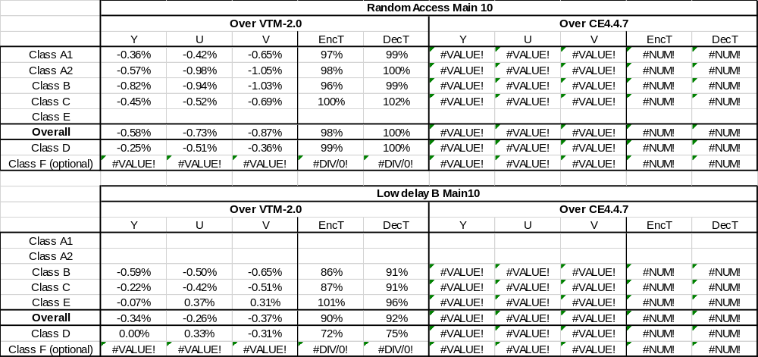

The test results of HMVP table equal to 16
Size of merge list equals to 8. The size of HMVP table equals to 16.
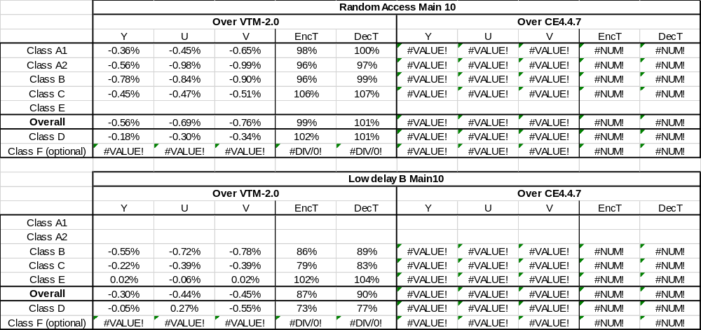

The test results of HMVP in both merge and AMVP modes
Size of merge list equals to 6. The size of HMVP table equals to 16.
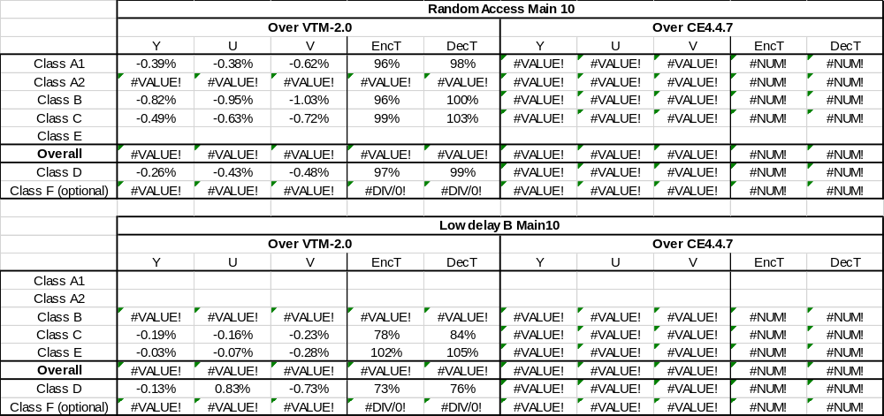

Patent rights declaration(s)
Intel Corporation does not have any current or pending patent rights relating to the technology described in this contribution

Reference
- W.-J. Chien, Y. Han, H. Huang, C.-C. Chen, M. Karczewicz, “CE4-related: Modification on History-based Mode Vector Prediction”, 12th Meeting: Macao, CN, 3–12 Oct. 2018.

