    Joint Video Experts Team (JVET)  of ITU-T SG 16 WP 3 and ISO/IEC JTC 1/SC 29/WG 11  12th Meeting: Macao, CN, 3–12 Oct. 2018 | Document: JVET-L0572-v2

Title: | CE11-related: CTU line buffer reduction for long filter deblocking
Status: | Input document to JVET
Purpose: | Proposal
Author(s) or  Contact(s): | A. M. Kotra, S. Esenlik, B.Wang, J. Chen,  W. Zhu, K. Misra, P. Cowan, A. Segall | Tel:  Email: | anand.meher.kotra@huawei.commisrak@sharplabs.com
Source: | Huawei Technologies Co., Ltd and Sharp Labs of America
_____________________________

Abstract
The contribution is a joint proposal between Huawei and Sharp. Long filter deblocking is asserted to provide significant visual benefit over the current approach in VTM-2.0.1. However, such approaches also extend the number of CTU line buffers. The contribution proposes modifying the filtering and control processes at the top edge of the CTU boundary to access samples within 4 luma lines and 2 chroma lines. Aspects of long filter deblocking and CTU line buffer aware filtering are based on tests CE11.1.7b and CE11.1.8. The proposal includes two further modifications, one for subsampling the chroma gradient computation to further reduce complexity and a threshold modification to improve objective gains. It is asserted that the visual impact of these changes is negligible. Objective evaluations show a luma BD rate impact of –0.02%/ 0.03%/0.15%,0.10%for AI/RA/LD/LDP compared to VTM-2.0.1 and -0.03%/0.02%,0.17%,0.03% for AI/RA/LD/LDP compared to VTM-2.0.1 when ALF is turned off.

Introduction
The proposed deblocking is based on the 8x8 grid – same as HEVC deblocking. It is based on CE11 tests CE11.1.7b [5] and CE11.1.8 [4] both of which make use of long filters to reduce blocking artifacts that result due to large blocks. However, the use of long filters at CTU boundary increases the number of line buffers needed for the CTU. The proposal therefore makes use of symmetric filters (including long filters) except at top CTU boundary where truncated long filters are used. The control process is appropriately modified so that no samples outside of 4 luma and 2 chroma line buffer are accessed. CE11.1.7b also makes use of HEVC strong filters and corresponding luma control in chroma. However the use of 2 sample segment classification for chroma implies that in the worst case gradient computations are carried out for every line of chroma. The chroma control process is therefore modified to compute gradients for only one of the 2 lines in chroma. Finally, a threshold modification is proposed for luma long filters that improves the overall objective performance of the proposal without compromising subjective quality.

Proposed solution
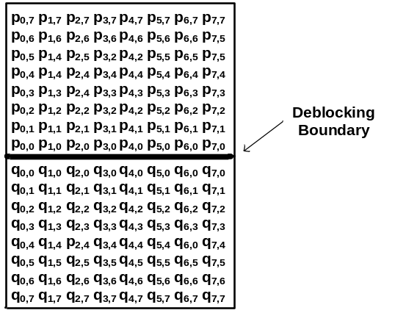
CE11.1.7b and CE11.1.8 incorporates stronger filters for both luma and chroma, compared to VTM-2.0.1 [2] deblocking. Additionally, the proposed modification includes a control process that considers the block sizes on both sides of the boundary being deblocked. The stronger filters are used for luma samples that correspond to larger block sizes, while the VTM-2.0.1 deblocking filters are still used for luma samples corresponding to the smaller block sizes. For chroma, the filter selection uses a different approach, and a stronger filter is applied when chroma samples on either sides of the deblocking boundary belong to a large block.

Luma is deblocked on 8x8 luma sample grid.
Luma stronger filters:
p₆′= (7*p₇+2*p₆+p₅+p₄+p₃+p₂+ p₁+p₀+q₀+ 8) >> 4
p₅′= (6*p₇+p₆+2*p₅+p₄+p₃+p₂+p₁+p₀+q₀+q₁+ 8) >> 4
p₄′= (5*p₇+p₆+p₅+2*p₄+p₃+p₂+p₁+p₀+q₀+q₁+q₂+ 8) >> 4
p₃′= (4*p₇+p₆+p₅+p₄+2*p₃+p₂+p₁+p₀+q₀+q₁+q₂+q₃+ 8) >> 4
p₂′= (3*p₇+p₆+p₅+p₄+p₃+2*p₂+p₁+p₀+q₀+q₁+q₂+q₃+q₄+8) >> 4
p₁′= (2*p₇+p₆+p₅+p₄+p₃+p₂+2*p₁+p₀+q₀+q₁+q₂+q₃+q₄+q₅+8) >> 4
p₀′= (p₇+p₆+p₅+p₄+p₃+p₂+p₁+2*p₀+q₀+q₁+q₂+q₃+q₄+q₅+q₆+8) >> 4
q₆′= (7*q₇+2*q₆+q₅+q₄+q₃+q₂+ q₁+q₀+p₀+ 8) >> 4
q₅′= (6*q₇+q₆+2*q₅+q₄+q₃+q₂+q₁+q₀+p₀+p₁+ 8) >> 4
q₄′= (5*q₇+q₆+q₅+2*q₄+q₃+q₂+q₁+q₀+p₀+p₁+p₂+ 8) >> 4
q₃′= (4*q₇+q₆+q₅+q₄+2*q₃+q₂+q₁+q₀+p₀+p₁+p₂+p₃+ 8) >> 4
q₂′= (3*q₇+q₆+q₅+q₄+q₃+2*q₂+q₁+q₀+p₀+p₁+p₂+p₃+p₄+8) >> 4
q₁′= (2*q₇+q₆+q₅+q₄+q₃+q₂+2*q₁+q₀+p₀+p₁+p₂+p₃+p₄+p₅+8) >> 4
q₀′= (q₇+q₆+q₅+q₄+q₃+q₂+q₁+2*q₀+p₀+p₁+p₂+p₃+p₄+p₅+p₆+8) >> 4

When p₀ belongs to CTU above current CTU, the following limited support luma filter is used:
p₂′= (6*p₃+3*p₂+p₁+p₀+q₀+q₁+q₂+q₃+q₄+8) >> 4
p₁′= (5*p₃+p₂+3*p₁+p₀+q₀+q₁+q₂+q₃+q₄+q₅+8) >> 4
p₀′= (5*p₃+p₂+p₁+2*p₀+q₀+q₁+q₂+q₃+q₄+q₅+q₆+8) >> 4
q₆′= (6*q₇+3*q₆+q₅+q₄+q₃+q₂+ q₁+q₀+p₀+ 8) >> 4
q₅′= (5*q₇+q₆+3*q₅+q₄+q₃+q₂+q₁+q₀+p₀+p₁+ 8) >> 4
q₄′= (4*q₇+q₆+q₅+3*q₄+q₃+q₂+q₁+q₀+p₀+p₁+p₂+ 8) >> 4
q₃′= (3*q₇+q₆+q₅+q₄+3*q₃+q₂+q₁+q₀+p₀+p₁+p₂+p₃+ 8) >> 4
q₂′= (2*q₇+q₆+q₅+q₄+q₃+3*q₂+q₁+q₀+p₀+p₁+p₂+2*p₃+8) >> 4
q₁′= (q₇+q₆+q₅+q₄+q₃+q₂+3*q₁+q₀+p₀+p₁+p₂+3*p₃+8) >> 4
q₀′= (q₇+q₆+q₅+q₄+q₃+q₂+q₁+2*q₀+p₀+p₁+p₂+4*p₃+8) >> 4

The use of the limited support filter results in no samples outside of the 4 CTU (luma) line buffers to be accessed.
Luma stronger filters are used for large blocks where large block corresponds to width >= 32 for a vertical edge, and height>=32 for a horizontal edge. The adjacent block must be greater than or equal to 16. The control process is further based on gradients computed for two lines of 4 sample segments; comparison of absolute pixel value difference with tc; and comparison of other absolute pixel value differences with β. More gradients are computed for large block side. The variable ControlSamplesAccessible is used to change the control process to prevent access of samples beyonf the 4 CTU (luma) line buffers.
- The variables dpq0, dpq3, dp, dq, and d are derived as follows:
dp0, dp3, dq0, dq3 are first derived as in HEVC
LongTapDeblocking = ( ( p side >= 32 && q side >= 16 ) || ( p side >= 16 && q side >= 32 ) ) ) ? TRUE : FALSE
ControlSamplesAccessible = p0 belongs to CTU above current CTU ? FALSE : TRUE
if ( LongTapDeblocking )
if (p side is greater than or equal to 32 && ControlSamplesAccessible )
dp0 = ( dp0 + Abs( p_{5,0} − 2 * p_{4,0} + p_{3,0} ) + 1 ) >> 1
dp3 = ( dp3 + Abs( p_{5,3} − 2 * p_{4,3} + p_{3,3} ) + 1 ) >> 1

if (q side is greater than or equal to 32)
dq0 = ( dq0 + Abs( q_{5,0} − 2 * q_{4,0} + q_{3,0} ) + 1 ) >> 1
dq3 = ( dq3 + Abs( q_{5,3} − 2 * q_{4,3} + q_{3,3} ) + 1 ) >> 1

dpq0, dpq3, dp, dq, d are then derived as in HEVC

- As in HEVC, When d is less than β, the following ordered steps apply:
- dpq is derived as in HEVC.
- sp₃ = Abs( p₃ − p₀ ), derived as in HEVC
if ( p side is greater than or equal to 32 && LongTapDeblocking && ControlSamplesAccessible )
sp₃ = ( sp₃ + Abs( p₇ − p₃ ) + 1) >> 1
- sq₃ = Abs( q₀ − q₃ ), derived as in HEVC
if (q side is greater than or equal to 32 && LongTapDeblocking )
sq₃ = ( sq₃ + Abs( q₇ − q₃ ) + 1) >> 1
- As in HEVC derive, StrongFilterCondition = (dpq is less than ( β >> 2 ), sp₃ + sq₃ is less than ( LongTapDeblocking ? ( 3*β >> 5 ) : ( β >> 3 ) ), and Abs( p₀ − q₀ ) is less than ( 5 * t_{C} + 1 ) >> 1) ? TRUE : FALSE
- When StrongFilterCondition is TRUE and LongTapDeblocking is TRUE, use luma stronger filter on the side with length perpendicular to boundary edge greater than or equal to 32.
Otherwise, When StrongFilterCondition is TRUE and LongTapDeblocking is FALSE, use HEVC strong filter

Chroma deblocks on a 4x4 chroma sample grid
Chroma stronger filters (i.e. HEVC luma strong filter):
p₀′ = ( p₂ + 2 * p₁ + 2 * p₀ + 2 * q₀ + q₁ + 4 ) >> 3
p₁′ = ( p₂ + p₁ + p₀ + q₀ + 2 ) >> 2
p₂′ = ( 2 * p₃ + 3 * p₂ + p₁ + p₀ + q₀ + 4 ) >> 3
q₀′ = ( p₁ + 2 * p₀ + 2 * q₀ + 2 * q₁ + q₂ + 4 ) >> 3
q₁′ = ( p₀ + q₀ + q₁ + q₂ + 2 ) >> 2
q₂′= ( p₀ + q₀ + q₁ + 3 * q₂ + 2 * q₃ + 4 ) >> 3
Chroma stronger filters are used on both sides of the block boundary. However when p₀ belongs to CTU above current CTU, the chroma weak fitler is used for the side above the CTU boundary. The use of the chroma weak filter results in no samples outside of the 2 CTU (chroma) line buffers to be accessed.
The strong filter is used when HEVC luma strong filter condition when computed for chroma is TRUE and any of the following conditions is true:
- The edge type is vertical an p₀ belongs to CU with width >= 8 (chroma samples) and q₀ belongs to CU with width >= 8 (chroma samples)
- The edge type is horizontal and p₀ belongs to CU with height >= 8 (chroma samples) and q₀ belongs to CU with height >= 8 (chroma samples)
Also, in CE11.1.7b gradient may be computed for every line of the 2-sample chroma deblocking segments (in the worst-case). Since the lines are just next to each the proposal uses only one line for gradient computation and scales it as follows: Compute dp0, dq0 as in HEVC.; dpq0 is then set to dp0 + dq0, d is then set to 2*dpq0.

Experimental Results
In CE11 [1], tests were evaluated versus the following two encoder configurations: 1) VTM-2.0.1 with ALF switched on 2) VTM-2.0.1 with ALF switched off. The proposed modifications were therefore evaluated in these two configurations as well. The summary results are presented below. The detailed results can be found in the attached excel files.
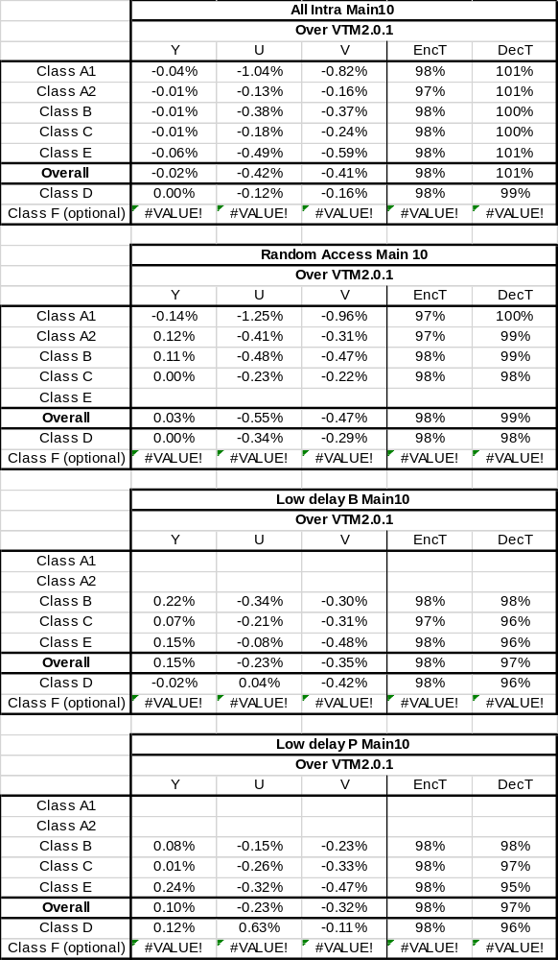
Table 1. Results with ALF ON
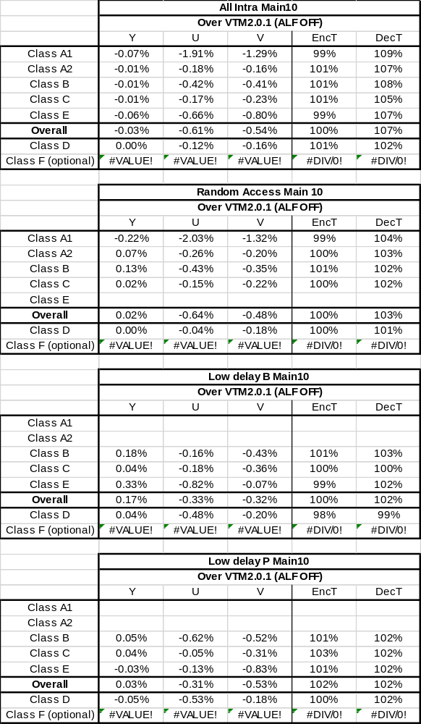
Table 2. Results with ALF OFF

Conclusions
The contribution proposes modifying the filtering and control processes at the top edge of the CTU boundary to access samples within 4 luma lines and 2 chroma lines. Aspects of long filter deblocking and CTU line buffer aware filtering are based on tests CE11.1.7b and CE11.1.8. The proposal includes two further modifications, one for subsampling the chroma gradient computation to further reduce complexity and a threshold modification to improve objective gains. We propose to adopt the proposed technologies into VVC.

References
- “Description of Core Experiment 11 (CE11): Deblocking”, JVET-K1031, July 2018.
- “Algorithm description for Versatile Video Coding and Test Model 2 (VTM2)”, JVET-K1002.
- “JVET common test conditions and software reference configurations”, JVET-K1010
- “CE11.1.8: Longer tap Luma deblocking filter”, JVET-L0224
- “CE11: Deblocking modifications for Large CUs both Luma and chroma (Test 11.1.7a and CE11.1.7b)”, JVET-L0405

Patent rights declaration(s)
Huawei Technologies Co., Ltd may have current or pending patent rights relating to the technology described in this contribution and, conditioned on reciprocity, is prepared to grant licenses under reasonable and non-discriminatory terms as necessary for implementation of the resulting ITU-T Recommendation | ISO/IEC International Standard (per box 2 of the ITU-T/ITU-R/ISO/IEC patent statement and licensing declaration form).
Sharp Labs of America may have current or pending patent rights relating to the technology described in this contribution and, conditioned on reciprocity, is prepared to grant licenses under reasonable and non-discriminatory terms as necessary for implementation of the resulting ITU-T Recommendation | ISO/IEC International Standard (per box 2 of the ITU-T/ITU-R/ISO/IEC patent statement and licensing declaration form).

