    Joint Video Experts Team (JVET)  of ITU-T SG 16 WP 3 and ISO/IEC JTC 1/SC 29/WG 11  12th Meeting: Macao, CN, 3–12 Oct. 2018 | Document: JVET-L0564-v1

Title: | CE3-related: Joint test of JVET-L0087 and JVET-L0152 for PDPC simplification
Status: | Input document to JVET
Purpose: | Proposal
Author(s) or  Contact(s): | Mohammed Golam Sarwer,  Chih-Wei Hsu, Yu-Wen Huang,  Shaw-Min Lei (MediaTek Inc.)  Jinho Lee, Hahyun Lee  Sung-Chang Lim, Jungwon Kang  Hui Yong Kim (ETRI) | Tel:  Email: | +886-3-5670766  {mohammed.sarwer, cw.hsu, yuwen.huang, shawmin.lei}  @mediatek.com  {jinosoul, hanilee, sclim, jungwon, hykim5}  @etri.re.kr
Source: | MediaTek Inc., ETRI
_____________________________

Abstract
In this contribution, a simplification of position dependent intra prediction combination (PDPC) is proposed. This contribution combined JVET-L0087 and JVET-L0152. Compared to VTM2.0.1, it is reported that the proposed simplified PDPC can simplify the PDPC with -0.01% (Y), -0.03% (U), and 0.01% (V) BD-rates for AI.

Introduction
In VTM2.0.1, PDPC is applied to planar, DC, horizontal, vertical, bottom-left angular mode and its 8 adjacent angular modes, and top-right angular mode and its 8 adjacent angular modes [1] [2]. The prediction sample pred(x,y) located at position (x, y) is predicted using an intra prediction mode (DC, planar, angular) and a linear combination of reference samples according to the PDPC expression [2]:
pred(x,y) = ( wL × R_{-1,y} + wT × R_{x,-1} – wTL × R_{-1,-1} + (64 – wL – wT + wTL) × pred(x,y) + 32 ) >> 6, (1)
where R_{x,-1} and R_{-1,y} represent the reference samples located at the top and left of current sample (x, y), respectively, and R_{-1,-1} represents the reference sample located at the top-left corner of the current block. The weights wL, wT, and wTL depend on the prediction mode, width, height, and position. The detail of weight computations can be found in [2].

Proposed method

Boundary PDPC
In this proposal, PDPC is applied only to the top-left boundary positions. The number of vertical and horizontal lines for PDPC depends on the width and height of a CB. Assume, PDPC is applied to N_{hor} horizontal lines and N_{ver} vertical lines. Then,
$if \left(x≥ N_{ver} \&\&y≥ N_{hor}\right)$,
$$PDPC is not applied$$
$$otherwise,$$
$$PDPC is applied as per Eq (1)$$
The set of thresholds values to determine N_{hor} and N_{ver} are defined as follows.
$T\left[7\right]=\{1, 2, 4, 4, 8, 0, 0\}$ (2)
$N_{ver}=T[\log_{2}\left(width\right)-1]$ (3)
$N_{hor}=T[\log_{2}\left(height\right)-1]$ (4)

PDPC scale modification
In VVC draft 2[1], a variable “nScale” is use to update the PDPC weights. In this proposal, nScale value is modified as follows
nScale = ((log2(width) + g_log2(height)) > 6 ? 1 : 0);

Removal of interpolation
For angular prediction, bilinear interpolation filter is applied to reference samples to generated prediction samples. For example, above two reference samples are interpolated for prediction when a vertical angular prediction mode is used as depicted in Fig. 1. In addition, left two reference samples are also interpolated in PDPC. To reduce computational complexity, an integer reference sample is used for PDPC rather than applying the interpolation in this simplification.

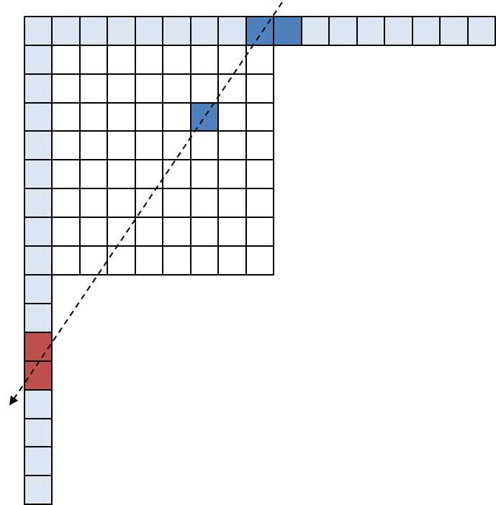
Figure 1. Interpolation for intra prediction and PDPC in VTM2.0

Restriction on wide angle intra prediction modes
In VTM 2.0, wide angle intra prediction (WAIP) modes are used when a ratio of non-square block and an intra prediction mode are satisfied with a certain condition. By harmonizing PDPC with WAIP, the PDPC is also applied to the WAIP modes. However, the PDPC reflecting higher weight to closer reference sample may not be efficient since the references samples for prediction are already replaced with closer reference sample by the WAIP. In this modification, the PDPC is simply disabled for the WAIP modes.

Simulation results
The proposed method is implemented in BMS2.0.1 with VTM configuration. All of the simulations are performed based on common test conditions [3]. Table 1 shows the results of the proposed method.

Conclusions
As compared to PDPC in VTM2.0.1, in All Intra configuration, the proposed method can save PDPC operations with -0.01%/-0.03%/0.01% Y/U/V BD-rates.

Patent rights declaration(s)
MediaTek Inc. may have current or pending patent rights relating to the technology described in this contribution and, conditioned on reciprocity, is prepared to grant licenses under reasonable and non-discriminatory terms as necessary for implementation of the resulting ITU-T Recommendation | ISO/IEC International Standard (per box 2 of the ITU-T/ITU-R/ISO/IEC patent statement and licensing declaration form).
ETRI may have current or pending patent rights relating to the technology described in this contribution and, conditioned on reciprocity, is prepared to grant licenses under reasonable and non-discriminatory terms as necessary for implementation of the resulting ITU-T Recommendation | ISO/IEC International Standard (per box 2 of the ITU-T/ITU-R/ISO/IEC patent statement and licensing declaration form).

Reference
[1] B. Bross, J. Chen, S. Liu, “Versatile Video Coding (Draft 2),” Document of Joint Video Experts Team, JVET-K1001.
[2] G. V. Auwere, V. Seregin, A. Said, A. K. Ramasubramonian, M. Ramasubramonian, “Simplified PDPC,” Document of Joint Video Experts Team, JVET-K0063.
[3] F. Bossen, J. Boyce, K. Suehring, X. Li, V. Seregin, “JVET common test conditions and software reference configurations,” Document of Joint Video Experts Team, JVET-K1010.
[4] M. G. Sarwer, C-W. Hsu, Y. W. Huang, S. M. Lei, “Boundary PDPC” JVET-L0087
[5] J. Lee, H. Lee, S-C. Lim, J. Kang, H. Y. Kim “Simplification of PDPC” JVET-L0152

Table 1. Results of the proposed method
 | All Intra Main10
 | Over VTM-2.0.1
 | Y | U | V | EncT | DecT
Class A1 | 0.02% | 0.13% | 0.14% | 97% | 100%
Class A2 | -0.04% | 0.00% | -0.01% | 96% | 103%
Class B | 0.01% | -0.03% | 0.02% | 97% | 106%
Class C | -0.03% | -0.14% | 0.06% | 99% | 97%
Class E | -0.05% | -0.04% | -0.19% | 98% | 94%
Overall | -0.01% | -0.03% | 0.01% | 97% | 101%
Class D | -0.05% | 0.07% | -0.34% | 99% | 98%
Class F (optional) | -0.11% | -0.27% | -0.24% | 99% | 98%
 | Random Access Main 10
 | Over VTM-2.0.1
 | Y | U | V | EncT | DecT
Class A1 | 0.07% | 0.20% | 0.27% | 97% | 102%
Class A2 | 0.01% | -0.02% | -0.08% | 97% | 103%
Class B | 0.05% | 0.03% | 0.11% | 98% | 106%
Class C | 0.04% | -0.03% | 0.19% | 98% | 93%
Class E
Overall | 0.04% | 0.04% | 0.13% | 97% | 101%
Class D | 0.03% | -0.51% | 0.05% | 99% | 96%
Class F (optional) | -0.07% | 0.01% | -0.02% | 98% | 97%

