    Joint Video Experts Team (JVET)  of ITU-T SG 16 WP 3 and ISO/IEC JTC 1/SC 29/WG 11  12th Meeting: Macao, CN, 3–12 Oct. 2018 | Document: JVET-L0525

Title: | Crosscheck report of L0158 (CE4-related: History-Based Motion Vector Prediction considering parallel processing)
Status: | Input document to JVET
Purpose: | Proposal
Author(s) or  Contact(s): | Byeongdoo Choi  5750 NW Pacific Rim Blvd  Camas, WA 98607  USA | Tel:  Email: | +1 360 817 8492  choib@sharplabs.com
Source: | Sharp Laboratories of America, Inc.
_____________________________

Abstract
This document is a cross-check report of JVET-L0158. The results provided the proponent can be identically reproduced by the cross checker. All simulation results with VTM configurations are verified. The cross-checker reports that the source code provided by the proponent (LG) conforms to the description provided in JVET- L0158.

Cross-check results
The simulation was carried out under the JVET common test condition. The encoder and decoder runtimes provided by the proponent are consistent with measured run times by the cross-checker. The summarized results are shown in Tables 1-2. Table 1 shows VTM results of the Test # 1 in JVET- L0158, while Table 2 shows VTM results of the Test #2 in JVET- L0158.

Test #1: Initialization on CTU Row basis
Test #2: Initialization on CTU basis

In JVET- L0158, it is suggested two methods to resolve data dependency added from HMVP. The Test #1 one is to initialize the HMVP buffer on CTU Row basis. The Test #2 is to initialize the buffer on CTU basis. It is asserted that both of two schemes are remove the additional dependency and it makes parallel processing possible in JVET-L0158.

- Simulation results of Test #1: Initialization on CTU Row basis
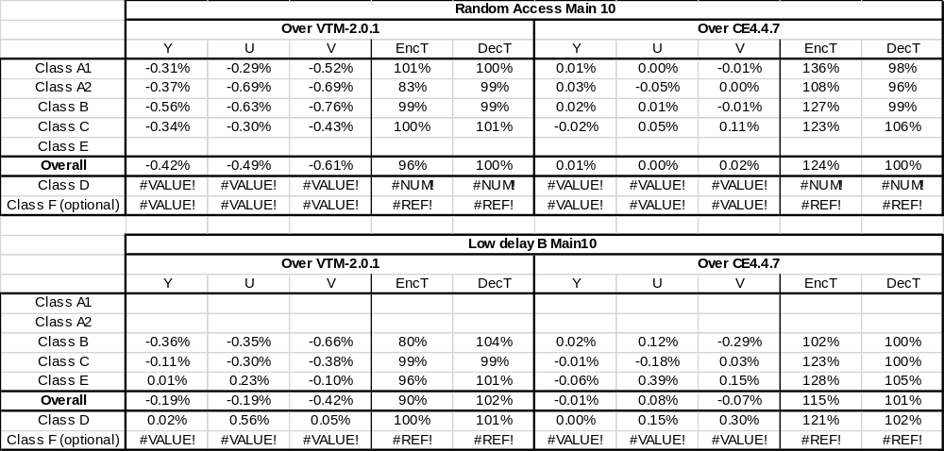

- Simulation results of Test #2: Initialization on CTU basis

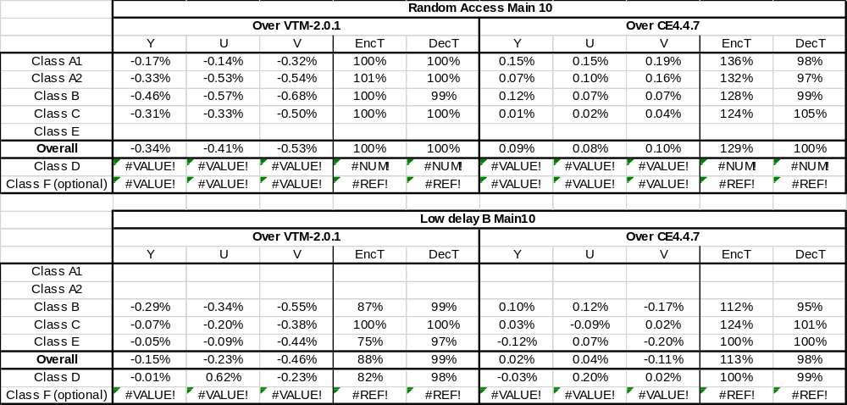

References
- J. Boyce, et al., “JVET common test conditions and software reference configurations”, Joint Video Exploration Team (JVET) of ITU-T SG 16 WP 3 and ISO/IEC JTC1/SC 29/WG 11 JVET-K1010, 11th meeting, Ljubljana, SI, 10-18 July 2018.

