    Joint Video Experts Team (JVET)  of ITU-T SG 16 WP 3 and ISO/IEC JTC 1/SC 29/WG 11  12th Meeting: Macao, CN, 3–12 Oct. 2018 | Document: JVET-L0451

Title: | CE15-related: Palette predictor list enhancement
Status: | Input document to JVET
Purpose: | Proposal
Author(s) or  Contact(s): | Jing Ye, Xiang Li, Xiaozhong Xu and Shan Liu | Tel:  Email: | jingye@tencent.com  xlxiangli@tencent.com  xiaozhongxu@tencent.com  shanl@tencent.com
Source: | Tencent
_____________________________

Abstract
In this contribution, it is proposed to derive the spatial palette predictor from the spatial neighboring blocks’ palette table first. Then combine the spatial palette predictor with HEVC SCC palette predictor. The proposed method reports -0.14%, -0.04%, and -0.04% luma and chroma BD rate changing for AI configuration on class SCC over CE 15.2.

Introduction
In CE15.2 [1], the HEVC palette predictor list is used when encoding the palette table entry. The palette predictor list stores the previously coded palette entries as predictor to the current block palette. This list is updated after each palette mode CU. The latest palette is inserted at the beginning of the list and the entries from the farthest CUs in scan order are discarded if the list size exceeds the maximum palette predictor size.

Proposed methods
1. Derive the spatial palette predictor:
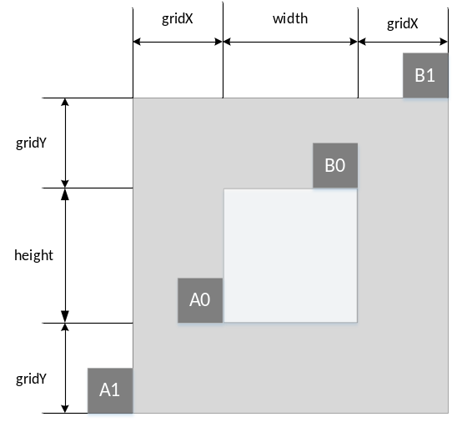
Fig.1 Illustration of the spatial palette predictor
To derive the spatial palette predictor, the adjacent neighboring and non-adjacent neighboring are both checked from the neighboring blocks that are close to the current block to the blocks that are far away. The left block (Ai) and above block (Bi) are checked. The non-adjacent neighboring candidates are in a virtual box that surrounding the current block. The virtual block size and position are illustrated in Fig.1. In the current implementation, the gridX is block width and gridY is block height. There are two rounds of search. So, the current search order is A0->B0->A1->B1.
2. Combine the spatial palette predictor and the HEVC SCC palette predictor:
After deriving the spatial palette predictor, the spatial palette predictor will be inserted into the palette predictor list for the current block first. If the size of palette predictor list for the current block doesn’t exceed the maximum palette predictor size, the HEVC SCC palette predictor is inserted into the palette predictor list. If the list size exceeds the maximum palette predictor size, the rest palette entry will be discarded. The combined palette predictor will be used to code the palette table entry of the current block.

Simulation results
The simulation is performed using VTM 2.0.1, under VTM configuration. The software is implemented on top of CE15.2. The mandatory common test conditions (CTC) as specified in the JVET-K1010 [3] are followed. Additional screen content testing materials as specified in CE8 [4] and CE15 [1] are also evaluated. Two anchors are used, the first anchor is VTM2.0.1, and the second anchor is CE15.2. Results are reported in the following table:
Table I: simulation results of the proposed method.
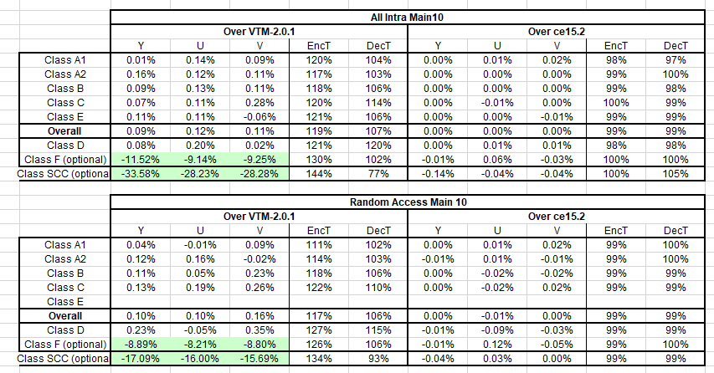

Conclusion
In this contribution, it is proposed to derive the spatial palette predictor from the spatial neighboring blocks’ palette table and combine the spatial palette predictor with HEVC SCC palette predictor. The proposed method reports -0.14%, -0.04%, and -0.04% luma and chroma BD rate changing for AI configuration on class SCC over CE 15.2. It is recommended to further study this contribution in CE.

References
[1] Y.-C. Sun, Y.-H. Chao, X. Xu, “Description of Core Experiment 15 (CE15): Palette mode”, JVET-K1035, Ljubljana, SL, July 2018
[2] High Efficiency Video Coding (HEVC), Rec. ITU-T H.265 and ISO/IEC 23008-2, Dec. 2016.
[3] F.Bossen, J. Boyce, X. Li, V. Sergin, and K. Suhring, ”JVET common test conditions and software reference configurations", JVET-K1010, 11th JVET meeting, July 2018.
[4] X. Xu, K. Müller, L. Wang, “Description of Core Experiment 8 (CE8): Current Picture Referencing”, JVET-K1028, Ljubljana, SL, July 2018

Patent rights declaration(s)
Tencent may have current or pending patent rights relating to the technology described in this contribution and, conditioned on reciprocity, is prepared to grant licenses under reasonable and non-discriminatory terms as necessary for implementation of the resulting ITU-T Recommendation | ISO/IEC International Standard (per box 2 of the ITU-T/ITU-R/ISO/IEC patent statement and licensing declaration form).

