    Joint Video Experts Team (JVET)  of ITU-T SG 16 WP 3 and ISO/IEC JTC 1/SC 29/WG 11  12th Meeting: Macao, CN, 3–12 Oct. 2018 | Document: JVET-L0403r1

Title: | CE11: Test on long deblocking filtering from JVET-J0021/JVET-K0334 (CE11.1.4)
Status: | Input document to JVET
Purpose: | Proposal
Author(s) or  Contact(s): | Dmytro Rusanovskyy  Marta Karczewicz | Tel:  Email: | dmytror@qti.qualcomm.com
Source: | Qualcomm
_____________________________

Abstract
This contribution report results of CE11.1.4 test on deblocking filtering method as it was proposed in the JVET-J0021. It is proposed to apply asymmetric filtering on boundary samples: a proposed long deblocking filter is applied to boundary samples of the blocks, with size (orthogonal to boundary) large than 16; the boundary samples of the blocks with size (orthogonal to the boundary) smaller or equal to 16 are filtered with HEVC deblocking. For long deblocking filtering, a total number of 4 boundary samples are filtered. The final output values are clipped with a position-dependent Tc parameter. Proposal allows a parallel implementation of the deblocking process.
Proposed deblocking was tested at the grid-4 (sub-test CE11.1.4a) and grid-8 (sub-test CE11.1.4.b) constrains for deblocking against the CE11 test conditions. With ALF OFF, proposed deblocking provides around 0.5% of BD rate reduction on average for UHD Class A1. With ALF ON, BD rate reduction of 0.3% on average for UHD Class A1 is provided. It is asserted that the proposed method achieves noticeable visual quality improvements in both smooth and mixed smooth/textural image fragments.
The following BD rate results comparing CTC (ALF ON) and CTC with ALF OFF anchors are reported in this document:
CE11.1.4a, ALF ON:
AI : 0.15%, -0.01%, -0.01%: RA: -0.15% -0.07% -0.25%: LDB: -0.15% -0.34% -0.37%, DLP: -0.18% -0.40% -0.08%
CE11.1.4a, ALF OFF:
AI : 0.06% 0.00% -0.01%; RA: -0.29% -0.22% -0.27%; LDB: -0.19% -0.18% -0.11%; LDP: -0.42% -0.38% -0.38%
CE11.1.4b, ALF ON:
AI: -0.03% 0.00% 0.00%; RA: -0.08% -0.09% -0.24%; LDB: -0.05% -0.17% -0.36%; LDP: -0.06% -0.27% -0.08%
CE11.1.4b, ALF OFF:
AI: -0.04% 0.00% 0.00%; RA: -0.12% -0.13% -0.21%; LDB: -0.03% -0.12% -0.15%; LDP: -0.08% -0.06% -0.12%

Introduction
This contribution reports results of CE11.1.4 test on deblocking filtering method as it was proposed in the JVET-J0021 and integrated to the VTM2.0.1 code base with simplifications. This method was earlier tested in VTM1.0 and BMS1.0 code bases and the results were provided in document JVET-K00334.
Proposed method employs an asymmetric filtering, with a long or a short-tap length filters are being applied to block boundary samples depending on the blocks size properties. Up-to 4 boundary samples are filtered with output values being clipped with a position-dependent Tc parameter. Proposed method allows parallel implementation, up-to 6 lines of neighboring block pixel data needed for a long filter and short tap filters following the HEVC complexity and memory constrains.
Details of the design are further described in Section 2, and experimental results are shown in Section 3. Md5sums for subjective data are listed in Section 4, which is then followed by conclusions.

Proposed technology
Proposed deblocking method follows the HEVC design, extending it with a longer tap length filter for a boundary samples of the large block sizes.

Applicability constrains:
Proposed deblocking method is applied to at the follows the HEVC design, extending it with a longer tap length filter for a boundary samples of the large block sizes.
The following applicability constrains are proposed:
- HEVC strong filter decision return TRUE
- Boundary separates blocks of size large than 8, with either side being large than 16
- Long filter smoothness criteria return TRUE
The following pseudo code provides an example of implementation:
minBLkSize = min(lengthP, lengthQ);
maxBLkSize = max(lengthP, lengthQ);
if ((maxBLkSize > LARGE_BLOCK_SIZE_DEBLOCK ) && (minBLkSize >= 8))
if ( isSmoothAsymArea() )
{
if (minBLkSize >= LARGE_BLOCK_SIZE_DEBLOCK)
{
ApplyLongSymmetricFiltering()
}
else if ((MODE_INTRA != cuP.predMode) && (MODE_INTRA != cuQ.predMode))
{
ApplyAsymmetricFiltering();
}
}
else
{
ApplyHEVCFiltering();
}

Long filter smoothness criterion:
Long filter smoothness criterion ( isSmoothAsymArea() ) is computed as an absolute value of second derivatives computed for P and Q blocks independently and this estimate is compared against the thresholds thresholdP and thresholdQ. Decision making is conducted for group of 4 lines, with only 2 out of these 4 lines are analyzed.
The thresholds thresholdP and thresholdQ are derived from the block size parameters, coded QP value and the type of the slice. Derivation of these threshold values can be tabulated.
The following pseudo code provides an example of implementation of the function isSmoothAsymArea():

function isSmoothAsymArea()
{
countQ = min(LARGE_BLOCK_SIZE_CLASSIFIER, (lengthQ >> 1)) - 2);
countP = min(LARGE_BLOCK_SIZE_CLASSIFIER, (lengthP >> 1)) - 2);
thresholdP = fun (countP, perCountTh, m_deblockSmoothThQP[iQP]);
thresholdQ = fun (countP, perCountTh, m_deblockSmoothThQP[iQP]);
varP = sum(abs(LaplacianOverP))
varQ = sum(abs(LaplacianOverQ))
if (varP < thresholdP && varQ < thresholdQ)
{
return true;
}
else
return false;
}

Proposed filtering process:
If specified in Section 2.2 smoothness criteria is not met for boundary samples of blocks of size (orthogonal to the filtered boundary) larger 16, but met smoothness criteria of HEVC, strong filter of HEVC is applied.
If specified in Section 2.2. smoothness criteria are met, boundary samples of the blocks with size (orthogonal to the boundary) smaller than 16 are filtered with strong HEVC filter.
For blocks with size (orthogonal to the boundary) larger than 16, four boundary samples $q_{0},q_{1}, q_{2},q_{3}$ or $p_{0},p_{1}, p_{2},p_{3}$ are filtered with following filters, hhe filter $h_{i}$ is centered at pixel $p_{i}$, where $i=0,1,2,3$:
$$h_{0}=\left[0, 2, 9, 12, 1, 3, 13, 16, 5, 3, 0\right],$$
$${ h}_{1}=\left[-1, 6, 7, 8, -2, 13, 15, 10, 8, 0, 0\right],$$
$$h_{2}=\left[-1, 4, 12, -3, 6, 14, 14, 16, 2, 0, 0\right],$$
${ h}_{3}=\left[-3, 16, -3, 1, 5, 16, 18, 14, 0, 0, 0\right]$.
It should be noted, that filters $h_{i}$ defined above are shown in 11-tap representation for simplicity of writing, effective filter support area is spanning to 6 boundary samples, as shown in Table below.
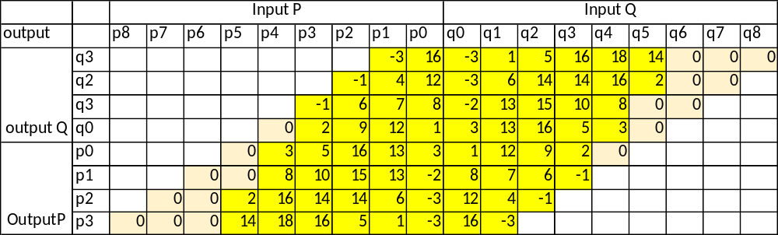
Additionally, position-dependent clip to the output sample value is applied. In current implementation, increased by 3x Tc value is applied for two the most boundary samples of the block, and two internal boundary samples are clipped by 2x.

Complexity estimates:
Complexity of the decision-making process on applicability of the long filter is a subject of the outcome from HEVC strong filter decision and meeting applicability criteria given in Section 2.1, including asymmetric filtering applicability. Therefore, not every boundary group of line (decision is made for a group of 4 lines) is undergoes this process. For the worse case scenario, when both sides of boundary are identified as sided with long blocks, estimates of additional to the HEVC complexity for decision-making is provided in Table 3.
Table 3. Number of operations required for proposed filtering
Type of operation | Per 1 filtered sample | Per 1 line | Per block of 4 lines
Multiplication | 0 | 0 | 0
Additions | 1.875 | 30 | 60
Shifts | 0.625 | 10 | 20
Comparators | 0.125 | 2 | 4

Complexity estimates (worst case) in terms of number of operations for the proposed filtering process (Section 2.3) is provided in Table 3.
Table 3. Number of operations required for proposed filtering
Type of operation | 1 filtered sample | 4 samples  1 side boundary | 8 samples  1 line
Multiplication | 4.875 | 19.5 | 39
Additions | 7 | 28 | 56
Shifts | 3.5 | 14 | 28
Comparators | 0 | 0 | 0

Experimental Results
The CE11.1.4 specifies the following two conditions: 1) VTM-2.0.1 with ALF switched on 2) VTM-2.0.1 with ALF switched off. And also LDP is mandatory in addition to CTC [4]. All reported results in this document are provided comparing against the Anchor 1 (VTM CTC with ALF ON) and Anchor 2( VTM CTC with ALF OFF).
Performance of the proposed deblocking filter was also tested at the grid-4 (sub-test CE11.1.4a) and grid-8 (sub-test CE11.1.4.b) constrains for the deblocking. Simulation results for tested method are provided in Tables 2 – 5. Note: more accurate time estimates will be provided in updated version.

Sub test CE11.1.4.a
Proposed deblocking method being tested with enabling grid 4 deblocking filtering.
Table 2. CE11.1.4.a simulation results, VTM2.01 CTC with ALF ON
CE11.1.4 | VTM 2.01 CTC, ALF ON
Grid 4 | All Intra Main10 |  |  |  |  | RA Main10
ALF ON | Y | U | V | EncT | DecT | Y | U | V | EncT | DecT
Class A1 | 0.05% | -0.01% | -0.01% | 100% | 100% | -0.29% | -0.10% | -0.51% | 100% | 101%
Class A2 | 0.17% | -0.01% | -0.01% | 100% | 102% | -0.17% | -0.20% | -0.20% | 99% | 101%
Class B | 0.21% | -0.01% | -0.01% | 99% | 98% | -0.06% | -0.07% | -0.15% | 99% | 101%
Class C | 0.19% | -0.01% | -0.01% | 100% | 103% | -0.14% | 0.04% | -0.23% | 99% | 100%
Class E | 0.10% | -0.01% | -0.01% | 99% | 99%
Overall | 0.15% | -0.01% | -0.01% | 100% | 100% | -0.15% | -0.07% | -0.25% | 99% | 101%
Class D | 0.17% | -0.02% | -0.01% | 100% | 102% | -0.07% | -0.12% | -0.14% | 100% | 101%

CE11.1.4 | VTM 2.01 CTC, ALF ON
Grid 4 | LowB Main10 |  |  |  |  | Low P Main 10
ALF ON | Y | U | V
Class A1
Class A2
Class B | -0.03% | -0.25% | -0.31% | 99% | 100% | -0.13% | -0.19% | 0.08% | 100% | 101%
Class C | -0.16% | -0.19% | -0.21% | 100% | 102% | -0.19% | -0.38% | -0.36% | 100% | 103%
Class E | -0.33% | -0.69% | -0.68% | 100% | 102% | -0.26% | -0.77% | 0.05% | 99% | 97%
Overall | -0.15% | -0.34% | -0.37% | 99% | 101% | -0.18% | -0.40% | -0.08% | 100% | 101%
Class D | -0.04% | 0.55% | -0.09% | 100% | 101% | -0.05% | 0.18% | -0.73% | 99% | 99%

Table 3. CE11.1.4.a simulation results with VTM2.01 CTC and ALF OFF
CE11.1.4 | VTM 2.01 CTC, ALF OFF
Grid 4 | All Intra Main10 |  |  |  |  | RA Main10
ALF OFF | Y | U | V | EncT | DecT | Y | U | V | EncT | DecT
Class A1 | -0.05% | -0.01% | -0.01% | 100% | 96% | -0.48% | -0.36% | -0.67% | 100% | 101%
Class A2 | 0.09% | -0.01% | -0.01% | 100% | 104% | -0.43% | -0.15% | -0.14% | 99% | 101%
Class B | 0.12% | 0.00% | -0.01% | 100% | 100% | -0.18% | -0.29% | -0.23% | 100% | 102%
Class C | 0.13% | 0.00% | -0.01% | 100% | 101% | -0.18% | -0.07% | -0.11% | 99% | 101%
Class E | -0.07% | 0.00% | -0.01% | 100% | 103%
Overall | 0.06% | 0.00% | -0.01% | 100% | 101% | -0.29% | -0.21% | -0.27% | 100% | 101%
Class D | 0.11% | -0.01% | 0.00% | 100% | 100% | -0.15% | -0.12% | -0.03% | 100% | 102%

CE11.1.4 | VTM 2.01 CTC, ALF OFF
Grid 4 | LowB Main10 |  |  |  |  | Low P Main 10
ALF OFF | Y | U | V
Class A1
Class A2
Class B | -0.15% | -0.12% | -0.16% | 101% | 104% | -0.36% | -0.34% | -0.21% | 100% | 100%
Class C | -0.23% | -0.04% | -0.08% | 100% | 101% | -0.34% | -0.25% | -0.14% | 100% | 98%
Class E | -0.21% | -0.44% | -0.08% | 100% | 101% | -0.65% | -0.61% | -0.98% | 100% | 105%
Overall | -0.19% | -0.17% | -0.11% | 100% | 102% | -0.42% | -0.38% | -0.38% | 100% | 101%
Class D | -0.11% | 0.04% | 0.47% | 100% | 106% | -0.25% | -0.47% | 0.14% | 100% | 105%

Sub test CE11.1.4.b
Proposed deblocking method being tested with enabling grid 8 deblocking filtering.
Table 4. CE11.1.4.b simulation results, VTM2.01 CTC with ALF ON

CE11.1.4.b | VTM 2.01 CTC, ALF ON
Grid 8 | All Intra Main10 |  |  |  |  | RA Main10
ALF ON | Y | U | V | EncT | DecT | Y | U | V | EncT | DecT
Class A1 | -0.07% | 0.00% | 0.00% | 100% | 101% | -0.27% | -0.05% | -0.50% | 100% | 101%
Class A2 | -0.02% | -0.01% | 0.00% | 100% | 103% | -0.08% | -0.21% | -0.23% | 99% | 100%
Class B | -0.02% | 0.00% | -0.01% | 99% | 98% | -0.02% | -0.13% | -0.18% | 99% | 100%
Class C | -0.01% | 0.00% | 0.00% | 99% | 101% | -0.01% | 0.04% | -0.11% | 99% | 100%
Class E | -0.06% | -0.01% | 0.00% | 99% | 99%
Overall | -0.03% | 0.00% | 0.00% | 99% | 100% | -0.08% | -0.09% | -0.24% | 99% | 100%
Class D | 0.00% | 0.00% | 0.00% | 100% | 99% | -0.02% | -0.03% | -0.07% | 100% | 100%

CE11.1.4.b | VTM 2.01 CTC, ALF ON
Grid 8 | LowB Main10 |  |  |  |  | Low P Main 10
ALF ON | Y | U | V | EncT | DecT
Class A1
Class A2
Class B | 0.00% | -0.29% | -0.50% | 99% | 100% | -0.07% | -0.08% | -0.09% | 100% | 100%
Class C | 0.03% | -0.16% | -0.22% | 99% | 101% | -0.01% | -0.21% | 0.16% | 100% | 105%
Class E | -0.23% | 0.01% | -0.31% | 100% | 102% | -0.11% | -0.68% | -0.39% | 99% | 102%
Overall | -0.05% | -0.17% | -0.36% | 99% | 101% | -0.06% | -0.27% | -0.08% | 100% | 102%
Class D | 0.02% | -0.13% | -0.02% | 99% | 98% | 0.09% | 0.06% | 0.35% | 99% | 100%

Table 5. CE11.1.4.b simulation results with VTM2.01 CTC and ALF OFF
CE11.1.4.b | VTM 2.01 CTC, ALF OFF
Grid 8 | All Intra Main10 |  |  |  |  | RA Main10
ALF OFF | Y | U | V | EncT | DecT | Y | U | V | EncT | DecT
Class A1 | -0.14% | 0.00% | 0.00% | 100% | 97% | -0.35% | -0.38% | -0.67% | 100% | 102%
Class A2 | -0.02% | -0.01% | -0.01% | 100% | 103% | -0.12% | -0.09% | -0.13% | 100% | 101%
Class B | -0.02% | 0.00% | 0.00% | 100% | 98% | -0.05% | -0.11% | -0.09% | 100% | 101%
Class C | -0.01% | 0.00% | 0.00% | 99% | 99% | -0.02% | -0.01% | -0.09% | 100% | 100%
Class E | -0.06% | 0.00% | 0.00% | 99% | 101%
Overall | -0.04% | 0.00% | 0.00% | 100% | 99% | -0.12% | -0.13% | -0.21% | 100% | 101%
Class D | 0.00% | 0.00% | 0.00% | 100% | 98% | -0.03% | -0.15% | 0.03% | 100% | 101%

CE11.1.4.b | VTM 2.01 CTC, ALF OFF
Grid 8 | LowB Main10 |  |  |  |  | Low P Main 10
ALF OFF | Y | U | V | EncT | DecT | Y | U | V | EncT | DecT
Class A1
Class A2
Class B | -0.06% | -0.03% | -0.29% | 101% | 104% | -0.08% | -0.31% | -0.10% | 100% | 101%
Class C | 0.00% | -0.06% | -0.18% | 99% | 100% | -0.02% | 0.19% | -0.05% | 101% | 101%
Class E | -0.04% | -0.34% | 0.10% | 100% | 97% | -0.18% | 0.03% | -0.23% | 100% | 101%
Overall | -0.03% | -0.12% | -0.15% | 100% | 101% | -0.08% | -0.06% | -0.12% | 100% | 101%
Class D | -0.03% | -0.22% | 0.03% | 100% | 103% | -0.02% | -0.13% | -0.44% | 100% | 100%

Visual improvement:
It is asserted that the proposed method achieves noticeable subjective visual quality improvements in both smooth and mixed (smooth/textural) image fragments. Figures below show some image fragments from tested video supporting this observation.
Figure 1 and 2 show fragments of images from visual test set (UHD) visualizing performance of the filter in smooth areas of the images, where symmetrical long deblocking filters are likely to be deployed. Figures 3 and 4 show fragments of images with mixed areas, where asymmetrical filtering is likely to be used.
Figure 1 shows a fragment of 4th frame of the FoodMarket test sequences, RA/QP37/ALF1 for Anchor (top) and tested method in CE11.1.4a (bottom). Provided fragment seems to demonstrate visual quality improvements provided by CE11.1.4.a in suppressing large blocking artifacts in generally smooth areas.


Figure 2. A fragment of 4th frame of the FoodMarket test sequences, RA/QP37/ALF1 for Anchor (top) and tested method in CE11.1.4a (bottom).
Figure 2 shows a fragment of 19th frame of the ParkRunning test sequences, RA/QP37/ALF0 for Anchor (left) and tested method in CE11.1.4a (right). Provided fragment seems to demonstrate visual quality improvements provided by CE11.1.4.a in suppressing large blocking artifacts in generally smooth areas.

Figure 2. A fragment of 19th frame of the ParkRunning test sequences, RA/QP37/ALF0 for Anchor (left) and tested method in CE11.1.4a (right).
Figure 3 show a fragment of 337th frame of the Kristen and Sara test sequences, LDP coded with QP=39 and ALF=OFF for Anchor (top) and CE11.1.4a (bottom). Anchor results feature very distortion including large blocking artifact and block-originated distortion to diagonal edge as well as large block decolorization, marked in red circles. Provided fragment seems to demonstrate visual quality improvements provided by CE11.1.4.a in suppressing blocking artifacts in high contrast/textural areas without introducing significant oversmoothnes in the image fragment.

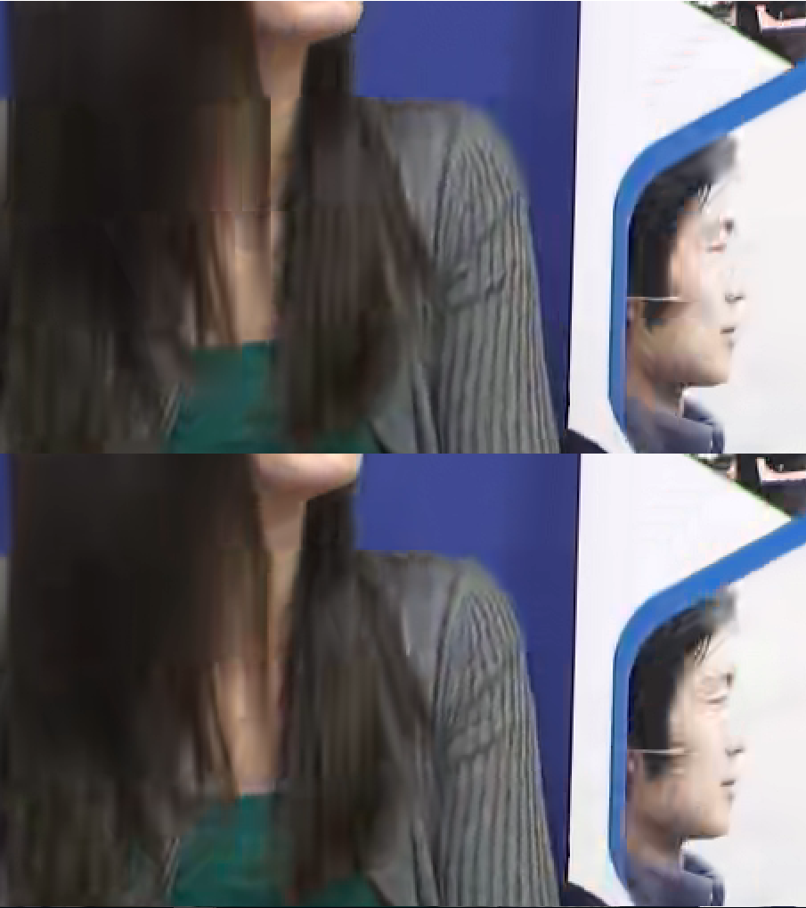
Figure 2. A fragment of 337th frame of the Kristen and Sara test sequences, LDP/ QP=39/ALF0 for Anchor (top) and CE11.1.4a (bottom).

Md5sums for subjective test data
The md5sums of reconstructed files submitted for the subjective viewing prior to the meeting with ALF switched off are provided in Table 3.
Name | Mode | QP | Md5sums
FoodMarket | RA | 34 | eeb054d3dde2794f8d40538ec3651a75
Park Running | RA | 34 | 10097fb3d449c36e3c8327c1572c872f
Campfire | RA | 34 | 0368bd405230ff3a3053a8854ff051eb
Kimono | LDB | 34 | c4345a45594661c3ed67e0f7d1f97779
KristenAndSara | LDP | 34 | 6b3113371cdee77ff1d792c72c93b75c
FoodMarket | RA | 39 | cbceb2efc563eb604ba9f364aee0cca4
Park Running | RA | 39 | 4dc981c5d21c98a6313906aa55863648
Campfire | RA | 39 | b6568a72300b89ef501671d5f9d830b0
Kimono | LDB | 39 | 0cb6858206b9b6e8d4ce235863eb1775
KristenAndSara | LDP | 39 | fa34f76954749227403df28bb7908d97

The md5sums of reconstructed files submitted for the subjective viewing prior to the meeting with ALF switched ON are provided in Table 4.
Name | Mode | QP | Md5sums
FoodMarket | RA | 34 | a432497a5fbcb015673bb40e597b9a76
Park Running | RA | 34 | 8af692863acb8fc6e4a067bb2b83cf33
Campfire | RA | 34 | adb24a0236bcab88c4639604d4c1961c
Kimono | LDB | 34 | 424e4478ce4b876c37421ed7540e6e98
KristenAndSara | LDP | 34 | 12e5150b2d23ecac012064c41c07c025
FoodMarket | RA | 39 | 2bbfafd5aaee70be3393e6f8a2e541ec
Park Running | RA | 39 | a872b1578c12c7f668d5d839aba8fe53
Campfire | RA | 39 | edce581b5050f93ceea3a1cef6fce6db
Kimono | LDB | 39 | 256479bd012d3d7850a455362563ba84
KristenAndSara | LDP | 39 | 708b190c45b66d352bee4889b4c922be

Conclusion
This contribution reports the performance of CE11.1.4 test, which propose to extend deblocking process with a longer tap length filtering and enabling asymmetric filtering of boundary samples. It is asserted that the proposed method achieves noticeable subjective quality improvements, there is also an objective gain is observed for all tested configuration, including ALF ON and OFF. Up to 0.5% of BD rate reduction on average for UHD Class A1 is observed for test with ALF OFF and 0.3% of average BD rate reduction for UHDR Class A1 is observed for ALF ON test configuration. It is proposed to adopt the proposed deblocking method and/or elements of its design into the next working draft.

Patent rights declaration(s)
Qualcomm Corporation may have current or pending patent rights relating to the technology described in this contribution and, conditioned on reciprocity, is prepared to grant licenses under reasonable and non-discriminatory terms as necessary for implementation of the resulting ITU-T Recommendation | ISO/IEC International Standard (per box 2 of the ITU-T/ITU-R/ISO/IEC patent statement and licensing declaration form).

References
- “Description of Core Experiment 11 (CE11): Deblocking”, JVET-K1031.
- “Description of SDR, HDR and 360° video coding technology proposal by Qualcomm and Technicolor – low and high complexity versions”, 10th JVET Meeting, San Diego, California, USA, April 2018, JVET-J0021.
- “CE2: Tests on long deblocking (CE2.2.1.4)”, 11th JVET Meeting, Ljubljana, Slovenia, July 2018, JVET-K0334.
- “JVET common test conditions and software reference configurations for SDR video”, JVET-K1010.

