    Joint Video Experts Team (JVET)  of ITU-T SG 16 WP 3 and ISO/IEC JTC 1/SC 29/WG 11  12th Meeting: Macao, CN, 3–12 Oct. 2018 | Document: JVET-L0362-v1

Title: | Quantization parameter signaling
Status: | Input document to JVET
Purpose: | Proposal
Author(s) or  Contact(s): | Yin Zhao,  Haitao Yang,  Jianle Chen | Email: | yin.zhao@huawei.com  haitao.yang@huawei.com  jianle.chen@huawei.com
Source: | Huawei Technologies Co., Ltd
_____________________________

Abstract
The concept of quantization group (QG) was introduced in HEVC for signaling QP for non-overlapped square regions in a coding picture. The QG size can be decided by an encoder for the trade-off between QP signaling overhead and picture quality improvement. A quantization group may contain multiple CUs while CU larger than quantization group is also supported. However, the concept of quantization group breaks in current design of VVC in that a quantization group may contain multiple incomplete CUs, due to non-square CUs. Two mechanism are introduced in this contribution to extend the concept of quantization group in the context of QT-MTT partitioning framework. The two methods are tested with CU-level perceptually-optimized delta QP calculation as described in CE7.2.3, with MaxCuDQPDepth = 2 and 4.

Introduction
In HEVC and VTM 2.0.1, the quantization group (QG) is NxN region, where N = CTUSize >> MaxCuDQPDepth. Delta QP can be signaled for each CU with depth ≤ MaxCuDQPDepth or only once for a group of CUs with depth > MaxCuDQPDepth in the same QG. In HEVC, the “depth” is QT depth, while in VTM2.0.1, the “depth” is QT depth plus MTT depth.
In HEVC design, a QG contains multiple complete CUs that are smaller than the QG, or a CU contain one or more complete QGs. However, this feature does not maintain for MTT when the QG is on a fixed grid.
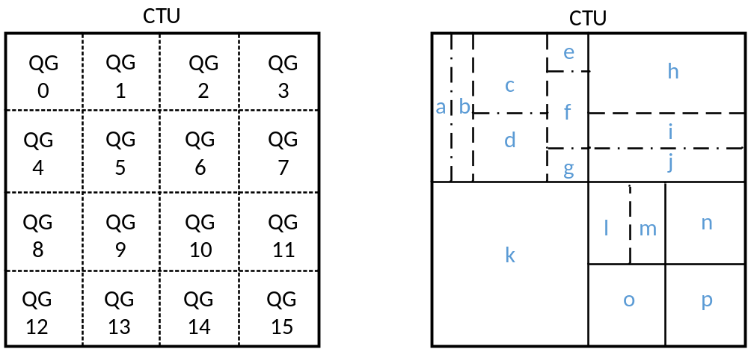
Figure 1 CU may not align with fixed region QG in QT-MTT

Proposal
Method 1: the node of depth = MaxCuDQPDepth is a quantization group, where the depth is the QT depth plus MTT depth. This method uses the same concept of depth as that in VTM2.0.1, but the QG is modified to avoid misalignment between CU boundaries and QG boundaries.
For example, if MaxCuDQPDepth = 2, in Figure 1, a and b are in one QG, c and d are in one QG, e, f and g are in one QG, h is in one QG, etc.
The method is an extension of HEVC QG, if the QG in HEVC can be consider as a region via N times of QT splits, and in this method, QG is a region via N times of QT or MTT splits. During parsing of coding tree nodes, a QG can be determined to be one node and shared to a group of child nodes.

Method 2: the QT leaf node of QT depth = MaxCuDQPDepth is a quantization group, i.e., a node with QT depth = MaxCuDQPDepth and MTT depth = 0 is a QG.
For example, if MaxCuDQPDepth = 2, in Figure 1, a to g are in one QG, h to j are in one QG, l and m are in one QG, etc.
The method is even closer to HEVC QG, in which QG derivation can be kept the same, the change is an additional check on MTT depth of a CU.

To test the two methods, the encoder CU-level delta QP for luma signal is derived by a method used in CE7.2.3 (chroma qp is constant), which is adapted based on the luminance masking and contrast masking of the CU. The CU-level lambda is changed according to the QP of a CU, and the RD-cost comparison between a CU and sub-CUs are based on slice lambda.

Simulation results
The proposed methods were integrated into the VTM 2.0.1 reference software, and Method 1 was released as a part of CE7.2.3 code. MaxCuDQPDepth = 2 and 4 were tested.
Table 1 summarizes the simulation results of the two tests under the VTM CTC configurations. Detailed results can be found in the attached excel sheets. The two methods perform similarly in MaxCuDQPDepth = 2, and method 2 gives better MsSSIM-Y BD-rate gain in MaxCuDQPDepth = 4. Since MaxBTSize is set as 32 for luma tree in I slice, the two methods can reach 32x32 by only using two QT splits, and thus the AI simulation results are the same when MaxCuDQPDepth = 2 (i.e., in this case, QGs from the two methods are both on 32x32 grid).
Table 1 Simulation results of the two QG derivation methods
MsSSIM-BD-rate |  | Method 2 |  |  | Method 1
 |  | Y | U | V | Y | U | V
MaxCuDQPDepth = 2 | AI | -4.66% | -1.97% | -2.09% | -4.66% | -1.97% | -2.09%
MaxCuDQPDepth = 2 | RA | -4.70% | 0.20% | 0.54% | -4.70% | 0.54% | 0.81%
MaxCuDQPDepth = 2 | LB | -4.26% | 3.40% | 3.08% | -4.25% | 4.17% | 3.90%
MaxCuDQPDepth = 4 | AI | -4.61% | -1.89% | -1.95%
MaxCuDQPDepth = 4 | RA | -4.72% | 0.13% | 0.47%
MaxCuDQPDepth = 4 | LB | -4.41% | 3.21% | 2.73%

Conclusions
This contribution introduces two schemes for defining quantization group for the QT-MTT partitioning framework.
It is recommended to adopt method 2 into VTM and continue the study on quantization parameter signaling.

Acknowledgement
We would like to thank KDDI for cross-checking this proposal (method 1, MaxCuDQPDepth = 2).

Patent rights declaration(s)
Huawei Technologies Co., Ltd may have current or pending patent rights relating to the technology described in this contribution and, conditioned on reciprocity, is prepared to grant licenses under reasonable and non-discriminatory terms as necessary for implementation of the resulting ITU-T Recommendation | ISO/IEC International Standard (per box 2 of the ITU-T/ITU-R/ISO/IEC patent statement and licensing declaration form).

