    Joint Video Experts Team (JVET)  of ITU-T SG 16 WP 3 and ISO/IEC JTC 1/SC 29/WG 11  12th Meeting: Macao, CN, 3–12 Oct. 2018 | Document: JVET-L0342_r2

Title: | CE3-related: Classification-based mean value for CCLM coefficients derivation
Status: | Input document to JVET
Purpose: | Proposal
Author(s) or  Contact(s): | Xiang Ma,  Fan Mu,  Haitao Yang,  Jianle Chen | Email: | maxiang6@huawei.com  mufan1@huawei.com  haitao.yang@huawei.com  jianle.chen@huawei.com
Source: | Huawei Technologies Co., Ltd
_____________________________

Abstract
In this contribution, a coefficients derivation method based on classification-based mean value is proposed. In the proposed method, the luma template samples are classified into two luma classes by the mean value of them. Correspondingly, two chroma classes are obtained. Then two luma mean values of the two luma classes, and two chroma mean values of the two chroma classes are obtained, respectively. CCLM coefficients are derived based on the two luma mean values and the two chroma mean values. Simulation results reportedly show BD rate on Y, Cb and Cr components for AI configuration over VTM2.0.1 is - 0.07%, 0.05%, and -0.44%, with 100% EncT, 98% DecT;

Tests description

Classification-based mean value for CCLM coefficients derivation
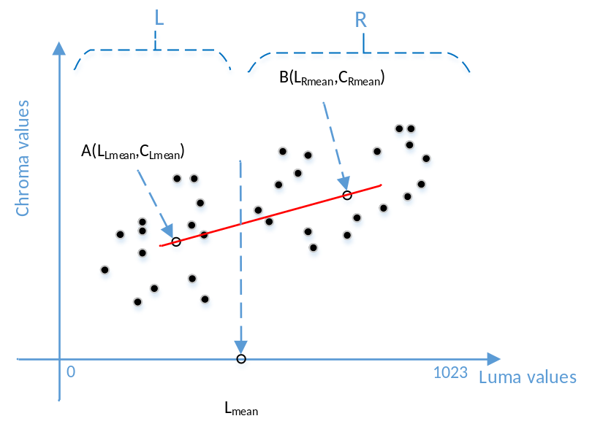
Figure 1: classification and mean value for CCLM mode.
As shown in Fig.1, L_{mean} is the mean value of the luma template samples. The luma template samples are classified into two luma classes by L_{mean}. Then, mean values of the two luma classes L_{Lmean} and L_{Rmean} are obtained. Correspondingly, C_{Lmean} and C_{Rmean} are obtained. The CCLM coefficients are derived as:
$α=\frac{C_{Lmean}-C_{Rmean}}{L_{Lmean}-L_{Rmean}}$ (1)
$β=C_{Lmean}-α*L_{Lmean}$ (2)

Using simplified method to get template samples

α1=CLLmean-CLRmeanLLLmean-LLRmeanβ1=CLLmean-α1*LLLmean

α2=CRLmean-CRRmeanLRLmean-LRRmeanβ2=CRLmean-α2*LRLmean

In the existing method, to get the luma template samples, 2 rows and 3 columns of neighboring luma samples of current luma block are needed for down-sampling. This will increase the line buffer, and also increase the complexity of model coefficients derivation. As shown in Fig.2.
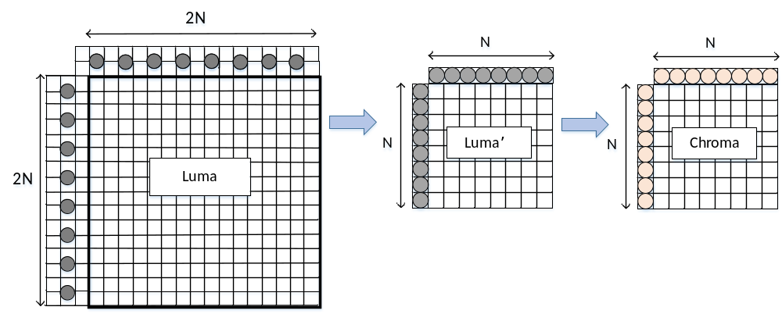
Figure 2: Template samples for CCLM mode (2 rows, 3 columns, with down-sampling).

In the proposed method, only 1 row and 1 column of neighboring luma samples of current luma block are needed. Which means, only the first top row and the second left column will be used for down-sampling to get the template samples. As shown in Fig.3.
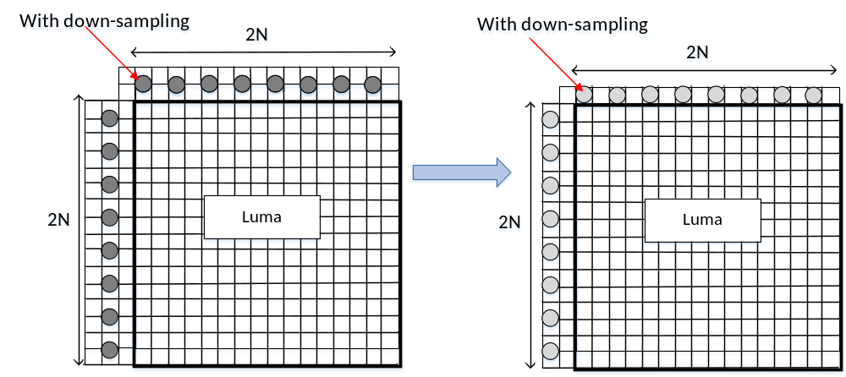
Figure 3: Template samples (1 row, 1 column, with down-sampling).

To further reduce the complexity, only the luma sample of which position are align with chroma samples will be checked, as shown in Fig.4. In this case, no down-sampling operation is needed to get the template samples.
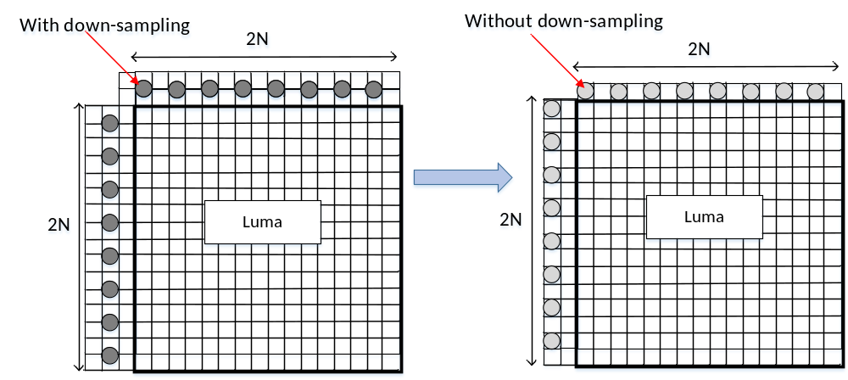
Figure 4: Template samples (1 row, 1 column, without down-sampling).

Experimental results
The proposed tests are implemented based on BMS2.0.1, and tested under VVC CTC [1] with VTM configuration. The results are summarized in Tabel1, Table2, Table3, Table4, Table5 and Table6.

CCLM
Table 1: test results of CCLM in AI configuration
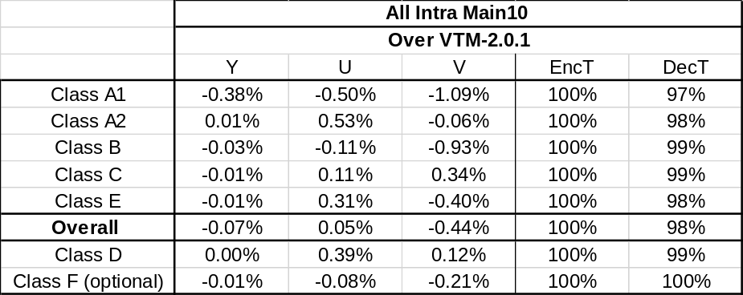
Table 2: test results of CCLM in RA configuration
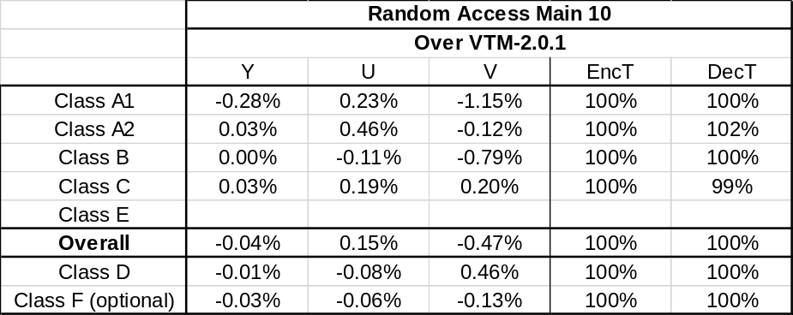

CCLM (template samples: 1 row, 1 column, with down-sampling)
Table 3: test results of CCLM in AI configuration (template: 1 row, 1 column, with down-sampling)
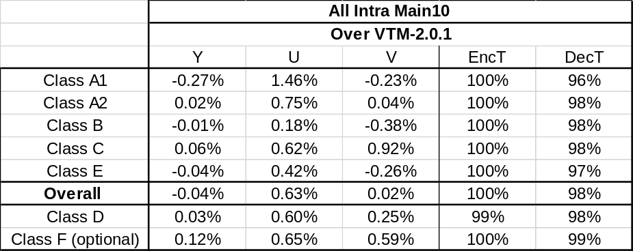
Table 4: test results of CCLM in RA configuration (template: 1 row, 1 column, with down-sampling)
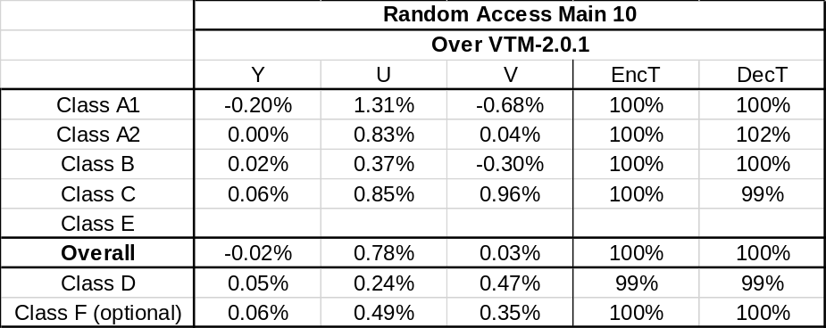

CCLM (template samples: 1 row, 1 column, without down-sampling)
Table 5: test results of CCLM in AI configuration (template: 1 row, 1 column, without down-sampling)
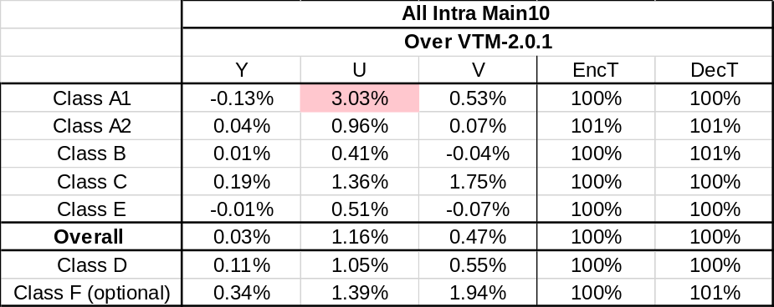
Table 6: test results of CCLM in RA configuration (template: 1 row, 1 column, without down-sampling)
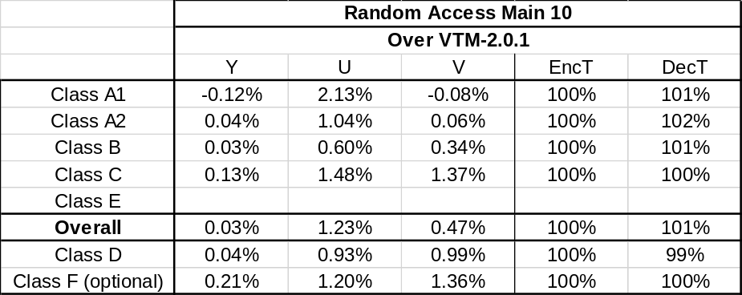

Conclusions
This proposal presents a CCLM coefficients derivation method, in which, the classification-based mean value are used. Simulation results reportedly show that, for CCLM, BD rate on Y, Cb and Cr components for AI configuration over VTM2.0.1 is -0.07%, 0.05 %, and -0.44 %.

References

- J. Boyce, K. Suehring, X. Li, and V. Seregin, “JVET common test conditions and software reference configurations,” JVET- K1010, Jul. 2018.

Patent rights declaration(s)
Huawei Technologies Co., Ltd may have current or pending patent rights relating to the technology described in this contribution and, conditioned on reciprocity, is prepared to grant licenses under reasonable and non-discriminatory terms as necessary for implementation of the resulting ITU-T Recommendation | ISO/IEC International Standard (per box 2 of the ITU-T/ITU-R/ISO/IEC patent statement and licensing declaration form).

