    Joint Video Experts Team (JVET)  of ITU-T SG 16 WP 3 and ISO/IEC JTC 1/SC 29/WG 11  12th Meeting: Macao, CN, 3–12 Oct. 2018 | Document: JVET-L0340_r1

Title: | CE3: CCLM/MDLM using simplified coefficients derivation method (Test 5.6.1, 5.6.2 and 5.6.3)
Status: | Input document to JVET
Purpose: | Proposal
Author(s) or  Contact(s): | Xiang Ma,  Haitao Yang,  Jianle Chen | Email: | maxiang6@huawei.com  haitao.yang@huawei.com  jianle.chen@huawei.com
Source: | Huawei Technologies Co., Ltd
_____________________________

Abstract
This contribution reports the test results of CCLM and multi-directional LM (MDLM) using one luma line buffer and simplified coefficients derivation method. In which, only 1 luma line will be used to get the top template samples in CCLM mode or MDLM mode, and simplified coefficients derivation method are used. The tests including:
- CCLM + MDLM, using simplified method
- CCLM, using 1 luma line buffer; using simplified method
- CCLM + MDLM, both using 1 luma line buffer; both using simplified method
Simulation results reportedly show BD rate on Y, Cb and Cr components over VTM2.0.1:
- CCLM + MDLM, using simplified method:
  - For AI configuration: 0.03%, -2.12%, and -2.87%, with 101% EncT, 99% DecT;
  - For RA configuration: 0.02%, -1.88%, and -2.66%, with 100% EncT, 98% DecT;
- CCLM, using 1 luma line buffer; using simplified method:
  - For AI configuration: 0.13%, 0.77%, and 0.25%, with 100% EncT, 99% DecT;
  - For RA configuration: 0.08%, 1.13%, and 0.44%, with 99% EncT, 99% DecT;
- CCLM + MDLM, both using 1 luma line buffer; both using simplified method:
  - For AI configuration: 0.05%, -1.88%, and -2.67%, with 101% EncT, 99% DecT;
  - For RA configuration: 0.03%, -1.59%, and -2.38%, with 101% EncT, 99% DecT;

Tests description

MDLM description
Besides the above template and left template can be used to calculate the linear model coefficients together, they also can be used alternatively in the other 2 LM modes, called LM_A, and LM_L modes.
In LM_A mode, only the above template are used to calculate the linear model coefficients. To get more samples, the above template are extended to (W+H).
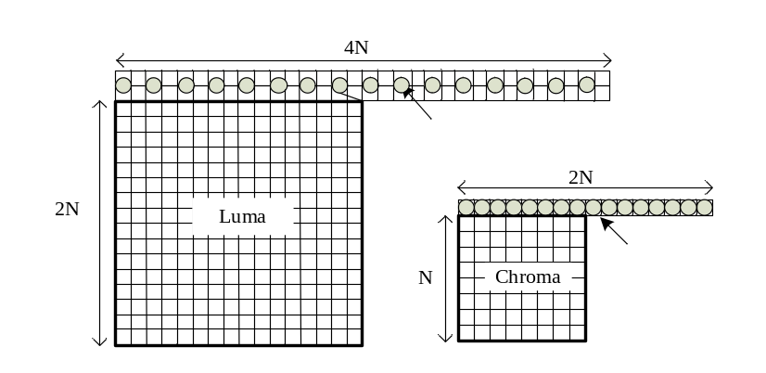
Figure 1: LM_A mode
In LM_L mode, only left template are used to calculate the linear model coefficients. To get more samples, the left template are extended to (H+W).

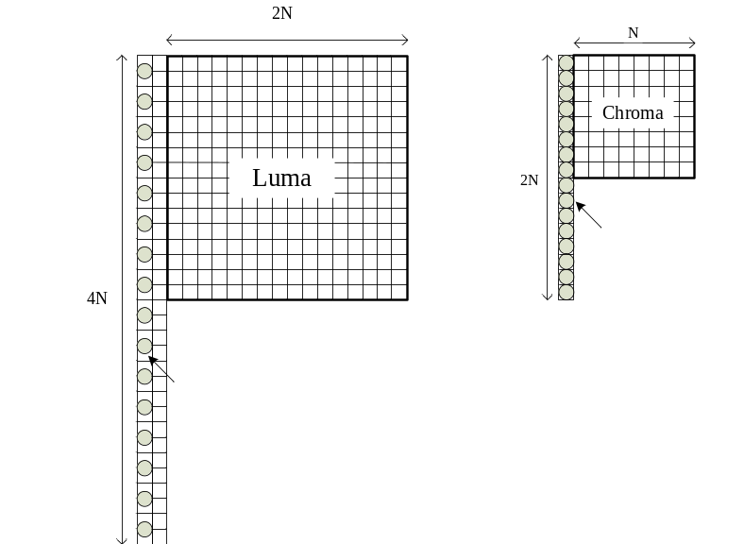
Figure 2: LM_L mode
For a non-square block, the above template are extended to W+W, the left template are extended to H+H.
If the above/left template is not available, then the LM_A/LM_L mode will not be checked or signaled. If the available samples not enough, the template will be padded by copying the right-most (for top template) sample or the below-most (for left template) sample to the nearest log2 number.

CCLM/MDLM using 1 luma line buffer
In current LM coefficients derivation process, 2 luma line buffer will be used for down-sampling to get the top template of LM-related mode (CCLM, or MDLM), while only 1 luma line buffer will be used in luma component intra prediction.
To reduce the line buffer, for the CUs using CCLM/MDLM mode, only 1 luma line will be used to get the top template samples.

Simplified coefficients derivation method
Different from the model coefficients derivation method using the least square method, a method using the maximum (max)/minimum (min) luma template sample value is proposed in JVET-K0204 [1]. Here, the method is called max-min method, for simple. In the max-min method, the max luma template sample value and the min luma template sample value are obtained by checking the values of the samples from down-sampling of the neighboring samples of current luma block. Also, the corresponding chroma sample value are obtained.
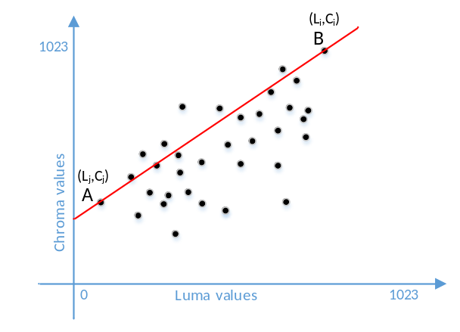
Figure 3: LM_A mode
Then the CCLM coefficients are derived as (shown in Fig.3):
$α=\frac{C_{i}-C_{j}}{L_{i}-L_{j}}$ (1)
$β=C_{j}-α*L_{j}$ (2)

All tests
There are 2 related tests totally:
Test 5.6.1: CCLM + MDLM, using simplified method
Test 5.6.2: CCLM, using 1 luma line buffer; using simplified method
Test 5.6.3: CCLM + MDLM, both using 1 luma line buffer; both using simplified method

Experimental results
The proposed tests are implemented based on BMS2.0.1, and tested under VVC CTC [2] with VTM configuration. The results are summarized in Tabel1, Table2, Tabel3, Table4, Table5 and Table6.

Test 5.6.1: CCLM + MDLM; using simplified method
Table 1: test results of 5.6.1 in AI configuration
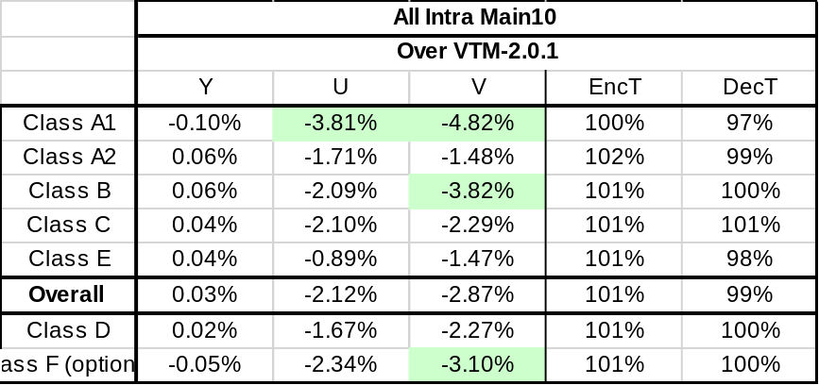
Table 2: test results of 5.6.1 in RA configuration
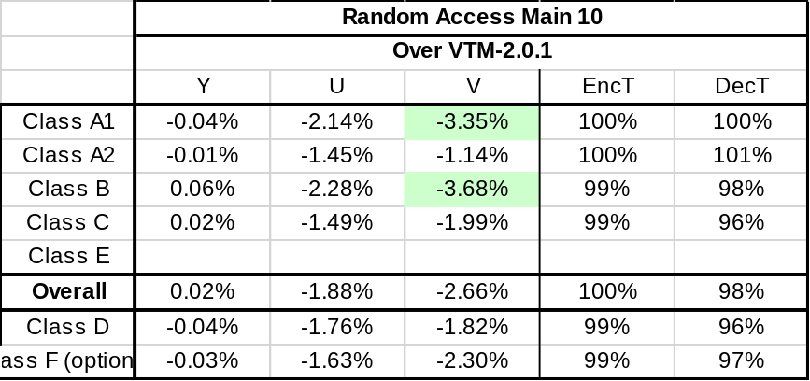

Test 5.6.2: CCLM; using 1 luma line buffer; using simplified method
Table 3: test results of 5.6.2 in AI configuration
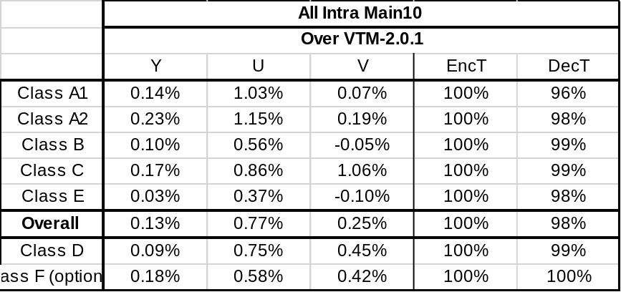
Table 4: test results of 5.6.2 in RA configuration
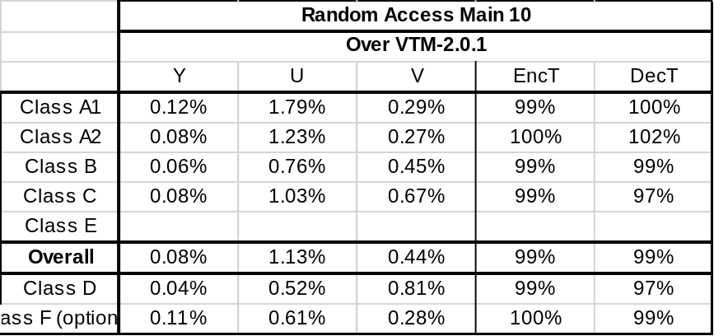

Test 5.6.3: CCLM + MDLM; both using 1 luma line buffer; both using simplified method

Table 5: test results of 5.6.3 in AI configuration
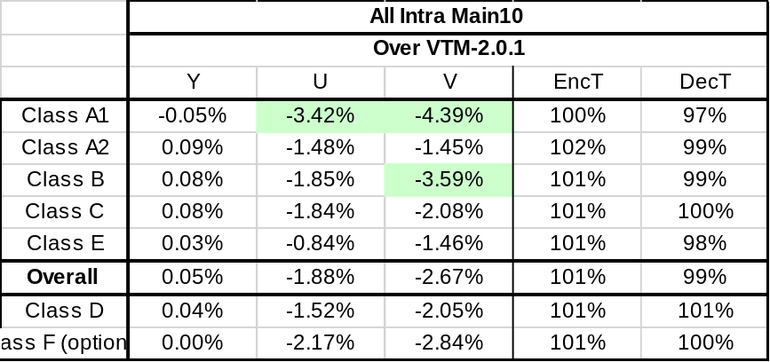
Table 6: test results of 5.6.3 in RA configuration
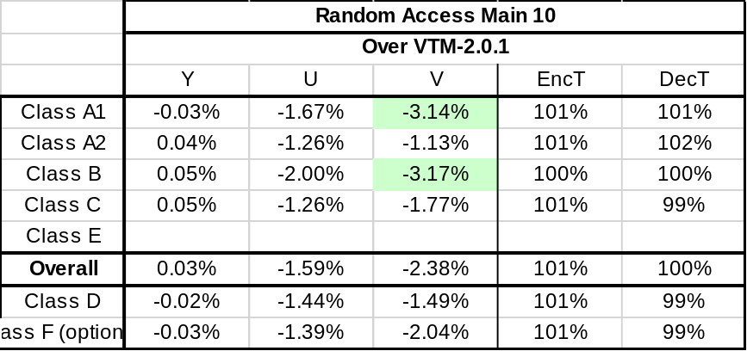

Conclusions
This proposal presents the results of CCLM/MDLM using 1 luma line buffer and using simplified coefficients derivation method tests. It can be seen that: test results of CCLM + MDLM, using simplified method, is 0.03%, -2.12%, and -2.87%; test results of CCLM; using 1 luma line buffer, using simplified method, is 0.13%, 0.77%, and 0.25%; test results of CCLM + MDLM, both using 1 luma line buffer, both using simplified method, is 0.05%, -1.88%, and -2.67%;

References
- G. Laroche, J. Taquet, C. Gisquet, and P. Onno, “Non-CE3: On cross-component linear model simplification,” JVET- K0204, Jul. 2018.
- J. Boyce, K. Suehring, X. Li, and V. Seregin, “JVET common test conditions and software reference configurations,” JVET- K1010, Jul. 2018.

Patent rights declaration(s)
Huawei Technologies Co., Ltd may have current or pending patent rights relating to the technology described in this contribution and, conditioned on reciprocity, is prepared to grant licenses under reasonable and non-discriminatory terms as necessary for implementation of the resulting ITU-T Recommendation | ISO/IEC International Standard (per box 2 of the ITU-T/ITU-R/ISO/IEC patent statement and licensing declaration form).

