Joint Video Experts Team (JVET)  of ITU-T SG 16 WP 3 and ISO/IEC JTC 1/SC 29/WG 11  12th Meeting: Macao, CN, 3–12 Oct. 2018 | Document: JVET-L0337r1

Title: | CE11.1.11: Combination of CE11.1.1 and CE11.1.7
Status: | Input document to JVET
Purpose: | Proposal
Author(s) or  Contact(s): | Weijia Zhu  Kiran Misra  Phil Cowan  Andrew Segall  Kenneth Andersson  Zhi Zhang  Rickard Sjöberg | Tel:  Email: | +1-360-834-8054  zhuw@sharplabs.com  misrak@sharplabs.com  cowanp@sharplabs.com  asegall@sharplabs.com  kenneth.r.andersson@ericsson.com
Source: | Ericsson and Sharp Labs of America
_____________________________

Abstract
The contribution reports the results of test CE11.1.11. The test is a combination of technologies proposed in CE11.1.1 and CE11.1.7. It is asserted that the proposed design reduces the blocking artifacts resulting from the use of large coding units and large transforms. The process incorporates stronger filters for both luma and chroma. Additionally, the process includes a control process that considers the block sizes on both sides of the boundary being deblocked. In the proposal, the stronger filters are used for luma samples when either side of the deblocking boundary belong to a large block. For chroma, the stronger filter is applied when chroma samples on both sides of the deblocking boundary belong to a large block and the HEVC luma strong filter conditions are satisfied. It is asserted that the proposed deblocking approach improves subjective quality at low bit-rates when compared with the deblocking process existing in the VTM software. The BD-Rate number for Y, U & V reportedly shows 0.02%, -0.43% & -0.41% at AI, 0.25%, -0.37% & -0.35% at RA, 0.43%, -0.18% & -0.11% at LDB and 0.30%, 0.05% & 0.00 % at LDP over VTM-2.0.1 with ALF switched on, respectively. When ALF is switched off, the BD-Rate results for Y, U & V reportedly shows -0.01, -0.56% & -0.50% at AI, 0.17%, -0.45% &-0.38% at RA, 0.45%, -0.08% &-0.09% at LDB, and -0.17%, 0.02%& -0.08% at LDP, respectively.
Revision 1 of the contribution updates the encoder-decoder runtime for ALF OFF case.

Introduction
Test CE11.1.11, proposes long tap filtering for luma and use of HEVC strong filer for chroma. The test is a combination of technologies proposed in CE11.1.1 [1] and CE11.1.7 [1]. The modifications are described in section 2. The experimental results are shown in section 3 and the conclusion is provided at the end.
The use of large transforms and block sizes results in significant blocking artifacts, especially in low bitrate scenarios. Figure 1 below shows the blocking artifacts that result in POC 28 for the FoodMarket sequence (used in CTC[2]) when coded with QP 42 and using BMS with random access VTM configuration[3].

Figure 1: Blocking artifacts at QP 39 resulting from use of large transforms in VVC

In studying this problem, we have observed that to overcome this issue, it is beneficial to use a stronger filter with more support than what is available in the VTM.

Proposed Scheme
Several modifications are proposed in this contribution. To facilitate this explanation, we use the following nomenclatures: First, samples on each side of a block boundary (perpendicular to the boundary edge) are represented as:
… p₈ p₇ p₆ p₅ p₄ p₃ p₂ p₁ p₀ | q₀ q₁ q₂ q₃ q₄ q₅ q₆ q₇ q₈ …
where | represents the block boundary edge.
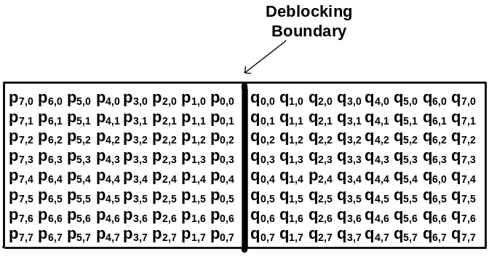 | 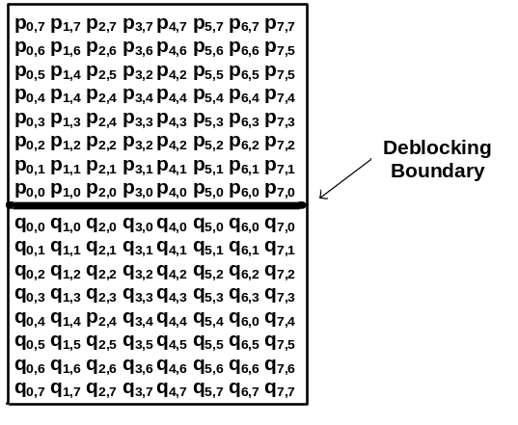
(a) | (b)
Figure 2: Deblocking boundary for (a) vertical edge (b) horizontal edge

Stronger deblocking filter for luma
On luma deblocking, we use a stronger bilinear filter when samples at either one side of a boundary belong to a large block. A sample belonging to a large block is defined as when the width >= 32 for a vertical edge, and when height>=32 for a horizontal edge.
The bilinear filter is listed below.
Block boundary samples p_{i} and q_{i} for i=0 to S-1 are then replaced by linear interpolation as follows:
- $p_{i}´={(f}_{i}*{Middle}_{s,t}+\left(64-f_{i}\right)*P_{s}+32)≫6), clipped to p_{i}±tc$
- $q_{i}´={(g}_{i}*{Middle}_{s,t}+\left(64-g_{i}\right)*Q_{s}+32)≫6), clipped to q_{i}±tc$
where $f_{i}$, ${Middle}_{s,t}$, $P_{s}$and $Q_{s}$are given below:
7, 7  (p side: 7,  q side: 7) | $$f_{i}=59-i*9, can also be described as f=\left\{59,50,41,32,23,14,5\right\}$$  $$g_{i}=59-i*9, can also be described as g=\left\{59,50,41,32,23,14,5\right\}$$  $${Middle}_{7,7}=(2*\left(p_{o}+q_{o}\right)+p_{1}+q_{1}+p_{2}+q_{2}{+p}_{3}+q_{3}{+p}_{4}+q_{4}{+p}_{5}+q_{5}{+p}_{6}+q_{6}+8)≫4$$  $$P_{7}=(p_{6}+p_{7}+1)≫1, Q_{7}=(q_{6}+q_{7}+1)≫1$$
7, 3  (p side: 7  q side: 3) | $$f_{i}=59-i*9, can also be described as f=\left\{59,50,41,32,23,14,5\right\}$$  $$g_{i}=53-i*21, can also be described as g=\left\{53,32,11\right\}$$  ${Middle}_{7,3}=(2*\left(p_{o}+q_{o}\right)+q_{0}+2*(q_{1}+q_{2})+p_{1}+q_{1}+p_{2}{+p}_{3}{+p}_{4}{+p_{5}+p}_{6}+8)≫4$  $$P_{7}=(p_{6}+p_{7}+1)≫1, Q_{3}=(q_{2}+q_{3}+1)≫1$$
3, 7  (p side: 3  q side: 7) | $$g_{i}=59-i*9, can also be described as g=\left\{59,50,41,32,23,14,5\right\}$$  $$f_{i}=53-i*21, can also be described as f=\left\{53,32,11\right\}$$  ${Middle}_{3.7}=(2*\left(q_{o}+p_{o}\right)+p_{0}+2*(p_{1}+p_{2})+q_{1}+p_{1}+q_{2}{+q}_{3}{+q}_{4}{+q_{5}+q}_{6}+8)≫4$  $$Q_{7}=(q_{6}+q_{7}+1)≫1, P_{3}=(p_{2}+p_{3}+1)≫1$$
When the samples at both P and Q sides belong to a small block, the VTM strong and weak filters may be further performed.

Deblocking control for luma
The deblocking decision process is described in this sub-section.
Wider-stronger luma filter is filters are used only if all of the Condition1, Condition2 and Condition 3 are TRUE.
The condition 1 is the “large block condition” in Fig.4. This condition detects whether the samples at P-side and Q-side belong to large blocks, which are represented by the variable bSidePisLargeBlk and bSideQisLargeBlk respectively. The bSidePisLargeBlk and bSideQisLargeBlk are defined as follows.
bSidePisLargeBlk = ((edge type is vertical and p₀ belongs to CU with width >= 32) | | (edge type is horizontal and p₀ belongs to CU with height >= 32))? TRUE: FALSE
bSideQisLargeBlk = ((edge type is vertical and q₀ belongs to CU with width >= 32) | | (edge type is horizontal and q₀ belongs to CU with height >= 32))? TRUE: FALSE
Based on bSidePisLargeBlk and bSideQisLargeBlk, the condition 1 is defined as follows.
Condition1 = (bSidePisLargeBlk || bSidePisLargeBlk) ? TRUE: FALSE
Next, if Condition 1 is true, the condition 2 will be further checked. First, the following variables are derived:
dp0, dp3, dq0, dq3 are first derived as in HEVC
if (p side is greater than or equal to 32)
dp0 = ( dp0 + Abs( p_{5,0} − 2 * p_{4,0} + p_{3,0} ) + 1 ) >> 1
dp3 = ( dp3 + Abs( p_{5,3} − 2 * p_{4,3} + p_{3,3} ) + 1 ) >> 1
if (q side is greater than or equal to 32)
dq0 = ( dq0 + Abs( q_{5,0} − 2 * q_{4,0} + q_{3,0} ) + 1 ) >> 1
dq3 = ( dq3 + Abs( q_{5,3} − 2 * q_{4,3} + q_{3,3} ) + 1 ) >> 1
dpq0, dpq3, dp, dq, d are then derived as in HEVC.
Then the condition 2 is defined as follows.
Condition2 = (d < β) ? TRUE: FALSE
Finally, if both the Condition 1 and Condition 2 are valid, the proposed deblocking method will check the condition 3(The Large Block Strong Filter Condition in Fig.4), which is defined as follows.
In the Condition3 StrongFilterCondition, the following variables are derived:
dpq is derived as in HEVC.
sp₃ = Abs( p₃ − p₀ ), derived as in HEVC
if (p side is greater than or equal to 32)
sp₃ = ( sp₃ + Abs( p₇ − p₃ ) + 1) >> 1
sq₃ = Abs( q₀ − q₃ ), derived as in HEVC
if (q side is greater than or equal to 32)
sp₃ = ( sp₃ + Abs( q₇ − q₃ ) + 1) >> 1
As in HEVC derive, StrongFilterCondition = (dpq is less than ( β >> 2 ), sp₃ + sq₃ is less than ( β >> 3 ), and Abs( p₀ − q₀ ) is less than ( 5 * t_{C} + 1 ) >> 1) ? TRUE : FALSE

Strong deblocking filter for chroma
The following strong deblocking filter for chroma is defined as:
p0′ = ( p2 + 2 * p1 + 2 * p0 + 2 * q0 + q1 + 4 ) >> 3
p1′ = ( p2 + p1 + p0 + q0 + 2 ) >> 2
p2′ = ( 2 * p3 + 3 * p2 + p1 + p0 + q0 + 4 ) >> 3
q0′ = ( p1 + 2 * p0 + 2 * q0 + 2 * q1 + q2 + 4 ) >> 3
q1′ = ( p0 + q0 + q1 + q2 + 2 ) >> 2
q2′ = ( p0 + q0 + q1 + 3 * q2 + 2 * q3 + 4 ) >> 3

Deblocking control for chroma
The chroma strong filters are used on both sides of the block boundary. Specifically, the strong filter is used when both sides of the chroma edge are greater than or equal to 16. The above test is the Large Block Condition test for chroma.
On top of the large block condition, the chroma stronger filters is used when HEVC luma strong filter condition when computed for chroma is TRUE.

Experimental Results
Results using the proposed method were generated and viewed. The proposed scheme denoted by CE11.1.11. A still image from the result is shown in Figure 7, which demonstrates the reduction in blocking artifacts as a result of the proposed deblocking modification.

- (b)
Figure 6: Comparison of (a) VTM2.0.1 (b) CE11.1.11 when QP=39
The objective performance is also reported by following the test condition in [2] on top of VTM2.0.1[3]. Simulation results random-access, all-intra, low-delay B and low-delay P configurations are given as follows. Both ALF on and ALF off are tested.
Table 1 Coding Performance of CE11.1.11(ALF on)
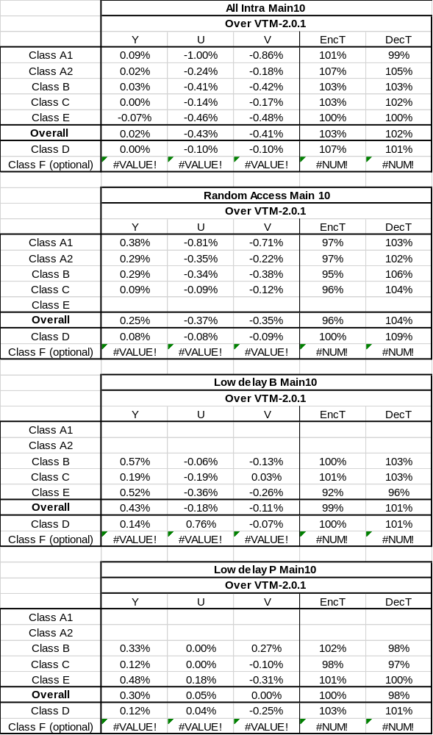

Table 3 Coding Performance of CE11.1.11(ALF off)
 | All Intra Main10
 | Over VTM2.0.1
 | Y | U | V | EncT | DecT
Class A1 | -0.02% | -1.64% | -1.25% | 97% | 102%
Class A2 | 0.01% | -0.27% | -0.18% | 104% | 104%
Class B | 0.02% | -0.44% | -0.45% | 99% | 103%
Class C | 0.00% | -0.14% | -0.16% | 100% | 102%
Class E | -0.08% | -0.54% | -0.59% | 98% | 102%
Overall | -0.01% | -0.56% | -0.50% | 100% | 102%
Class D | 0.00% | -0.10% | -0.10% | 104% | 103%
Class F (optional) | #VALUE! | #VALUE! | #VALUE! | #DIV/0! | #DIV/0!
 | Random Access Main 10
 | Over VTM2.0.1
 | Y | U | V | EncT | DecT
Class A1 | 0.18% | -1.32% | -0.96% | 101% | 103%
Class A2 | 0.22% | -0.23% | -0.12% | 102% | 103%
Class B | 0.21% | -0.34% | -0.34% | 103% | 102%
Class C | 0.07% | -0.09% | -0.18% | 103% | 103%
Class E
Overall | 0.17% | -0.45% | -0.38% | 102% | 103%
Class D | 0.03% | -0.02% | -0.03% | 103% | 103%
Class F (optional) | #VALUE! | #VALUE! | #VALUE! | #DIV/0! | #DIV/0!
 | Low delay B Main10
 | Over VTM2.0.1
 | Y | U | V | EncT | DecT
Class A1
Class A2
Class B | 0.54% | 0.14% | -0.34% | 101% | 104%
Class C | 0.16% | -0.23% | -0.18% | 101% | 103%
Class E | 0.69% | -0.23% | 0.45% | 101% | 103%
Overall | 0.45% | -0.08% | -0.09% | 101% | 103%
Class D | 0.06% | -0.17% | 0.69% | 100% | 102%
Class F (optional) | #VALUE! | #VALUE! | #VALUE! | #DIV/0! | #DIV/0!
 | Low delay P Main10
 | Over VTM2.0.1
 | Y | U | V | EncT | DecT
Class A1
Class A2
Class B | 0.22% | -0.17% | -0.19% | 101% | 103%
Class C | 0.16% | 0.23% | 0.10% | 101% | 102%
Class E | 0.10% | 0.06% | -0.13% | 101% | 101%
Overall | 0.17% | 0.02% | -0.08% | 101% | 102%
Class D | 0.03% | -0.63% | -0.01% | 99% | 100%
Class F (optional) | #VALUE! | #VALUE! | #VALUE! | #DIV/0! | #DIV/0!

md5sums for CE11 test set
67519cdc9fe9a4a414c51704df8c4ca5 CE11_1_11_ALF_Campfire_RA_QP34.yuv
39e71843fcf18780b4b0d4494d3827b0 CE11_1_11_ALF_Campfire_RA_QP39.yuv
bfe180f2d13fa464ca916e6a79af5b6f CE11_1_11_ALF_FoodMarket_RA_QP34.yuv
7e8e1deba45b5ba6617725ca5c513885 CE11_1_11_ALF_FoodMarket_RA_QP39.yuv
bf9a8806e13d3a0a935b27ffeb8fe168 CE11_1_11_ALF_Kimono_LDB_QP34.yuv
b5e097adc49e3c4fdc4d9b62c030e8d1 CE11_1_11_ALF_Kimono_LDB_QP39.yuv
d8f03a4ee4884c2847a47abac36bae15 CE11_1_11_ALF_KristenAndSara_LDP_QP34.yuv
5517d57af1af52d326bc08cbc981d573 CE11_1_11_ALF_KristenAndSara_LDP_QP39.yuv
1b5b0e8cd43e77545facc0f6aa917e60 CE11_1_11_ALF_ParkRunning_RA_QP34.yuv
5a46ed8f8cc37911041ad0c32072d9b4 CE11_1_11_ALF_ParkRunning_RA_QP39.yuv
28e9357b26569756e1d41ed236426b22 CE11_1_11_NoALF_Campfire_RA_QP34.yuv
00eac14cd103c8f71693b285bb1e8738 CE11_1_11_NoALF_Campfire_RA_QP39.yuv
05da7e43373f7d7a88030cd0e7d49572 CE11_1_11_NoALF_FoodMarket_RA_QP34.yuv
e0f1db72e035b6769ee156d1e61ea535 CE11_1_11_NoALF_FoodMarket_RA_QP39.yuv
c598eded884e7a05155a9c12fed9c3f9 CE11_1_11_NoALF_Kimono_LDB_QP34.yuv
09563fc38851cd8e1b40a02d15e2c73e CE11_1_11_NoALF_Kimono_LDB_QP39.yuv
a194e843e73e2aace86728e756316061 CE11_1_11_NoALF_KristenAndSara_LDP_QP34.yuv
3e610281e4f721f4d023a40d8d3e3230 CE11_1_11_NoALF_KristenAndSara_LDP_QP39.yuv
a4e580f3c32426a64e9f75aa8f2d16cd CE11_1_11_NoALF_ParkRunning_RA_QP34.yuv
52959912db6f14382703e58b95b347f4 CE11_1_11_NoALF_ParkRunning_RA_QP39.yuv

Conclusion
In this proposal, a new adaptive long-tap deblocking filtering method is proposed. It is asserted that the proposed method achieves significant subjective quality improvements. We, Ericsson and Sharp, propose adopting the method into the next version of the versatile video coding working draft.

Reference
- A. Norkin, A. M. Kotra “ Description of Core Experiment 11 (CE11): Deblocking”, JVET-K1031, July 2018, Ljubljana, Slovenia.
- F. Bossen, J. Boyce, X. Li, V. Seregin, K. Sühring “JVET common test conditions and software reference configurations for SDR video”, JVET-K1010, July 2018, Ljubljana, Slovenia.
- VTM 2.0.1, https://vcgit.hhi.fraunhofer.de/jvet/VVCSoftware_vtm.git

Patent rights declaration(s)
Ericsson may have current or pending patent rights relating to the technology described in this contribution and, conditioned on reciprocity, is prepared to grant licenses under reasonable and non-discriminatory terms as necessary for implementation of the resulting ITU-T Recommendation | ISO/IEC International Standard (per box 2 of the ITU-T/ITU-R/ISO/IEC patent statement and licensing declaration form).
Sharp Labs of America may have current or pending patent rights relating to the technology described in this contribution and, conditioned on reciprocity, is prepared to grant licenses under reasonable and non-discriminatory terms as necessary for implementation of the resulting ITU-T Recommendation | ISO/IEC International Standard (per box 2 of the ITU-T/ITU-R/ISO/IEC patent statement and licensing declaration form).

Appendix
A flowchart for the luma and chroma deblocking control process are shown below:
Luma deblocking control:
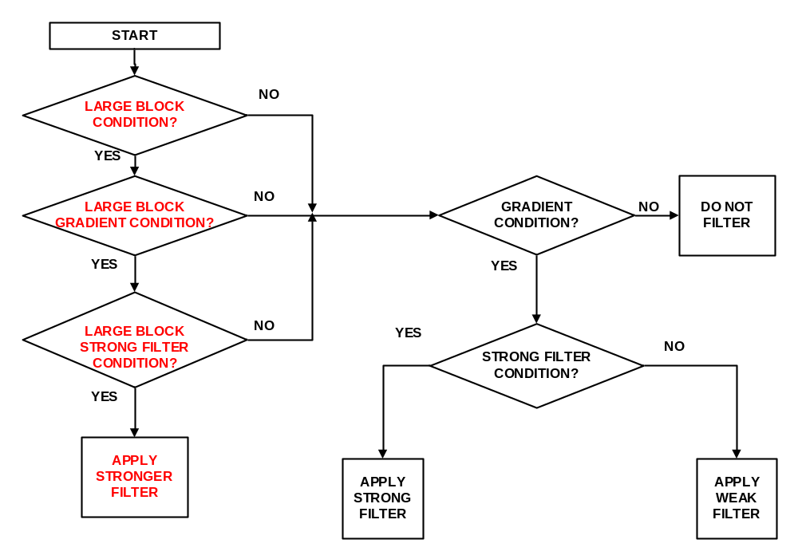
Flowchart of luma deblocking control
Where, text in red corresponds to the proposed modifications, while the text in black corresponds to existing VVC deblocking.
Chroma deblocking control:

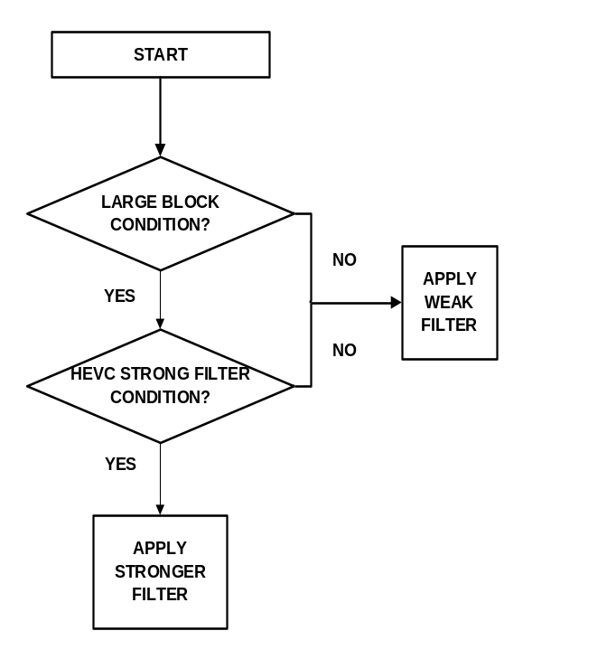
Flowchart of chroma deblocking control in test (b)

