    Joint Video Experts Team (JVET)  of ITU-T SG 16 WP 3 and ISO/IEC JTC 1/SC 29/WG 11  12th Meeting: Macao, CN, 3–12 Oct. 2018 | Document: JVET-L0308

Title: | CE15-related: palette mode when dual-tree is enabled
Status: | Input document to JVET
Purpose: | Proposal
Author(s) or  Contact(s): | Jing Ye, Xiang Li, Shan Liu, and Xiaozhong Xu | Tel:  Email: | jingye@tencent.com  xlxiangli@tencent.com  shanl@tencent.com  xiaozhongxu@tencent.com
Source: | Tencent
_____________________________

Abstract
In this contribution, the modification on palette mode when dual tree is enabled is proposed. In VTM 2.0.1, for I slice, the dual tree is enabled, and luma CTU and chroma CTU have different tree structure. In the HEVC SCC palette mode, the luma sample and chroma sample are interleaved coded. In this case, the HEVC SCC palette mode cannot directly be applied on VTM 2.0.1. In this contribution, two methods are proposed to solve this issue. The proposed method 1 reports -11.64%, -7.75%, -7.55% luma and chroma BD rate changing for AI configuration on class F over VTM 2.0.1. And reports -9.00%, -7.07%, -7.14% luma and chroma BD rate changing for RA configuration on class F over VTM 2.0.1. The proposed method 2 reports -11.60%, -8.56%, -8.35% luma and chroma BD rate changing for AI configuration on class F over VTM 2.0.1. And reports -8.88%, -7.75%, -8.12% luma and chroma BD rate changing for RA configuration on class F over VTM 2.0.1.

Introduction
In CE15.2 [1], the chroma and luma have separate palette tables and index maps for luma plane and chroma plane when dual tree is enabled. This is different from HEVC SCC [2]. In HEVC, one palette entry is composed of three color components. And one index map is signalled for all the three components. This contribution proposes alternative ways to apply palette mode when dual tree is enabled.

Proposed methods
Method 1: only apply palette mode to luma plane when dual tree is enabled. In this case, only one palette table and one index map for luma CU will be signaled. When coding chroma plane separately, palette mode will not be used. The other available modes, such as intra chroma mode coding, will be used.
Method 2: apply palette mode to luma plane when dual tree is enabled. When coding chroma plane, if the co-located luma block are all palette mode, the chroma block are also have the flexibility to use palette mode. A flag is signaled whether the chroma block using palette mode or not. If the chroma block using palette mode, the corresponding palette mode syntax will be signaled.

Simulation results

The simulation is performed using VTM 2.0.1, under VTM configuration. The software is implemented on top of CE15.2. The mandatory common test conditions (CTC) as specified in the JVET-K1010 [3] are followed. Additional screen content testing materials as specified in CE8 [4] and CE15 [1] are also evaluated. Two anchors are used, the first anchor is VTM2.0.1, and the second anchor is CE15.2. Results are reported in the following table:
Table I: simulation results of method 1.
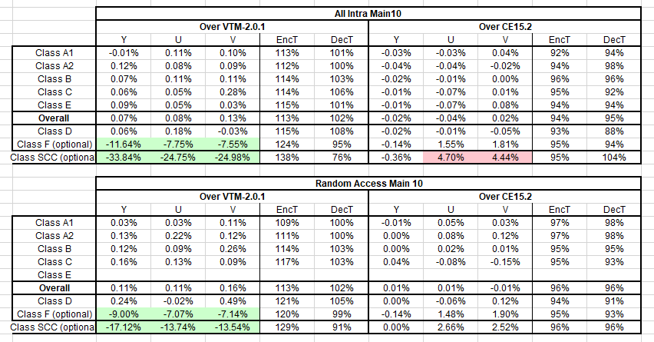

Table 2: simulation results of method 2.
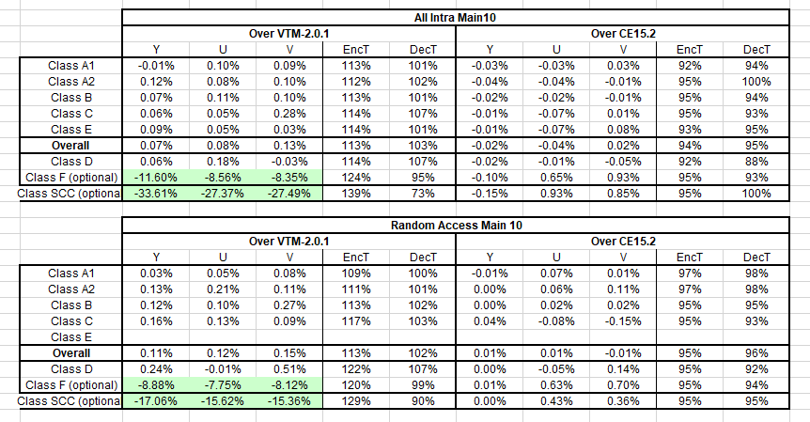

Conclusion
In this contribution, an alternative way of palette mode modification when dual tree enabled is proposed. The proposed method 1 reports -11.64%, -7.75%, -7.55% luma and chroma BD rate changing for AI configuration on class F over VTM 2.0.1. And reports -9.00%, -7.07%, -7.14% luma and chroma BD rate changing for RA configuration on class F over VTM 2.0.1. The proposed method 2 reports -11.60%, -8.56%, -8.35% luma and chroma BD rate changing for AI configuration on class F over VTM 2.0.1. And reports -8.88%, -7.75%, -8.12% luma and chroma BD rate changing for RA configuration on class F over VTM 2.0.1. It is recommended to further study this contribution in CE.

References
[1] Y.-C. Sun, Y.-H. Chao, X. Xu, “Description of Core Experiment 15 (CE15): Palette mode”, JVET-K1035, Ljubljana, SL, July 2018
[2] High Efficiency Video Coding (HEVC), Rec. ITU-T H.265 and ISO/IEC 23008-2, Dec. 2016.
[3] F.Bossen, J. Boyce, X. Li, V. Sergin, and K. Suhring, ”JVET common test conditions and software reference configurations", JVET-K1010, 11th JVET meeting, July 2018.
[4] X. Xu, K. Müller, L. Wang, “Description of Core Experiment 8 (CE8): Current Picture Referencing”, JVET-K1028, Ljubljana, SL, July 2018

Patent rights declaration(s)
Tencent may have current or pending patent rights relating to the technology described in this contribution and, conditioned on reciprocity, is prepared to grant licenses under reasonable and non-discriminatory terms as necessary for implementation of the resulting ITU-T Recommendation | ISO/IEC International Standard (per box 2 of the ITU-T/ITU-R/ISO/IEC patent statement and licensing declaration form).

