    Joint Video Experts Team (JVET)  of ITU-T SG 16 WP 3 and ISO/IEC JTC 1/SC 29/WG 11  12th Meeting: Macao, CN, 3–12 Oct. 2018 | Document: JVET-L0265

Title: | CE4: Affine Prediction with 4×4 Sub-blocks for Chroma Components (Test 4.1.16)
Status: | Input document to JVET
Purpose: | Proposal
Author(s) or  Contact(s): | Kai Zhang, Li Zhang, Hongbin Liu,  Yue Wang, Pengwei Zhao, Dingkun Hong  8910 University Center Lane,  San Diego, CA, U.S.A. 92122 | Tel:  Email: | +1-858-380-8522  zhangkai.video@bytedance.com  lizhang.idm@bytedance.com
Source: | Bytedance Inc.
_____________________________

Abstract
In this contribution, the sub-block size for chroma components is expanded from 2×2 to 4×4. Simulation results reportedly show 0.02% and -0.02% BD-rate changing on the Y component for Random Access (RA) and Low-delay B (LB) configurations, respectively, in average compared with VTM-2.0.1.

Introduction
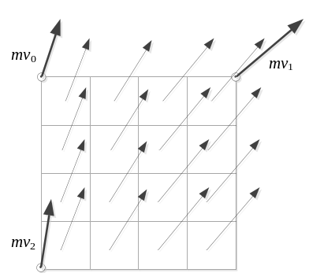
Fig. 1. 4×4 sub-blocks in a 16×16 block coded with AMC.
With the affine motion compensation (AMC) in the benchmark set (BMS), a coding block is divided into sub-blocks, each of which is assigned with an individual motion vector (MV) derived by the affine model, as shown in Fig. 1.The minimum size of sub-block is 4×4 for the luma-component, while it is 2×2 for chroma-components correspondingly if the colour format is 4:2:0.

4×4 Sub-blocks for Chroma Components
In this contribution, the minimum sub-block size of chroma-components is also set to be 4×4. The MV of a 4×4 chroma sub-block is calculated as the average of the MVs of the four corresponding 4×4 luma sub-blocks. With the expanded sub-block size, the bandwidth in the worst case is reduced. Take an 8×8 block as an example, in the original design, the MC procedure needs to fetch 11×11×4 = 484 samples for the four 4×4 luma sub-blocks, and 5×5×4×2 = 200 samples for the four 2×2 chroma sub-blocks for both the Cb and Cr components. With the proposed design, the MC procedure still needs to fetch 484 luma samples, but only needs to fetch 7×7×2=98 chroma samples. Therefore, the total bandwidth is reduced by (200-98)/(200+484)≈15%.

Experimental Results
The proposed method is implemented on VTM-2.0.1. The simulations were performed following the JVET CTC [1]. Results of Random Access (RA) configuration and Low-delay B (LB) configuration are summarized in the Table 1. More detail results can be found in the attached spreadsheets.
Table 1: Test compared with VTM-2.0.1
 | RA |  |  |  |  | LB
 | Y | U | V | EncT | DecT | Y | U | V | EncT | DecT
Class A1 | -0.01% | 0.13% | 0.04% | 99% | 98%
Class A2 | 0.09% | 0.51% | 0.46% | 99% | 94%
Class B | 0.03% | 0.21% | 0.32% | 100% | 97% | 0.02% | 0.12% | -0.23% | 99% | 96%
Class C | 0.00% | 0.27% | 0.20% | 100% | 98% | 0.03% | 0.11% | 0.08% | 99% | 91%
Class E |  |  |  |  |  | -0.15% | 0.42% | -0.11% | 99% | 90%
Overall | 0.02% | 0.27% | 0.26% | 99% | 97% | -0.02% | 0.19% | -0.10% | 99% | 93%

References
- F. Bossen, J. Boyce, X. Li, V. Seregin, K. Sühring, JVET-K1010, “JVET common test conditions and software reference configurations for SDR video”, Jul. 2018.

Patent rights declaration(s)
Bytedance Inc. may have current or pending patent rights relating to the technology described in this contribution and, conditioned on reciprocity, is prepared to grant licenses under reasonable and non-discriminatory terms as necessary for implementation of the resulting ITU-T Recommendation | ISO/IEC International Standard (per box 2 of the ITU-T/ITU-R/ISO/IEC patent statement and licensing declaration form).

